STAFF REPORT

Agenda Item: | 7 | Name: | Jenny Giambattista
Proposed No.: | 2022-0014 | Date: | February 15, 2022

SUBJECT

A motion acknowledging receipt of a report on public health-related climate action needs, in response to Motion 15866.

SUMMARY

Motion 15866, adopting the 2020 Strategic Climate Action Plan (SCAP), included a request for the Executive to provide a report on the staffing and budgetary resources needed to implement the public health-related actions and strategies in the SCAP. The transmitted report, Implementation of the Blueprint for Addressing Climate and Health, describes a phased approach to implementing a Climate and Health Program. The report estimates the staffing needs as follows:

- Phase I: Capacity-Building and Emergency Response (2021-2022, 4-5 FTE).

- Phase II: Foundational Implementation 2023-2024 (10-15 FTE)

- Phase III: Full Implementation and Evolution 2025 and beyond (FTEs to be determined)

For Phase One, Public Health-Seattle & King County (PHSKC) reports it will use existing funding for 2021-2022 and the work will be allocated among eleven positions. The report notes that grants, contracts, investments, and internal funds will be needed to build the Climate and Health Program.

The transmitted report meets the requirements of Motion 15866.

BACKGROUND

As noted in the transmitted report, climate change has been recognized as a global health emergency by the World Health Organization (WHO) and by multiple public health and medical organizations in the U.S. The figure below from the Centers for Disease Control and Prevention highlights the impact of climate change on public health.

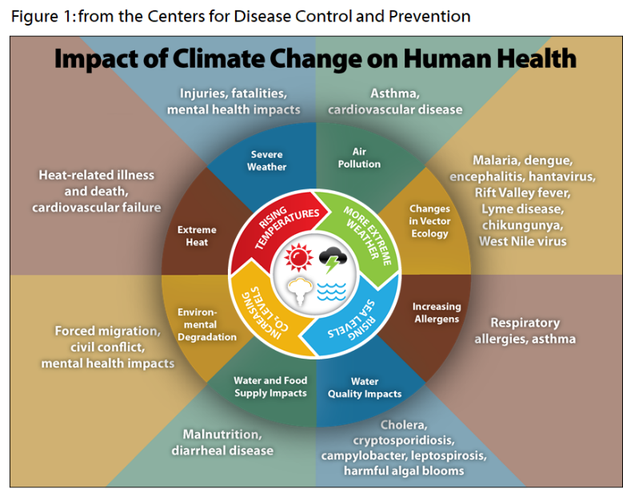

In 2018, PHSKC finalized the Blueprint for Addressing Climate Change and Health ("Blueprint") (Attachment 3). The Blueprint outlines six core public health functions; under these core functions are a set of 15 strategies and 49 recommended actions that the agency must take to address the health impacts of climate change while prioritizing the most vulnerable residents. The Blueprint describes how low-income communities and communities of color will disproportionately face climate change burdens. These frontline communities have higher rates of asthma, less access to affordable healthy foods, face more barriers to quality healthcare, and are less likely to work and live in places that can offer shelter from extreme heat and smoke. In summary, frontline communities are the most likely to be impacted by the health-related climate change impacts and the least likely to have the resources to respond.

The 2020 Strategic Climate Action Plan (SCAP) includes prioritized actions from the Blueprint and additional public health-related strategies and actions in its Sustainable Frontline Communities and Preparedness sections. The SCAP included 11 priority actions where PHSKC is the lead and over 70 actions where it is identified as a supporting partner. The Council staff analysis of the 2020 SCAP identified the lack of public health resources dedicated to this work as an issue. Specifically, the Blueprint reports that PHSKC coordination and planning related to climate change is limited because there are no designated resources. Additionally, the 2021 status update on the 2015 SCAP actions also noted that a lack of dedicated funding for climate work by the PHSKC had made it difficult to implement the recommendations in the Blueprint. Lastly, given that COVID-19 has placed an additional significant workload on the PHSKC, Council staff identified the concern of whether PHSKC had the resources to complete the work.

To address these concerns, the Council added the following reporting requirement related to climate and public health to Motion 15866, adopting the 2020 SCAP.

The council requests that, no later than December 31, 2021, the executive transmit to the council a report on public health-related climate action needs, along with a motion acknowledging receipt of the report. The report should include, but not be limited to, information on the staffing and budgetary resources needed to implement the community health actions and strategies in the Blueprint for Addressing Climate Change and Health report, the Community Health and Emergency Preparedness focus area of the SCAP and the Preparing for Climate Change section of the SCAP, and potential options for addressing these needs. The report and accompanying motion should be filed in the form of a paper original and an electronic copy with the clerk of the council, who will retain the original and provide an electronic copy to all councilmembers, the council chief of staff and the lead staff to the mobility and environment committee or its successor.

As described above, the transmitted report is required to address the staffing and budgetary resources needed to implement community health and preparedness actions in the Blueprint report and community health and preparedness sections of the SCAP.

Proposed Motion 2022-0014 responds to the report called for by Motion 15866 and was transmitted on December 23, 2021.

ANALYSIS

According to the transmitted report, the PHSKC will implement the Blueprint for Addressing Climate Change and Health and SCAP climate health actions through establishing an integrated, interdisciplinary Climate and Health Program. The program will be built over time as resources allow and will be centrally coordinated in PHSKC with interdivisional collaboration. The Blueprint’s six core functions (shown below) for addressing climate change and health will be the foundation for the Climate and Health Program’s strategies and actions.

Table 1.
Health Blueprint Core Functions and Outcomes

Health Blueprint  Core Function | Outcome
- Leadership and organizational capacity | Knowledgeable leaders in climate and health collaborate across divisions and agencies and with communities to drive results for communities.
- Assessment, surveillance, and research | Data brings visibility to the health impacts of climate change and guides activities and resources where they are most needed.
- Listen and educate | Highly impacted communities are informed about the health effects of climate change and lead efforts to educate others.
- Community partnership development and capacity building | Highly impacted communities co-create and lead strategies that increase resiliency in responding to climate change.
- Preparedness and response | Highly impacted communities are prepared and can act to save lives during climate-related emergencies.
- Policy and planning | Local health policies promote environmental justice and account for the impacts of climate change.

PHSKC will use a phased approach to establish and implement its Climate and Health Program. Phase 1 includes near-term work (2021-2022) described below.

Phase I: Capacity-Building and Emergency Response (2021-2022, 4-5 positions), in which PHSKC will develop a detailed operational plan to implement the Blueprint, engage in near term health-related SCAP actions, and respond to ongoing climate events in partnership with community-based organizations and other County agencies. The report includes a list (page 13) of key actions for 2021-2022. Many of the actions are related to planning and capacity building.

One of the actions for 2021-2022 is developing a wildfire smoke mitigation strategy plan. PHKSC reports this work has not yet begun. Additionally, PHKSC will also work with DNRP to develop a strategic plan to mitigate the impacts of higher temperatures on communities in King County, with an emphasis on low income neighborhoods, communities of color and other vulnerable communities in King County that experience a confluence of multiple inequities. An appropriation of $190,000 for the heat mitigation strategy was approved in the 2021 2nd omnibus and is intended to be funded using a FEMA grant. The FEMA grant has not yet been approved but Executive staff expect it to be approved soon. Given the importance and time sensitivity of this work, Executive staff report that if the FEMA grant is not approved soon or if FEMA chooses not to fund the work, Executive staff will work on moving the heat mitigation strategy forward soon with other resources. For example, Executive staff report the ongoing work within the County and with partner jurisdictions to be ready for any heat events in the Ssummer of 2022 could be leveraged while DNRP secures alternate funding.

PHSKC plans to use existing staff and cover the cost of Phase 1 positions through Foundational Public Health Services revenue and other existing revenue. PHSKC reports they may hire 1-2 additional staff with existing resources. The table below shows how the work will be allocated among various positions.

Table 2.
Staffing Plan October 2021 to 2022
Role | Position | FTE
Program Manager | Project Program Manager 4 | .75
Program Manager | Project Program Manager 4 | .50
Program Manager | Project Program Manager 3 | .25
Central Management | Project Program Manager 3 | 1
Wildfire | Education consultant | .25
Wildfire | Project Program Manager 3 | .25
Wildfire | Environmental Scientist 4 | .25
Data Team | Epidemiologist | .50
Data Team | Social Research Scientist | .50
Communication | Communications Specialist 4 | .20
Environmental Health/Policy Managers | Environmental Planner | .25
Total |  | 4.95

Phase II: Foundational Implementation 2023-2024 (10-15 positions), in which PHSKC will implement the highest-priority actions defined in the operational plan developed during Phase I, deepen partnerships with community-based organizations and other County agencies, expand engagement on health related SCAP actions, and continue to respond to ongoing climate events in partnership with community. The report does list potential funding sources for this work, but there are no definitive options included. PHSKC reports it will use Foundational Public Health Services revenue to cover the costs of three ongoing FTE and will identify additional funding needs as part of the considerations for the 2023-2024 budget.

Phase III: Full Implementation and Evolution 2025 and beyond (FTEs to be determined), in which PHSKC will fully implement the Blueprint core functions, strategies, and actions, engage on all the health related SCAP actions that promote equity, improve health in partnership with frontline communities, and deepen and broaden work in strategies and core functions from Phases I and II while incorporating new actions.

The report notes that grants, contracts, investments, and internal funds will be needed to build the Climate and Health Program.
Issues for Council Consideration. Staff has identified the following issue for Council consideration.

Future briefing on Implementation of Phase 1 to ensure operational plan addresses the specific needs of frontline communities. As noted in the report, PHSKC intends to use 2021-2022 to develop a detailed operational plan to implement the Health Blueprint, engage in near term health-related SCAP actions, and respond to ongoing climate events in partnership with community-based organizations and other County agencies. The Council may wish to request an update from PHSKC at the end of Phase 1 in order to better understand the specific near and longer term actions the County is taking to help frontline communities respond to the public health impacts of climate change.

INVITED

- Carine Elsenboss, Preparedness Director, Public Health-Seattle & King County
- Ryan Kellogg, Environmental Health Assistant Division Director, Public Health-Seattle & King County
- Rachel Brombaugh, Director, Climate and Energy Initiatives, Office of King County Executive Dow Constantine

ATTACHMENTS

- Proposed Motion 2022-0014 (and its attachment)
- Transmittal Letter
- Blueprint for Addressing Climate Change and Health

https://kingcounty.gov/depts/health/~/media/depts/health/environmental-health/documents/publications/blueprint-climate-change-and-health.ashx

