Attachment B-3

Description of the 2021B LTGO (Sewer) Bonds
(a) Principal Amount: $94,510,000.00
(b) Purchase Price: $94,303,164.08, representing the stated principal amount of the 2021B LTGO (Sewer) Bonds minus an underwriter’s discount of $206,835.92.

(c) Interest Payment Dates: January 1 and July 1, beginning January 1, 2022.

(d) Maturity and Interest Rates: The 2021B LTGO (Sewer) Bonds shall mature on the dates and bear interest at the rates (computed on the basis of a 360-day year of twelve 30-day months), as follows:

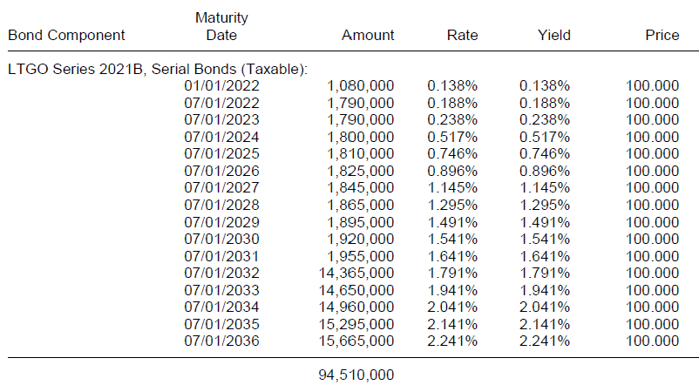

(e) Optional Redemption. The 2021B LTGO (Sewer) Bonds are subject to redemption prior to their stated maturities at the option of the County in whole or in part, at any time before July 1, 2031, at the “Make-Whole Redemption Price.” The 2021B LTGO (Sewer) Bonds maturing on and after July 1, 2032, are subject to redemption prior to their stated maturities at the option of the County in whole or in part, at any time on or after July 1, 2031, at the price of par plus accrued interest, if any, to the date fixed for redemption.

If the 2021B LTGO (Sewer) Bonds are registered in book-entry only form and so long as DTC or a successor securities depository is the sole registered owner of the 2021B LTGO (Sewer) Bonds, if fewer than all of a maturity of a series of 2021B LTGO (Sewer) Bonds are to be redeemed prior to maturity, the particular 2021B LTGO (Sewer) Bonds or portions thereof to be redeemed shall be selected on a “Pro Rata Pass-Through Distribution of Principal” basis in accordance with DTC procedures, provided that, so long as the 2021B LTGO (Sewer) Bonds are held in book-entry form, the selection for redemption of such 2021B LTGO (Sewer) Bonds shall be made in accordance with the operational arrangements of DTC then in effect that currently provide for adjustment of the principal by a factor provided by the Registrar pursuant to DTC operational arrangements. If the Registrar does not provide the necessary information and identify the redemption as on a Pro Rata Pass-Through Distribution of Principal basis, the 2021B LTGO (Sewer) Bonds will be selected for redemption in accordance with DTC procedures by lot within a maturity.

If the 2021B LTGO (Sewer) Bonds are not registered in book-entry only form, the 2021B LTGO (Sewer) Bonds will be assigned certificate numbers. Any redemptions of less than all of a maturity of a series of the 2021B LTGO (Sewer) Bonds shall be effected by the Fiscal Agent by designating such 2021B LTGO (Sewer) Bonds for optional redemption within a maturity in the order of the assigned certificate numbers.

