Attachment B-2

Description of the 2021A LTGO (Sewer) Bonds
(a) Principal Amount: $239,585,000.00
(b) Purchase Price: $292,350,592.38, representing the stated principal amount of the 2021A LTGO (Sewer) Bonds, plus a premium of $53,289,926.20, minus an underwriter’s discount of $524,333.82.

(c) Interest Payment Dates: January 1 and July 1, beginning January 1, 2022.

(d) Maturity and Interest Rates*: The 2021A LTGO (Sewer) Bonds shall mature on the dates and bear interest at the rates (computed on the basis of a 360-day year of twelve 30-day months), as follows:

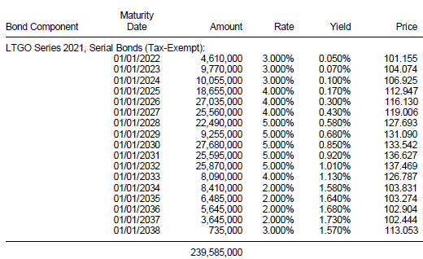

* For 2021A LTGO (Sewer) Bonds maturing on and after January 1, 2032, price is calculated to the first par call date of July 1, 2031.
(e) Optional Redemption. The 2021A LTGO (Sewer) Bonds maturing prior to July 1, 2031, are not subject to optional redemption prior to maturity. The 2021A LTGO (Sewer) Bonds maturing on and after January 1, 2032, are subject to redemption prior to their stated maturities at the option of the County in whole or in part, at any time on or after July 1, 2031, at the price of par plus accrued interest, if any, to the date fixed for redemption.

Whenever less than all of the 2021A LTGO (Sewer) Bonds of a single maturity of a Series are to be redeemed, the Securities Depository will select the 2021A LTGO (Sewer) Bonds registered in the name of the Securities Depository to be redeemed in accordance with the Letter of Representations, and the Registrar will select all other 2021A LTGO (Sewer) Bonds to be redeemed randomly, or in such other manner as the Registrar determines.

