2012
May 31, 2013

Taxicab Annual Report

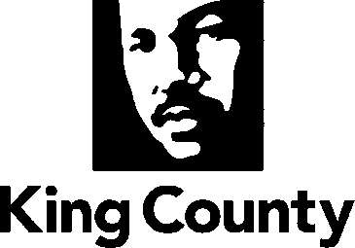
Department of Executive Services
Records and Licensing Services Division
Table of Contents

Executive Summary 3
Background 5
Service Agreements 6
Services Provided 7
Taxicab Demonstration Project 16
Wheelchair Accessible Taxicab Licenses 16
Appendix – King County Taxicab History 1976 to 2012 17

Executive Summary
The King County Records and Licensing Services Division (RALS) provides regulation and enforcement of the taxicab industry in Washington’s most populous County and is charged with safeguarding passengers, drivers, and the public. In 2012, the number of King County taxicab licenses issued decreased to 587 from 592 based on the reversion to King County of five licenses issued under the Alternative Way to Structure a Taxicab Association Project. See Table 1.
RALS regulates the operation of taxicabs in unincorporated King County and has an agreement with the City of Seattle that allows the City to carry out all vehicle licensing functions for the County and in return the County manages all taxicab driver licensing functions for both jurisdictions. In addition, RALS has interlocal service agreements with 16 cities and the Port of Seattle to provide taxicab regulation services.
Produced in accordance with King County Code 6.64.740, the 2012 Taxicab Annual Report provides statistical information on taxicabs and drivers, service response times, complaints, and other information relating to the licensing and enforcement of taxicab vehicles and drivers in King County for the period January 1, 2012, through December 31, 2012.
Table 1 - Number of King County Licensed Taxicabs
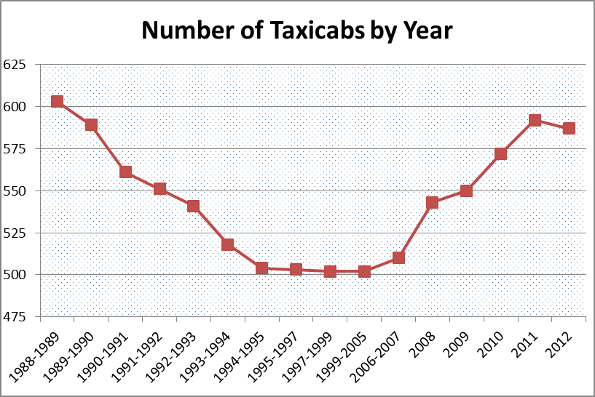
Table 2 - Taxicab Affiliation by Association
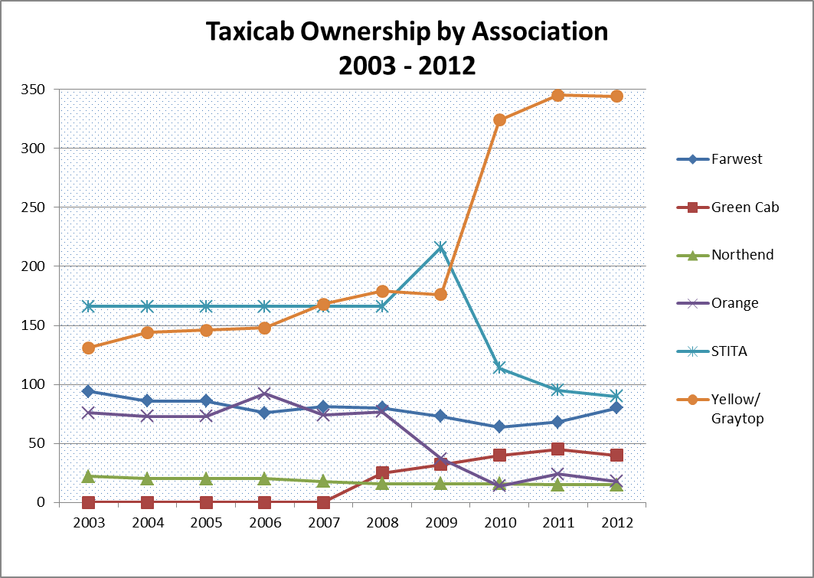

Background
In 1979, King County, the City of Seattle, and the Port of Seattle embarked on a program to regionalize taxicab regulations and licensing by developing consistent regulations and services across jurisdictions. This promoted public safety and customer service by standardizing fees, regulations, enforcement, and rate review procedures throughout King County.
This program continued until September 1988, when these three entities formed the Regional Taxicab Commission. The Regional Taxicab Commission recommended rates, entry restrictions, and other related revisions to the King County Code prior to ending on December 31, 1990.
Based on the Regional Taxicab Commission’s recommendation to issue a moratorium on new taxicab licenses, the King County Council passed Ordinance 9986 on June 10, 1991, permanently closing the issuance of new taxicab licenses.
RALS provides licensing and regulatory services for drivers in the City of Seattle and King County as a result of a cooperative agreement that has been in effect since August 1995. This agreement grants authority to both the City and the County to issue for-hire driver’s licenses and taxicab vehicle licenses. A more complete history of taxicab and for-hire licensing and program statistics is located in the appendix.

Service Agreements
King County has service agreements with the City of Seattle, the Port of Seattle, which operates the Seattle-Tacoma International Airport, and 16 other cities in King County for taxicab licensing and enforcement services.
Table 3 – Jurisdiction & Type of Agreement

Services Provided

For-Hire Driver Licensing
Every driver operating a taxicab in King County must have a for-hire driver’s license. In 2012, RALS processed 2,966 for-hire driver applications. On December 31, 2012, there were a total of 2,942 licensed for-hire drivers. The actual number of for-hire drivers operating at any given time is difficult to calculate as taxicab drivers operate on a full-time, part-time, and seasonal basis. See Table 4, below, for the historical information on annual applications received and processed.
To ensure public and passenger safety, each applicant is carefully screened and must complete several requirements to qualify and obtain a for-hire driver’s license. All for-hire driver applicants are required to take an oral English exam, attend a two-day training program, and take a written examination. Applicants for a City of Seattle license or a dual city/County license are also required to complete a one week taxicab association training where they learn how to use the taximeter and safety equipment. In addition, all applicants must have a ride-a-long with an experienced driver. Beginning in 2008, the Port of Seattle required all Seattle-Tacoma International Airport limousine and town car drivers to obtain a King County for-hire driver license in addition to a limousine license.
Table 4 - For-Hire License Applications Processed

As part of the application process for both new and renewing drivers, RALS reviews driving records from the State of Washington Department of Licensing. Licensing staff conducts in-person driver interviews where an applicant’s driving records show increased moving violations but are not serious or numerous enough to substantiate an immediate denial.
All applicants must take and pass a written examination. The examination tests applicant knowledge of fare determination, driver-passenger relations, driver conduct, ability to understand oral and written directions, vehicle safety requirements, driver regulations, emergency procedures and taxicab equipment for drivers’ personal safety. A separate section of the examination tests geographic knowledge of King County, its surrounding areas, local tourist attractions and destinations.
Applicants must obtain a passing score of 80 percent on both sections of the exam. The examination fee allows applicants two attempts to pass the test. If a driver fails the exam a second time, their license application is denied, and the driver must wait 60 days before reapplying. This provides the driver an opportunity to study and become better prepared to pass the exam. There were 579 tests given in 2012 (Table 5), a portion of these were re-tests administered to applicants who had previously failed an earlier test or tests. In 2012, applicants achieved a 54% pass rate, compared to 37% pass rate in 2011. Increased passing rate is attributable to a comprehensive review and subsequent update of the test and study guide.
Table 5 - Written Examination Results

Regulatory
King County Code 6.64.730 requires RALS to establish and regulate a schedule of optimum times for responses to requests for taxi service. Each year, RALS conducts an audit of taxicab company dispatch records to determine actual response times (Table 7) for service requests, which are then compared to the optimum response times (Table 8). In 2012, the average service response times met the established optimum response time guidelines in seven of the eight zones. The one zone that did not meet the optimum average was the North City zone.
In developing the optimum average taxicab response times, King County is divided into the following eight zones described in Table 6 below and shown in Figure 1 on page 11.

Table 6 - King County Taxicab Service Area by Zone

Table 7 - Average Response Time in Minutes

Table 8 - Minutes +/- Optimum Response Time by Zone

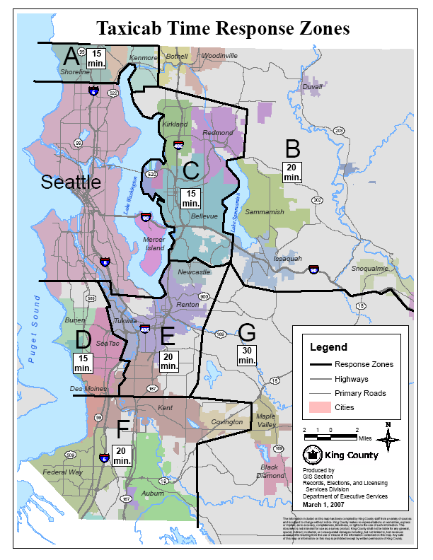
Figure 1 - Taxicab Time Response Zones

Enforcement
Overview
Since 1995, King County and the City of Seattle have worked under a cooperative agreement to regulate the taxicab industry in King County. The agreement divides the licensing functions whereby the County manages and issues all for-hire driver licenses, including background checks, test administration and scoring; and the City of Seattle issues all taxicab vehicle licenses, including all inspections. As a result of this agreement, each respective jurisdiction is granted the authority to enforce the regulations of the other for their respective licensing responsibilities.
In addition to unincorporated King County, RALS also enforces taxicab regulations for the Port of Seattle at the Seattle-Tacoma International Airport, and in the cities of Auburn, Bellevue, Burien, Covington, Enumclaw, Federal Way, Issaquah, Kenmore, Kent, Kirkland, Maple Valley, Redmond, Renton, Sammamish, SeaTac, and Shoreline (Table 2). This work is done through interlocal agreements, which address regulation of rates, the manner in which fees are established, operating requirements regarding customer service and public safety, and the requirements for obtaining vehicle and for-hire driver’s licenses.
Process
The King County Code provides different avenues for enforcement of taxicab regulations. These include:
1) Notices of violation that are issued in the field upon observation of a violation;
2) Administrative notice and orders with a provision for an administrative appeal; and,
3) Citations.
The City of Seattle issues notices of violations to city and city/County (dual) licensed taxicabs for field violations, such as a driver failing to complete a trip sheet. In the County, an administrative notice and order process is used which assesses a monetary civil penalty for trip sheet violations. More serious violations can be escalated and criminal charges can be filed. For example, it is a criminal misdemeanor to operate a taxicab without a license. In addition, notice and orders may carry a monetary civil penalty.

Passenger Complaints
King County, the City of Seattle, and the Port of Seattle share a taxicab complaint line 206-296-TAXI. This number is visibly displayed in all Seattle and King County taxicabs so that passengers have easy access to the taxicab regulatory body if their experience is such that a complaint is warranted. All complaints are investigated and results may include an assessment of monetary civil penalties and/or temporary or permanent license suspension issued through a notice and order process.
A concerted effort began in 2011 and continued into 2012 to investigate complaints regarding taxicab drivers and conduct active field inspections to determine the reason for the significant complaint growth from 2009 to 2011. The complaints did decrease in 2012, which is attributed to increased enforcement efforts by the County. RALS will continue to monitor this in 2013.

Table 9 - Number and Nature of Complaints

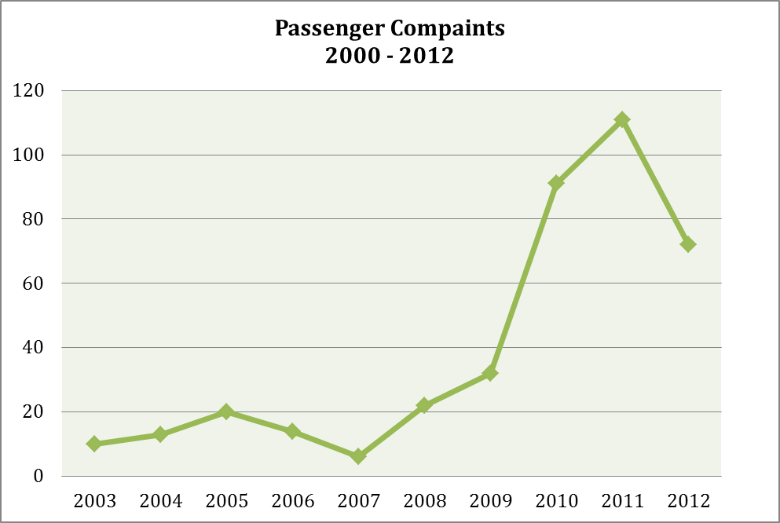

Rates
The meter rate taxicab drivers charge the public is set by King County Code. Table 10 below, provides the breakdown of the taxicab rates since 1974. The initial charge is called the “drop rate”. In September of 2012 the fee per mile charge changed to 1/9 of a mile from the previous 1/10 of a mile. When the vehicle slows down below 12 mph, the passenger is charged based on wait time instead of the per mile fee.
Table 10 - King County Historical Taxicab Rates

Taxicab Scrip Vouchers
King County Metro's Accessible Services program issues taxicab scrip to King County residents who have a reduced bus fare permit and have income at or below 70 percent of the state median income.
Registrants may purchase up to six books of scrip each month; scrip does not expire. Each booklet has a $10 face value and contains coupons in $0.50 and $1 denominations. Registrants pay 50% of the face value or $5 per booklet. Currently, six taxicab companies participate in the taxicab scrip program. Historically, most trips are short and taken in the urban Seattle area where taxi service is more available and destinations are closer together.

Taxicab Demonstration Project
The Alternative Ways to Structure a Taxicab Association Project was launched by King County in 2005. It is a demonstration project (Public Rule LIC 8-3) designed to improve customer service and driver safety, provide beneficial impacts to the environment, and test alternatives to the ways taxi associations are structured. The taxicab licenses for this project are temporary and available through reapportionment of reverted licenses. This project is a County only project; the taxicabs can pick up passengers only in unincorporated King County and its contract cities. The project requires the selected company to comply with special conditions including:
- the use of hybrid electric taxicabs with minimum rating of 40 mpg
- provide wheelchair accessible vehicles
- consider its drivers to be employees with bargaining rights.
In August 2008, Green Cab Taxi and Disabled Service Association, LLC (Green Cab) was awarded vehicle licenses through a Request for Proposal (RFP) to provide King County taxi services for this project. This project has operated for over three years and had 40 taxicabs operating at the end of 2012, which includes three wheelchair accessible taxicabs.

Wheelchair Accessible Taxicab Licenses

In 2010, the King County Council established 45 permanent Wheelchair Accessible Taxicab (WAT) licenses through approval of Ordinance 16824. In cooperation with the City of Seattle, these licenses were approved and issued as dual, City-County, WAT licenses. Thirty of the licenses were issued through a lottery process conducted by the City of Seattle in 2010 and the remaining 15 were issued in 2011 through a Request for Proposal process managed by the County.

Appendix– King County Taxicab History 1976 to 2012

1976: King County, the City of Seattle, and the Port of Seattle embarked on a program to regionalize taxicab regulations and licensing by developing consistent regulations and services across jurisdictions. The intent was to promote public safety and customer service by standardizing fees, regulations, enforcement, and rate review procedures throughout King County (King County Motion 2362).

King County regulated entry into the taxicab market and rates charged to passengers. Entry was restricted by a population ratio formula and the King County Council set rates after reviewing prescribed criteria. This “need and necessity” provision required new applicants to show that there was a bona fide need for taxicab service in that zone.

1976 to 1979: The “need and necessity” provision of the King County Motion limiting entry was deleted, resulting in an increased number of licensed taxicabs. The Port terminated its exclusive contract for taxicab services at Seattle-Tacoma International Airport, and a growing number of independent taxicab operators obtained permits to service Seattle-Tacoma International Airport.

1979 to 1984: The County and the City of Seattle passed ordinances deregulating entry standards and rates (King County Ordinance 4232). With no restrictions on the numbers of licenses issued, taxi owners set their own rates. The deregulation of taxicab licensing resulted in many problems in each jurisdiction. As deregulation continued, consumer views of taxicabs continued to decline; conditions were viewed as deteriorated and rate differences created the perception of price gouging.

1984: Regulation returned and a conscious effort was made to address the rate variation problem and to increase safety and improve cab conditions. A moratorium was placed on the issuance of new taxicab licenses and rates were set by ordinance.

1985: The County's entry moratorium on licenses expired in 1985, returning the County to open entry; however, rates continued to be set by County ordinance. Also in 1985, the Port of Seattle placed a moratorium on permits to operate at Seattle-Tacoma International Airport.

1986: The Ad Hoc Taxi Committee was created to study and recommend a method for determining the optimum number of taxis to operate in the County, the criteria and method for setting and/or changing taxicab rates, and to develop a plan for ensuring reciprocity in enforcement and licensing of taxicab businesses. The work of the committee resulted in Ordinance 7964, which created a process to establish rate and entry recommendations based on objective data rather than industry requests, while also placing a moratorium on the issuance of new taxicab licenses.

Since 1986, open entry existed for three brief periods, once during the verification process of a referendum in 1987, in early 1988, and for approximately one month in 1989.

1988: King County, the City of Seattle and the Port of Seattle formed the Regional Taxicab Commission to recommend rates, entry restrictions, and other related revisions to the King County Code (King County Ordinance 8450).

1990-91: In the fall of 1990, County and city staff drafted an ordinance incorporating many of the 1988 Regional Taxicab Commission entry model recommendations. Recommendations included increased standards for licensing and operations of taxicab vehicles and for-hire drivers, proposed closed entry and maintained a single ordained rate at an increase of approximately eight percent from $1.20 drop/$1.40 mile, to $1.30 drop/$1.50 mile. The fixed rate proposed was the same as the highest rate the city allowed (ceiling rate). County Proposed Ordinance 90-948 and the City of Seattle Ordinance 108357 were submitted to the county and city councils in November, 1990. A joint hearing was held on January 14, 1991, and the City of Seattle adopted the proposed ordinance. The City of Seattle, however, maintained its ceiling rate approach. The King County Council passed Ordinance 9986, permanently closing the issuance of new taxicab licensing.

1992: The County Executive's original rate submission in 1990 of $1.30 drop/$1.50 mile was increased in July 1992 to $1.60 drop/$1.60 mile. The industry lobbied for a higher rate, and the County Council adopted its request of $1.80 drop/$1.80 mile/$.50 per minute waiting time.

The County Council passed Ordinance 10498 which significantly changed the for-hire vehicle or taxicab, and for-hire driver standards and regulations. Ordinance 10498 implemented many changes, including:

- Continuing the closed entry system;
- Increasing taxicab rate fee from 1.60 drop/$1.60 mile to $1.80 drop/$1.80 mile;
- Changing the quarterly data collection process to an annual filing;
- Eliminating the required use of net profit ratio formula in rate and entry recommendations;
- Enhancing the mechanical certification process for vehicles;
- Enhancing the safety and cleanliness requirements for vehicles;
- Increasing the number of mandatory safety inspections;
- Increasing the for-hire driver standards for entry and denial of licenses; and
- Establishing several provisions to address consumer protection issues.

1995: King County and the City of Seattle entered into a Cooperative Agreement. The agreement grants authority for the County to issue the City of Seattle for-hire driver’s licenses as an agent for the city and for the city to issue County taxicab vehicle licenses as an agent for the County. This agreement also grants authority for City and County license inspectors to enforce both City and County taxi codes, and both licenses can be obtained at one convenient location.

1996: In late 1996, the City of Seattle proposed changes to its taxicab ordinance to streamline its laws with County regulations. However, the City of Seattle went further in several areas. Most significant was the requirement that taxicabs belong to associations. Associations are separately licensed entities that maintain a level of oversight liability for operations by vehicle owners and drivers, thereby placing some of the burden of cost to improve service standards on the industry itself. A monetary penalty schedule was established that set fines for violations by drivers, owners, and taxicab associations. Vehicle age restrictions were also implemented. In 1997, all city drivers were required to retake the written examination. All city drivers (new and renewals alike), were required to take an oral test to demonstrate English language proficiency. These changes affected approximately 80 percent of County licensees since drivers were required to have both city and County licenses.

2000: The County Council passed Ordinance 13984 amending standards for the denial of a for-hire driver’s license. The ordinance added mandatory denial language for applicants with bail forfeitures or convictions within five years of the date of application for vehicle assault, vehicular homicide or reckless driving. In addition, the ordinance itemized a number of criminal offenses as set out in state law (RCW Title 9) as discretionary grounds for the denial of a license.

2001-08: Beginning in the spring of 2001, King County, the Port of Seattle, and the City of Seattle formed a “Regionalization Workgroup” to study the feasibility of opening access at Seattle-Tacoma International Airport to all licensed taxicabs. The desire was to create efficiencies by further regionalizing the County, city and port ordinances and reducing “dead-heading” (taxicabs unable to pick-up passengers must travel back empty), reduce excess pollutants, and expand the number of taxicabs operating across the entire region. Port Commissioners declined to open entry to all taxicabs operating in King County at Seattle-Tacoma International Airport and re-signed an exclusive operating agreement with one taxicab company, STITA.

The County, led by Metro’s Accessible Services, joined a task force with representatives from the City of Seattle, Port of Seattle, and other stakeholders to address the issue of taxicab accessibility for citizens with wheelchairs and other mobility devices. In late 2003, Metro Accessible Services secured grant money from the state and began meeting with King County Records, Elections, and Licensing Services and City of Seattle representatives to develop implementation plans for licensing and placing into service wheelchair-accessible taxicabs. Ordinances were passed by both King County and the City of Seattle to initiate a demonstration project to study wheelchair accessible taxicab service issues.

In 2004, Ordinance 15059 increased taxicab vehicle and driver fees to help recover licensing and enforcement costs and reflect inflation. Vehicle fees increased from $240 to $300 per year and for-hire driver application fees increased from $60 to $75 per year (plus a $5 photo fee).

A taximeter rate increase was proposed (Proposed Ordinance 2004-0466) to increase rates from $1.80 drop/$1.80 per mile to $2.50 drop/$2.00 per mile. Rates had not been increased in nearly twelve years (since 1992) and the cost of living had increased 36 percent. In addition, operating costs such as fuel had soared by more than 78 percent since 1992. Based on a 15 mile trip, the proposed rate represented only a 13 percent increase. The increase was proposed by the City of Seattle’s, Taxicab Advisory Group, which included taxicab drivers, owners and associations; senior and disabled citizens from the community; and Department of Social and Health Services providers.

2005: County Ordinance 15132 increased taximeter rates to $2.50 drop/$2.00 per mile. The rates went into effect on April 1, 2005, for both the County and the City of Seattle. King County and the City of Seattle inspectors worked together to ensure all 842 taxicabs had their meters tested and sealed by early afternoon that day. As an added convenience to the taxicab owners and drivers, King County and the City of Seattle staff arranged the special meter inspections to occur at the taxi company lots.

County Ordinance 15263 established the Wheelchair Accessible Taxicab (WAT) Demonstration project, and also included minor changes which affected taxicab insurance, added an additional driver safety training requirement, added a mandatory oral English test, and changed the taxicab licensee year. The ordinance became effective September 18, 2005, and the pilot project was implemented in October 2006.

County Ordinance 15309 approved a methodology for issuing additional taxicab licenses and made taxicab licenses issued after January 1, 2006, nontransferable (effective November 13, 2005). Taxicab licenses issued before January 1, 2006, are transferable meaning that they can be bought and sold on the open market. The non-transferability issue arose from complaints and comments received from taxicab drivers during public hearings on the WAT Demonstration project.

County Ordinance 15282 established the Accessible Taxi Advisory Committee to be selected in the spring of 2006. The committee consists of nine members recruited by the Executive in consultation with the Council. Membership of the committee reflects the diversity and geographic distribution of County residents. Seven of the members were appointed before start-up of the WAT Demonstration project and the remaining two positions were filled later by WAT users having experience with the service. This committee helped ensure that the pilot project was implemented in a way that accurately gauged the demand for and viability of accessible taxi service in the Seattle and King County markets. The committee monitored the preparation for and implementation of the pilot project and advised the King County Licensing and Metro Accessible Service sections.

2007: Public Rule LIC 8-3 was adopted, as allowed under the 2005 Ordinance 15309, to test alternative ways of structuring taxi associations and the terms of taxicab license leases, while improving taxi driver/lessee economic viability and achieving environmental benefits by requiring hybrid vehicles.

2008: Ordinance 15951 increased and changed meter rates as follows: fee per mile changed to $0.25 per 1/10 mile from $0.20 per 1/10 mile and fee per wait minute changed to $0.50 per minute (charged at $0.25 per 30 seconds) when the vehicle slows below 12 miles per hour from $0.20 per minute when the vehicle slows below 17 miles per hour. There was no change in the drop rate.

2009: Ordinance 16695 increased fees for the for-hire driver’s licenses, added a new fee for rescheduling and corrected change of owner dates, which took effect January 1, 2010.

2010: Ordinance 16824 established forty-five (45) permanent Wheelchair Accessible Taxicab licenses to be issued as dual city-County licenses and regulating wheelchair accessible taxicab licenses; making technical corrections; and amending Ordinance 10498.

2011: The King County Council and Seattle City Council appointed 10 members to the joint Seattle/King County Taxicab Advisory Commission, which was established by Ordinance in 2009. The commission had its first meeting in July. The purpose of the Taxicab Advisory Commission is to study regulations, rules, policies and issues relevant to the provision of high-quality taxicab service in the city of Seattle and King County while ensuring the economic viability owning and driving taxicabs, and to make recommendations to the city of Seattle and King County on these matters.

2012: Ordinance 17404 increased and changed taxicab meter rates in September as follows: increasing the fee per mile changed to $0.30 per 1/9 mile from $0.25 per 1/10 mile and the fee per wait time of $0.50 per minute changed to charge at .$0.30 per 36 seconds from $0.25 per 30 seconds. There was no change in the drop rate.

Taxicabs at Seattle-Tacoma International Airport are available on demand; therefore, the response time is zero and is not included in Zone D (the airport area).
Response times are calculated as the time elapsed from when the trip is created in the dispatch system to the time the meter is engaged. The meter is engaged after the customer has been seated and the vehicle begins to move.

