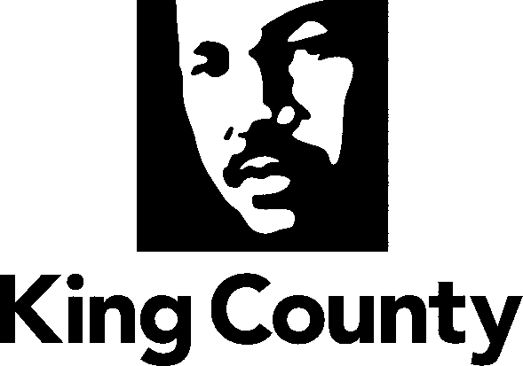

Metropolitan King County Council
Growth Management and Natural Resources Committee

Agenda Item: | 7 | Name: | Rick Bautista
Proposed Ord: | 2008-0476 Illegal Dumping | Date: | September 9, 2008
Attending: | Pam Badger, DNRP  Harry Reinert, DDES

SUBJECT:
Ordinance adopting revisions to KCC Title 23 to clarify and strengthen the county’s role in enforcing the laws that prohibit illegal dumping on public and private lands

BACKGROUND:
The dumping of trash outside of an approved landfill or transfer station is illegal under state law. Illegal dumping is a continuing and growing problem for government agencies, businesses, and private landowners who find yard waste, appliances, car bodies, and other waste dumped on their properties.
King County alone received hundreds of reports of illegal dumping In 2006 and 2007 and spends more than $2 million annually to field reports, clean up dump sites on county land, deal with dumping on private land and enforce regulations. Aside from the fiscal impacts, illegal dumping can decrease land values, contribute to fires, contaminate lakes, rivers and drinking-water wells, constitute a health hazard and attract rodents, mosquitoes and other pests.
In 2003, the executive convened an Illegal Dumping Task Force, with the objectives of 1) improving the county’s interagency coordination when responding to reports of illegal dumping and 2) reducing the number of incidents of illegal dumping. The task force brought together the many King County agencies involved in handling incidents of illegal dumping, including the:
- Department of Development & Environmental Services
- Department of Natural Resources and Parks
- Seattle-King County Department of Public Health
- Department of Transportation
- Sheriff’s Office
- Prosecuting Attorney’s Office
- Local Hazardous Waste Management Program

Each agency has important responsibilities for response, investigation, and cleanup to prevention and enforcement. The task force recommended a number steps to improve the county’s response to illegal dumping. One recommendation created a Streamlining Enforcement Work Group to examine ways to enhance the county’s enforcement ability.

ORDINANCE SUMMARY:
The executive transmittal letter notes that “Studies of jurisdictions that have strengthened their civil citation process and increased enforcement efforts show significant decreases in illegal dumping over time”. Proposed Ordinance 2008-0476 is intended to strengthen county enforcement against illegal dumping by broadening the ability of county agencies to investigate violations.

The enclosed ordinance proposes specific changes to KCC Title 23 to:
- State that illegal dumping violates county code and is subject to civil enforcement.
- Authorize all affected agencies to enforce violations on their custodial lands.
- Allow investigators to search the trash for evidence of the identity of the dumper
- State that releasing solid waste to a transporter does not absolve a person from responsibility if their waste is illegally dumped.
- Allow a rebuttable presumption that a person whose name appears on three or more items of illegally dumped waste commit the act.
- Simplify citation procedures and clarify the citation appeal process.
- Enable county agencies to assess penalties and charge cleanup restitution payments. Note: The proposed language is similar to that in statutes that authorize charging a restitution payment to illegal dumpers. This payment is to be divided equally between the enforcement agency and the landowner. The payment may be waived if the illegal dumper cleans up and properly disposes of the waste. Junk vehicles are included in the types of waste that can be charged a restitution payment.
- Allow re-inspection fees when violations are not corrected within the time specified in a Notice and Order.
- Reduce the appeal period for citations and notice and orders from 21 to 14 days.
- Authorize no action on de minimis violations.
- Authorize the Prosecuting Attorney’s Office to conduct misdemeanor prosecutions for willful or knowing civil code violations.
- Authorize and provide criteria for the development of enforcement procedures by public rule.

attachments:
- Proposed Ordinance 2008-0476

