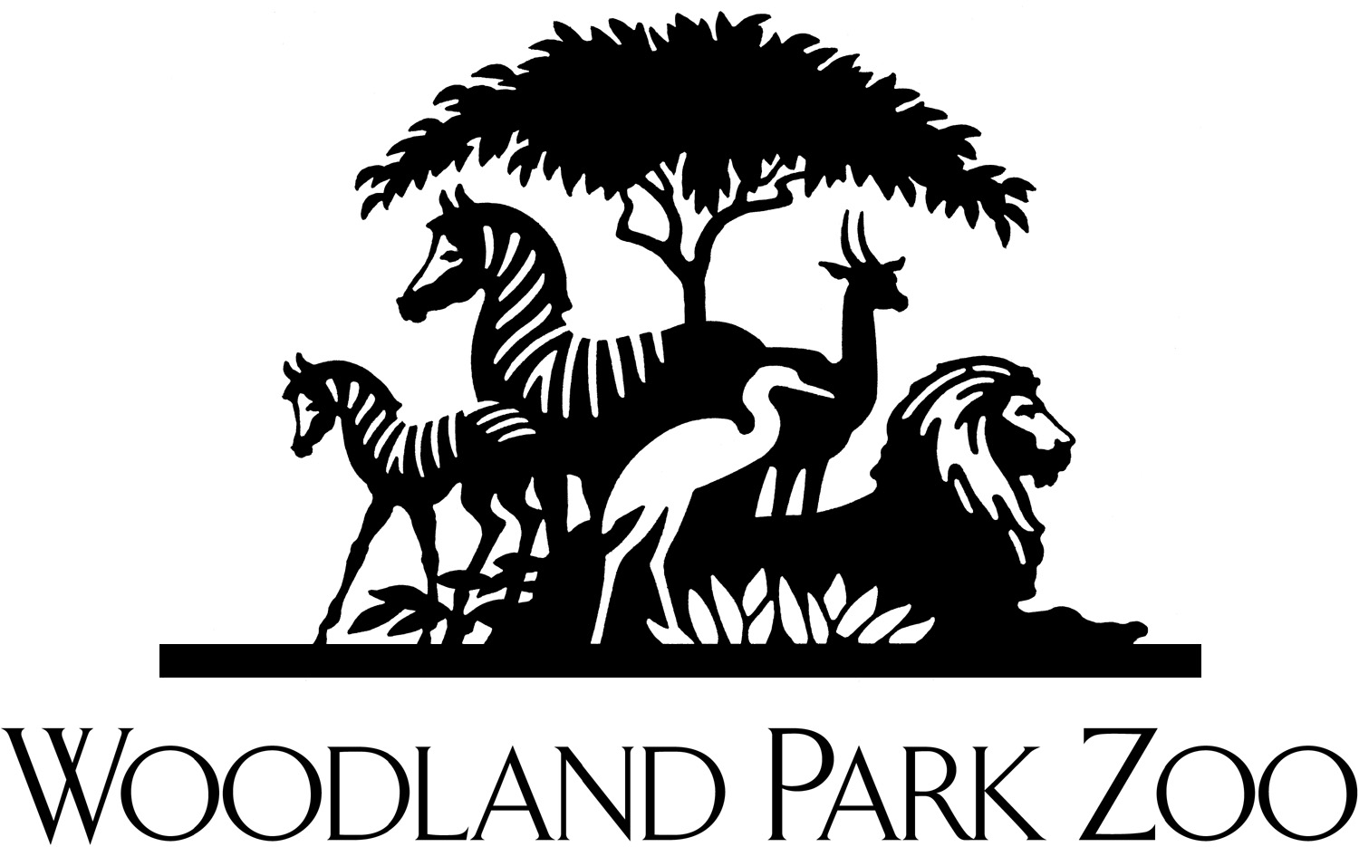

King County Parks Levy
Proposed Funding for Zoo

New and Improved Animal Exhibits

As the home for over 1000 animals, funds could build new animal exhibits and improve existing animal exhibits. Funds could be used to accomplish such projects as:

- New penguin exhibit to replace aging and antiquated exhibit
- New flamingo exhibit
- New Greater One Horned Rhino exhibit
- Major improvements for hornbills

Environmental and Conservation Education Programs
With a mission of education and conservation, the zoo is a platform for educational purposes and participation in global efforts to understand and protect the world’s animals and their habitats. As a vital resource, the zoo serves tens of thousands of students and teachers across the state each year. Funds could be used to support our efforts to increase services and programs for:
- Pre K-12 education programs
- Adult education programs
- Teacher education programs
- Conservation education outreach
- New Conservation Exhibit Gallery to promote conservation education
- Field research for NW conservation projects
- Improved educational signage at exhibits

Improvements to Guest Amenities and Furthering the "Greening" of the Zoo

As a 108-year old community organization that serves one million plus guests annually, we constantly need to improve our guest experience and provide necessary amenities. Additionally, as a 108-year old organization, our infrastructure needs updating to further our efforts to be a showcase of "green" practices ranging from water and energy use to carbon emission. Funds could be used to:

- Improve safety and handicapped access
- Improve amenities for our aging population
- Improve facilities and exhibits to reduce water and energy consumption
- Provide educational signage to expand the adoption of "green" practices

