 | Metropolitan King County Council  Staff Report

Committee: | Budget and Fiscal Management Committee
Agenda Item: | 10 | Analyst: | Nick Bowman
Proposed No.: | 2026-0097 | Meeting Date: | July 22, 2026

OVERVIEW
TOPIC: An ordinance authorizing the sale of surplus County property located near South 328th Street and Military Road South in the City of Federal Way.
LEGISLATION SUMMARY
Proposed Ordinance 2026-0097 would approve the sale of 149,410 square feet of surplus County property located in the City of Federal Way, in Council District 7, for $675,000 to a private individual. The property has no formal physical address due to its vacant and undeveloped status. According to the Executive, the property was purchased by the Road Services Division in 1919 as a borrow pit for gravel but has not been used for many years and is no longer needed to support current or future County operations.
The Facilities Management Division (FMD) declared the parcel surplus to County needs on October 24, 2025. Selling the property to a private individual would provide one-time revenue to Roads.

KEY ISSUES FROM THE ANALYSIS
- Consistency with County Code. All occupancy, vacancy, and leasing decisions regarding County-owned real property are under the purview of either FMD or departmental custodians. Under County Code, in the case where a custodian has indicated it no longer needs a property, FMD must conduct an analysis of whether that property can be declared surplus before it can be sold. The declaration of surplus and proposed sale of the property appears to be consistent with County Code requirements.
AMENDMENTS
- Amendment 1 would delete the transmitted Attachment A, the Purchase and Sale Agreement, and replace it with a new Attachment A, that includes a signed 1st amendment extending the Council approval period to September 15, 2026.

BACKGROUND & TIMING CONSIDERATIONS BACK TO TOP
Property History. The 149,410 square foot parcel (Parcel #1521049016) commonly referred to as the Hatfield Pit, was purchased by the Road Services Division of the Department of Local Services (Roads) in 1919 as a borrow pit for gravel but has not been used for many years. According to the Executive, the property is no longer needed to support current or future County operations.
The vacant, undeveloped property is located near South 328th Street and Military Road South in the City of Federal Way. There is no formal physical address to the property.
The property is zoned RS-9.6 meaning one dwelling unit per 9,600 square feet. Any future development on the property by the buyer, a private individual, who also owns the adjoining property, would be subject to review and approval by the City of Federal Way.
Maps of the property are provided below.
Figure 1. Map of Parcel with Satellite Imagery
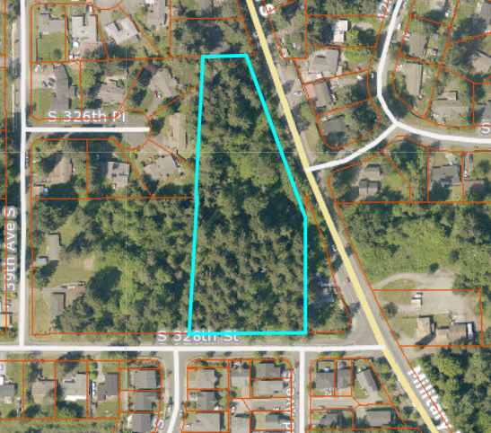

Figure 2. Vicinity View Map
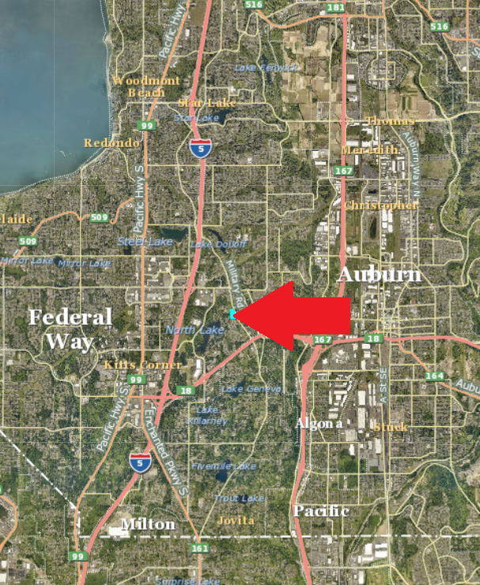
Timing Considerations. According to the Purchase and Sale Agreement, the proposed ordinance was to be in effect by June 17, 2026, however King County negotiated with the buyer to extend the Council approval period to September 15, 2026.

ANALYSIS BACK TO TOP
Key Issue A. Consistency with King County Code. According to King County Code Section 4.56.080, any surplus property sales greater than $100,000 require Council approval. Section 4.56.060 authorizes FMD to conduct sales of all County surplus properties. All surplus property sales need to abide by the requirements outlined in K.C.C. chapter 4.56.
Table 1 provides the requirements, the King County Code reference, and the outcome or status for each requirement. The requirements are listed chronologically, since each depends on the outcome of another (i.e., the custodial agency surplus declaration must occur before FMD offers a parcel to other County agencies).
Table 1. Surplus Property Sale Requirements
No. | Requirement | K.C.C. Reference | Outcome/Status
1. | Roads Surplus Declaration | 4.56.070 | The Road Services Division declared the property surplus to its needs on March 3, 2025.
2. | FMD Offer of Property to other County Agencies | 4.56.070 | FMD stated that it offered the property to other county agencies on May 2, 2025, and received no interest.
3. | Property Evaluated for Affordable Housing | 4.56.070.C.1 | DCHS determined that the surplus property was not suitable for affordable housing on October 1, 2025. DCHS based its determination on potential environmental concerns with the property which was previously used as a gravel pit. According to DCHS, “a Phase I environmental assessment is needed to better determine development suitability. DCHS does not have resources available to conduct environmental assessments to further investigate and perform due diligence.”  Additional concerns cited by DCHS include the site not being in a walkable area to amenities, no existing sidewalk infrastructure along Military Rd S, and no connection to public transit.  The site also has steep slopes and no existing sewer infrastructure.
4. | Final Surplus Declaration | 4.56.070 | FMD declared that the property was surplus to County needs on October 24, 2025.
5. | FMD Appraisal | N/A | According to the Property Summary, the property was appraised on April 12, 2025, by Integra Realty Resources using a sales comparison approach. Seven comparable land sales were utilized to determine an estimated Fair Market Value of $600,000.
6. | Bid Process | 4.56.100 | According to the Executive, the sale of this parcel was listed with a Multiple Listing Service (MLS), marketed on the County’s website, and with onsite signage.
7. | Purchase and Sale Agreement | N/A | The Purchase and Sale Agreement (PSA) was executed on December 19, 2025.
8. | Council Approval | 4.56.080 | As the value of the surplus property being conveyed exceeds $100,000, Council approval of the sale is required. Under the terms of the PSA, the sale is contingent on the Council approving the PSA by April 18, 2026, with an optional 60-day extension to June 17, 2026.
9. | Disposition of Sale Proceeds | 4.56.130 | If approved by the Council, the sale proceeds would be disbursed first to the Department of Executive Services – FMD Real Estate Services (RES) for work associated with the sale of the surplus property.  Remaining proceeds would be deposited into the Roads Operating Fund.

Rationale for Sale. The Property Summary states that the rationale for the proposed sale is that “the property is surplus to the current and future needs of Roads and the County. The sale will provide one-time revenues to Roads.”

AMENDMENTS BACK TO TOP
The following amendments are publicly available as of the date of packet distribution and attached to this staff report. Additional amendments may be released prior to the committee meeting.
Amendment | Sponsor | Effect Statement
1  New Attachment A | Dembowski | Amendment 1 would delete the transmitted Attachment A, the Purchase and Sale Agreement, and replace it with a new Attachment A, a Purchase and Sale Agreement dated June 18, 2026, that includes a signed 1st amendment to the Purchase and Sale Agreement extending the Council contingency period to September 15, 2026.

INVITED
- Amanda Tran, Real Property Agent, Facilities Management Division.

ATTACHMENTS
- Proposed Ordinance 2026-0097 (and its attachment)
- Amendment 1 (and its attachment)
- Transmittal Letter
- Fiscal Note

