STAFF REPORT

Agenda Item: | 7 | Name: | Terra Rose
Proposed No.: | 2026-0150 | Date: | June 16, 2026

SUBJECT

Proposed Ordinance 2026-0150 would authorize the Executive to enter into an amendment to the solid waste interlocal agreement (ILA) with the City of Bothell related to solid waste management services in areas annexed into the City from Snohomish County.

SUMMARY

The City of Bothell, whose city limits include areas located in both King and Snohomish Counties, participates in King County's solid waste system through an interlocal agreement that provides that the City shall cause all solid waste and moderate risk waste that is generated and/or collected within the city limits to be delivered to King County for disposal. In 2014, the ILA was amended to direct waste generated and/or collected in areas of Snohomish County annexed to the City after January 2, 2011, to be disposed in the Snohomish County system.

The Bloomberg Hill Island Annexation Area, comprised of 11.9 acres located in Snohomish County just north of the county border line, was annexed into the City effective December 31, 2012. However, despite being in Snohomish County and having been annexed after the January 2, 2011 cutoff date established in the ILA, Executive staff indicate that this annexation area has been served by waste haulers that for years have taken waste from this area to King County facilities for disposal. Executive staff further note that this oversight was discovered during the City's contract negotiations with waste haulers.

Proposed Ordinance 2026-0150 would authorize the Executive to amend the solid waste ILA with Bothell to allow King County to accept waste from the Bloomberg Hill Island Annexation Area in line with current and past practice, and as requested by the City. Executive staff indicate that only the Bloomberg Hill Island Annexation Area and no other annexed areas would be affected by this change. Executive staff have further noted that, according to the City, memorializing this practice would eliminate the need for the City to contract with a different hauler, and for the hauler to change disposal sites, which would add significant mileage and associated environmental impacts.

Executive staff estimate that the amount of waste that would go to the Cedar Hills Regional Landfill from new development happening in the annexed area would be less than 26 tons per year, or 0.15 percent of the total tonnage going to the landfill from within the Bothell city limits.

BACKGROUND

Solid Waste System Interlocal Agreements. King County's Solid Waste Division operates a regional solid waste system for the unincorporated areas and the 37 partner cities, including the City of Bothell, that have executed solid waste interlocal agreements with the County. These ILAs establish the various rights and responsibilities for the partner cities and the County with respect to disposal of solid waste generated and/or collected within the city limits. Under the ILAs, the cities are responsible for ensuring solid waste generated or collected within the city are delivered to the County system's facilities, and the County is responsible for disposal of the collected waste, which currently occurs at the County's Cedar Hills Regional Landfill. The ILA provides that no solid waste generated or collected within a City may be diverted from the designated disposal sites without County approval.

Bothell City Limits and Disposal Service. The City of Bothell is bisected by the border between King and Snohomish County and therefore the city limits include areas in both King and Snohomish Counties, as illustrated in Figure 1 on the following page.

The current ILA between King County and Bothell provides that the City shall deliver all solid waste and moderate risk waste that is generated and/or collected within the city limits to King County for disposal, with the exception of waste from areas of Snohomish County annexed to the City after January 2, 2011. Waste from those areas is to be disposed by Snohomish County, which operates its own regional solid waste system separate from King County's.

Bloomberg Hill Island Annexation Area. The Bloomberg Hill Island Annexation Area, illustrated in Figure 1, is an area comprised of 11.9 acres just north of the boundary line between King and Snohomish Counties that was annexed into the City of Bothell effective December 31, 2012. According to Executive staff, the Bloomberg Hill Island Annexation Area previously contained five homes but is currently being developed for 48 homes.

Figure 1. Bloomberg Hill Island Annexation Area in the City of Bothell

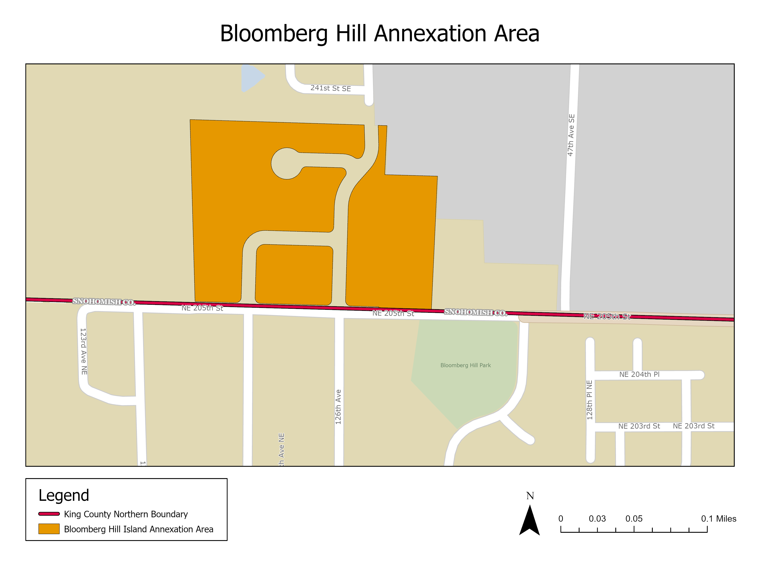

Despite being in Snohomish County and having been annexed after the January 2, 2011 cutoff date established in the current ILA, Executive staff indicate that the Bloomberg Hill Island Annexation Area has been served by waste haulers that for years have taken solid waste from this area to King County facilities for disposal. Therefore, King County has received the per ton fee revenue for the disposal of solid waste from this annexed area. Executive staff further note that this oversight was discovered during the City's contract negotiations with waste haulers.

Proposed Motion 2025-0363. In November 2025, the Executive transmitted Proposed Motion 2025-0363, which would amend the solid waste ILA between King County and the City of Bothell with "Amendment 2" that would allow King County to accept waste from the Bloomberg Hill Island Annexation Area in line with current and past practice, and as requested by the City of Bothell. Executive staff indicate Snohomish County is willing to agree to such an amendment. The transmittal letter and fiscal note for this legislation are provided as Attachments 2 and 3 to the staff report, respectively.

Council staff and legal counsel identified issues with this legislation, namely that it was incorrectly transmitted as a motion. For ILAs and amendments thereto to have legal effect, they must be adopted by ordinance.

ANALYSIS

Proposed Ordinance 2026-0150 would convert the transmitted motion described above to an ordinance that would authorize the Executive to enter into Amendment 2 to the solid waste ILA between King County and the City of Bothell to align the ILA language with the current and past practice of King County being responsible with disposing waste from the Bloomberg Hill Island Annexation Area. According to Executive staff, this change was requested by the City of Bothell and is agreeable to Snohomish County.

To allow the Bloomberg Hill Island Annexation Area to be served by King County's disposal system, the ILA amendment language proposed by the ordinance would change the cutoff date after which point waste generated or collected in areas of Snohomish County annexed into the City of Bothell is to be served by the Snohomish County system. The amendment would change the cutoff from after January 2, 2011 to after December 31, 2012, which is the effective date of the Bloomberg Hill Island Annexation Area.

Executive staff have noted that, according to the City, memorializing the current and past practice of King County serving the area with disposal services would eliminate the need for the City to contract with a different hauler and for the hauler to change disposal sites, which would add significant mileage and associated environmental impacts.

According to Executive staff, no other annexed areas would be affected by this change. Executive staff estimate that the amount of waste that would go to the Cedar Hills Regional Landfill from the new development happening in the Bloomberg Hill annexation area would be less than 26 tons per year, or 0.15 percent of the total tonnage going to the landfill from within the Bothell City limits. The fiscal note provided with the proposed motion that formed the basis for this ordinance (Attachment 3) indicates approximately $10,000 in estimated revenues in the 2026-2027 biennium from disposal of waste from the annexed area.

This ILA amendment between Bothell and King County would only be effective after the City and Snohomish County also amend their separate ILA to the same effect.

ATTACHMENTS

- Proposed Ordinance 2026-0150 (and its attachment)
- Transmittal Letter from Proposed Motion 2025-0363
- Fiscal Note from Proposed Motion 2025-0363

Ordinance 17721
Ordinance 17721

