Downtown Redmond Link Extension

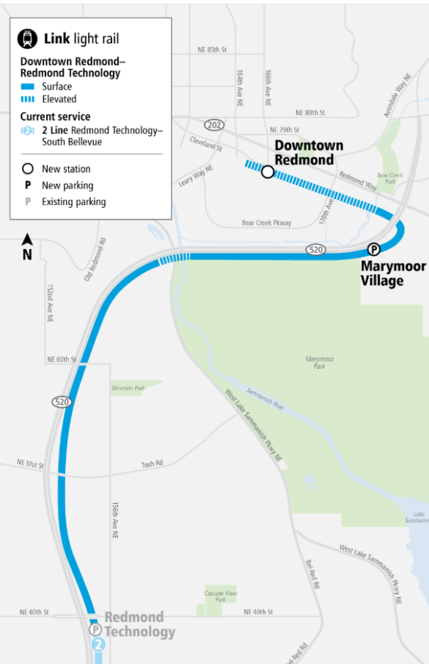
Source: Sound Transit

