STAFF REPORT

Agenda Item: | 5 | Name: | Sherrie Hsu
Proposed No.: | 2026-0022 | Date: | April 22, 2026

SUBJECT

Proposed Ordinance 2026-0022 would amend an interlocal agreement between King County and the City of Seattle regarding the Landscape Conservation and Local Infrastructure Program.

SUMMARY

Proposed Ordinance (PO) 2026-0022 would amend an interlocal agreement (ILA) between King County and the City of Seattle regarding the Landscape Conservation and Local Infrastructure Program (LCLIP), which is a transfer of development rights partnership.

The City of Seattle requested the proposed ILA amendment to update the list of Seattle open space projects that would be financed with revenue shared from King County through the LCLIP.

According to the City of Seattle, all the open space projects currently listed in the ILA have been completed using other funding sources, except for the North Downtown Community Center, and this community center is expected to be funded by a bond.

BACKGROUND

Washington State Growth Management Act. The Washington State Growth Management Act establishes a policy of directing growth and development into urban areas, protecting rural and resource land, and encouraging the use of tools such as transfer of development rights (TDR) to accomplish these outcomes.

King County Transfer of Development Rights Program. In 2001, King County adopted a TDR program, which is a voluntary, incentive-based, and market-driven approach to conserve land and steer development growth away from rural and resource lands into King County’s urban area.

The TDR program allows landowners of designated sending sites to separate the right to develop land from other property rights, and then to sell those rights to developers of designated receiving sites. Sending sites remain in private ownership but the land is permanently protected open space.

- Sending sites are typically rural or resource lands with farm, forest, open space, or regional trail amenities, and in some cases, urban land with conservation value.
- Receiving sites are typically properties in urban areas eligible for increased density.
- Purchasing TDRs allows developers the ability to build additional houses, lots, or floor area that exceed the base density allowed by zoning, or to gain other non-density bonus.

Since 2001, the TDR program has protected over 148,000 acres of rural and resource lands in the county.

Landscape Conservation and Local Infrastructure Program (LCLIP). The LCLIP is a regional TDR program created by Washington State to allow cities and counties to partner on regional TDR efforts in supporting both urban growth and rural and resource land conservation. The LCLIP is currently available to cities in King, Pierce, and Snohomish counties.

Under the LCLIP, development rights may be transferred from county rural and resource lands to cities to increase development capacity inside incorporated urban areas. After cities implement a program to obtain regional TDRs, developers would be able to purchase development rights from regional farms and forests, allowing them increased density or square footage in designated areas in a Local Infrastructure Project Area (LIPA).

In exchange, cities receive a portion of county property tax revenue generated from new construction in the LIPA. Cities are required to invest the money in infrastructure projects and public improvements, such as roads, utilities, and schools, that support the increased development growth in the LIPA.

Interlocal Agreement with the City of Seattle. In 2013, the County and the City of Seattle signed an ILA to implement the LCLIP in the South Lake Union and Downtown neighborhoods LIPA. The LIPA from the ILA is shown in Exhibit 1.

Exhibit 1. Local Infrastructure Project Area (2013 ILA)

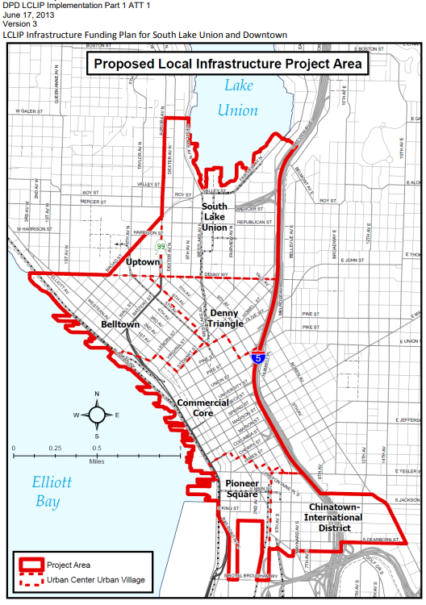

Under the ILA, the City receives 17.44% of property tax revenue from new development occurring in the LIPA for up to 25 years. At the time the ILA was signed in 2013, the program was estimated to result in $27.5 million from county property taxes over 25 years for the City of Seattle (or $15.7 million in 2012 dollars).

The initial program length would be 10 years, and would be extended to:
- 15 years if 400 credits are obtained within 9.5 years;
- 20 years if 600 credits are obtained within 14.5 years; or
- 25 years if 800 credits are obtained within 19.5 years.

Status update. The LCLIP is currently at approximately its midpoint since the ILA was executed in 2013. According to Executive staff:
- New construction projects in Seattle have purchased 1,279 credits from the King County TDR bank. This represents over 100,000 acres of conservation.
- Sales from the King County TDR bank into the City of Seattle have generated $30.5 million for the county.
- King County has active contracts for approximately $10 million and pending contracts for approximately $5 million in future sales, which together represent over 300 additional credits.
- The County has shared approximately $10.2 million with the City of Seattle.
- The County has been spending revenues on new conservation, including city priorities for farmland conservation.

Based on these figures, the City of Seattle has met its milestones.

Projects. Under the 2013 ILA, the first 10 years of revenue would support streetscape and transportation projects, the second 10 years of revenue would support park projects, and the last five years would support streetscape projects.

The ILA includes a list of streetscape investments and open space investments projects in Exhibit C to the ILA. This is summarized in Table 2 and Table 3.

Table 2. South Lake Union Streetscape and Downtown Streetscape Investments (2013 ILA)

Thomas Street Green Street (Dexter Ave. to Fairview Ave.) | $1.5 million
8th Avenue NE Green Street (Mercer St. to John St.) | $2.5 million
Harrison Street Improvements (Dexter Ave. to Fairview Ave.) | $5.5 million
Denny Way Improvements (Broad St. to Stewart St.) | $2.5 million
Third Avenue Corridor Improvements | $40 - $70 million
Total | $52 - $82 million

Table 3. Open Space Investments (2013 ILA)

North Downtown Community Center | $10 million
Enterprise Car Rental Lot Park Development | $3 million
Bell Street Green Street Enhancement | $1.3 million
Hing Hay Extension Park Development | $2.5 million
Central Waterfront Pier Redevelopment | $3 million
Total | $19.8 million

ANALYSIS

PO 2026-0022 would amend the ILA governing the TDR program between King County and the City of Seattle. The City of Seattle requested the proposed amendment to update Exhibit C of the ILA with an updated list of Seattle neighborhood open space investments that would be financed, in part, with revenue shared through the LCLIP.

According to the City of Seattle, all the open space projects currently listed in Exhibit C of the ILA have been completed using other funding sources, except for the North Downtown Community Center.

The North Downtown Community Center project is included in the City of Seattle’s 2026-2031 Capital Improvement Plan (CIP) as "8th and Mercer Community Center Development." According to the City of Seattle, as part of conditions of the property sale of city-owned property, Seattle Parks and Recreation (SPR) would have a lease on the ground floor and a mezzanine level of approximately 30,000 square feet to operate a new community center. SPR would be responsible for funding tenant improvements to the community center space.

According to the CIP, $750,000 has been provided by the Metropolitan Park District to conduct planning and design for the tenant improvements, and $17 million is allocated in the CIP for a 2027 bond measure to be issued to pay for construction.

The table below summarizes the status of each open space investment listed in the existing ILA.

Table 4. Status of Open Space Investments Listed in 2013 ILA

North Downtown Community Center | - Project is still pending and depends on the developer’s timeline.  - City of Seattle plans to fund the project with a bond measure backed by Seattle Park District funds.
Enterprise Car Rental Lot Park Development | - Park was opened in 2019, and play equipment was installed in 2023.  - Funded with Seattle Park District funds.  - The new park is called Urban Triangle Park.
Bell Street Green Street Enhancement | - Project completed in 2014.  - Funded with 2008 Parks Levy funding.
Hing Hay Extension Park Development | - Project completed in 2017.  - Funded with 2008 Parks Levy Funding.
Central Waterfront Pier Redevelopment | - Project is complete.  - Funded using a variety of sources including, but not limited to, Seattle Park District funds, Local Improvement District funding, and Real Estate Excise Tax.

In July 2025, the City of Seattle approved an ILA amendment to update the list of open space investment projects.

In December 2025, the City of Seattle further amended this project list to include Westlake Park and to allocate an additional $1 million in LCLIP revenue to the project. According to the City of Seattle, this is because the Seattle Parks Foundation received approximately $1 million in excess revenue above the amount originally projected in their first year of the program, and the money is being allocated to support upgrades to Westlake Park.

Table 4 shows the proposed updated list of open space investments that would be adopted by the amended ILA. According to City of Seattle staff, the City led a community engagement process to identify parks needs based on input from residents and neighborhood groups.

The new project list has a total of $15 million in open space investments, compared with $19 million in the original list. According to City of Seattle staff, the reason for this change is that the City of expecting lower revenues and is making conservative forecasts. According to Executive staff, the City’s expectation of lower revenues is generally consistent with the County’s outlook.

Table 5. Proposed Updated List of Open Space Investments (2026 Amendment)

Northwest Native Canoe Carving Center | $550,000
Prefontaine Plaza | $400,000
Lake Union Waterline Project | $4.5 million
City Hall Park | $3 million
Westlake Park | $1 million
South Lake Union Community Council SLU Parks Task Force Projects | $2.73 million
Downtown District Community-Led Projects | $1.07 million
Chinatown/International District Community-led Projects | $750,000
Reserve | $1 million
Total | $15 million

PO 2026-0022 would amend the ILA to reflect the updated list of open space investments as approved by the Seattle City Council.

AMENDMENT

The attachment included in the transmitted legislation references Seattle City Ordinance 127252 (dated April 2025), which was the version passed by the Seattle City Council in July 2025. A technical amendment would update the ILA to reference Seattle City Ordinance 127377, dated December 2025, as this is the final version passed by the Seattle City Council.

INVITED

- Josh Baldi, Director, Water and Land Resources Division, Department of Natural Resources and Parks
- Nicholas Bratton, Transfer of Development Rights Program Manager, Water and Land Resources Division, Department of Natural Resources and Parks

ATTACHMENTS

- Proposed Ordinance 2026-0022 and its attachment
- Amendment 1 with attachment
- Transmittal Letter
- Fiscal Note

Chapter 36.70A RCW
King County Code Chapter 21A.37
“Transfer of Development Rights Program Overview”. https://kingcounty.gov/en/dept/dnrp/buildings-property/green-sustainable-building/transfer-of-development-rights/overview
Chapter 318, Laws of Washington 2011 (Senate Bill 5253); Chapter 39.108 RCW
Chapter 39.108 RCW
King County Ordinance 17663
City of Seattle 2026-2031 Adopted Capital Improvement Program
CB 121008, Ordinance 127252.
CB 121137; Ordinance 127377.

