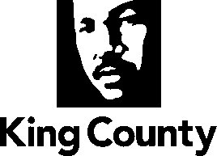
Metropolitan King County Council
Budget and Fiscal Management Committee

Support a Safe King County for Everyone
October 13, 2022 – 9:30 a.m.
Councilmembers: Dave Upthegrove, Chair; Claudia Balducci, Rod Dembowski, Jeanne Kohl-Welles, Joe McDermott, Sarah Perry, Pete von Reichbauer and Girmay Zahilay

Miranda Leskinen, Council Staff
Marka Steadman, Committee Assistant
To show a PDF of the written materials for an agenda item, click on the agenda item below.

INDEX
Briefing No. 2022-B0127
Briefing on Proposed 2023 2024 Biennial Budget - Support a Safe King County for Everyone
Agency Overview and Highlights | Page no.
DISCUSSION
District Court  Erica Newman | xx
Office of Inquest  Jenny Giambattista | xx
Prosecuting Attorney  Jenny Giambattista | xx
Adult And Juvenile Detention  Leah Krekel-Zoppi | xx
Office Of Law Enforcement Oversight  Nick Bowman | xx
Sheriff  Nick Bowman | xx
Local Services Administration  Erin Auzins | xx
Planning and Permitting  Erin Auzins | xx
Office of Performance Strategy and Budget  Jeff Muhm | xx

