STAFF REPORT

Agenda Item: | 5 | Name: | Erica Newman  Melissa Bailey
Proposed No.: | 2024-0293 | Date: | January 22, 2025

SUBJECT

A motion acknowledging receipt of the second of two reports on progress toward addressing the legal system backlog that resulted from the COVID-19 pandemic, in response to the 2023-2024 Biennial Budget Ordinance, Ordinance 19546, Section 17, Proviso P4.

SUMMARY

Ordinance 19546, the 2023-2024 Biennial Budget appropriated $23.2 million to address the legal system backlog. Proposed Motion 2024-0293 would acknowledge receipt of the second of two reports on the progress toward addressing the legal system backlog as required by Ordinance 19546.

According to the report, District Court’s filed backlog was fully resolved as of March 31, 2023. For Superior Court, the report states that the number of unfiled pending cases is similar to the pre-pandemic volume as of June 30, 2024. For the filed felony pending caseload, if the volume continues to decline at the rate since Q1 2023, it is projected to reach 2019 levels in Q2 2026. However, the report goes on to state that this projection is highly uncertain and unlikely to be achieved as resources to address cases will likely decrease in 2025 and other factors affecting filings and resolutions are difficult to predict. This report appears to meet the requirements as outlined under Ordinance 19546, Section 17, Proviso P4.

BACKGROUND

The COVID-19 pandemic created backlogs in several case types for Superior and District Court. In June 2021, the Prosecuting Attorney’s Office (PAO) reported that the overall level of year-to-date felony filings was less than in 2018 and 2019 and that there was a backlog in the criminal justice system due to the operational impacts from COVID-19, which prevented some cases from resolving. At the time, PAO reported 6,450 pending felonies as compared to an average of 3,250 from January 2019 through March 2020. In addition, PAO reported a significant increase in the number of pending more serious offense (homicide, rape, domestic violence, robbery, shootings) from 1,700 such cases pre-COVID to an estimated 2,700 in June 2021.

Ordinance 19318. In July 2021, the Council adopted Ordinance 19318 (“COVID 8”), which included a funding request from Prosecuting Attorney’s Office (PAO), Department of Public Defense (DPD), Superior Court, Department of Judicial Administration (DJA), and District Court to address the legal system backlog. As shown in Table 1, Ordinance 19318 appropriated $42,460,000 to address the legal system backlog resulting from the pandemic.

Table 1. Legal System Backlog COVID 8 Appropriation

Agency | Appropriation
Department of Judicial Administration | $3,643,000
Department of Public Defense | $10,661,000
District Court | $4,398,000
Prosecuting Attorney | $12,862,000
Superior Court | $10,896,000
Total | $42,460,000

Blake Appropriation. In addition to the funding appropriated in Ordinance 19318, the Council also adopted Ordinance 19319 on July 27, 2021, which appropriated $19.5 million to address the funding needs resulting from the Washington State Supreme Court decision in State v. Blake.

Ordinance 19546. In November 2022, Council adopted the 2023-2024 Biennial Budget, which included the following proviso requirement of the Office of Performance, Strategy, and Budget:

Of this appropriation, $200,000 shall not be expended or encumbered until the executive transmits two reports on progress toward addressing the legal system backlog that resulted from the COVID-19 pandemic and a motion with each report that should acknowledge its receipt and both motions are passed by the council. Each motion should reference the subject matter, the proviso's ordinance number, ordinance section and proviso number in both the title and body of the motion. Both reports shall include information from the department of judicial administration, the prosecuting attorney’s office, the department of public defense, district court and superior court.

The first report shall cover the period from October 1, 2022, through March 31, 2023, and report on the following:

A. A list of positions supported by Coronavirus State and Local Fiscal Recovery ("CLFR") revenues, identified by job type and the number of vacant positions, for the department of judicial administration, the prosecuting attorney's office, the department of public defense, superior court and district court;

B. The amount of 2023-2024 biennial CLFR appropriation for district court, the department of judicial administration, the prosecuting attorney’s office, the department of public defense, superior court and district court that has been expended as of March 31, 2023, as well as the total CLFR appropriations and expenditures to date;

C. The anticipated date by which the backlog of cases will be addressed assuming various funding scenarios for 2024;

D. The identification and discussion of barriers or system challenges to addressing the backlog;

E. A plan, developed in consultation with the department of judicial administration, superior court, the prosecuting attorney's office and the department of public defense for how to address the felony criminal backlog in cases given the appropriation amount provided in this ordinance;

F. Funding options to address the backlog in felony criminal cases;

G. For superior court cases, the report should also include the following data for the reporting period, by quarter, with prepandemic data from 2019 as comparison:
1. The pending caseload for all criminal cases;
2. The pending caseload for the most serious felonies, defined as homicides, sex crimes, robbery in the first degree and assault in the first degree and in the second degree;
3. The number of total resolutions for all criminal cases by jury trial, by nonjury trial, resolved by plea and dismissed;
4. A summary of resolutions for the most serious felony cases, by jury trial, by non-jury trial, resolved by plea and dismissed; and
5. The number of filings and total pending cases for unlawful detainer cases; and

H. For district court cases, the report should also include the status of backlog cases, including the number of unfiled criminal cases.

The executive should electronically file the first report and motion required by this proviso no later than May 15, 2023, with the clerk of the council, who shall retain an electronic copy and provide an electronic copy to all councilmembers, the council chief of staff and the lead staff for the law, justice, health and human services committee or its successor.

The second report shall cover the period from April 1, 2023, through June 30, 2024, and include, but not be limited to, the following information from the district court, the department of judicial administration, the prosecuting attorney’s office, the department of public defense and superior court:

A. A list of positions supported by CLFR revenues for the department of judicial administration, the prosecuting attorney's office, the department of public defense and superior court district court, identified by job type and the number of vacant positions;

B. The amount of 2023-2024 biennial CLFR appropriation for district court, the department of judicial administration, the prosecuting attorney's office, the department of public defense and superior court district court has been expended as of June 30, 2024, as well as the total CLFR appropriations and expenditures to date;

C. The anticipated date by which the backlog of cases will be addressed assuming various funding scenarios for 2025-2026;

D. Identification and discussion of barriers or system challenges to addressing the backlog;

E. For superior court cases, the report should also report the following data for the reporting period, by quarter, with prepandemic data from 2019 as comparison:
1. The pending caseload for all criminal cases;
2. The pending caseload for the most serious felonies, defined as homicides, sex crimes, robbery in the first degree and assault in the first degree and in the second degree;
3. Total resolutions for all criminal cases by jury trial, by nonjury trial, resolved by plea and dismissed;
4. Resolutions for the most serious felony cases, by jury trial, by nonjury trial, resolved by plea and dismissed; and
5. Filings and total pending cases for unlawful detainer cases; and

F. For district court cases, the report should also include the status of backlog cases, including the number of pending unfiled criminal cases.

The executive should electronically file the second report and motion required by this proviso no later than September 16, 2024, with the clerk of the council, who shall retain an electronic copy and provide an electronic copy to all councilmembers, the council chief of staff and the lead staff for the law, justice, health and human services committee or its successor.

Motion 16441. In October 2023, Council passed Motion 16441 which acknowledged receipt of the first of two reports on progress toward addressing the legal system backlog that resulted from the COVID-19 pandemic, in response to the 2023-2024 Biennial Budget, Ordinance 19546, Section 17, Proviso P4. According to this first report, District Court’s filed backlog was fully resolved as of March 31, 2023. For Superior Court, the report stated that reducing the felony pending caseload to 2019 levels is unlikely to occur in the next several years under any plausible funding scenario. Total pending felony cases increased in Q2 2022 and Q1 2023, and pending felony caseloads are likely to increase more sharply once CLFR resources are fully expended.

ANALYSIS

Proposed Motion 2024-0293 would acknowledge receipt of the second report on addressing the legal system backlog that resulted from the COVID-19 pandemic, in response to the 2023-2024 Biennial Budget, Ordinance 19546, Section 17, Proviso P4. This staff report provides a breakdown of the contents of the report as required by each section of the proviso.

A. A list of positions supported by CLFR revenues for the department of judicial administration, the prosecuting attorney's office, the department of public defense and superior court district court, identified by job type and the number of vacant positions.

Appendix B to the report (pages 44-48) provides the full list of positions supported by CLFR funds in Ordinance 19546. Table 2 below lists the number of vacant and filled positions (as of June 30, 2024) by agency.

Table 2. CLFR Funded Positions as of June 30, 2024

Agency | Total filled positions | Total vacant positions
District Court | 2 | 0
DJA | 13 | 10
DPD | 30 | 2
Superior Court | 16 | 0
PAO | n/a | n/a
Total | 61 | 12

The report notes that the work to resolve pending cases is handled by CLFR-funded and General Fund funded positions and the number of positions whose compensation is supported by CLFR is not a direct reflection of resources expended on resolving the backlog.

B. The amount of 2023-2024 biennial CLFR appropriation for district court, the department of judicial administration, the prosecuting attorney's office, the department of public defense and superior court district court has been expended as of June 30, 2024, as well as the total CLFR appropriations and expenditures to date.

According to the report, King County criminal legal agencies spent a total of $20.6 million in CLFR funds through June 30, 2024, of the $23.2 million appropriated in the 2023-2024 budget. The total legal system CLFR funds spent through June 30, 2024, is $52.4 million. All $54.9 million of CLFR funding is expected to be spent by the end of 2024 and additional CLFR funds are not expected to be allocated in 2025. Table 3, listed below provides a breakdown of CLFR appropriation expended by each criminal justice agency as of June 30, 2024.

Table 3. CLFR Appropriation Expended as of June 30, 2024

 | 2023-2024 Revised Biennial Appropriation | 2023-2024 Appropriation Expended as of June 30, 2024 | Total CLFR  Allocated | Total CLFR Expended as of June 30, 2024
District Court | $820,000 | $823,000 | $3,657,000 | $3,660,000
DJA | $2,571,000 | $2,044,000 | $4,852,000 | $4,325,000
PAO | $6,847,000 | $7,043,000 | $14,644,000 | $14,840,000
DPD | $6,265,000 | $5,460,000 | $16,632,000 | $15,827,000
Superior Court | $7,296,000 | $5,276,000 | $15,765,000 | $13,744,000
Total | $23,799,000 | $20,645,000 | $55,550,000 | $52,395,000

C. The anticipated date by which the backlog of cases will be addressed assuming various funding scenarios for 2025-2026.

Pandemic-related legal system backlog is defined as excess pending cases above pre-pandemic levels affecting PAO, DPD, DJA, Superior Court, and District Court operations. Each agency’s workload is driven by responsibilities for different case types and stages in the legal system. For the purposes of tracking progress towards resolving current pending cases and avoiding delays in resolving new cases, the report provides measures of pending case volume (both filed cases and unfiled criminal cases referred to the PAO) and volume of resolutions. The backlog measures assess the rate at which current legal system operations are resolving cases and whether there are changes in total backlog volume.

District Court. The District Court filed backlog is fully resolved as of Q1 2023.

Superior Court. Pandemic-related felony backlog is defined as pending caseloads above 2019 volume. Individual cases are not designated backlog or non-backlog based on the age of the case. Even under pre-pandemic conditions, the time to resolution was highly variable. Backlog is influenced by various factors, including new incoming cases.

The report notes that substantial progress was made in reducing the backlog between Q1 2023, when the previous report was submitted to Council, and Q2 2024. The PAO reports unfiled pending felony case volume is similar to pre-pandemic levels in Q2 2024. Much of the filed backlog reduction has been in the most serious case types, even though these cases take substantially longer to resolve than other case types. The report points to agencies prioritizing resources to these more serious cases.

According to the report, "while the rate and direction of change in the volume of pending felony cases is related to funding and resource allocation, it is also influenced by operational changes, policy decisions, and factors outside the control of County agencies. This includes prioritization decisions by individual agencies on how limited resources are allocated within their organizations, changes in filing decisions, law enforcement staffing, and underlying crime rates."

The report includes a graph (page 18, copied below) that shows projections of filed felony backlogs assuming all factors influencing the rate of decline stay constant. If the rate of decline in pending cases remains similar to the past year, pending cases could return to pre-pandemic levels in about two years (see blue line in the chart below). Using different assumptions regarding the past rate of change (yellow and orange lines below), the projected time to eliminate the filed felony backlog is longer. These projections assume no major changes in the number of cases referred by law enforcement (either due to underlying changes in criminal activity or in law enforcement staffing or practices) or major policy or operational changes. It also assumes resources remain constant.

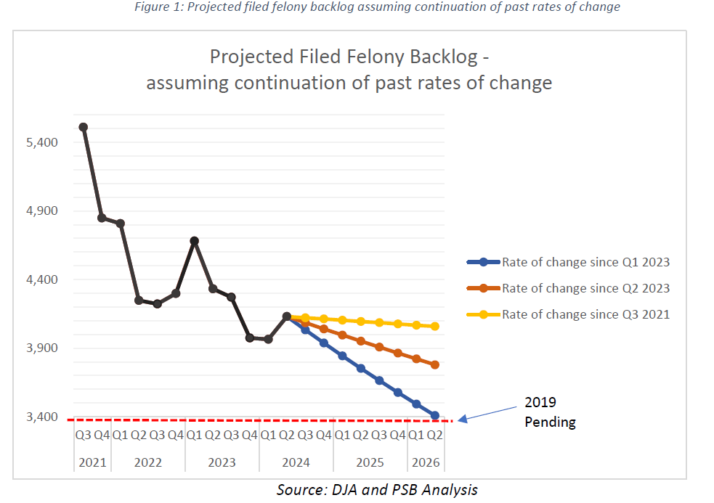

The report, however, anticipates a reduction in resources allocated to case processing given CLFR funding is ending and the General Fund base budgets will likely decrease due to General Fund financial challenges.

Most costs in the King County legal system are paid by the General Fund, so maintaining the current level of resources allocated to case processing would require additional General Fund spending on case processing. The report notes that the General Fund faces a shortfall caused by state law that prevents property tax from keeping up with inflation. Revenue constraints in the General Fund required budget reductions in most legal system agencies in 2024. General Fund budgets for District Court, Superior Court, DJA, and the PAO were reduced by $5.2 million (annualized) in Ordinance 19791.

The report goes on to say that "if there are no changes in General Fund resources allocated to case processing in 2025, pending felony cases may increase as staff are reduced, though patterns depend on various factors, including agency resource prioritization. Pending cases might also continue to decline, but at a slower rate."

The report was transmitted while the Executive was still developing the 2025 proposed budget. PSB has confirmed that all agencies spent their remaining CLFR allocations in 2024 and no CLFR funding is being carried into 2025. The 2025 Adopted Budget avoided significant cuts to legal system agencies; however, PSB has warned that deeper cuts can likely be expected in the 2026-2027 biennial budget given the state of the county's General Fund.

D. Identification and discussion of barriers or system challenges to addressing the backlog.

The report identifies and discusses various barriers or system challenges to addressing the backlog (see pages 19-48), much of which have already been discussed in prior backlog reports. The challenges and barriers to address the backlog are interrelated, with key categories identified as:

- Staffing and scheduling challenges. These include:
- Labor market restraints;
- Hiring challenges specific to TLT positions;
- Employee impacts (stress, anxiety, morale, etc.);
- Training requirements;
- Qualified and experienced attorneys for serious felony cases;
- Department of Adult and Juvenile Detention vacancies; and
- Interpreter availability.

- Continued direct and indirect impacts of the pandemic. According to the report, as of June 30, 2024, the remaining direct impacts of the pandemic are either resolved or are expected to remain a permanent part of court operations. For example, both Superior and District Court expect to continue utilizing hybrid remote and in-person services, including remote jury selection. The report notes that if resource constraints reduce the capabilities to operate hybrid or video operations, case processing would be negatively affected.

- Difficulties with addressing backlogged felony cases, including higher levels of serious violent crime compared to pre-pandemic. The report discusses numerous factors cited by one or more agencies as a challenge or barrier specific to addressing the felony criminal backlog. Some examples include:
- The experience level required of attorneys who work on the most serious cases and the number of attorneys needed to staff these cases. Furthermore, the county is in the process of phasing in new state standards limiting public defender caseloads.
- Felony cases are more likely to go to trial or resolve at a later stage. Trials are also taking longer.
- Felony cases are likely to have extensive forensic evidence and require lengthy preparation.
- Felony cases may be assigned to attorneys who carry heavy trial calendars and are already in trial, which complicates and delays scheduling.
- Delays in competency evaluations are also a challenge. Competency can be raised at arraignment and competency returns are heard on this calendar, which can slow down arraignment calendars and further reduce the number of cases heard. According to the report, a competency return calendar has been created to help mitigate arraignment calendar congestion.

The report notes that the PAO has implemented process and policy changes to reduce court backlog and mitigate challenges related to staffing serious cases. To resolve more cases and provide trial experience for newer attorneys, the office has prioritized trying all cases that are ready for trial, not just the most serious cases that require the most seasoned attorneys. In addition to providing experience for newer attorneys, it offers respite periods for those in back-to-back serious cases.

In addition to these challenges, the report points to an increased workload related to a rise in serious violent crime. While total felony filings are lower than pre-pandemic volume, largely due to changes in drug laws and in law enforcement staffing and practices, indicators suggest serious violent crime and workload related to violent crime is higher than pre-pandemic as of Q2 2024. As shown in the graph below, gun homicides were up in 2023 compared to 2022 and the number of gun injuries remained flat. Data through Q2 2024 suggests a decline in gunshot homicides and injuries in 2024, though levels remain higher than 2019.

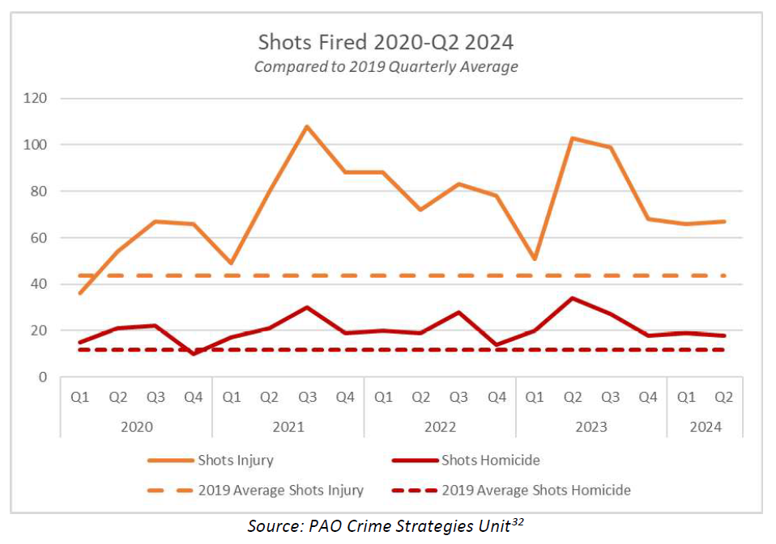

- Challenges to addressing eviction cases. According to the report, the total number of unlawful detainer (eviction) cases filed in Superior Court has exceeded pre-pandemic levels as of June 30, 2024. Superior Court and DJA report the following challenges in addressing eviction cases:

- Limited number of commissioners able to handle unlawful detainers. Per the State Constitution, the Court is permitted three Constitutional Commissioners who can hear unlawful detainer matters. While judges can also hear these cases, they are either busy with the increased criminal caseload, family law matters, child welfare matters, Involuntary Treatment Act matters, or other civil matters. Note, Superior Court plans to continue working with the state legislature on changes in state law to allow for more commissioners dedicated to unlawful detainers. Additionally, the 2025 Adopted Budget provided for two additional commissioners and, while these new commissioners are not able to work on unlawful detainer cases, they will help alleviate the commissioner workload by handling the increasing number of protection order cases.

- Insufficient staffing on unlawful detainer cases (both DJA and Court staffing). Superior Court notes that best practices recommend courts utilize case management to prescreen each case file; however, there are not enough resources to conduct this type of review and often judicial officers must review materials during the hearing, which results in delays and limits the number of cases that can be heard. Similarly, DJA reports that an increase in cases have strained capacity.

- Language and other barriers for litigants. According to the report, most plaintiffs are represented by experienced attorneys, while most respondents are, at least initially, unrepresented. Many litigants fail to access services until their hearing, and the Court does not have the staff resources to provide plain language procedural and substantive legal information for all parties at various stages of their case in a variety of languages. Additionally, the report states that remote hearings can create a barrier for litigants who are not "technology literate".

- Additional procedural steps required by state law (SB 5160 and HB 1236), which the report notes has extended the time necessary to administer proceedings. SB 5160 established a right to counsel and corresponding duty of the Court to appoint counsel to indigent litigants in eviction proceedings. HB 1236 established just-cause eviction requirements such that housing providers must provide a reason to terminate a tenancy under specific timeframes.

- Space constraints. The Court is currently experiencing higher numbers of hearings calendared at the MRJC than the Seattle Courthouse due to Seattle's lengthier moratorium on evictions, and physical space limitations at the MRJC facility create operational challenges.

- Unlawful detainer filings have increased as a result of the Washington State Eviction Resolution Pilot Program sunsetting on July 1, 2023. The reports states that the requirement to complete an alternative dispute resolution process before filing eviction proceedings sunsetting along with the pilot program.

- More unlawful detainer case filings are anticipated as the result of a recent Court of Appeals case that affects settlement agreements in unlawful detainer cases (Court of Appeals Division II Case Princeton Property Management vs. Allen, Case 58183-3-II).

- Factors that facilitated pending felony case reductions in 2021. Progress on felony backlog reduction was faster in 2021 due to a substantial number of case dismissals related to the Blake decision, cases going on failure to appear warrant status after pandemic warrant restrictions were lifted, and pandemic-related practices to dismiss cases. New drug possession cases are no longer filed into Superior Court, which reduces incoming cases.

E. For superior court cases, the report should also report the following data for the reporting period, by quarter, with prepandemic data from 2019 as comparison:

1. The pending caseload for all criminal cases;

As of Q2 2024, the PAO reports the total unfiled backlog is similar to 2019 volume. The filed pending backlog is around 700 cases above 2019 volume.

Table 4. Felony Pending Caseload
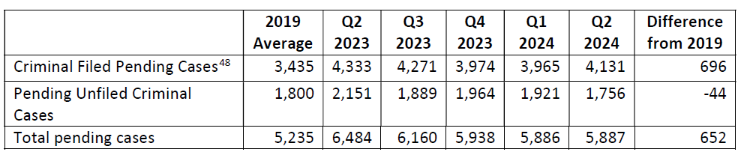

2. The pending caseload for the most serious felonies, defined as homicides, sex crimes, robbery in the first degree and assault in the first degree and in the second degree;

The report notes that these cases require the most system resources to resolve. As of Q2 2024 there were 109 more pending cases than the 2019 average.

Table 5. Most Serious Pending Cases
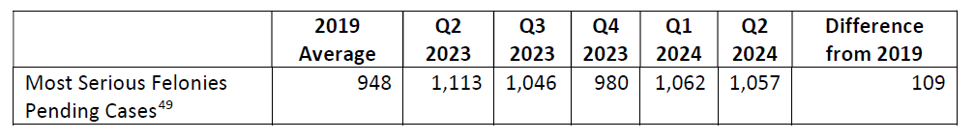

3. Total resolutions for all criminal cases by jury trial, by nonjury trial, resolved by plea and dismissed;

Per the report, cases that "resolve through trial require substantially more resources, though they make up a small fraction of overall resolutions. Despite additional CLFR resources, 10 percent fewer cases resolved overall in Q2 2024 compared to average quarterly resolutions in 2019, and 39 percent fewer cases resolved through trial. A lower proportion of cases were resolved through guilty pleas in Q2 2024, compared to 2019 resolutions. Case dismissals continue to be higher than in 2019."

Table 6. Felony Case Resolutions
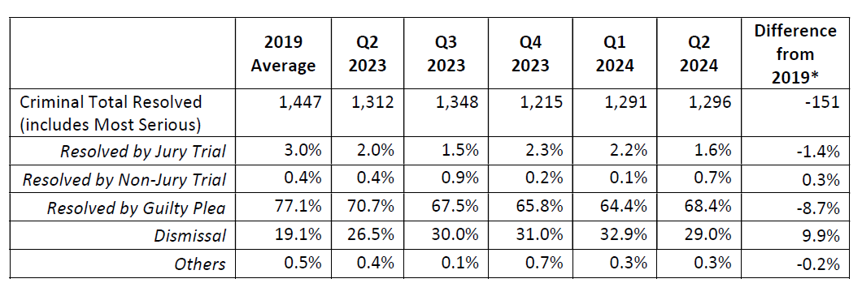

4. Resolutions for the most serious felony cases, by jury trial, by nonjury trial, resolved by plea and dismissed; and

The number of most serious felony resolutions increased in 2023 and 2024, relative to 2021 and 2022, but mostly remained below 2019 averages, despite the prioritization of resources on these case types.

Table 7. Most Serious Case Resolutions
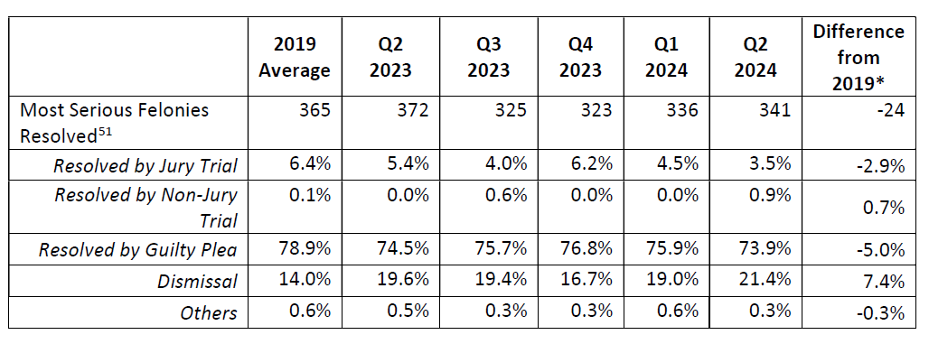

5. Filings and total pending cases for unlawful detainer cases; and

As noted in the report, quarterly unlawful detainer filings were higher than 2019 volume beginning in Q2 2023 and have increased every quarter since. Pending unlawful detainer cases exceed pre-pandemic levels due to the challenges previously described in this staff report (see proviso requirement D).

Table 8. Unlawful Detainers
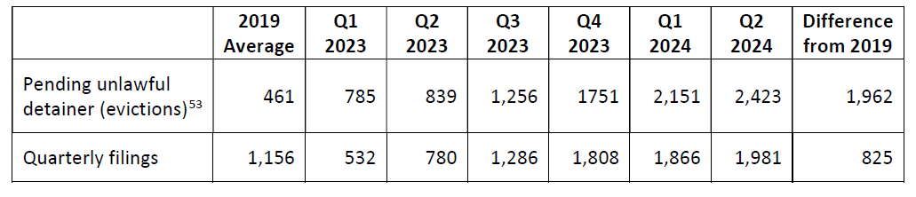

F. For district court cases, the report should also include the status of backlog cases, including the number of pending unfiled criminal cases.

As previously noted, the District Court backlog was fully resolved as of Q1 2023.

Council Action on Proposed Motion 2024-0293. This report appears to meet the requirements as outlined under Ordinance 19546, Section 17, Proviso P4. Council passage of the proposed motion would have no budgetary impact as the 2023-2024 biennial budget cycle has elapsed. Passage of the motion would only acknowledge receipt of the report.

AMENDMENT

Amendment 1 is a technical amendment that would correct typographical errors and change language to align with the proviso language.

INVITED

- Judge Ketu Shah, Presiding Judge, King County Superior Court
- Judge Corinna Harn, District Court
- Leesa Manion, King County Prosecutor
- David Baker, Director of Data and Analytics, Prosecuting Attorney's Office
- Matthew Sanders, Interim Director, Department of Public Defense
- Matt Pang, Interim Deputy Director, Department of Public Defense
- Stev Weidlich, Strategic Planning Manager, Department of Public Defense
- Elly Slakie, Executive Analyst, Office of Performance, Strategy, and Budget

ATTACHMENTS

- Proposed Motion 2024-0293 (and its attachments)
- Amendment 1
- Transmittal Letter

The second report covers the period of April 1, 2023- June 30, 2024. Passage of the motion would only acknowledge receipt of the report; there would be no budgetary impact as the 2023-2024 biennial budget cycle has elapsed.
Cases that have been filed by the PAO and are set for trial.
State v. Blake, 197 Wash. 2d 170, 174, 481 P.3d 521, 524 (2021)
The number of District Court positions under Appendix B does not include pro tem judges that were funded in Q1, as they were no longer needed as of March 31, 2023.
DPD mostly ceased hiring attorneys into TLT positions with the hopes of attracting more and better qualified candidates and ensuring a more stable workforce. DPD CLFR-funded FTEs are in the base budget and will revert to General Fund when CLFR funds end.
According to the first report, PAO positions include TLT, special duty, and unfunded FTE positions. The second report notes that the PAO spent all CLFR funding as of June 30, 2024, and there were no positions billed to CLFR at that time.
On page 16 of the report, it states, "Total legal system CLFR funds spent through June 30, 2023, is $52.4 million." Executive staff confirm this is a typographical error and should read June 30, 2024.
Table 2 on page 16 of the proviso report. Numbers are rounded.
Includes supplemental changes. Executive staff confirm that the total in Table 3 is correct; there is an error in the total included in the report.
Unspent 2021-2022 CLFR funds were reappropriated in 2023-2024, so adding total appropriated amount from multiple budgets overstates the total amount of CLFR funding allocated. Executive staff confirm that the total in Table 3 is correct; there is an error in the total included in the report.
The report notes that, given the County will adopt an annual budget for 2025, this section of the report assumes various funding scenarios for the 2025 budget only.
2023-RPT0051, PSB - COVID-19 Legal System Backlog: 2023-2024 Report - Ordinance 19546
According to the report, reductions were not made in the DPD General Fund budget as their costs are largely driven by staffing costs determined by legally required caseload standards.
According to the report, "the Prosecuting Attorney has communicated significant concern regarding the effect of the new caseload standards given current budget considerations, challenges with staffing, and the lack of similar standards for PAO attorneys. However, the new standards are not expected to have an immediate impact on the pandemic-related backlog and discussion of broader effects on the court system is beyond the scope of this report."
Table 3, page 32 of the report.
Table 4, page 32 of the report.
Table 5, page 33 of the report.
Table 6, page 33 of the report.
Table 7, page 38 of the report.

