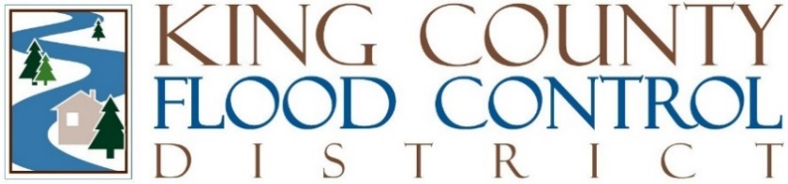

STAFF REPORT

Agenda Item: | 7 | Name: | Steven Schauer
Proposed Legislation: | FCDECM2025-01 | Date: | March 5, 2025

Proposed FCDEC Motion FCDECM2025-01: A MOTION authorizing the chair to enter into the 2025 - 2026 Amendment to Contract for Flood Preparedness Brochure Graphic Design and Project Management.

Proposed FCDEC Motion FCDECM2025-01 authorizes the chair to amend a contract with Lund Faucett, LLC, for the purpose of developing the 2025-2026 Be Flood Ready Brochure ("Brochure").

The Brochure is a critical resource distributed annually to residents, advising them on flood preparedness for the upcoming flood season. For the 2025-2026 flood season, the King County Flood Control Zone District (District) is proposing a redesign of the Brochure and the development of two additional postcard pieces for distribution. The content and format of the Brochure will be designed in collaboration with King County’s Water and Land Resources Division (WLRD) staff to ensure compliance with FEMA’s National Flood Insurance Program (NFIP) requirements. Additionally, Community Navigators will be engaged to help ensure the Brochure is accessible, informative, and culturally appropriate for various communities. The Brochure will continue to be distributed by direct mail, as it has been historically, and the Community Navigators will also help with the distribution, which is a new distribution method.

As key components of the amendment, Lund Faucett, LLC, will:
- Content & Design Support: Facilitate coordination between District staff, WLRD, Community Navigators, and design vendors.
- Translation Services: Ensure the county-wide Brochure is available in multiple languages to serve non-English speaking residents, and each District-specific Brochure will be produced in English and Spanish.
- Community Navigator Engagement: Facilitate Community Navigator feedback on Brochure content, format, and distribution strategy and some distribution at community events.

By FCDEC Motion FCDECM2023-03, the District entered into a Contract for Professional Services with Lund Faucett, LLC, for the preparation and distribution of the Be Flood Ready Brochure. In April 2024, the District amended the contract by FCDEC Motion FCDECM2024-02, establishing a contract for an amount not to exceed a total of $45,000. In September 2024, the first amendment to the contract was revised by FCDEC Motion FCDECM2024-03, increasing the not to exceed total by $3,000 to account for an unexpected budget shortfall related to translation services, for an amended contract amount not to exceed a total of $48,000.

This proposed motion for the second amendment to the contract with Lund Faucett, LLC is for an amount not to exceed a total of $90,200. This amount is within the approved budget.

