BEHAVIORAL HEALTH ADMINISTRATIVE SERVICES FUND
Analyst: Sam Porter

 |  | Expenditures |  | Revenues |  | FTEs |  | TLTs
2025 Revised Budget Biennialized |  | $0 |  | $0 |  | 0.0 |  | 0.0
2026-2027 Base Budget Adjust. |  | $0 |  | $0 |  | 0.0 |  | 0.0
2026-2027 Decision Packages |  | $145,500,967 |  | $145,516,678 |  | 80.8 |  | 0.0
2026-2027 Proposed Budget |  | $145,501,000 |  | $145,517,000 |  | 80.8 |  | 0.0
% Change from prior biennium, biennialized |  | n/a
Dec. Pkg. as % of prior biennium, biennialized |  | n/a
Major Revenue Sources: State non-Medicaid funds supporting the crisis system, Federal Mental Health and Substance Use Disorder Block Grants

Description

The Behavioral Health Administrative Services Fund is a new fund proposed through Proposed Ordinance 2025-0303 transmitted with the budget. The fund is being proposed in response to the Washington State Health Care Authority (HCA) corrective action plan requiring, among other things, detailed accounting and reporting of Behavioral Health Administrative Services Organization (BHASO) Funds in response to a recent On-Site Fiscal Monitoring Review. The fund would solely account for the BHASO finances.

The BHASO administers the State-funded crisis behavioral health system, including the Involuntary Treatment Act (ITA) system, Washington State Hospital liaison functions, Federal block grant funded services, and other non-Medicaid-funded behavioral health services. Figure 1 provided by Executive staff outlines the funding structure in the Behavioral Health and Recovery Division (BHRD) with the BHASO highlighted at the top of the chart. The King County Integrated Care Network, Mental Illness & Drug Dependency (MIDD) sales tax, and Crisis Care Center Levy funds have separate appropriation units discussed elsewhere in this staff report packet.

Figure 1. Behavioral Health Funding Structure
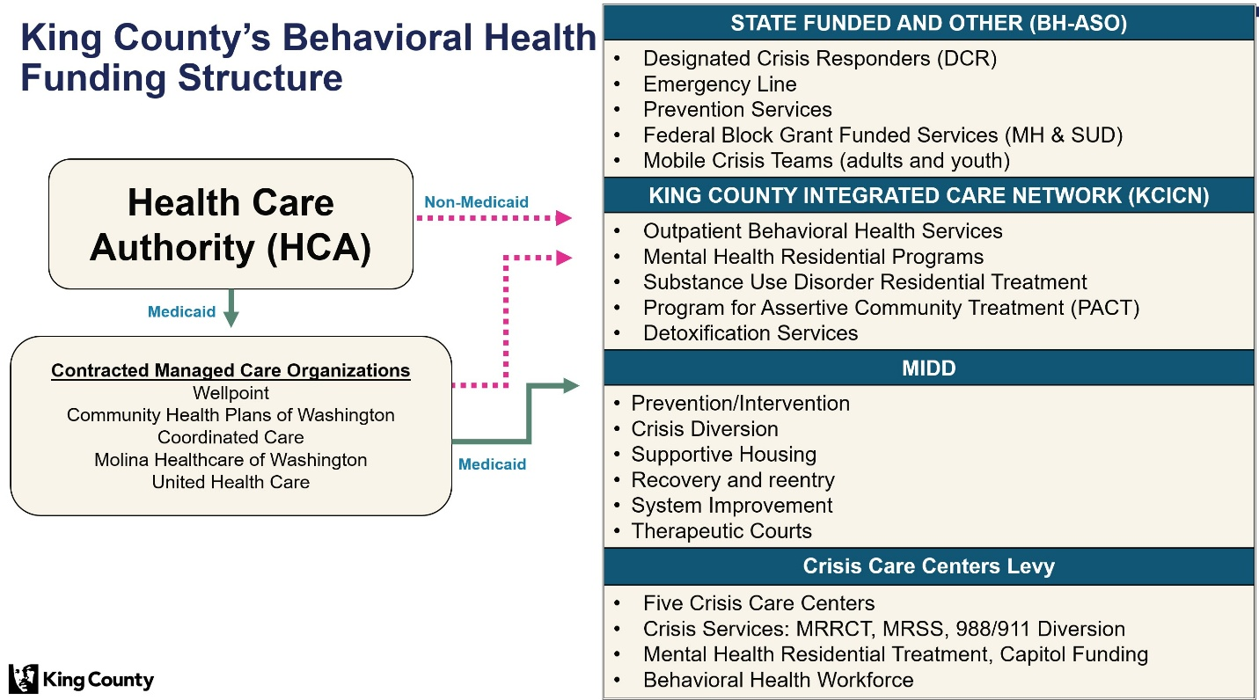

Summary of Proposed Budget and Changes

The Executive's proposed budget would appropriate $145,501,000 of BHASO-related funding and 80.8 FTEs. The primary decision package in this appropriation unit is for $141,366,241 to create this fund and transfer in all BHASO contracted expenditures, revenues, and 70.8 FTEs. The proposed budget also allocates $600,000 to Superior Court to cover guardian ad litem costs. There are additional revenue-backed FTE additions described below.

- BHASO Fund Manager [$379,045, 1.0 FTE] to serve as the Manager and ensure financial oversight, management, and compliance of the BHASO Fund.
- Peer Bridgers [$451,962, 2.0 FTEs, revenue-backed] convert two TLT positions to FTEs backed by revenue received in the state’s BHASO contract.
- PACT Program Manager [$359,620,000, 1.0 FTE, revenue-backed] to convert a TLT to FTE for supervision, implementation, and utilization management of the Program for Assertive Community Treatment (PACT) due to increased demand. PACT is an intensive, team-based behavioral health service package which offers individualized support in the community to people with serious mental health conditions and high service needs.² As PACT and Trueblood have both expanded, an additional position was needed to maintain program oversight. According to Executive staff, community demand for PACT has increased with more than 80 people on the waitlist and a 75 percent increase in the number of referrals to PACT that BHRD processes. This request is backed primarily by state PACT funding received in the BHASO contract, and Medicaid Quality Improvement Activity funding for allowable activities.
- ITA Screeners [$1,891,625, 6.0 FTEs, revenue-backed] convert six TLT ITA screener positions to FTEs to sustain State-mandated process improvements. These screeners have been in place since February 2025 in response to the State HCA's Corrective Action Plan regarding DCR response times for community referrals.
- Add a second ITA Coordinator to Superior Court [$265,000, revenue-backed]. According to Executive staff, ITA Coordinator work has become more complex with the addition of the state transfer cases, increased hearings and continued growth in long-term beds to meet growing needs, the level of communication with legal staff from multiple agencies internal and external to the County, and multiple courtrooms. Superior Court notes this request is in response to the growing workload in ITA Court
- Assisted Outpatient Treatment Coordinator [$187,474, revenue-backed] to Superior Court. This decision package would provide dedicated AOT funding from the State to Superior Court for an Assisted Outpatient Treatment (AOT) Coordinator for ITA Court.

Key Issues

Staff have not identified any key issues for this fund.

The various MIDD funds have separate decision packages and are discussed elsewhere in this staff report packet.

