STAFF REPORT

Agenda Item: | 10 | Name: | Erin Auzins  Jenny Ngo  Jake Tracy
Proposed No.: | 2024-B0113 | Date: | September 24, 2024

Subject

A briefing on the 2024 Comprehensive Plan.

Summary

The 2024 King County Comprehensive Plan (2024 KCCP) is the first opportunity where the entire plan will be open for review and update since 2016. Additionally, it also serves as the Growth Management Act (GMA) mandated periodic review and update. The Executive transmitted the Executive's Recommended 2024 KCCP to the Council on December 7, 2023. Review of the 2024 KCCP has been led by the Local Services and Land Use (LSLU) Chair, and included Committee briefings on the substance of the Executive's Recommended 2024 KCCP, analysis by policy staff of each substantive change, public outreach, development of a LSLU Chair's striking amendment, line amendments by LSLU Committee members, and a vote in LSLU in June 2024. Full Council adoption is expected in December 2024, after a formal public hearing on November 19, 2024.

At today's meeting, Council staff will give a briefing on the 2024 KCCP, including broad themes of the substantive changes, and the timing for full Council action.

Background

King County Comprehensive Planning. The King County Comprehensive Plan (KCCP) is the guiding policy document for land use and development regulations in unincorporated King County. The King County Code (K.C.C.) allows for amendments to the KCCP on an annual, midpoint, or ten-year update schedule. The ten-year update is on the same timeline as the GMA mandated review and update. The entire KCCP, and associated implementing regulations, is open for substantive revision, subject to limitations in the GMA, VISION 2050, the Countywide Planning Policies, KCCP policies, and the K.C.C.

Scoping Motion. K.C.C. 20.18.060 requires the County to approve a scope of work for the ten-year KCCP update, known as the scoping motion. The scoping motion establishes the baseline issues that the County proposes to consider in the development of the 2024 KCCP; additional issues beyond what is in the scope of work may also be addressed in the ten-year update. The Council approved the scoping motion, as well as the State Environmental Policy Act (SEPA) work program and public participation plan, as part of Motion 16142 in June 2022. The scope of work included three focus areas: Pro-Equity, Housing, and Climate Change and the Environment. It also adopted a General category to cover other required and priority items for the County.

SEPA Environmental Impact Statement. The SEPA review for the 2024 KCCP includes an environmental impact statement (EIS), which includes alternatives analysis based on the scope of work and other potential amendment concepts. The Executive issued a Draft EIS concurrent with transmittal of the 2024 KCCP to the Council on December 7, 2023. The public comment period on the Draft EIS closed on January 31, 2024. A Final EIS will be developed based on any comments received, and the Committee-Recommended version of the 2024 KCCP and any new amendment concepts to be considered by the Council before final adoption. Amendment concepts raised after publication of the Draft EIS must be within the scope of the alternatives analyzed in the Draft EIS, otherwise a supplemental EIS may be required. The Final EIS is expected to be issued in early November, in advance of the Council's November 19th public hearing.

Subarea Planning. As part of the 2016 KCCP, the Council included Workplan Action #1, Implementation of the Community Service Area (CSA) Subarea Planning Program. As part of this Workplan Action item, the County will conduct subarea planning using the geography of the six rural CSAs, and the five remaining large urban unincorporated potential annexation areas (PAAs), as shown in the map in Chapter 11 of the 2024 KCCP and in Figure 1 of this staff report.

Figure 1. Community Service Areas Map
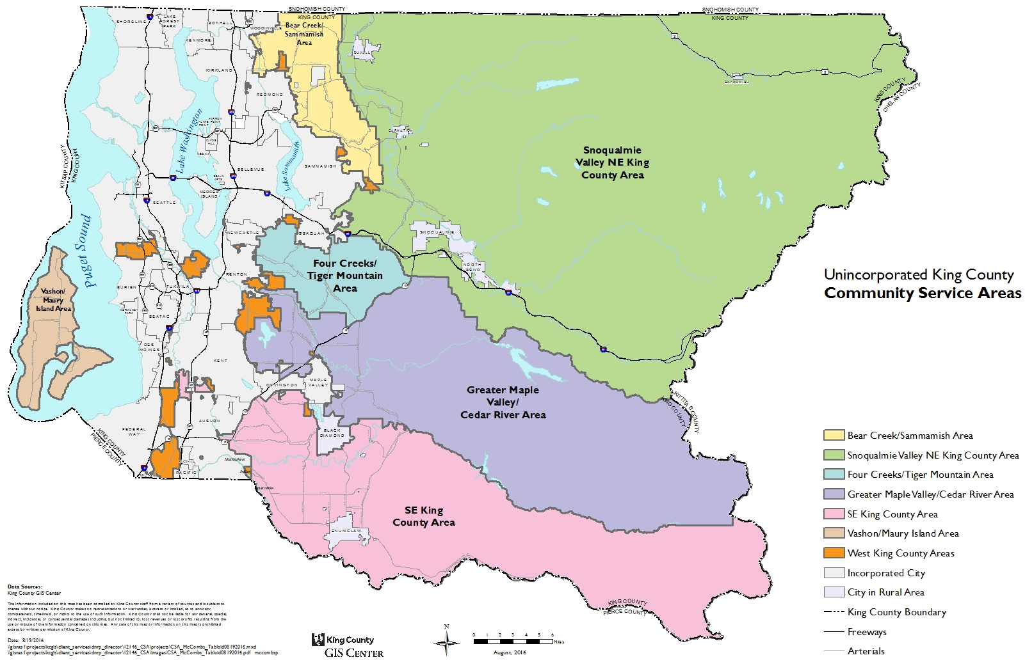

Since the implementation of the Subarea Planning Program in 2016, three subarea plans have been adopted: Vashon-Maury Island in 2017, Skyway-West Hill in 2022, and North Highline in 2022. The Executive's proposed Snoqualmie Valley/NE King County (SVNE) subarea plan was taken up concurrently with the 2024 KCCP. The remaining subarea plans will later be taken up in the following order: Greater Maple Valley/Cedar River CSA, Fairwood PAA, Bear Creek/Sammamish CSA, Southeast King County CSA, Four Creeks/Tiger Mountain CSA, East Renton PAA, and Federal Way PAA.

2020 Changes to the Subarea Planning Program. As part of the 2020 KCCP, policy and code changes were made regarding the Subarea Planning Program. Generally, the changes required that subarea plans be developed based on an established scope of work, use equity impact tools and resources in plan development, have more robust community engagement, and be monitored through performance measures and evaluation. K.C.C. 2.16.055.B. requires the Department of Local Services (DLS), in coordination with the regional planning unit and the Councilmember office representing the geography, to manage the CSA subarea planning program, and requires that each subarea plan:

- Be consistent with the KCCP;
- Be based on a scope of work established with the community;
- Establish a long-range vision and policies that implement that vision, but that are not redundant to the KCCP;
- Establish performance metrics and monitoring;
- Use the tools and resources of the Executive's Office of Equity and Racial and Social Justice (OERSJ) throughout development, implementation and monitoring, including for community engagement and incorporating the findings of an equity impact analysis;
- Review existing policies (primarily from Chapter 11) of the KCCP and retain/transfer those that are still applicable;
- Review land use designations and zoning classifications, including special district overlays (SDOs) and property-specific (P-suffix) development conditions, and amend as necessary; and
- Incorporate the community needs list required to be developed simultaneously.

Community Needs List. As part of the 2020 KCCP, the Council established a Community Needs List (CNL) for each of the CSA geographies in the subarea planning program. Each CNL is intended to be consistent with its respective subarea plan by identifying potential services, programs, facilities, and improvements that respond to community-identified needs. Development of the CNLs, including community engagement, must use tools from the County's Office of Equity and Racial and Social Justice (formerly OESJ). CNLs are required to be submitted with transmittal of the applicable subarea plan, and with each county budget, via ordinance.

ANALYSIS

Executive Transmittal. The Executive transmittal of the 2024 KCCP follows 18 months of work by the Executive, including, in part, public issuance of an early concepts document, an interbranch review by Council staff at two stages, a Public Review Draft with a public comment period, and an interdepartmental review of the plan by Executive staff. There were three proposed ordinances in the Executive's transmittal to the Council.

- Proposed Ordinance 2023-0440 would make changes to development and other implementing regulations and adopt the 2024 King County Comprehensive Plan, as well as the associated appendices (Housing, Transportation, Capital Facilities and Utilities, Regional Trails, Growth Targets). The transmittal also includes the following:

- Changes to the Vashon-Maury Island Subarea Plan and associated zoning map conditions;
- Proposed land use designation and zoning map amendments;
- I-207 matrices and Plain Language Summary;
- Equity Analysis; and
- Other supporting materials (i.e., Public Participation Summary, area zoning and land use studies, code studies, best available science summary).

- Proposed Ordinance 2023-0439 would adopt the Snoqualmie Valley/Northeast King County Subarea Plan with subarea-specific development regulations and map amendments, as well as a Fall City residential study.

- Proposed Ordinance 2023-0438 would adopt updated Countywide Planning Policies.

The Executive also transmitted a best available science report, changes to policies related to critical areas, and code updates related to critical area regulations, on March 1, 2024.

Council Review Process. The LSLU Committee met on the 1st and 3rd Wednesday of each month from January through June 2024, and made a "do pass" recommendation to the full Council at its June 5, 2024, Committee meeting.

Special LSLU Evening Meetings. The LSLU Committee held five special evening meetings on the 2024 KCCP and Draft EIS. The dates, locations, and the focus of each special evening meeting are provided in the following table.

Meeting Date/Time | Location | Focus
Thursday, January 18, 2024  Doors open: 6:00pm  Meeting starts: 6:30pm | County Council Chambers  516 Third Ave, Room 1200  Seattle | Hearing on Draft EIS
Thursday, February 8, 2024  Doors open: 6:00pm  Meeting starts: 6:30pm | Covington City Hall  16720 SE 271st Street, Suite 100  Covington | KCCP Overview
Thursday, March 7, 2024  Doors open: 6:00pm  Meeting starts: 6:30pm | Riverview Educational Service Center  15510 1st Ave NE  Duvall | Snoqualmie Valley / NE King County Subarea Plan
Thursday, April 4, 2024  Doors open: 5:00pm  Meeting starts: 5:30pm | Vashon Center for the Arts  19600 Vashon Hwy SW  Vashon | Map changes, Shoreline code changes
Thursday, May 16, 2024  Doors open: 6:00pm  Meeting starts: 6:30pm | Skyway VFW  7421 S 126th St  Seattle | Committee Striking Amendment

Evening meetings included: a welcome/open house at the beginning, followed by Councilmember remarks, a staff presentation, and public comment. The majority of the meetings were dedicated to receiving public comment. Materials to share information and obtain written comment were provided at each meeting.

Committee Recommendation. During Committee review, policy staff prepared analysis and potential options that were distributed to all Committee members' offices for their consideration in advance of the amendment request deadline. Those policy matrices are included in this packet as Attachment 2.

The LSLU Committee Chair sponsored and led development of the Committee striking amendment. In Committee, there were also twenty line amendments to the striking amendment that were adopted. The Committee made a "do pass" recommendation to the full Council after adopting the striking amendment, as amended. A summary of the key changes in the striking amendment, and a tracker of the line amendments, are included in this packet as Attachment 3.

Full Council Amendment Deadlines. The review schedule, Attachment 1 to this staff report, includes the amendment deadlines for full Council.

Key dates include:

Date | Event
September 27  end of day | Final deadline for public hearing concepts  Councilmember amendment requests for Striking Amendment due
October 11 | Substantive direction deadline on Striking Amendment – except budget related
October 28 | Striking Amendment (except budget related) distributed to Councilmembers
November 8 | Substantive direction deadline on Striking Amendment - budget related
November 14 | Striking Amendment released
November 15  end of day | Line amendment concepts due from Councilmembers
November 18 | Line amendment concepts released
November 19  11:00am | Public Hearing at full Council
November 22  end of day | Line amendment direction due
December 3 | Line amendments released
December 3  1:30pm | Vote at full Council

ATTACHMENTS

- Council's Review Schedule for 2024 KCCP, updated September 10, 2024
- Council staff analysis matrices and write ups
- Committee striker key changes summary and summary of line amendments

INVITED

- Chris Jensen, Comprehensive Planning Manager, Office of Performance, Strategy and Budget

LINKS

All materials of the transmitted 2024 KCCP, as well as additional information about the Council's review of the proposal, can be found at:

https://kingcounty.gov/en/dept/council/governance-leadership/county-council/useful-links/comprehensive-plan/2024

K.C.C. 20.18.030, including changes proposed with the 2024 KCCP.

