Harborview Bond Program Monthly Status Report

May 2026

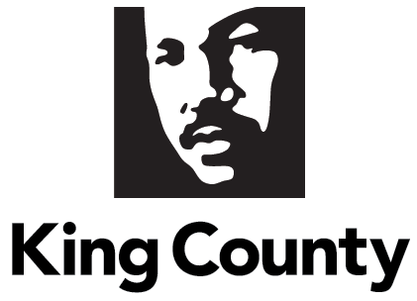

Contents
Contents 2
Executive Summary 3
Background 5
Department Overview 5
Historical Context 5
Current Context 11
Report Methodology 11
IV. Report Requirements 11
1. Description of the Current Program Scope 11
2. Updates on the Project Schedule Including Status of and Planned Dates for Major Milestones 16
3. Status and Progress for Each Component Capital Improvement Projects 17
4. Budgetary Update 24
5. Update on Tasks Completed on Major Milestones Since the Preceding Report and a Three-Month Projected Outlook on Upcoming Tasks to Accomplish Milestones 27
6. A Description of Stakeholder Engagement and Public Communications Including Appearances on Agendas at Regional Meetings and Mailings 29
7. A Description of Risks Including Newly Identified Risks and Realized Risks 31
V. Conclusion 38
VI. Appendices 39

Executive Summary

On November 3, 2020, more than 70 percent of King County voters approved Proposition 1, authorizing the County to sell $1.74 billion in bonds to fund facility and infrastructure improvements at Harborview Medical Center (HMC). Since its passage, the staff has worked diligently to establish the necessary organization and management structures needed to implement this complex capital program; one of the largest in King County’s history.

HMC is a 540-licensed-bed hospital owned by King County and operated by UW Medicine through a Hospital Services Agreement between King County and the University of Washington (UW). The hospital is typically overseen by a 13-member Board of Trustees appointed by King County (currently 11 members). HMC’s unique mission statement identifies and prioritizes services to the most vulnerable residents of King County. Harborview is the only adult and pediatric Level I trauma center serving a five-state region (Alaska, Idaho, Montana, Wyoming and Washington). It provides centers of emphasis and specialized comprehensive emergency services to a broad range of patients and throughout the region. Harborview is also the disaster preparedness and disaster control location for the City of Seattle and King County.

For nearly 100 years, Harborview provided medical services from its location atop Seattle’s First Hill. It is distinctive in its consistent provision of care to King County residents regardless of their race, religion, ethnic origins, or ability to pay. As stewards of the campus facilities, King County regularly provides facility improvements and expansions through voter-approved financing, generally occurring every 15-20 years. The original center tower was constructed with bonds in 1930 and through the ensuing years, the voters continued to entrust King County with funding approvals on behalf of Harborview.

King County Council Motion 15183 called for the establishment of a planning group to identify hospital and community needs, and to make recommendations regarding a capital program. The resulting Harborview Leadership Group (HLG) was comprised of representatives from Harborview administration, the Board of Trustees, UW Medicine, labor partners, the First Hill Improvement Association, the mission population, the King County Council, and the King County Executive Office. The HLG provided a report making recommendations for health and safety improvements at HMC. The recommendations included building a new inpatient tower to increase critical care capacity and meet modern infection control standards, as well as making seismic improvements to older structures on the campus to increase surge capacity, expand flexibility for hospital operations, and save lives in the event of a major earthquake.

Since the approval of the $1.74 billion bond funding, the Facilities Management Division (FMD) of the Department of Executive Services (DES) focused on establishing structures and processes and created essential milestones for the Bond Program.

As part of Bond planning, King County requested that the Bond Program’s project management consulting firm, Vanir, review and update the 2019 cost assumptions used to establish the Bond. A significant impact to cost assumptions was the Coronavirus Disease 2019 (COVID-19) global pandemic, and associated impacts on supply chains and workforce. The King County Council passed Ordinance 19583 (Appendix A), which called for the creation of a workgroup to identify a Program Plan for the allocation of voter-approved bond funds within the escalated pricing for health and safety improvements at HMC.

The updated Program Plan was approved by Motion 16435. It has three key components: 1) construction of a new multi-story medical tower; 2) renovation of essential services currently located in older hospital spaces; and 3) expansion of County spaces located in older hospital facilities. The updated Program Plan was determined after considering the operational needs of Harborview and the shared priorities of King County, the Board of Trustees, and UW Medicine.

In November 2025, the King County Council approved the transformation of the FMD Bond Program Office into the Harborview Construction and Infrastructure Division (HCID) through Ordinance 20020. The division’s work includes coordinating and managing the Harborview Bond Program budget and projects as well as the King County Hospital Property Tax budget and projects.

HCID continues with key elements of the program scope that aligns with the Bond Program’s mission. Tasks associated include:
- Collaborating with King County and UW Medicine departments to understand new and modified space needs;
- Updating the request for proposal (RFP) procurement processes and pre-bid work activities needed to accomplish the Bond Program goals;
- Coordinating with the design-builder and subconsultants on building the new tower and related projects;
- Managing the capital improvement project budget and expenditures;
- Coordinating and conducting stakeholder engagement, meetings, and mailings;
- Developing the Bond Program to become a division under King County’s Department of Executive Services in 2026 with King County Executive and King County Council approval;
- Identifying key milestones, risks, and realized risks for the Program Plan.

Updates since last report. This May 2026 report provides data for March 2026. Four substantive changes are reflected in this document since the April 2026 report with February 2026 data. The changes include:
- Updated budget actual expenditures for the month of March 2026, identified variances from projected expenditures included in the April 2026 report.
- Updated tasks for milestones 7 and 9 to reflect completed tasks, and projected tasks through June 2026.
- Updated status and progress for components in the Capital Improvement Projects section with further details and progress for actions presented in the previous report. This includes contacting tribal leaders for public comment about the major institution master plan (MIMP) major amendment work, including the Environmental Impact Statement (EIS) and new patient care tower, continuing negotiations about the contract amendment for 9th and Alder, and planning the next phase of geotechnical drilling for the new tower.
- Updated risk register with current program risks as of March 2026.

In addition, this report includes task updates on the March 2026 activities of the Bond Program, including:
- Completed review of public comments on draft EIS;
- Fulfilled Implementation Advisory Committee (IAC) request by providing example of letter of support for draft EIS;
- Drafted amendment for 9th and Alder design work;
- Continued coordinating the validation phase for the new tower, infrastructure, and renovations work;
- Updated the projected community meetings and events calendar; and
- Provided monthly project updates to HMC’s Capital Projects Oversight Committee, Board of Trustees, and the King County Auditor’s Office.

Background

Department Overview
DES provides internal services to King County agencies and departments, and public-facing services directly to King County residents. The divisions and offices that make up DES include the Business Resource Center, Finance and Business Operations Division, Office of Emergency Management, Facilities Management Division, Fleet Services Division, Inquest Program, King County International Airport-Boeing Field, Office of Risk Management Services, Records and Licensing Services Division, and the Harborview Infrastructure and Construction Division.

Historical Context
HMC is a 540-licensed-bed hospital owned by King County and operated by UW Medicine through a Hospital Services Agreement between King County and UW. The hospital is overseen by a 13-member Board of Trustees appointed by King County.

HMC is a comprehensive regional health care facility dedicated to providing specialized care for a broad spectrum of patients, the control of illness, and the promotion and restoration of health. Harborview is one of the nation’s leading academic medical centers and is the only adult and pediatric Level I trauma and burn center serving a five-state region (Alaska, Idaho, Montana, Wyoming, and Washington).

Harborview is home to a wide range of critical medical and behavioral health services, including state-of-the-art emergency medical services, general medicine, and specialty clinics and centers of excellence in burn, neurosciences, ophthalmology, infectious disease, and rehabilitation therapy. Harborview’s mission ensures that the following patients and programs are given priority care:
- Persons who are non-English speaking poor
- Persons who are uninsured or underinsured
- Persons who experience domestic violence
- Persons who experience sexual assault
- Persons incarcerated in King County’s jails
- Persons with mental illness, particularly those treated involuntarily
- Persons with substance abuse
- Persons with sexually transmitted diseases
- Persons who require specialized emergency care
- Persons who require trauma care
- Persons who require burn care

Services Offered at HMC - The Harborview campus facilities house a variety of services provided by UW Medicine and King County as highlighted below:

- Behavioral Health: A variety of in and out-patient behavioral health services, including psychiatric emergency services, outpatient clinics, and medication-assisted treatment are provided at the HMC campus. In addition, King County’s Superior Court operates the Involuntary Treatment Act (ITA) Court at Harborview.

- Trauma Response: As the only Level I Adult and Pediatric Trauma Center in Washington, HMC provides specialized comprehensive emergency services to patients throughout the region and serves as the disaster preparedness and disaster control hospital for the City of Seattle and King County. It is also the only Level I trauma center serving a five-state region (Alaska, Idaho, Montana, Wyoming, and Washington).

- International Medicine: HMC is unique in its offering of an International Medicine Clinic, providing primary care and mental health care services to adult refugees and immigrants. Staff speak several languages in addition to English, including Spanish, Amharic, Cantonese, Chao Jo, Mandarin, Hmong, Khmer, Laotian, Mien, Oromo, Somali, Tigrinya, and Vietnamese; interpreter services are also available.

- Emergency Management / Disaster Relief: The medical center is the regional emergency management command center during a natural disaster or major crisis event. The hospital is required to have flexible inpatient beds, operating capacity, and rapid response systems as needed for crisis response.

- Infection and Infectious Disease Control: HMC is at the forefront of containing and combating infectious diseases. Harborview is required to have clinical facilities and isolation room capacity to respond to emergency infectious disease outbreaks.

- King County Clinics and Services: A number of King County’s core public health services are located at Harborview, including the Tuberculosis (TB) Clinic, Sexual Health Clinic, the County’s Public Health Lab, and the King County Medical Examiner’s Office (MEO). The King County Regional Homeless Authority operates a 24/7 homeless shelter at Harborview Hall in partnership with the Salvation Army.

Harborview Facility Improvements - Over time, Harborview’s medical facilities have evolved to meet the demands of a growing and diverse population, as well as advancements in the fields of patient care, research, medicine, and technology. King County has provided for such facility improvements and expansions through voter-approved financing, generally every 15-20 years. Prior to the 2020 election, the last bond measure approved by voters was in 1999.

King County Council Motion 15183 called for the establishment of a planning group to identify hospital and community needs and make recommendations regarding the capital program to the Harborview Board of Trustees, the King County Executive, and the King County Council. The resulting HLG — comprised of representatives from HMC management, the Board of Trustees, UW, labor partners, the First Hill Improvement Association, the mission population served by HMC, the King County Council, and the King County Executive Office — conducted a 13-month assessment between December 2018 and January 2020 of Harborview’s facility needs.

Supported by staff from HMC, UW Medicine, the King County Council, and the King County Executive Office, the HLG reviewed data and information provided by industry experts. The group hosted numerous community forums to gather public input. After conducting the assessment process, the HLG determined:
  - A majority of the medical center’s facilities are aging and out of date in terms of modern medical best practice standards for infection control and privacy.
- Due to facility configuration, HMC often operates at more than 100 percent capacity, and critical surge capacity and emergency department (ED) capacity are limited.
- The majority of the medical center’s patient beds are located in double patient rooms or multi-patient wards. On average, 50 patient beds per day cannot be used due to modern infection control requirements for shared rooms.
- A new inpatient facility would increase single-bed capacity and enable HMC to meet modern infection control and privacy standards. It would provide surge capacity for the hospital to effectively respond to a disaster or mass casualty event.

Table 1 summarizes the key elements of the HLG recommendations for capital improvements at Harborview to address the medical center’s facility needs.

Table 1 – Harborview Facility Improvement Recommendations
Harborview Facility Improvement Recommendations: Harborview Leadership Group 2020
Component Name | Component Description
New Tower | Increase bed capacity; expand/modify ED; meet privacy and infection control standards; disaster preparedness; plant infrastructure
New Behavioral Health Building | Existing behavioral health services/programs and Behavioral Health Institute services/programs
Existing Hospital Space Renovations | Expand ITA court; move/expand gamma knife; lab; Public Health TB, sexually transmitted disease (STD), MEO; nutrition, etc.
Harborview Hall | Seismic upgrades; improve and modify space; create space for up to 150 respite beds; (maintain enhanced homeless shelter in most appropriate location)
Center Tower | Seismic upgrades; improve and modify space for offices
Pioneer Square Clinic | Seismic and code improvements; improve and modify space for medical clinic/office space
East Clinic | Demolish East Clinic building

Ultimately the HLG provided recommendations to the Harborview Board of Trustees, King County Executive, and King County Council on the size and scope of a potential bond measure.

The King County Council, via Ordinance 19117, voted to place Proposition 1 on the November 2020 General Election ballot for consideration by King County voters. The measure sought voter approval of $1.74 billion in general obligation bond funding over 20 years for health and safety improvements at HMC including: increasing critical health care capacity; updating and expanding infection control capability; and expanding capacity for behavioral health services. On November 3, 2020, more than 76 percent of King County residents once again confirmed their commitment to public health and Harborview through the approval of Proposition 1.

County Bond Program Launch - The first two years of the Bond Program work (2021-2022) saw FMD establishing the structures and processes necessary to implement the historic, multi-year Harborview Bond Program. Bond Program start-up activities included:
- Hiring key County staff;
- Selecting project management firms;
- Developing financial accounting reporting protocols;
- Expanding partnerships and collaborations with Harborview staff, and
- Establishing monthly meetings with the King County Auditor’s Office staff.

Cost Escalation - In late 2022, King County requested that its HMC Bond Program project management consulting firm, Vanir, review and update the 2019 cost assumptions used to establish the HMC Bond Program. King County requested this review both as part of its planning for the next phases of the Bond work but also due to the global COVID-19 pandemic and associated impacts to the supply chain and workforce.

Reflective of rising costs across the country post-pandemic, the Vanir team’s review and resulting Cost Study report confirmed that the HMC Bond Program faces financial pressures from the impacts of inflation, labor, and supply chain challenges. The initial Vanir team Cost Study, dated January 24, 2023, identified an estimated $900 million gap between anticipated revenues and updated cost of the Harborview Bond Program.

In February 2023, each King County Councilmember, along with leadership from UW Medicine and the HMC Board of Trustees, received individual briefings on the expanded costs. Digital copies of the Cost Study were also provided. On March 6, 2023, the King County Council’s Committee of the Whole received an initial briefing from FMD and the Vanir team (Bond Program consultants). On March 7, 2023, as a result of analysis from the Auditor’s Office, the consultants updated the Cost Study. The funding gap was updated from $900 million to $888 million (Appendix C).

On March 29, 2023, the King County Council passed Ordinance 19583 (Appendix A) calling for a workgroup to develop and submit to the King County Council, a Program Plan recommending health and safety improvements at HMC that can be built within the amount of the bond revenues estimated to be available. An Ordinance Workgroup (OWG) was established shortly after passage of the Ordinance, comprised of leaders from UW Medicine, Harborview’s Board of Trustees, the King County Council, Facilities Management Division, and King County Executive’s Office.

The OWG’s recommended Program Plan was submitted to the Council on August 1, 2023, with three key components: 1) construction of a new 10-story tower (base tower) with seven finished and three shelled floors; 2) construction of essential services currently located in older hospital spaces requiring renovation; and 3) expansion of County spaces located in older hospital facilities. Data provided by the Vanir team estimates that the components can be built within the $1.7 billion bond revenue amount. The OWG’s recommended Program Plan was determined by the OWG after considering the operational needs of Harborview and the shared priorities of King County, the Board of Trustees, and UW Medicine.

The King County Council approved the proposed Program Plan with no changes on October 3, 2023.

King County Hospital Property Tax – December 2024 – In 2024, the Washington State Legislature expanded property tax authority to support public hospitals, enabling King County to levy a councilmanic property tax to support capital and operating cost of Harborview. The King County Council set the annual tax rate for 2025 at 10 cents per $1,000 of assessed value, raising $86.5 million (see Ordinance 19841). Of this amount, $21 million was allocated to support the Bond Program. The County’s 2026-2027 budget sets the 2026 annual tax rate at 15 cents per $1,000 of assessed value, and this is expected to raise $275 million over the biennium. Of this amount, $42 million is restricted for use on the Bond Program (see Ordinance 20023).

Current Context
Harborview Construction and Infrastructure Division – November 2025
The Harborview Bond Program will be managed by the Harborview Construction and Infrastructure Division starting in the January 2026 reporting period. Following the King County Executive’s request for code change, King County Council members approved Ordinance 20020 on November 18, 2025, to establish the HCID as a division under the Department of Executive Services in January 2026. HCID is funded by the Harborview Bond Program and the King County Hospital Property Tax.

King County Council also approved the development of the Harborview Construction and Infrastructure Administration Fund through Ordinance 20023 as a special revenue fund to receive reimbursements for costs related to Harborview construction and infrastructure capital projects and support increased transparency and tracking of specific operational costs associated with the construction activities.

Report Methodology
This report was drafted by HCID. Data in the report is for March 2026.

IV. Report Requirements

This section is organized to align with the requirements of Ordinance 19583 (Appendix A).

Description of the Current Program Scope

This report defines the program scope proposed in the Program Plan that was approved by the King County Council on October 3, 2023. The Program Plan, approved by Motion 16435 (Appendix E), includes the health and safety improvements at Harborview built within the amount of the bond revenues ($1.74 billion) estimated to be available and as authorized by Ordinance 19117.

Program Plan Description - As outlined above, the Program Plan has three components: 1) construction of a new 10-story tower (base tower) with seven finished and three shelled floors; 2) construction of essential services currently located in older hospital spaces requiring renovation, and 3) expansion of County spaces located in older hospital facilities. Integrated within these components are necessary supporting infrastructure such as a new roadway and energy infrastructure. The scope of the Program Plan components are detailed below in Tables 2 and 3.

Table 2 - Program Plan Component 1: New In-Patient Tower
New Tower Component | Description of Planned Component | Estimated Square Footage of Completed  Component
Seven finished inpatient bed floors | - Estimated minimum 224 beds  - 32 beds per floor x 7 floors = 224 new beds  - Usable upon completion | 34,000 sq ft / floor
Three shelled inpatient bed floors | - Completed, but unfinished floors  - Floors, windows, walls, some infrastructure (e.g., plumbing and heating, ventilation, air conditioning (HVAC)  - Will be completed as further funding become available | 34,000 sq ft /floor
12 operating rooms (ORs) | - Increased ORs  - Including perioperative support (e.g., post-anesthesia care unit, prep/holding and OR support spaces) | 65,000 sq ft
Expanded single floor emergency department (ED) | - Expanded ED with increased single-patient treatment rooms and allowing for modern models of emergency care | 87,000 sq ft (includes PES & CSU)
Expanded Behavioral Health Services | - Psychiatric Emergency Services (PES): renovated & expanded by up to six new single-patient rooms | 87,000 sq ft (includes PES & CSU)
Expanded Behavioral Health Services | - New Crisis Stabilization Unit (CSU): 23-hour observation unit with approximately 18 recliner chairs and single patient quiet rooms | 87,000 sq ft (includes PES & CSU)
Observation Unit | - For patients requiring less than a 24-hour stay for medical care | 20,000 sq ft
Right-sized essential services | - Pharmacy, lab, clinical engineering, environmental services, kitchen | 150,000 sq ft
Parking | - Minimum 350 replacement parking spots for View Park Garage spots that will be lost to make room for new tower | 160,000 sq ft
Helicopter pads | - Minimum two pads; potentially a third if feasible | 35,000 sq ft

Table 3 - Program Plan Component 2: County Space Expansion
County Space Expansion Component | Description of Planned Component | Estimated Square Footage of Completed  Component
Involuntary Treatment Act (ITA) Court | - Increased space for courtrooms, admin, attorney workspace, client areas, and public entry | 20,000 sq ft
Medical Examiner’s  Office (MEO) | - Increased square footage for cooler space, offices, and education rooms | 36,300 sq ft
Tuberculosis (TB) Clinic | - Increased spaces for outreach, staff offices, and a conference room/break room | 11,000 sq ft
Sexual Health Clinic | - Expanded clinic and office spaces | 22,000 sq ft

As of February 2024, the Laboratory Director of the Public Health Lab determined there are no space needs as part of the Harborview Bond Program.

This report identifies no changes to the number, size, or components of the Program Plan.

Key Elements of the Program Scope: This subsection describes key elements associated with the scope of the Program Plan. Tasks associated with these items are discussed in subsequent subsections.

City of Seattle MIMP Major Amendment
- The City’s MIMP establishes the zoning rules and requirements for major institutions, such as universities, colleges, and hospitals. Changes to HMC’s adopted MIMP will be made through a prescribed, multi-step process involving the City Department of Neighborhoods (DON), Seattle Department of Construction and Inspections (SDCI), the City Hearing Examiner, and the City Council in a process that could take up to two years and potentially longer.

- The County submitted an application in April 2024 for approval from the City of Seattle for a major amendment to Harborview’s MIMP. The Seattle City Council has authority to revise Hearing Examiner decisions and/or attach conditions to HMC’s MIMP major amendment, either of which could potentially involve open space, parking, transportation management, building height or other items, which in turn could result in increased costs and impacts to timeline.

- Beginning February 2023, Seattle’s DON has led meetings with a standing IAC to discuss HMC’s facility and campus plans as part of the MIMP major amendment process. Once the IAC provided its feedback to DON, the County initiated the MIMP major amendment application process. The IAC provided a letter of support for the County’s MIMP application in September 2023. The IAC will be asked to submit another letter of support following the MIMP public comment and public hearing phase led by SDCI. HCID led development of the EIS.

- FMD started the EIS phase of the MIMP major amendment by developing the EIS scoping notice in March 2025 and publishing the notice for public comment with the MIMP major amendment in April 2025. HCID released the draft EIS and started a public comment period in December 2025. Commenting ended more than 45 days later in January 2026. The following EIS phases will be managed by HCID as well and include publishing the final EIS.

Infrastructure Master Plan Projects
- FMD developed a campuswide utility and infrastructure master plan for Harborview’s campus. The infrastructure master plan identified the condition and capacities of the existing campus utility infrastructure to develop strategies to meet the growth in demand anticipated from the bond program components. It also included identifying engineering solutions to enable future growth, including re-routing utilities and systems, providing energy usage improvements, and developing redundancy for mission-critical systems.

- The final Infrastructure Master Plan document is an alternatives analysis that will outline infrastructure redevelopment options for the campus. It reflects the goals of HMC and the County, including resilience; economic, environmental, and social sustainability; reduce reliance on fossil fuels; and will evaluate options for meeting sustainability goals and potentially certification under third-party programs for the new medical tower and renovation projects. Notably, identified alternatives and upgrades that fall outside of the scope of the proposed Bond projects may be designed and developed in future phases. As related projects are completed, the Infrastructure Master Plan will be updated to capture the latest findings.

- The Infrastructure Master Plan contract was awarded to the OAC Services team that started evaluating and rating the existing buildings and systems in August 2023. The team completed the plan by 1Q 2024.
- FMD completed further infrastructure master plan work in January 2025 with Seattle Public Utilities and Seattle City Light in identifying challenges and opportunities for infrastructure plans at HMC.
- FMD identified alignment between the Harborview campus plant and King County district energy exploration efforts and released a request for information (RFI) in May 2025 to help shape future related request for qualifications (RFQs) and RFPs. In July of 2025, FMD completed a review of the RFI responses and started studying system options. FMD and HCID continued to explore the district energy plant possibilities by developing a draft project feasibility report in December 2025, and the submission for a Washington State Department of Commerce grant.

Space Programming
- The space assessment informs the needs of key programs across Harborview campuses through 2040, including King County departments located in the hospital. Space programming includes planning for new or modified spaces for Harborview-located programs, developing and maintaining space planning guidelines, assessing available space to address changing needs, finding solutions for immediate and long-term space issues, and managing space requests and reallocations for County-owned and leased properties.

The process includes learning about department needs and using tools to provide space, equipment, and furniture needed for the department to function efficiently. Departments consider items such as service-level projections, industry standards, operating needs, storage, adjacencies, and other spacing needs in their projected outlook.

- King County, HMC, Harborview-located departments, and various consultants are involved in space programming through the Campus Master Plan work. HMC staff continue to provide further department needs, location requirements, and general floor layout details. This work will influence concurrent projects, such as the Infrastructure Master Plan, and information will be used to inform the procurement documents, such as the new tower RFP. The Bond’s involvement in the Campus Master Plan concluded in March 2026. HCID expects coordination between the Campus Master Plan and the design-builder to be ongoing throughout the design phase.

Parking
- Parking is severely constrained at HMC, and current demand far exceeds existing capacity. The planned construction of the new tower will result in the demolition of View Park 1 garage, eliminating a minimum of 340 stalls. The impact could increase to 800 stalls during construction due to access and structural dependencies with the adjacent View Park 2 garage. To mitigate the parking shortage, HCID is evaluating multiple capital construction options to increase parking capacity on campus.

- HMC has implemented business changes that encourage staff to use public transit or carpool and discourage use of campus garages by members of the public who are not visiting the hospital. HMC also initiated supplemental parking off-site for staff.

- HCID and HMC have established a parking oversight group to supervise the feasibility analysis of potential sites for a new or expanded parking structure(s). The goal is to provide the best parking alternatives that address both immediate needs and long-term growth, while balancing the complex challenges of construction, community impacts, and financial feasibility.

- In April 2025, FMD drafted a parking alternatives analysis that identified five potential parking sites for consideration. Since then, the parking workgroup has drafted multiple predesign reports (e.g., Boren garage and 9th and Alder alternatives) outlined the needs for a 9th and Alder parking alternatives study, produced a parking status report in June 2025 that narrowed potential parking alternative options to three sites, and provided a parking alternatives analysis report to the King County Council in September 2025. HCID completed the study of parking alternatives 1 to 5 to support parking needs on the HMC campus. Ninth and Alder (medical office building and parking structure) remains an option that meets cost and long-term planning requirements if funding is approved in a future supplemental budget.

2. Updates on the Project Schedule Including Status of and Planned Dates for Major Milestones

The schedule of major milestones included below as Table 4 was included in the August 1, 2023, Harborview Program Plan Report transmitted to the Council. The timeline and milestones shown below in Table 4 were updated in the October monthly report, transmitted to Council on October 30, 2023, along with updates as identified in subsequent reports transmitted to the Council.

To expedite program development, several key tasks are occurring concurrently and driving toward procurement for design and construction of the new tower. It should be noted, however, that some milestones are dependent on the sequential completion of key tasks. Meeting these major milestones includes managing several tasks and sub-tasks. The subsections below outline the work being conducted by HCID around major schedule milestones and provide a three-month progress outlook. This schedule below is predicated on working with the City of Seattle to expedite its MIMP and permitting processes, particularly items denoted with * in Table 4, below.

Table 4 - OWG Program Plan Milestones
Milestone | Estimated Completion Timeframe
- MIMP Major Amendment: file notice of Intent (NOI) to apply for Major Amendment to the City of Seattle | Completed December 2023*
- Submit MIMP major amendment application to the City of Seattle | Completed April 2024
- Issue new tower RFQ | Completed September 2024
- Issue new tower RFP | Completed January 2025
- Selection of design-builder | Completed July 2025
- Notice to proceed | Completed July 2025
- City of Seattle MIMP submission process: (DON, SDCI, Hearing Examiner, and City Council) | 2Q 2026*
- Receive City permitting approval for land use | 3Q 2026*
- Design, construction, and permitting | 4Q 2028*
- Occupy new tower | 4Q 2031*
- Renovation of essential services outside of the new tower | TBD
- Renovation of County hospital spaces | TBD
- Closeout | 4Q 2032

3. Status and Progress for Each Component Capital Improvement Projects

Component 1 – New Tower
The following narrative summarizes key elements underway for the new tower (Table 5).

Table 5 - Project Component Activities for March 2026
Item | Activities Update | Objective
MIMP Major Amendment | HCID started contacting tribal leaders to raise awareness about the new tower and future construction work for public comment.  Also, HCID met with Washington State Department of Archaeology and Historic Preservation (DAHP) to discuss comments from the draft EIS public comment period. HCID will provide a letter to DAHP demonstrating that the ground is significantly disturbed within the proposed project footprint.  HCID anticipates the IAC providing a letter of support in 3Q 2026 to the Hearing Examiner. The committee requested an example of a letter of support for the draft EIS in March 2026 that HCID fulfilled.  The draft EIS will project if or how the new tower construction could change the neighborhood’s environment (e.g., soil, air quality, and water) and identify mitigation options.  Next steps include:  - Developing and publishing the final EIS and final updated MIMP major amendment in August 2026;  - IAC submitting a letter of support in 3Q 2026 to the Hearing Examiner.  - SDCI submitting report to the Hearing Examiner in 3Q 2026;  - Reviewing and approving the MIMP major amendment by the City of Seattle Hearing Examiner*;  - Holding hearings and legislation by Seattle City Council*.  *The estimated completion dates are predicated on working with the City of Seattle to expedite the MIMP major amendment and EIS processes. | Achieve City of Seattle approval of a major amendment to the MIMP.  The MIMP will outline a number of actions, some of which have environmental impacts. The EIS will show the impacts of those actions and the alternatives considered by King County in the development of the MIMP major amendment application.
Infrastructure Master Plan | HCID explored further impacts and interdependencies of critical make-ready infrastructure work. Make-ready work projects help ensure the proper configuration of support for future construction, renovations, and equipment installations.  Contractor Haley and Aldrich continued analyzing soil samples to support the construction of the new tower and loop road.  HCID started planning the next phase of geotechnical drilling for the new tower.  Received the Washington state Commerce grant to further explore and design a district energy plant or central utility plant, specifically the first phase to support the new tower.  Next steps include:  - Determining possible scope for district energy plant.  - Onboarding the new owner-advisor team working on infrastructure. | Analyze campuswide internal and external systems (e.g., electricity, gas, and steam), informing energy options to meet the hospital’s growing needs.
Design-Build Contract | Continued coordinating the validation phase, including the development of division one requirements. These include the initial design phase schedule, and outlining key milestones, critical path tasks, timelines for reviews, approvals, and coordination. These items will serve as the baseline for tracking progress, an ongoing task. | Validate program scope, schedule, and budget.
Campus Master Plan Coordination (formerly Space Programming) | HCID completed Campus Master Plan work in March 2026. HCID expects coordination between the Campus Master Plan and the design-builder to be ongoing throughout the design phase. | Align Bond Program projects with campus master plan efforts.
Parking | HCID continued negotiating the contract amendment for 9th and Alder (a medical office building with parking structure), and planning for land surveying and geotechnical exploration.  This work follows the latest parking milestones that include exploration of parking alternatives 1 through 5, various parking analyses and studies, and a predesign report for 9th and Alder. These efforts are addressing the existing parking shortage and will reduce the future need for on campus parking and may provide insight into initiatives to manage parking during Bond Program construction.  Next steps include:  - Negotiating contract amendment for the scope of work with the design-builder.  - Entering schematic design for the medical office building and parking structure at the 9th and Alder location within the Council appropriation. | Identify and provide parking alternatives in recognition of the significant parking constraints that exist at HMC and the expected exacerbation by new tower construction.
Construction Team Co-Location Workspace | Rolluda, architectural consultant, and Pacific Mobile, modular fabricator, continued site civil design, building engineering, and architectural design. They concluded 100 percent of site drawings in March 2026.  HCID submitted building plans to SDCI as HCID and HMC further reviewed completed drawings in March 2026.  Next steps include:  - Anticipating building plans review by SDCI in eight weeks.  - Anticipating a determination from WA L&I by June 2026 at the latest (12-16 weeks review).  - Determining viability of project by HCID leadership in Q2 2026.  - If the project moves forward, HCID anticipates site work beginning in May 2026 with construction substantially complete by November 2026, and anticipated owner’s move in by January 2027*.  *This schedule is predicated on working with the City of Seattle to expedite permitting processes. | Build a collaborative workspace that co-locates Bond Program team members from HCID, UW Medicine, the design-builder, and owner’s advisor to accomplish the Bond Program goals.
Procurement | HCID anticipates executing a contract for program management and owner advisor services for the Harborview Bond Program by the end of April 2026. The owner advisor RFP was released in November 2025, due to the Vanir contract expiring on April 30, 2026.  Next steps include:  - Onboarding the new owner advisor.  - Procurement activities for HCID projects funded by the County hospital tax and HMC funded projects that exceed the threshold amount identified in the Hospital Services Agreement (for County engagement). | Seek the owner’s advisor to support or manage individual projects and subprojects of the Bond Program.
Property Coordination | HCID continued property use coordination with the Washington Department of Transportation (WSDOT), and further property sites needed to complete the OWG Program Plan milestones and support construction teams. KC has solicited proposals from three appraisers as part of the lease negotiation process.  Geotechnical engineers continued to analyze soil samples obtained from drilling operations on the WSDOT property and monitor groundwater levels at selected drilling locations with water monitoring wells installed. The next phase of soil sampling will begin in May 2026, and well monitoring will be ongoing throughout 2026. HCID will maintain ongoing communication with WSDOT as geotechnical information becomes available. | Secure use of the property required for the completion of projects under the Bond Program.

Budgetary Update

Ordinance 19583 calls for “updates on the budget including expenditures to date and remaining budget for each component capital improvement project, budget and expenditures.” Table 6 below provides the required information along with projections for upcoming months.

As acknowledged in the initial monthly report (September 2023), due to the timing of the availability of the County’s final monthly financial data and the timeline for the completion of this report for transmittal to the Council, financial data in this report is for two months prior. To provide more relevant financial information to the Council, this report also includes projected expenditure data for the upcoming two months, and variance information between projected and actual months. This report provides March 2026 actuals, variance to March 2026 projected in the April 2026 report, and projected budgets for April 2026 and May 2026.

The 2020 voter-approved bonds are expected to provide $1.74 billion in revenue. As shown in Table 6, $460 million of expenditure authority has been granted with the transfer of funds from the approval of Ordinance 20023 in November 2025. An additional $63 million in funding from the hospital property tax levy has been restricted to support the Bond Program. Total program expenditure through March 2026 is $100,018,900 with less than 6 percent of total revenues expended.

HCID has identified that Milestone 8—city permitting—will provide detailed financial information with support from the new tower RFP-selected design-build contractor.

With the approval of Ordinances 20020 and 19583, HCID must provide a budgetary update for the County Hospital Capital Fund, detailing the use of the hospital tax revenue, to ensure transparency of funds used to support extended safety, infrastructure, and health improvement projects at HMC.

Key Updates for May 2026 Report - The April 2026 report projected $4,152,099 in expenditures for the March 2026 reporting period. The actual expenditures in March 2026 are $2,884,706. The variance in projected to actual expenditures is due to contract/vendor estimate, actual payment amount difference, and date of submission.

Table 6 - March 2026 Expenditures and Projected Financial Data for HMC Capital Bond Program 2020 Prop 1 (Fund 3750)

Fund 3750 Harborview Medical Center Capital Program 2020
March 2026 Data
Harborview Project Plan Component | Adopted 2023-2027 Budget | March 2026 Actual Expenditures | March 2026 Projected | March 2026 Variance | April 2026 Projected | May 2026 Projected
New Tower | 414,846,775 | 2,884,706 | 4,152,099 | (1,267,393) | 5,985,754 | 4,854,654
Existing Space Renovations | 35,169,985 | 0 | 0 | 0 | 0 | 0
Other Costs | 10,600,000 | 0 | 0 | 0 | 0 | 0
 | 460,616,760 | 2,884,706 | 4,152,099 | (1,267,393) | 5,985,754 | 4,854,654

In addition to this financial reporting, a joint County/HMC group meets monthly to monitor bond program financial activity. Members of this group include:
- UW Medicine Chief Finance Director;
- UW Medicine Controller;
- King County Business and Finance Officer;
- King County Harborview Bond Program Administrator;
- King County Executive Budget Analyst; and
- UW Medicine Accountants.

Finally, a data dashboard is provided to the Auditor’s office and the Capital Projects Oversight Committee (CPOC) each month, which includes financial data.

Update on Tasks Completed on Major Milestones Since the Preceding Report and a Three-Month Projected Outlook on Upcoming Tasks to Accomplish Milestones

Key Updates for May 2026 Report – The task list below has been updated to reflect completed March 2026 tasks, including further tasks not previously reported. New or updated tasks are shown in italics. FMD completed Milestone 1: MIMP Major Amendment: Application to the City of Seattle in 4Q 2023 as projected, Milestone 2: Submit MIMP major amendment application in 2Q 2024, Milestone 3: Issue new tower request RFQ in 3Q 2024, Milestone 4: Issue new tower request for proposals (RFP) in 1Q 2025, Milestone 5: Selection of design-builder, and Milestone 6: Issue notice to proceed. HCID aligned and updated the milestone reporting outlook with the major milestones identified and added in the project schedule.

Milestone 1: MIMP Major Amendment: Application Notice to the City of Seattle
Completed December 2023

Milestone 2: Submit MIMP Major Amendment application
Completed April 2024

Milestone 3: Issue new tower RFQ
Completed September 2024

Milestone 4: Issue new tower RFPs
Completed January 2025

Milestone 5: Selection of design-builder
Completed July 2025

Milestone 6 – Notice to proceed
Completed July 2025

Milestone 7: City of Seattle MIMP submission process (DON, SDCI, Hearing Examiner, City Council)
Tasks completed through March 2026 include:
- Completed review of public comments on draft EIS; and
- Fulfilled IAC request by providing example of letter of support for draft EIS.

Projected April 2026 Tasks:
- Begin developing the final EIS; and
- Begin developing final updated MIMP major amendment.

Projected May 2026 Tasks:
- Continue developing the final EIS;
- Complete responses to all SDCI draft MIMP comments; and
- Continue developing final updated MIMP major amendment.

Projected June 2026 Tasks:
- Continue developing the final EIS and final updated MIMP major amendment.

Milestone 8 – City permitting approval for land use
- Milestone 8 is dependent on the completion of key tasks in previous milestones.

Milestone 9 – Design, construction, and permitting
Tasks completed through March 2026 include:
- Drafted amendment for 9th and Alder design work; and
- Continued coordinating the validation phase.

Projected April 2026 Tasks:
- Completion of amendment and amendment negotiations for 9th and Alder;
- Issue notice to proceed for 9th and Alder;
- Issue Task Zero extension and funded a series of deliverables related to schematic design.; and
- Start schematic design for 9th and Alder.

Projected May 2026 Tasks:
• Continue schematic design for 9th and Alder.

Projected June 2026 Tasks:
- Progress on critical make-ready permitting and design of new tower; and
- Design development for 9th and Alder.

Milestone 10 - Occupy new tower
- Milestone 10 is dependent on the completion of key tasks in previous milestones.

Milestone 11 – Renovation of essential services outside of the new tower
- Milestone 11 is dependent on the completion of key tasks in previous milestones, except Milestone 10.

Milestone 12 – Renovation of County spaces
- Milestone 12 is dependent on the completion of key tasks in previous milestones, except Milestones 10 and 11.

Milestone 13 – Closeout
- Milestone 13 is dependent on the completion of all previous milestones.

A Description of Stakeholder Engagement and Public Communications Including Appearances on Agendas at Regional Meetings and Mailings

HCID conducts outreach and engagement around the Bond Program and attended eight events in March 2026. HCID is identifying future presentation opportunities and community events to attend as well as meetings to schedule with community organizational leaders.

Table 7 – Bond Program Outreach and Engagement
March 2026 | Event Description | Event Purpose
First Hill Improvement Association | A monthly meeting with community members, neighborhood group leaders, and neighborhood organization/business leaders to discuss community design/ development. | An opportunity where HCID answered questions about the Bond Program and the EIS process. Also, the association and guest speakers presented about other neighborhood-based projects that could impact the Bond Program.
Alliance Northwest | Annual statewide contractor networking event between owners/government agencies, primes, and small businesses. | An opportunity where HCID shared further details about the Bond Program and Levy projects, and upcoming bid opportunities with HCID and its design-build partners (e.g., Mortenson and Perkins&Will). Small businesses also networked for opportunities to collaborate with each other and met Bond Program team members from King County and Mortenson.
National Association of Minority Contractors | A monthly meeting where owners, primes, and small businesses network, build advocacy tools, and learn about opportunities from owners and primes. | An opportunity where Mortenson educated and engaged with local small businesses interested in the Bond Program opportunities.
Association of Women & Minority Businesses | A monthly meeting where owners, primes, and small businesses network, build advocacy tools, and learn about opportunities from owners and primes. | An event where Mortenson educated and engaged with local small businesses interested in the Bond Program-funded opportunities.
Enlighten Women's Forum | An annual event bringing women in the construction and machining trades together to empower them in their careers, create valuable connections with their peers, and foster leadership development in their field. | An event where Mortenson educated and engaged with local small businesses interested in the Bond Program-funded opportunities.
Harborview Medical Center Town Hall | Periodic event with HMC leadership and HMC staff. | HMC leaders informed HMC staff about the status of the Bond Program, features videos about the Bond Program activities, and addressed any existing questions.
Northwest Minority Builders Alliance | A monthly meeting where owners, primes, and small businesses network, build advocacy tools, and learn about opportunities from owners and primes. | An event where Mortenson educated and engaged with local small businesses interested in the Bond Program-funded opportunities.
Port of Seattle Industry Construction Day | An annual event bringing together primes and small businesses that have an interest in government/Port of Seattle and related projects. | Mortenson staff educated and engaged small businesses interested in the Bond Program-funded opportunities.

7. A Description of Risks Including Newly Identified Risks and Realized Risks

Ordinance 19583 requires this report to include the “description of risks including newly identified risks and realized risks since the preceding monthly report, with a focus on risks that may have significant impacts on the program plan scope, schedule, or budget.”

Program and project risk refers to events or conditions that, if realized, would have a negative or positive effect. Realized risk can have significant impacts on program, on capital project scope, schedule, budget, and quality, and can affect whether the project can meet its original objectives. By identifying and monitoring project and program risks, effective responses can be planned and implemented with minimum impact on the project or program. Risk management is primarily the responsibility of the Risk Manager.

This information is used to determine budget and schedule contingencies, communicate with sponsors and stakeholders, and inform decision-making. A common tool used to monitor risk is a risk register. Risks may be active, closed, or realized (i.e., point at which the risk will be managed as an issue). HCID began developing the risk register continuously in September 2025 with the new Risk Manager by identifying program and project risks.

The current realized risks are as follows:
- WSDOT Haul/Loop Road (WSDOT Lease) - WSDOT rejected the initial WSDOT right-of-way (ROW) lease request. HCID formed a government relations team (including representatives from King County and HMC) to continue conversations with WSDOT in pursuit of a ROW lease for the proposed haul and loop road immediately alongside the new tower. HCID will maintain ongoing communication with WSDOT as further information and studies become available. The haul road is essential for HMC traffic circulation during construction and operation of the new tower (i.e., direct access to the new tower Emergency Department, and utility infrastructure corridors). The original projected date to significantly complete steps to develop a formal WSDOT lease agreement was late January 2026. Progressive discussions with WSDOT are ongoing, although the risk has been realized. King County has restarted lease negotiations with WSDOT for a temporary haul road lease.

- Alignment of scope, schedule and budget – HCID is collaborating with the design-builder to define the target values for major Bond Program sub-projects: 1) The podium and new tower, 2) Infrastructure; and 3) Renovations/Enabling. Additional time to achieve alignment is necessary. Costs will continue to escalate with time, therefore the risk has been realized. HCID and the design-builder are currently negotiating an amendment to extend Task Zero efforts to further define the scope, schedule, and budget prior to progressing into the design phases.

- Program Governance – HCID is currently developing a Program Management Plan (PgMP) and a Project Management Manual (PMM) that will provide guidance to effectively manage the sub-projects, including the management/mitigation of schedule delays, avoidable costs; and boost team morale. The documents will be useful as the Bond Program welcomes a new owner’s advisor to further implement the guidance details. HCID is currently clarifying roles and responsibilities with the design-builder through the Division 1 general requirements specifications. Until the completion of the Division 1 specifications, some team members may continue to experience confusion towards roles and responsibilities; incur additional time, budget, and resources; and team morale may be negatively impacted.

- Parking – The parking risk will close if additional funding is approved in a future supplemental budget. In the meantime, the Risk Manager continued to align parking risk with the HMC campus master plan (9th and Alder [medical office building and parking garage]) risk. HCID proposes 9th and Alder may provide an estimated 749 new parking spaces and help mitigate the loss of parking due to construction of the new patient care medical tower. HCID continued negotiating the design-build contract amendment to start the design of the parking garage to be funded by the Hospital Property Tax. HCID and the design-builder will make consideration for medical offices above the parking garage in the design phase for 9th and Alder, although the funding for this effort has yet to be secured.

Please see the following for the complete Bond Program Risk Register.
`````````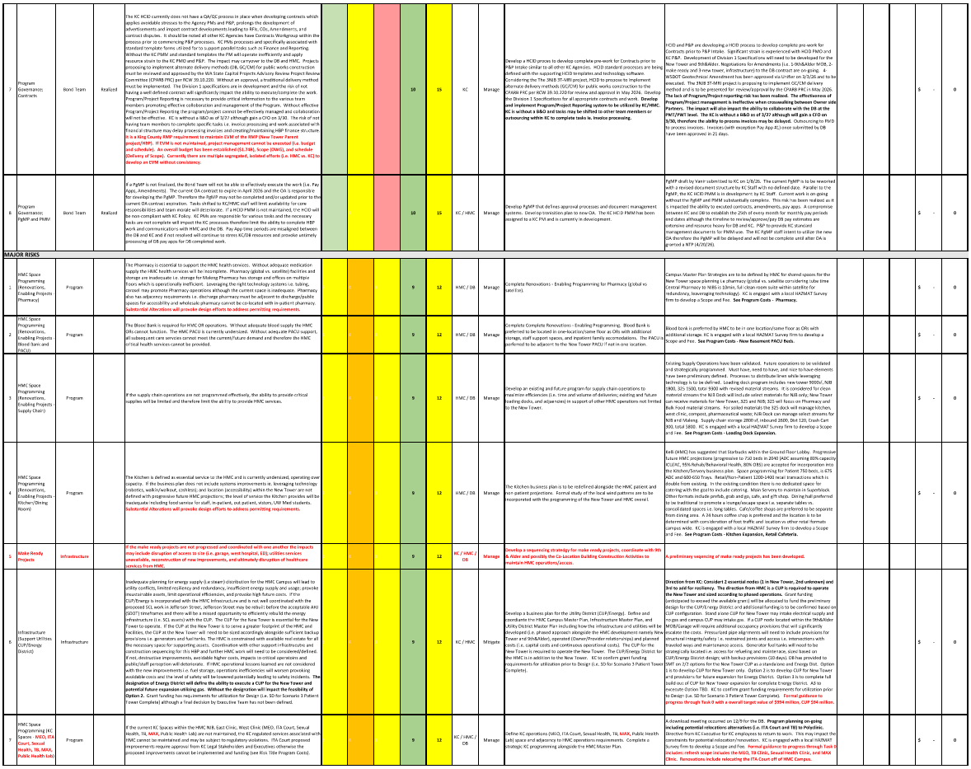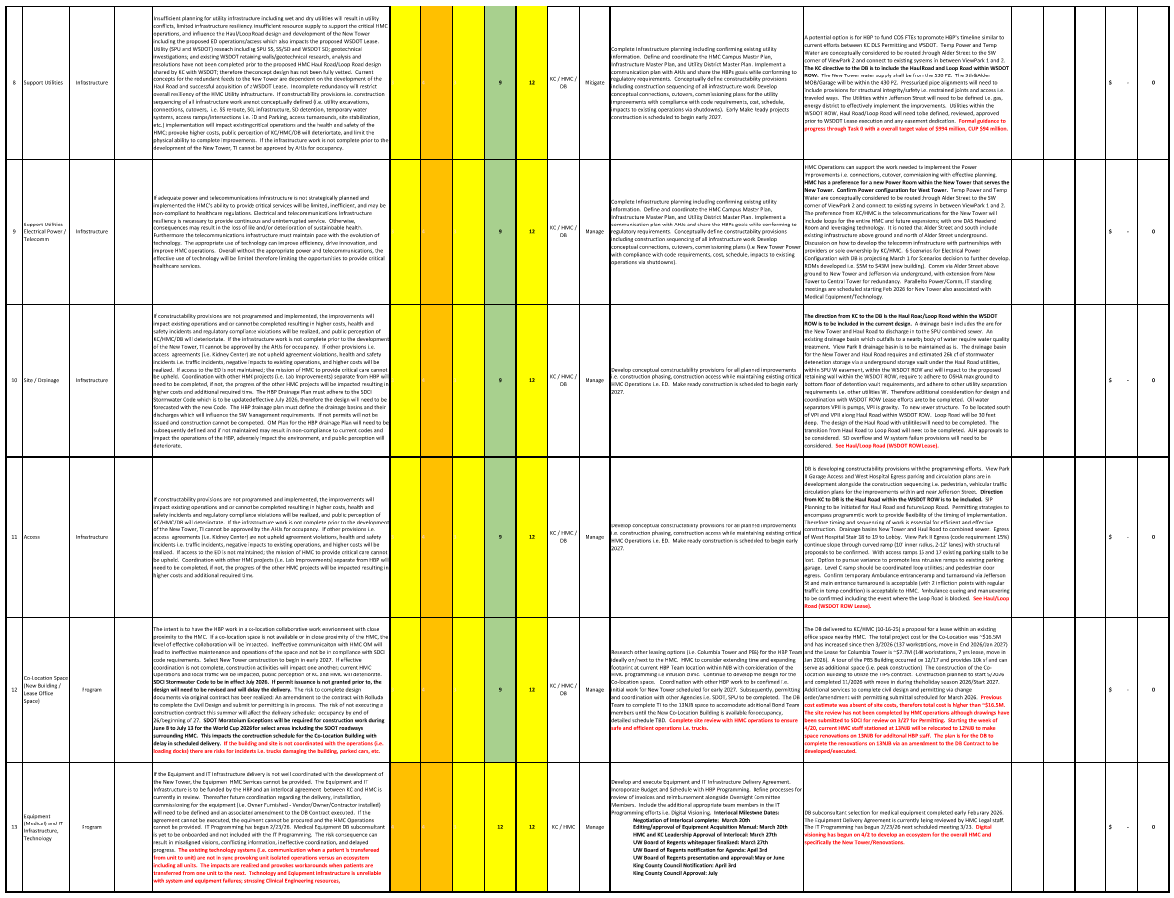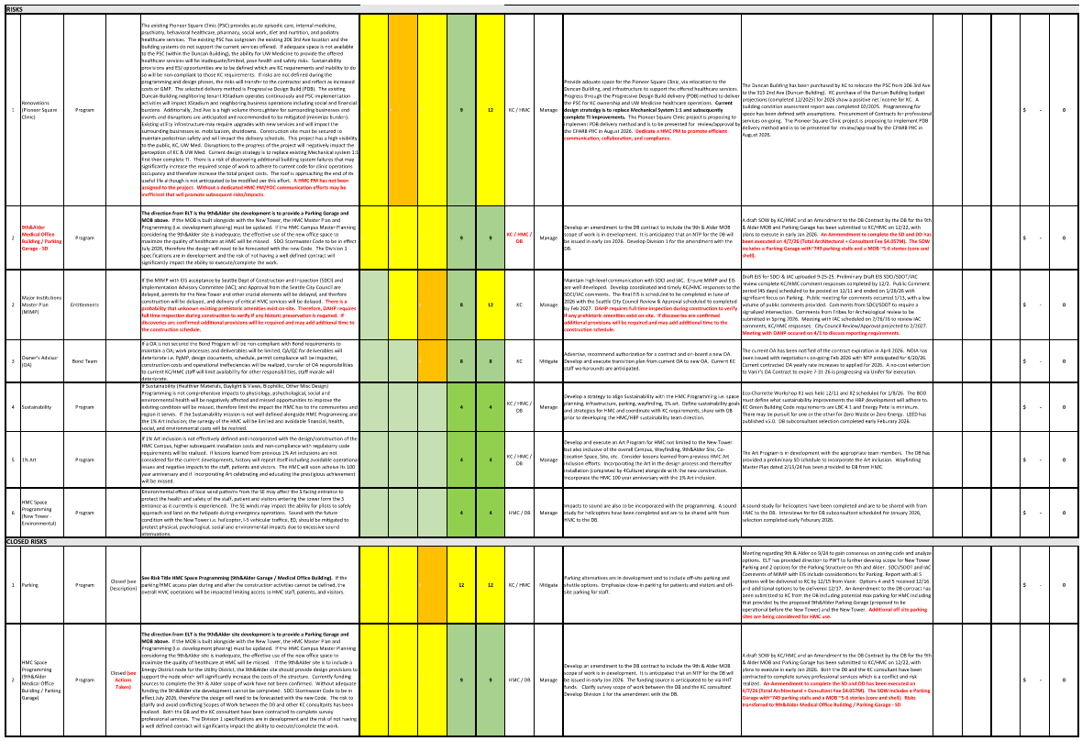

V. Conclusion

This report identifies tasks accomplished to advance the Bond Program work and details on HCID’s progress toward achieving the Bond Program goals. In addition to this report, HCID provides monthly project updates to Harborview’s CPOC and Board of Trustees and King County Auditor’s Office.

Subsequent reports will update the information in this document.

VI. Appendices
Appendix A – Ordinance 19583
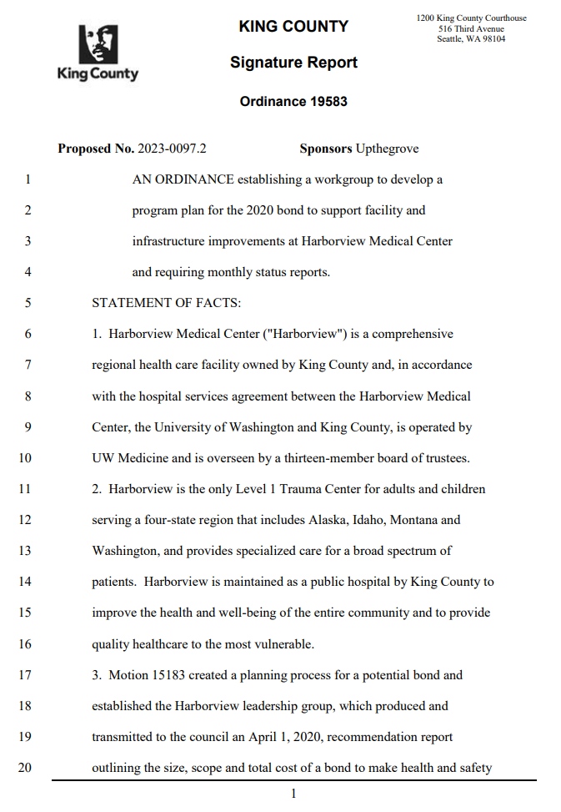
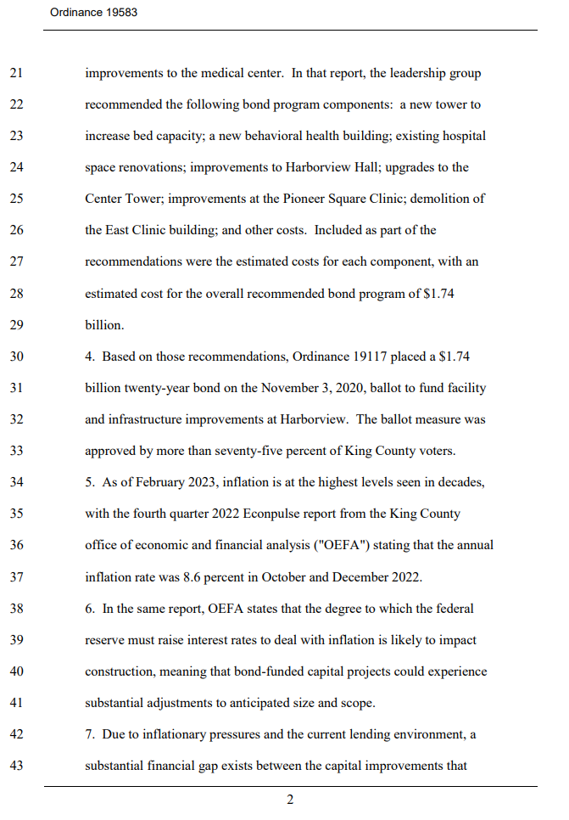
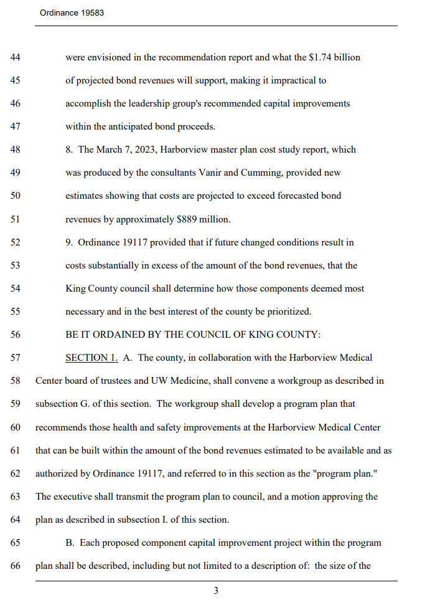
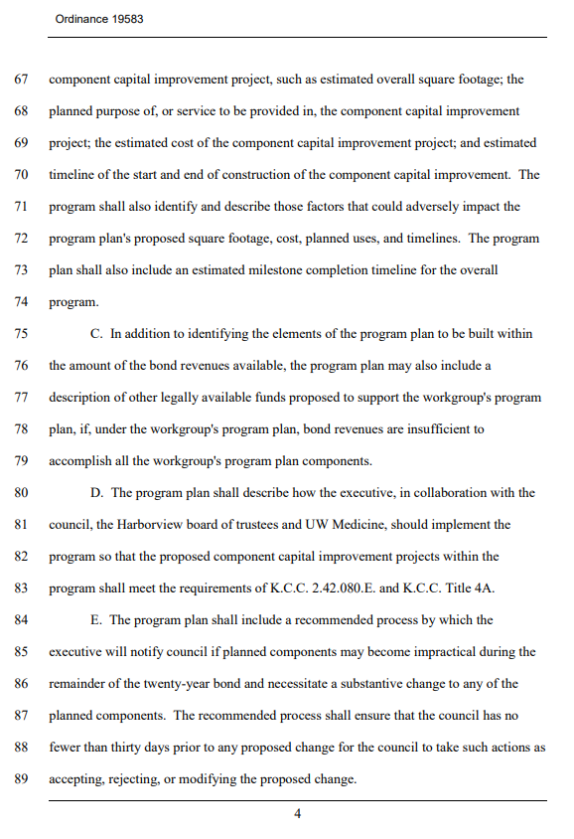
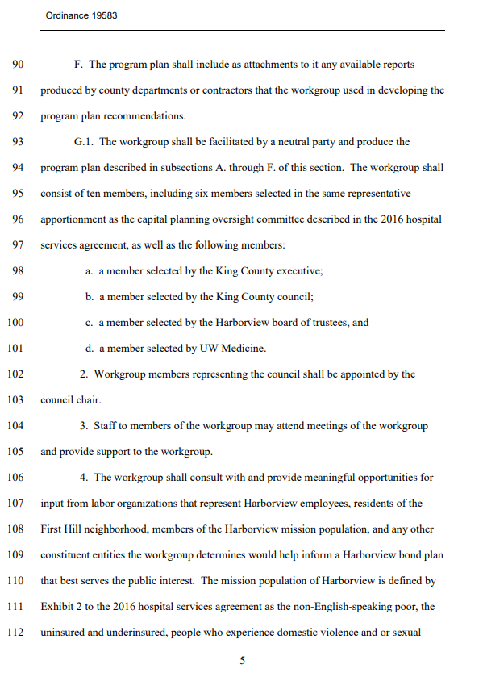
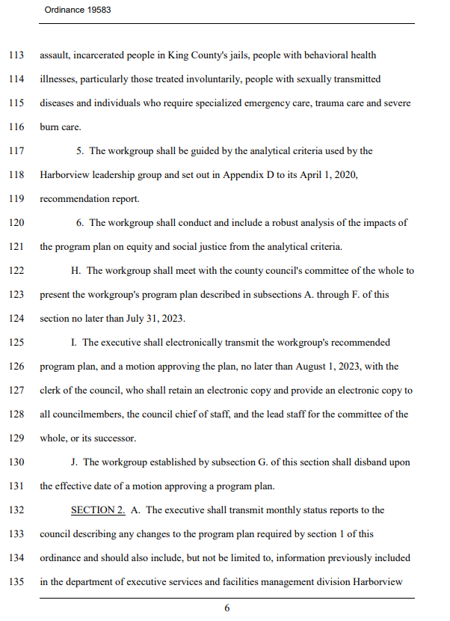
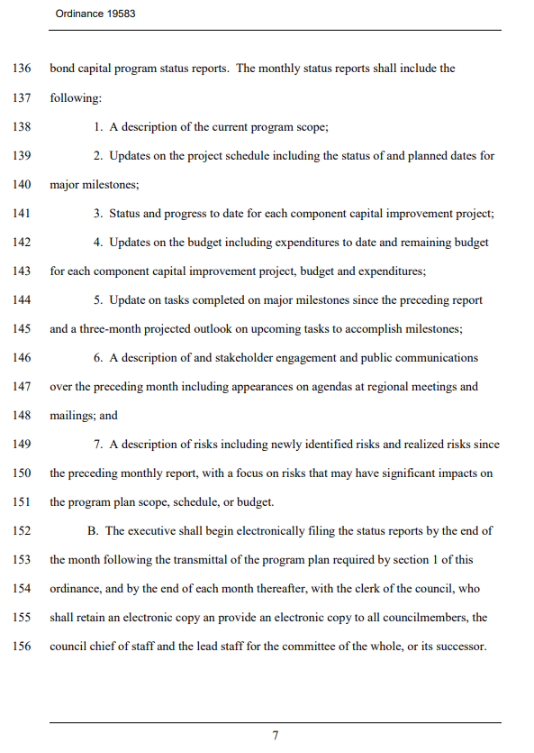
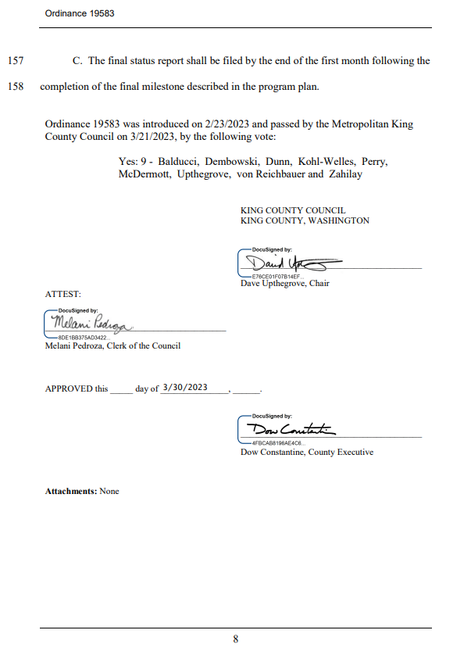
Appendix B – Harborview Mission Statement
Harborview Medical Center Mission Statement
Harborview Medical Center is a comprehensive healthcare facility dedicated to the control of illness and the promotion and restoration of health. Its primary mission is to provide healthcare for the most vulnerable residents of King County; to provide and teach exemplary patient care; to provide care for a broad spectrum of patients from throughout the region; and to develop and maintain leading-edge centers of emphasis. As the only Level I Adult and Pediatric Trauma Center in Washington, Harborview Medical Center provides specialized, comprehensive emergency services to patients throughout the region and serves as the disaster preparedness and disaster control hospital for Seattle and King County.

The following groups of patients and programs will be given priority for care:
- Persons who are non-English speaking poor
- Persons who are uninsured or underinsured
- Persons who experience domestic violence
- Persons who experience sexual assault
- Persons incarcerated in King County's Jails
- Persons with mental illness, particularly those treated involuntarily
- Persons with substance abuse
- Persons with sexually transmitted diseases
- Persons who require specialized emergency care
- Persons who require trauma care
- Persons who require burn care

Harborview's patient care mission is accomplished by assuming and maintaining a strong leadership position in the Pacific Northwest and the local community. This leadership role is nurtured through the delivery of health services of the highest quality to all patients and through effective use of its resources as determined by the Harborview Board of Trustees.

Harborview, in cooperation with UW Medicine, plans and coordinates with Public Health Seattle and King County, other County agencies, community providers, and area hospitals, to provide programs and services.

Harborview fulfills its educational mission through commitment to the support of undergraduate, graduate, post-graduate, and continuing education programs of the health professions of the University of Washington and other educational institutions, as well as programs relating to patient education.

Harborview recognizes that the delivery of the highest quality of healthcare is enhanced by a strong commitment to teaching, community service and research.

Appendix C – Vanir Cost Study Report Updated Bond Project Cost Modeling

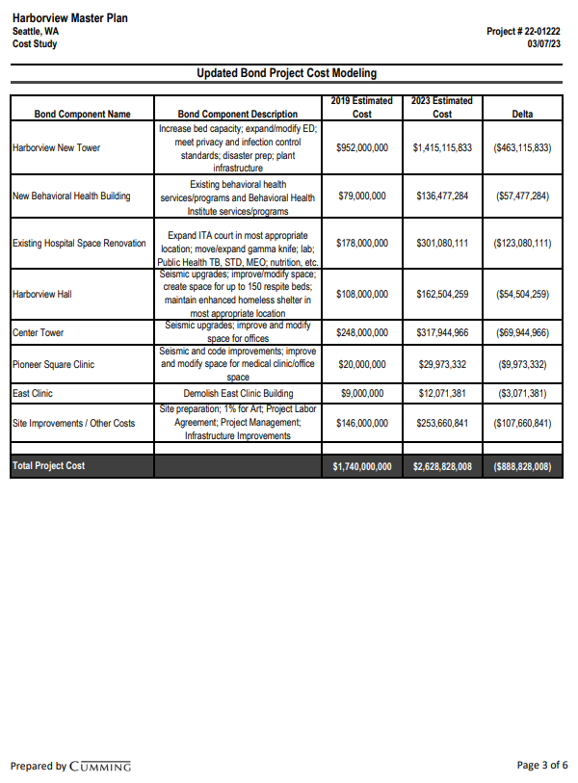

Appendix D – Phases of Construction

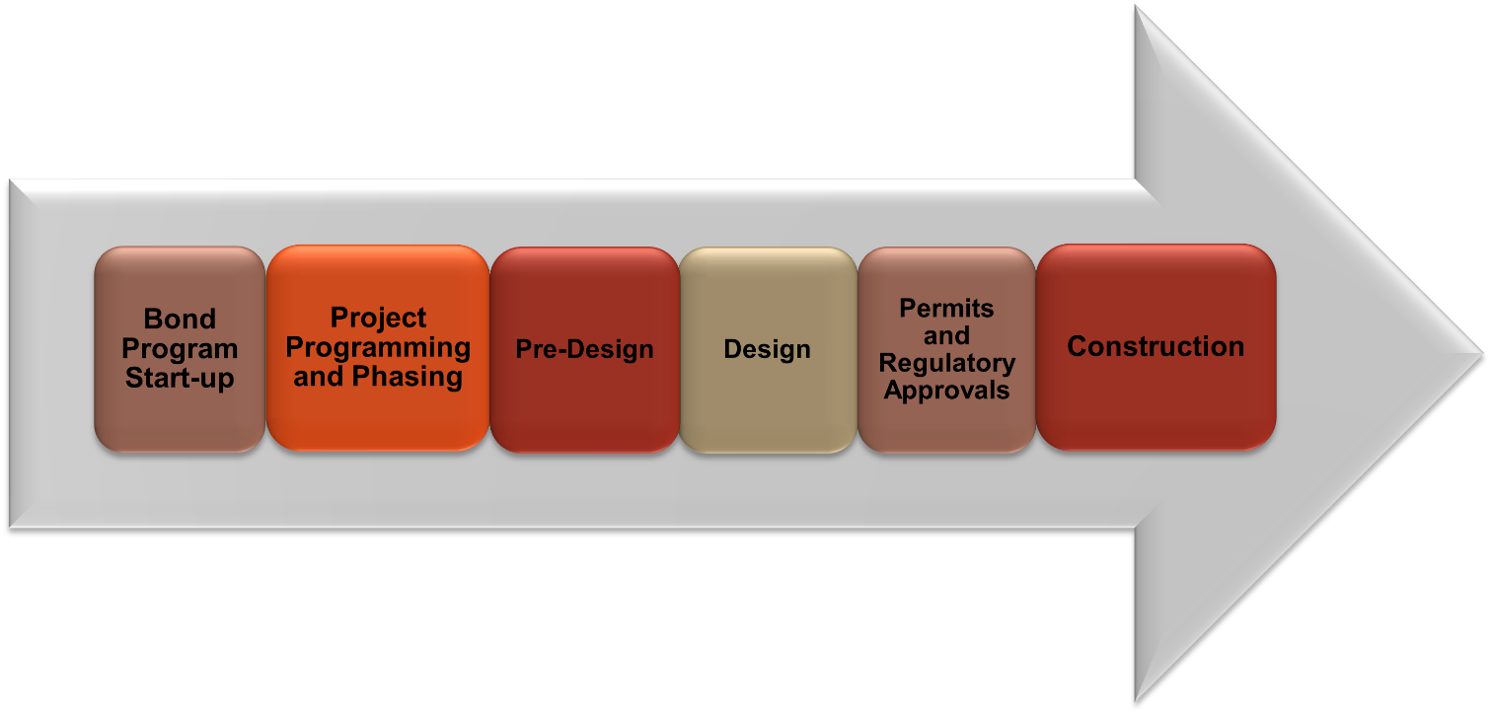

Appendix E – Motion 16435
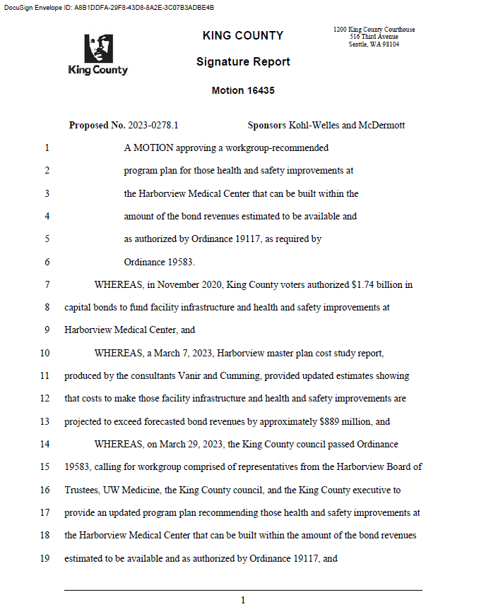

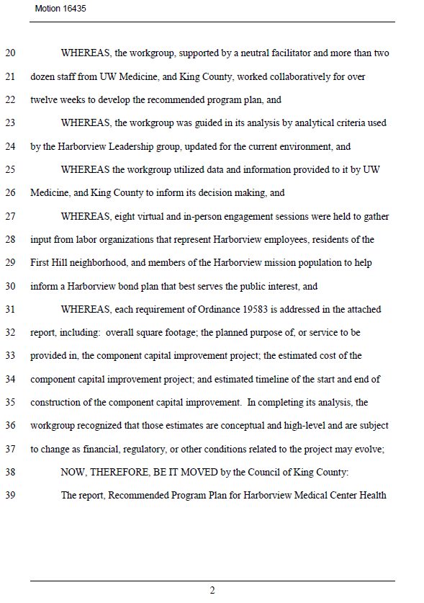

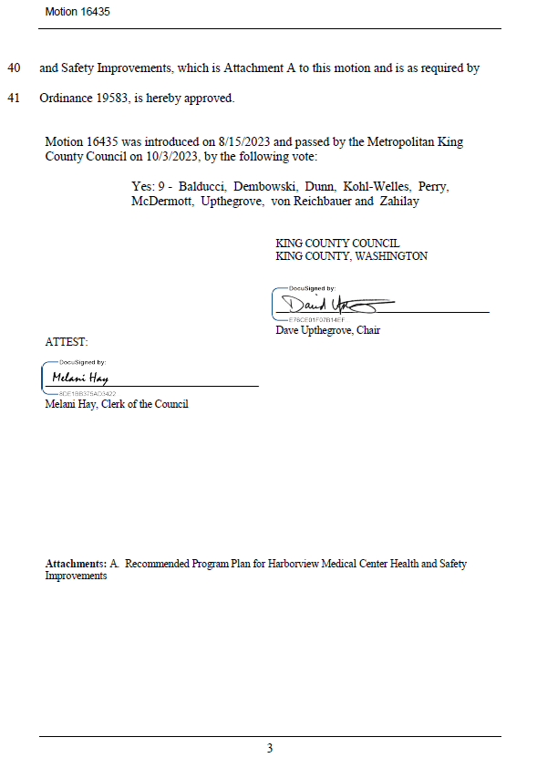

Appendix F – Implementation Advisory Committee’s final endorsed recommendation letter

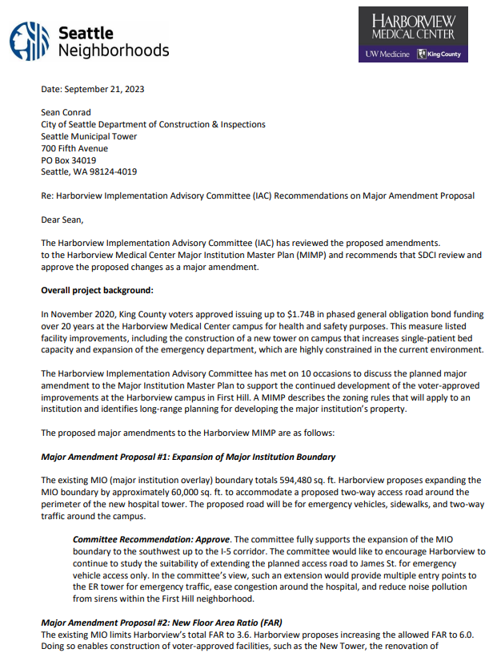

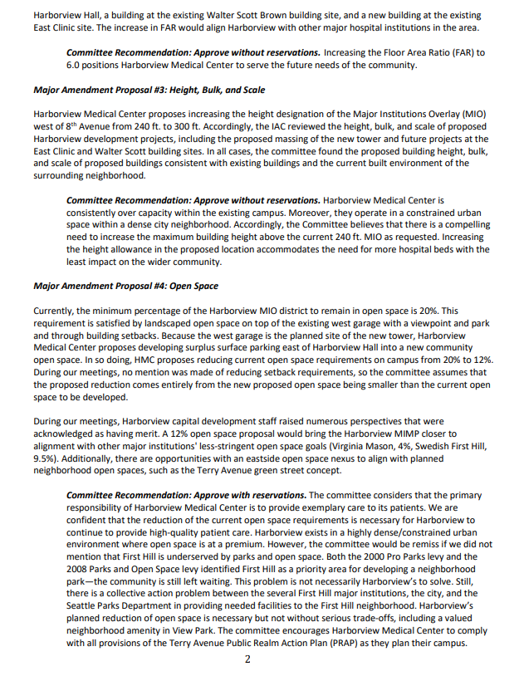

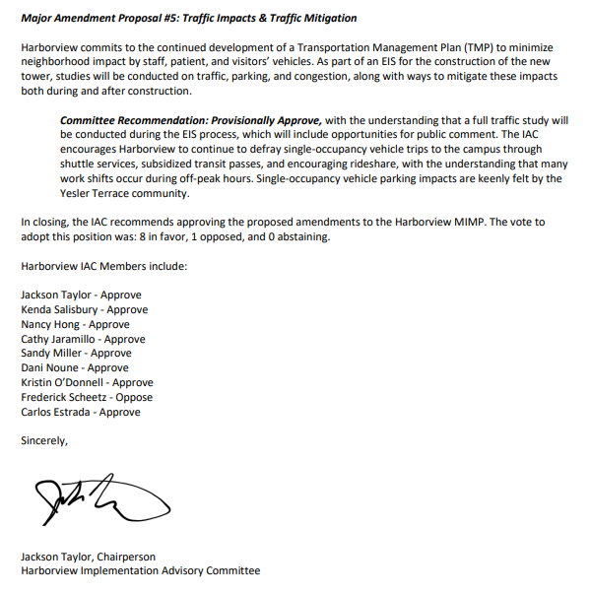

Appendix G – Advantages of Progressive Design-Build

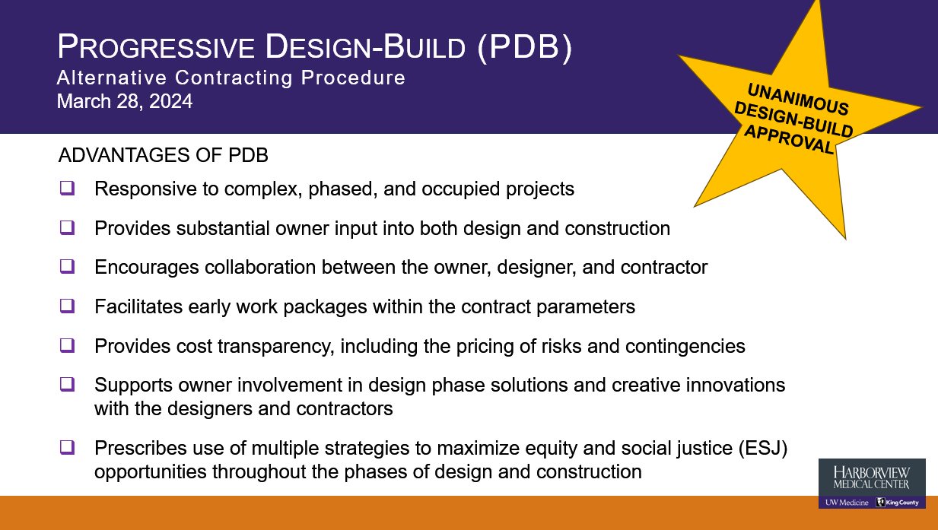

Appendix H – Ordinance 19790

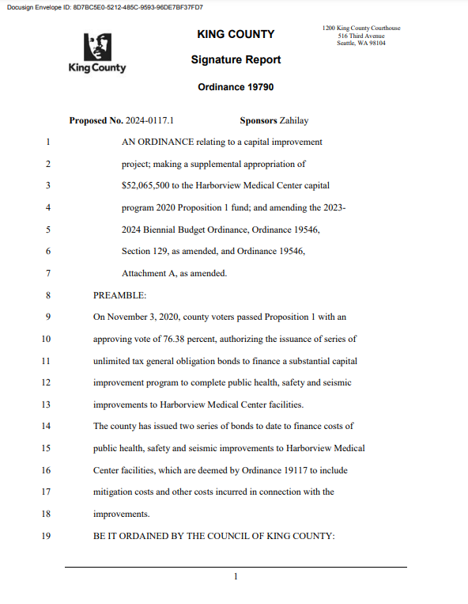
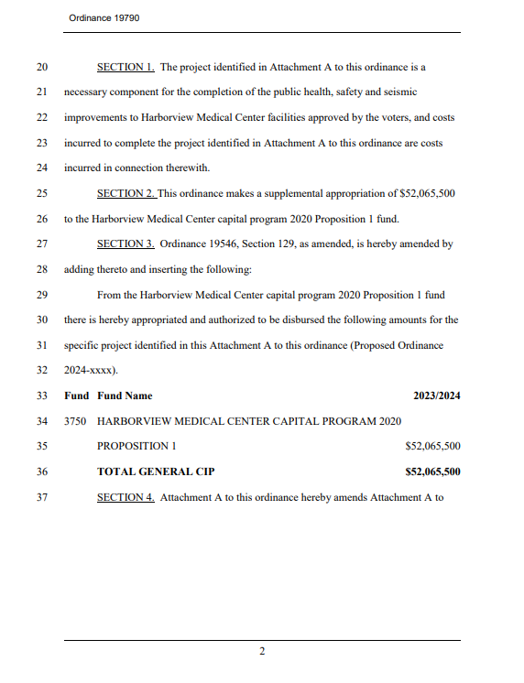

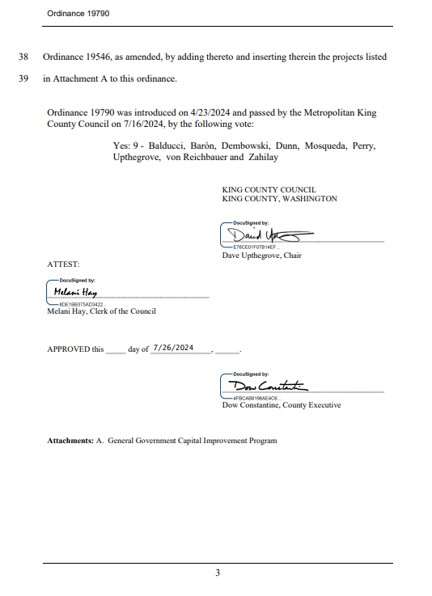

Appendix I – 9th and Alder Property Update

9th and Alder Property Update

Background
In August 2024, King County Facilities Management Division acquired a 1.6-acre land parcel immediately adjacent to the HMC campus at the corner of 9th Avenue and Alder Street in Seattle. The property provides King County and HMC an opportunity to expand the Harborview campus to meet the region’s growing demands for physical and behavioral health care. The property is also strategically located to provide needed construction staging and parking space to support the upcoming construction of a new medical tower under the Harborview Bond Program. The site is within the Yesler Terrace Master Planned Community, and the County’s planned use for the property is permitted under the land use code for this zone. In May 2024, the County was awarded a $5 million behavioral health grant from the Washington State Department of Commerce to begin project programming, siting, and pre-design work. The initial programming and pre-design work informed the project’s estimated cost. Further funding will be needed for full design and construction on the property.

Scope
Due to the estimated costs of a behavioral health facility, FMD started exploring alternative uses for the 9th and Alder property in the near term. HCID is continuing this work. The use of the 9th and Alder site for interim parking will help alleviate the anticipated parking shortage that will result from the construction of the new inpatient medical tower due to the demolition of View Park 1 garage. The long-term goal remains to build an innovative, accessible, and sustainable medical facility integrating behavioral health services with related primary care functions and providing space for further programming spaces to address the forecasted growth in hospital programs and services.

March 2026 Status Overview
- HCID continued negotiating the amendment about 9th and Alder with the design-builder. The 9th and Alder medical office building will include a parking structure.
Appendix J – Governor’s Executive Order (GEO) 21-02


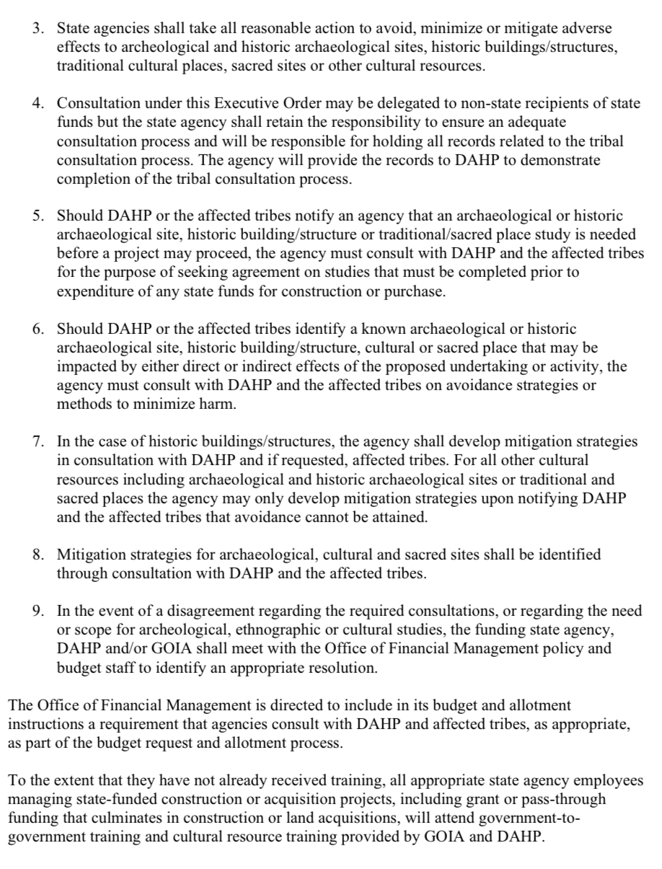

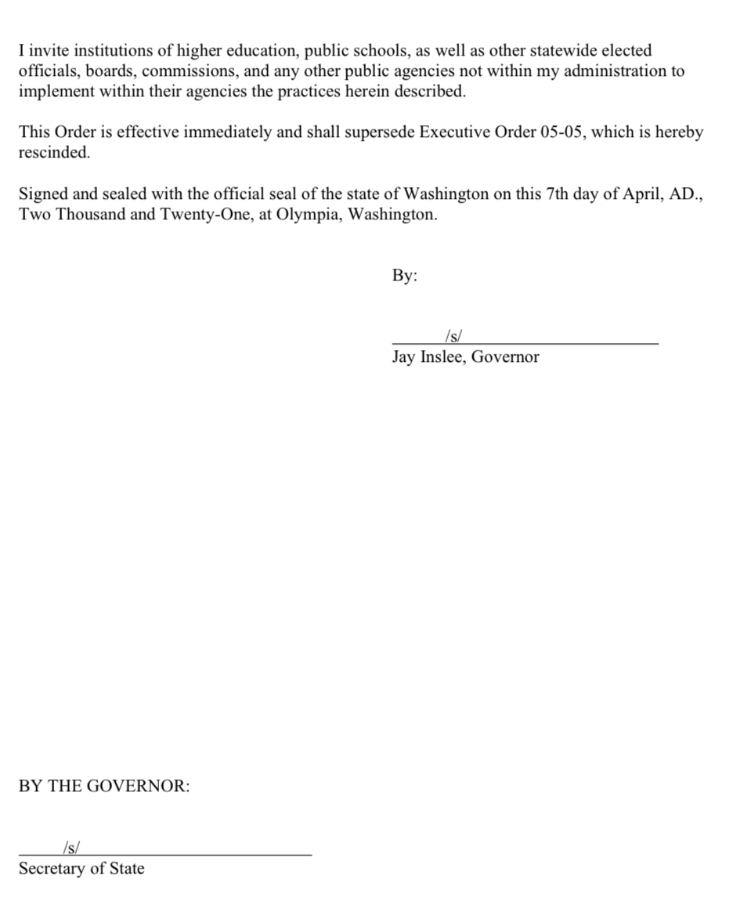

Appendix K – Ordinance 19861 (Abbreviated)
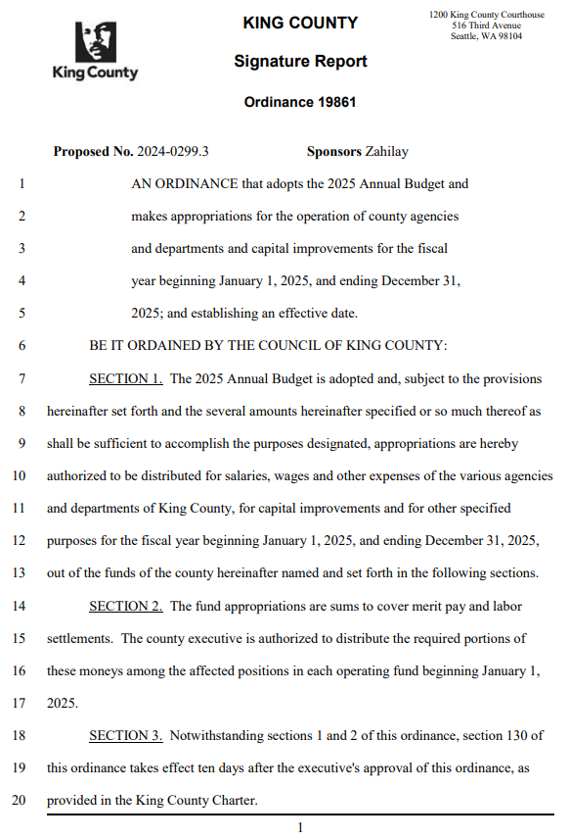
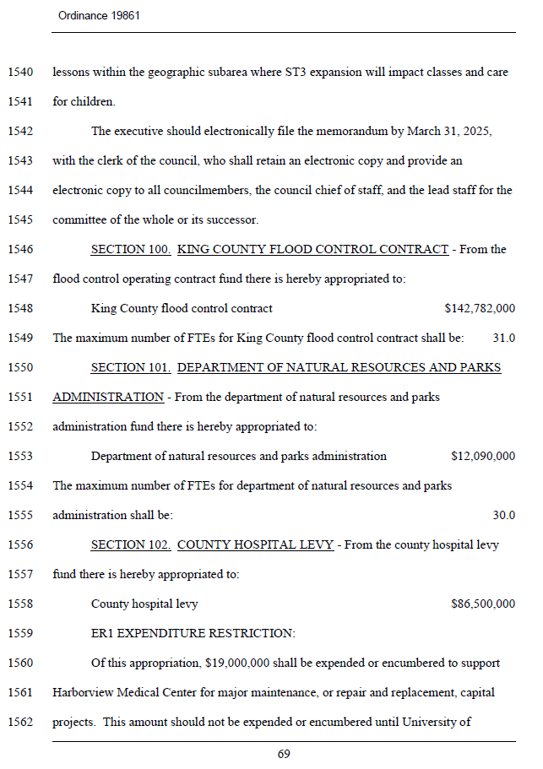
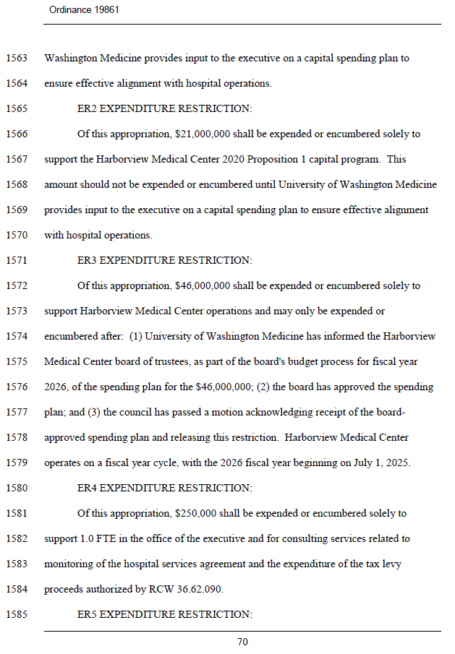
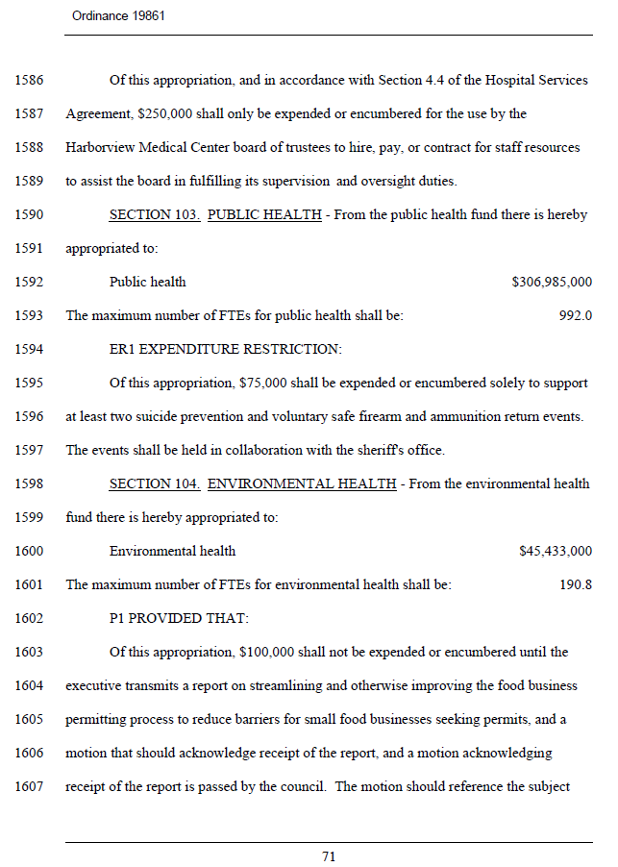
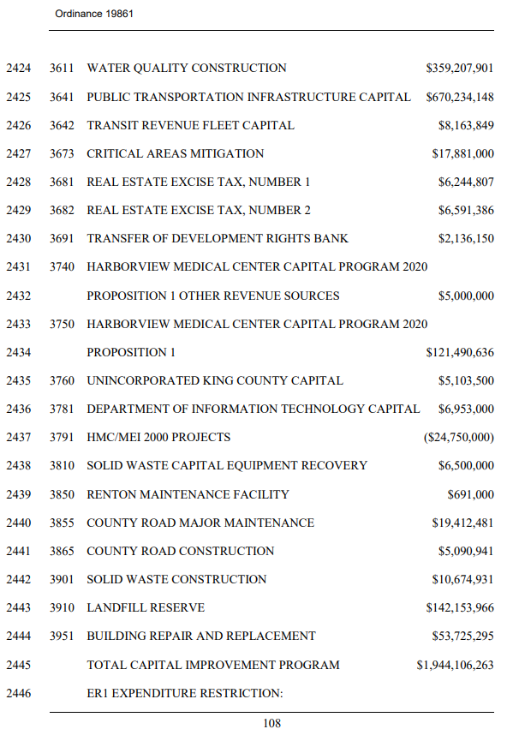

Appendix L – Ordinance 19841
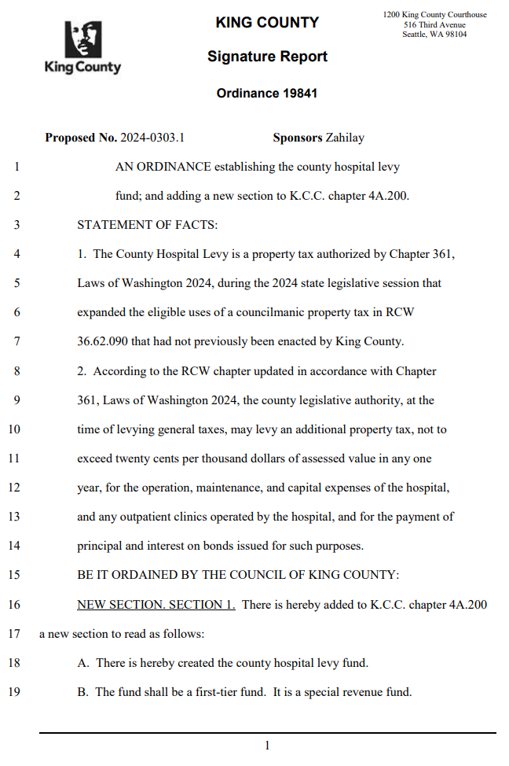
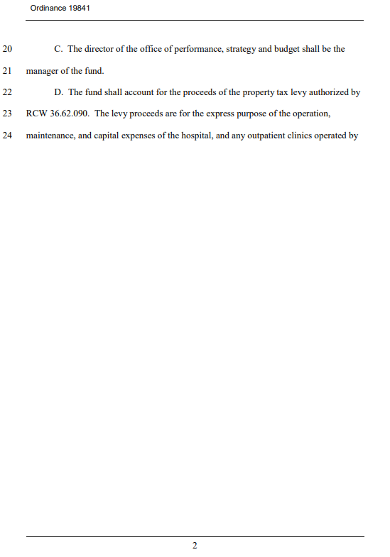
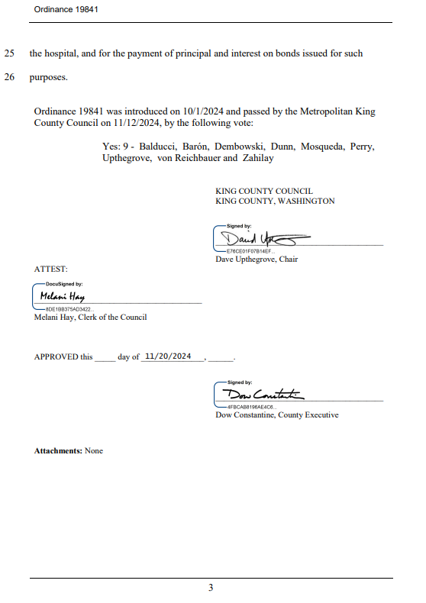

Appendix M – Senate Bill 5949 (2024) - Sec. 1030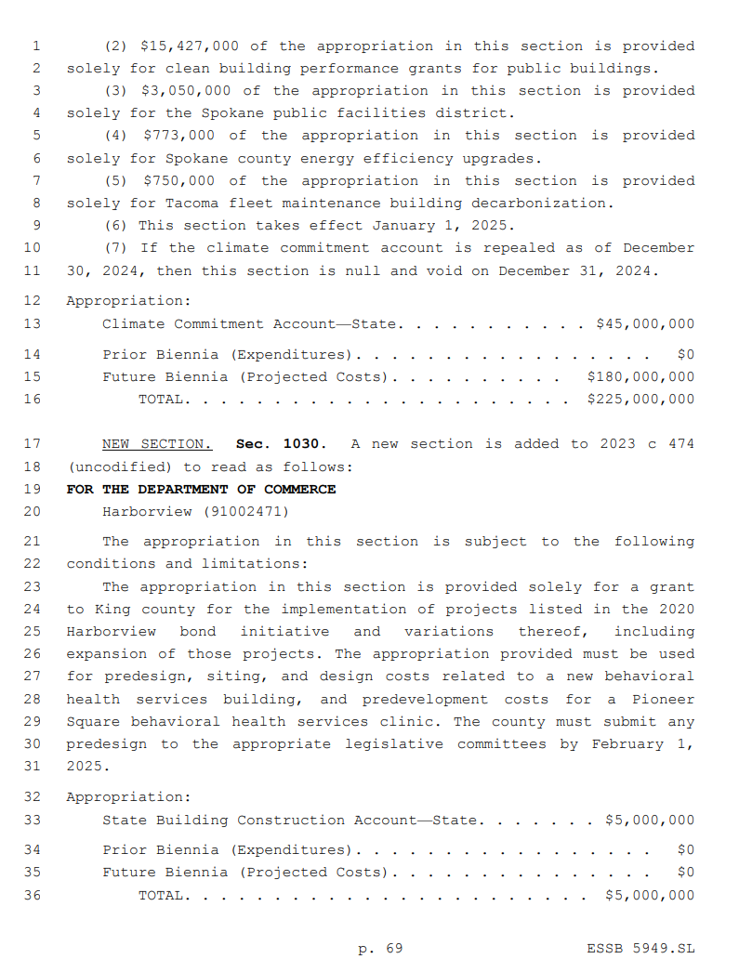

Appendix N – Motion 15183
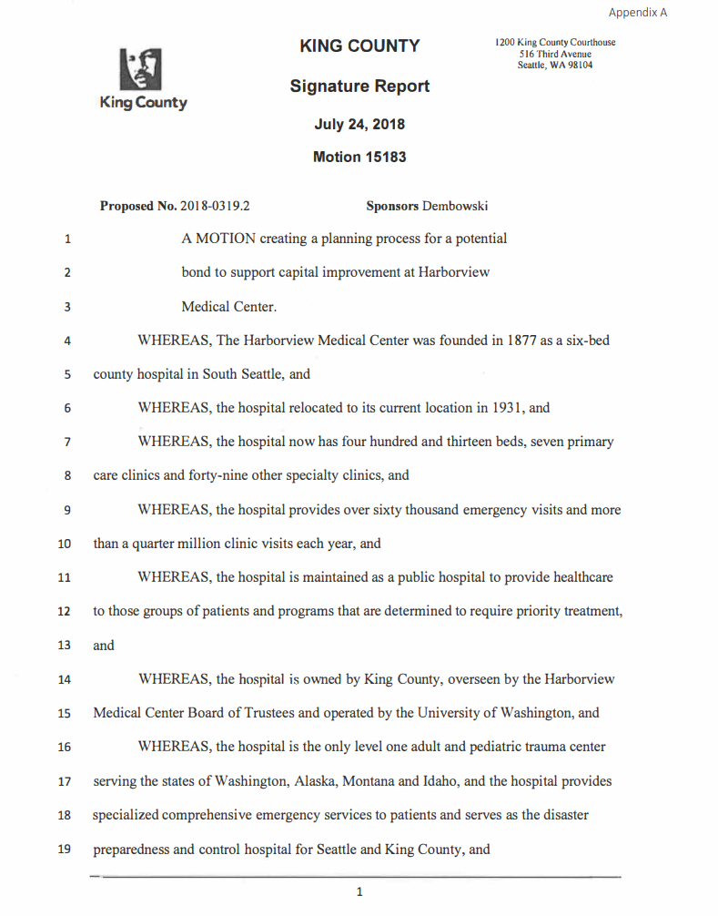
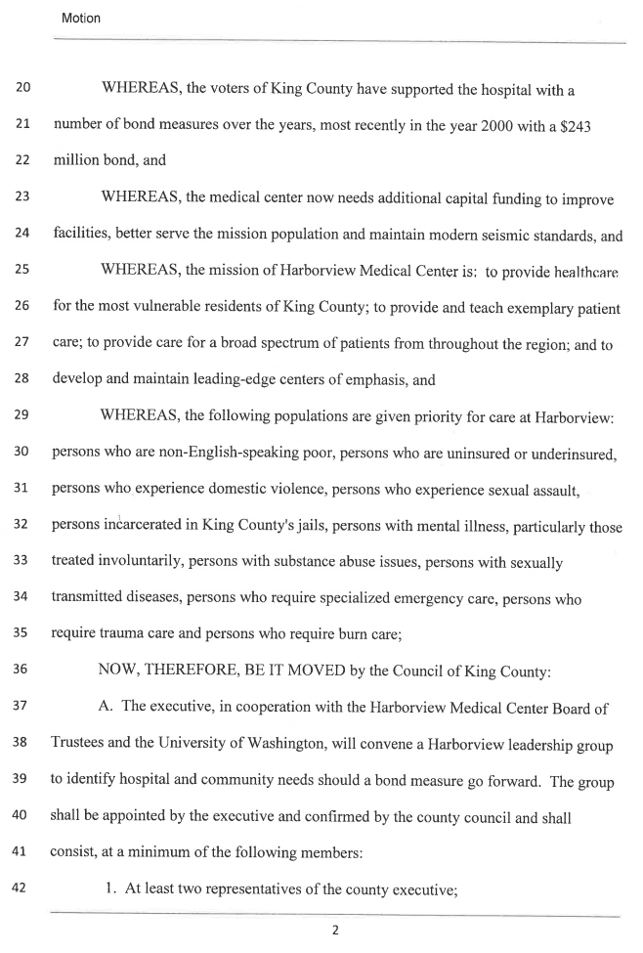
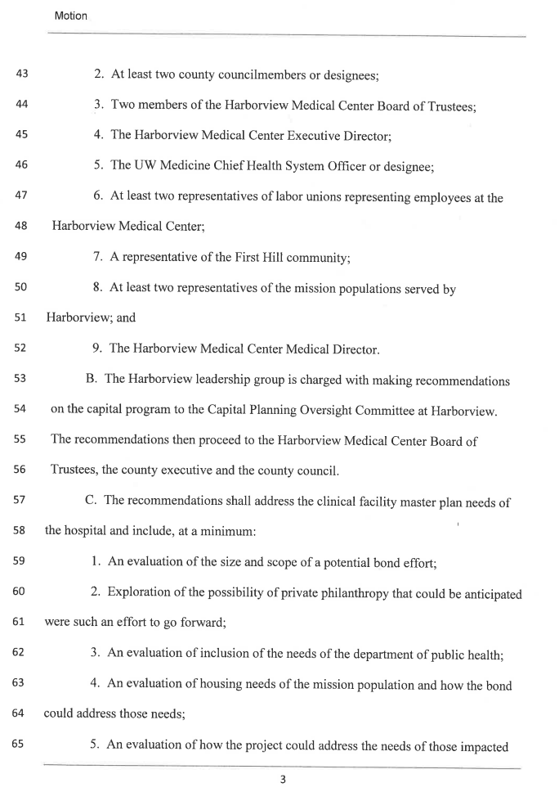
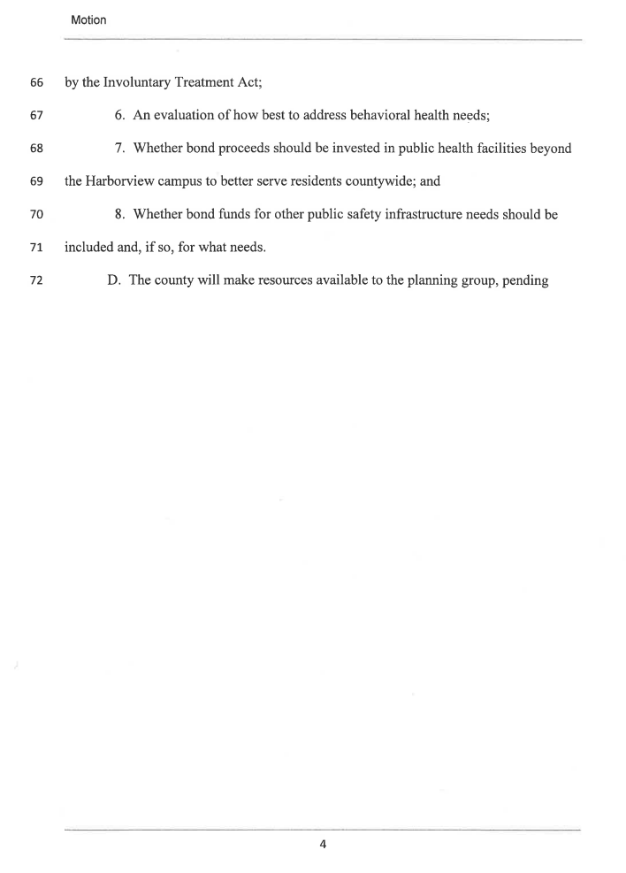
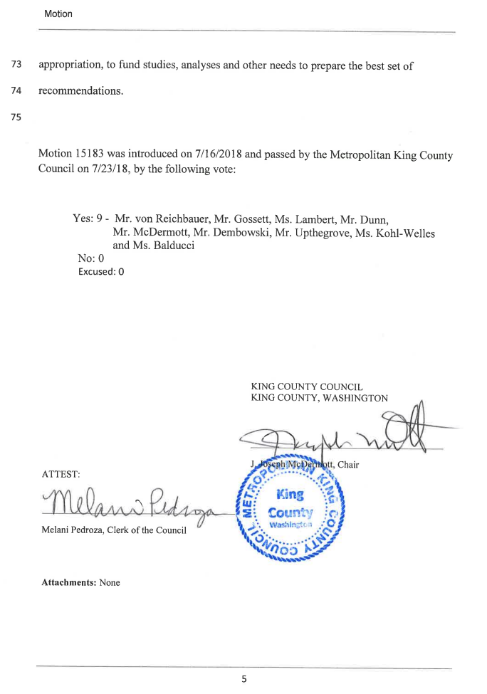

Appendix P – Ordinance 19117
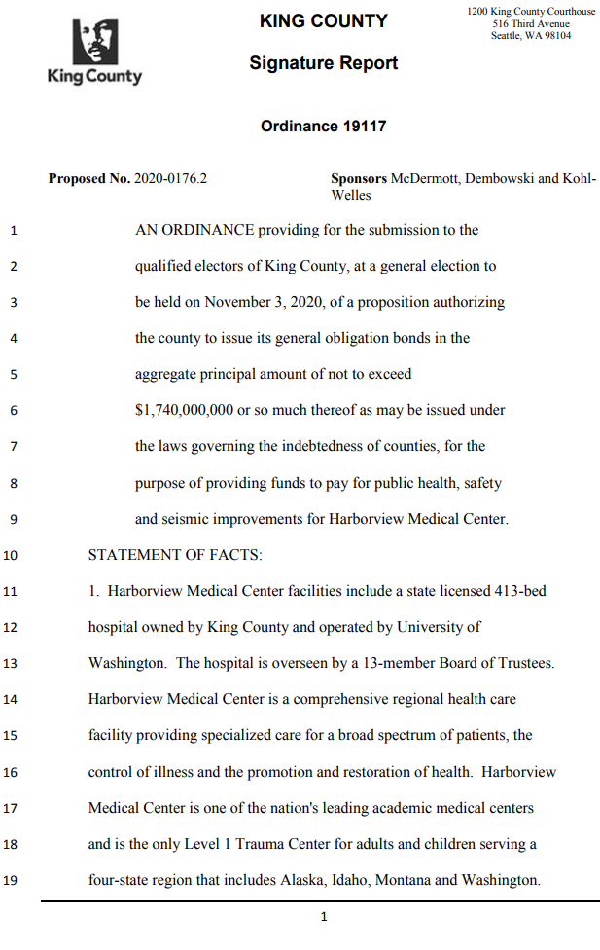
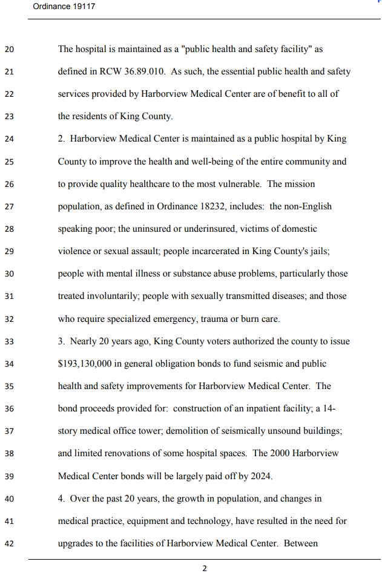
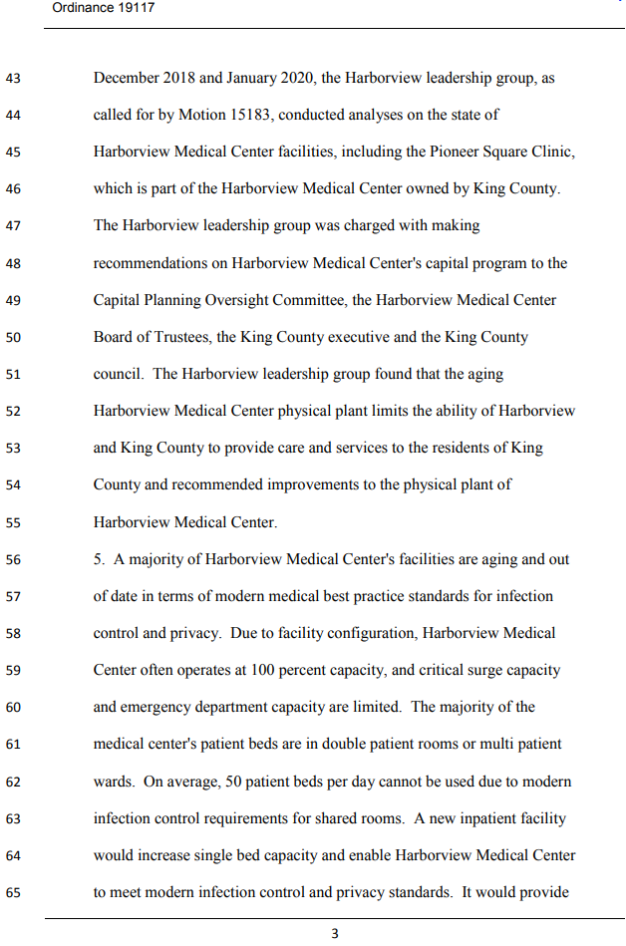
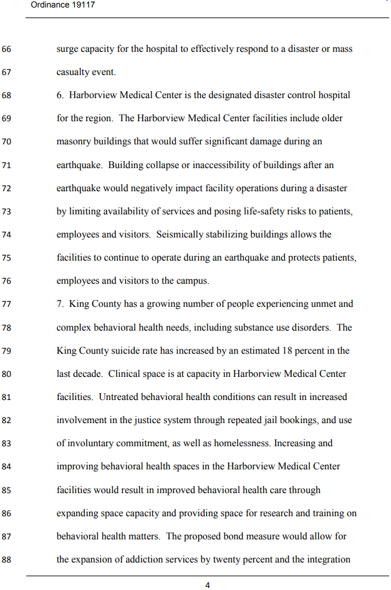
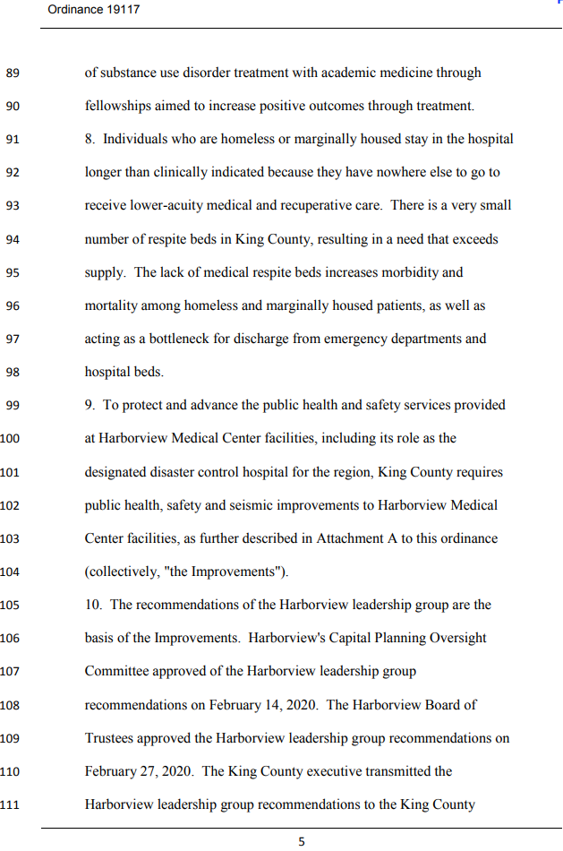
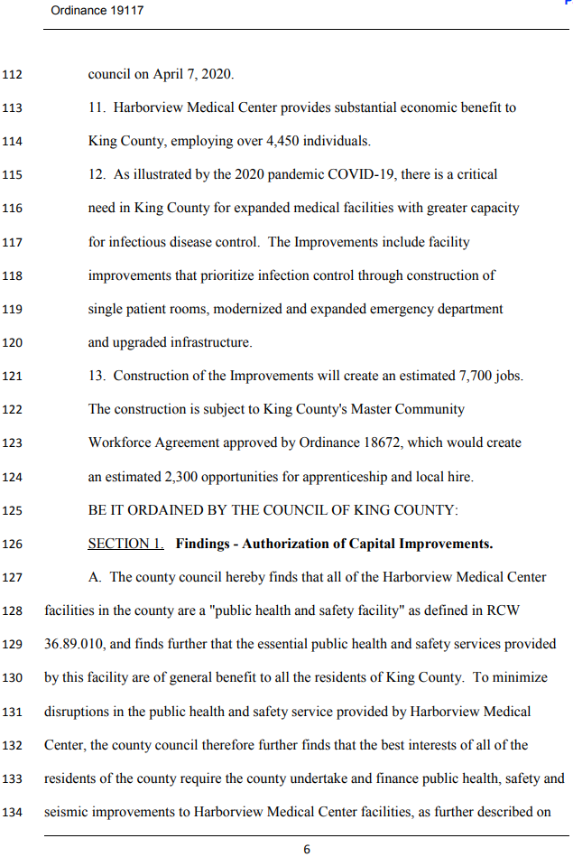
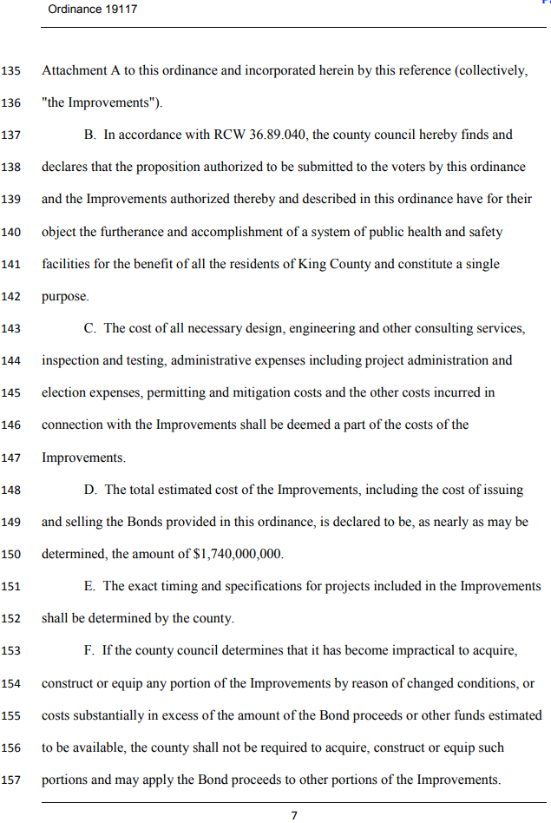
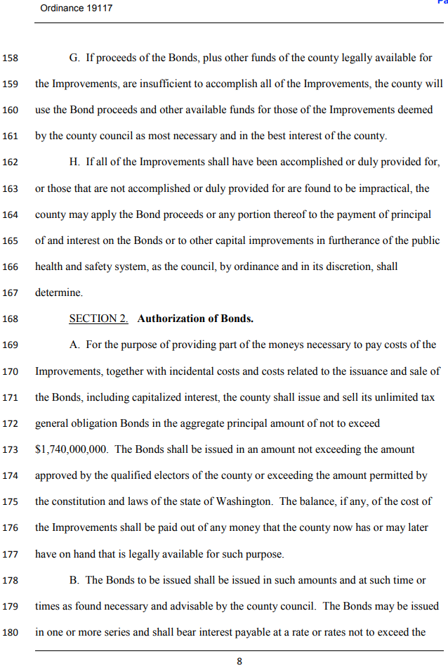
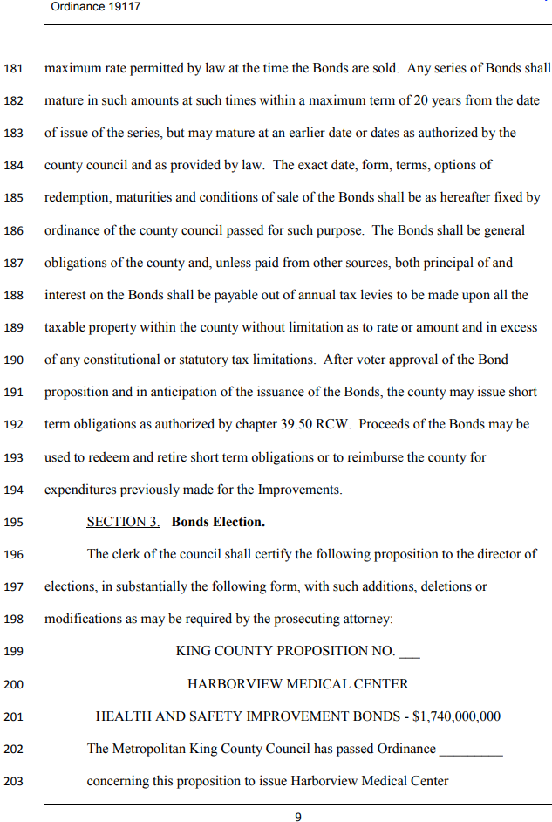
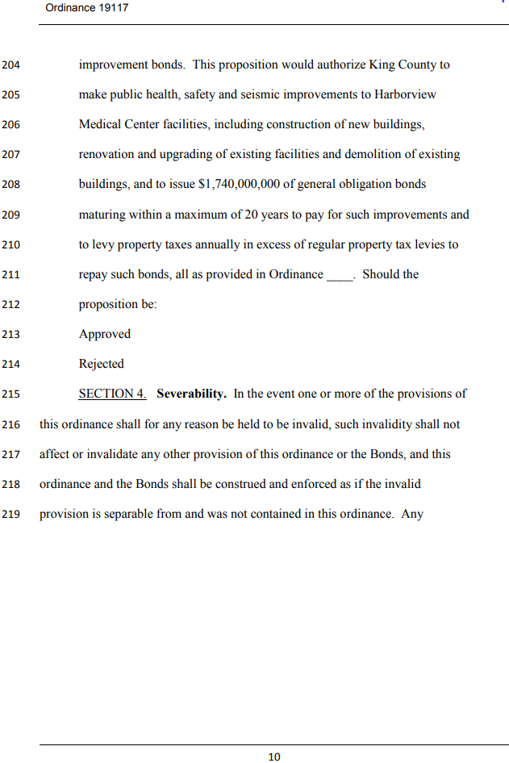

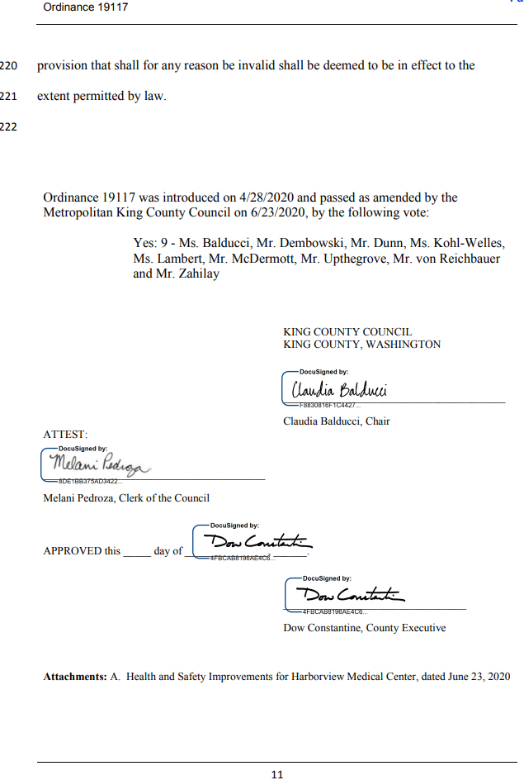

Appendix Q - Motion 16901
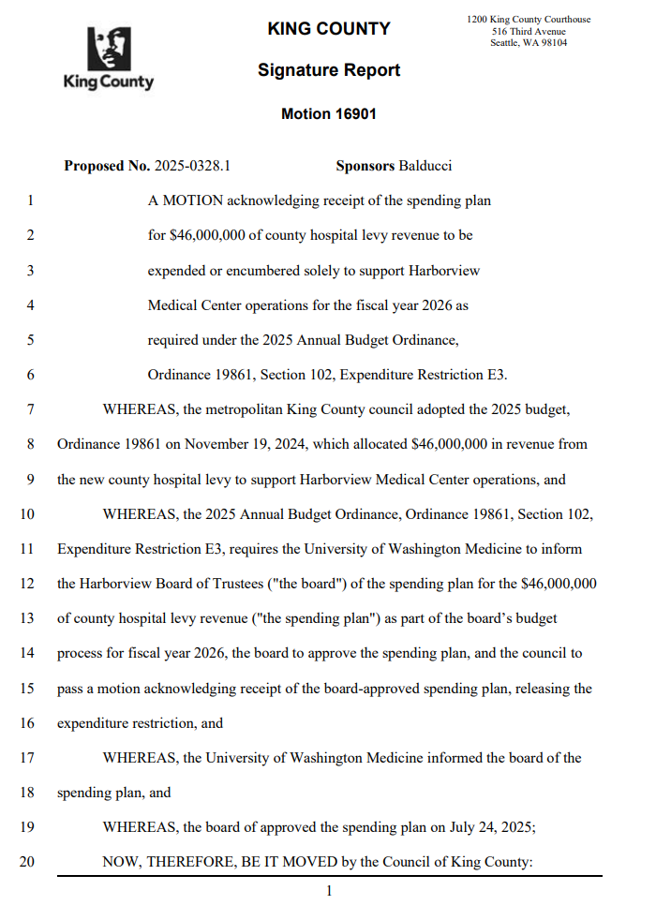
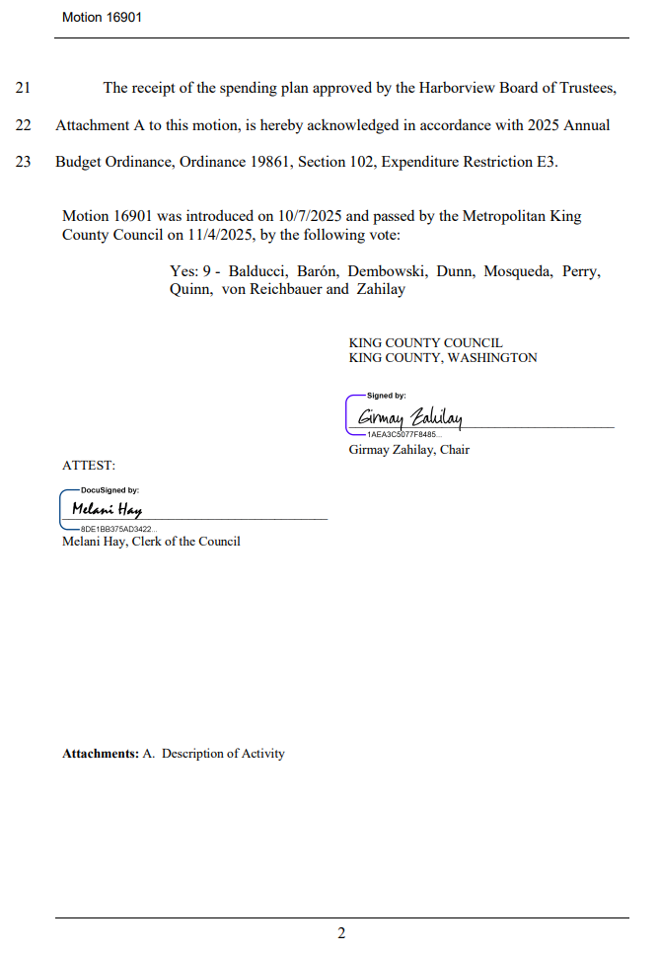
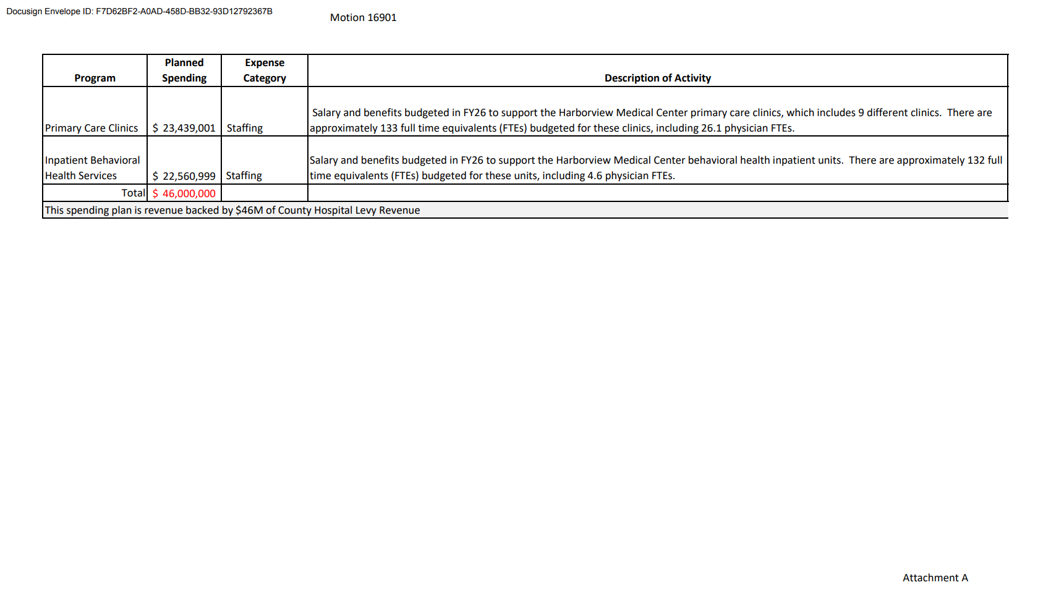

Appendix R – Ordinance 20020
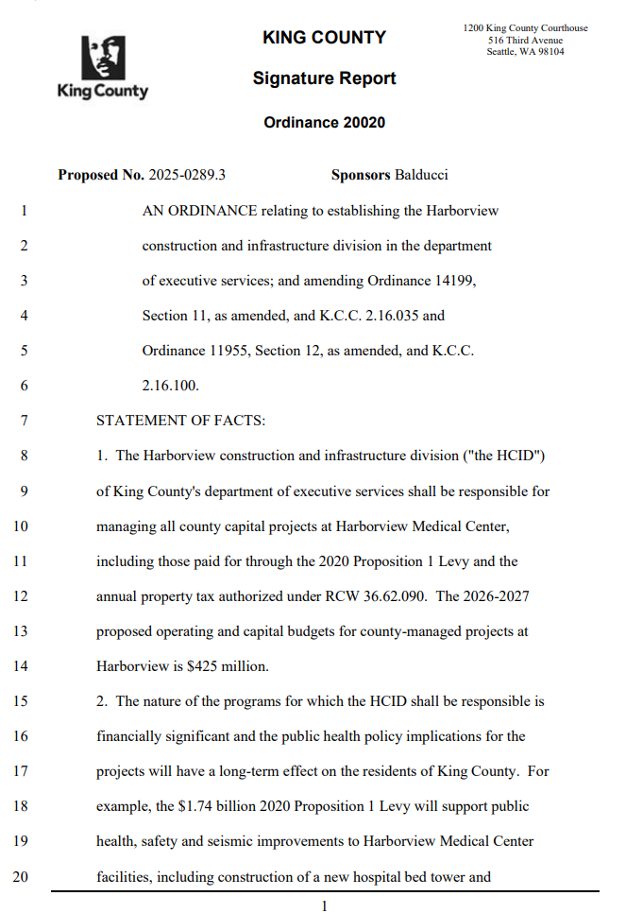
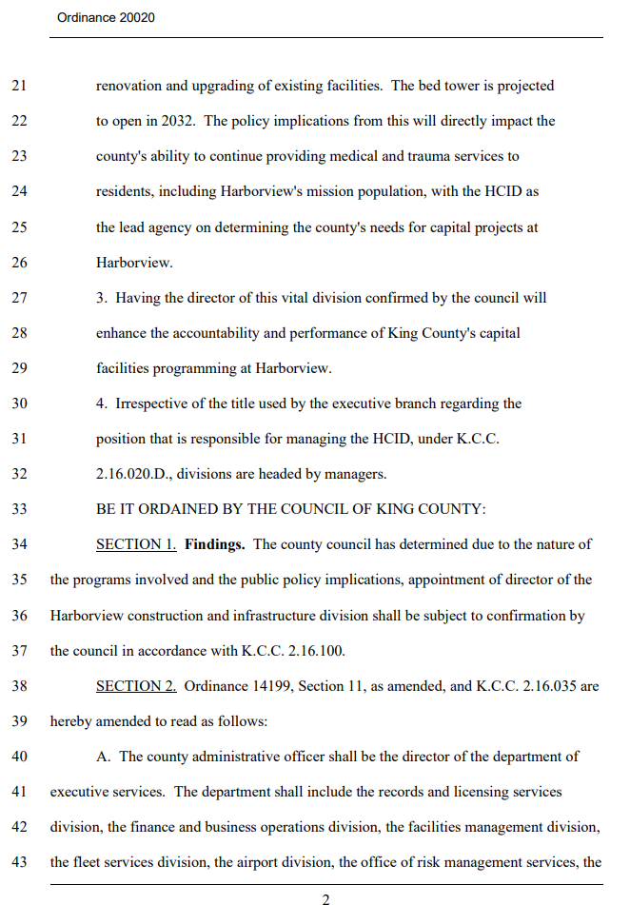
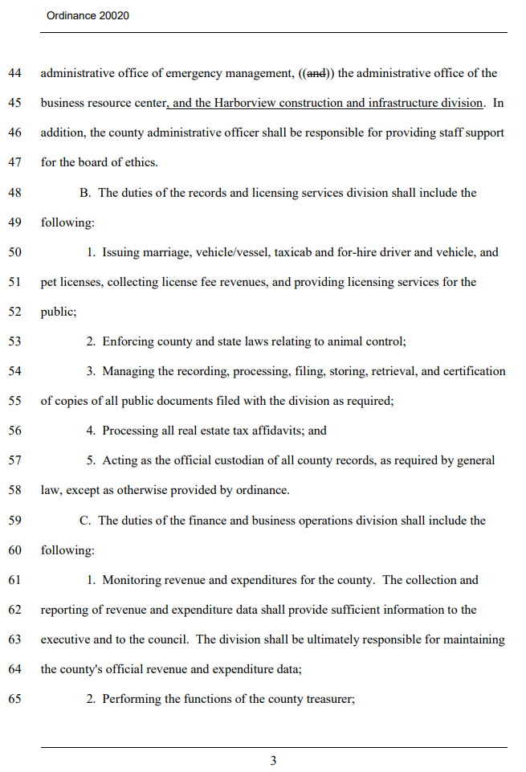
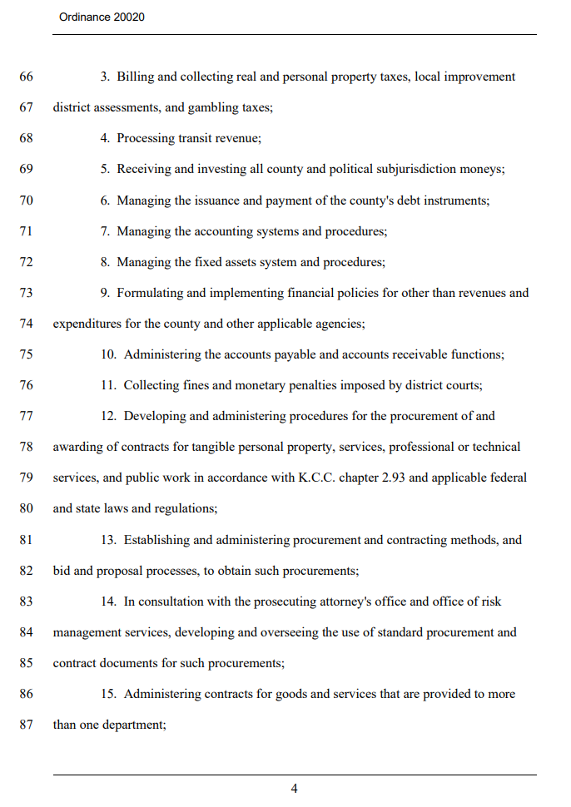
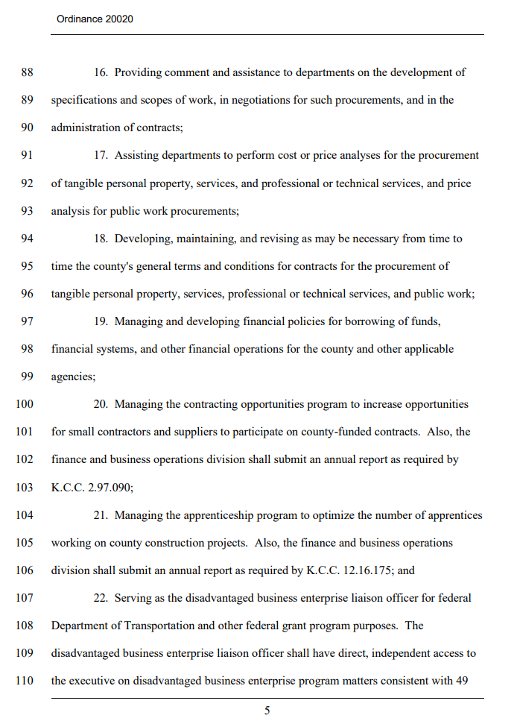
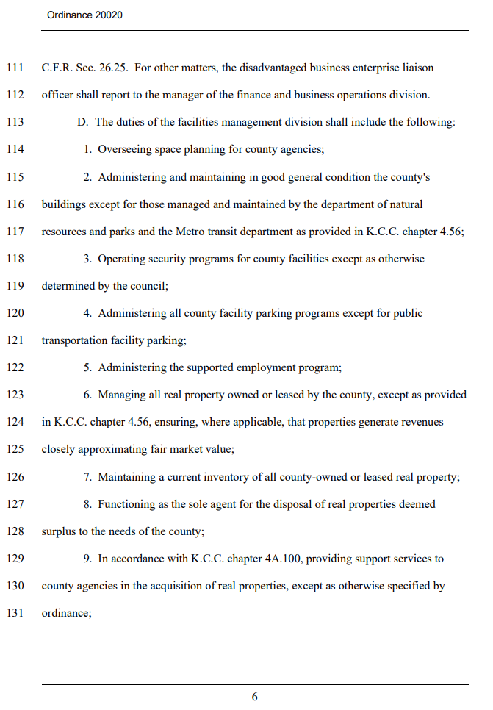
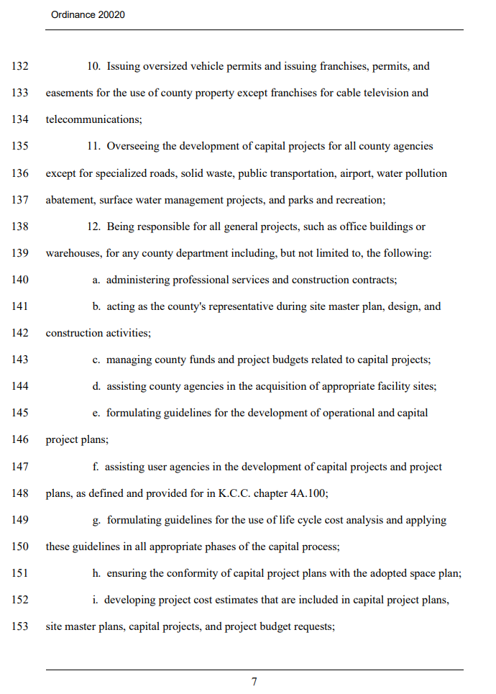
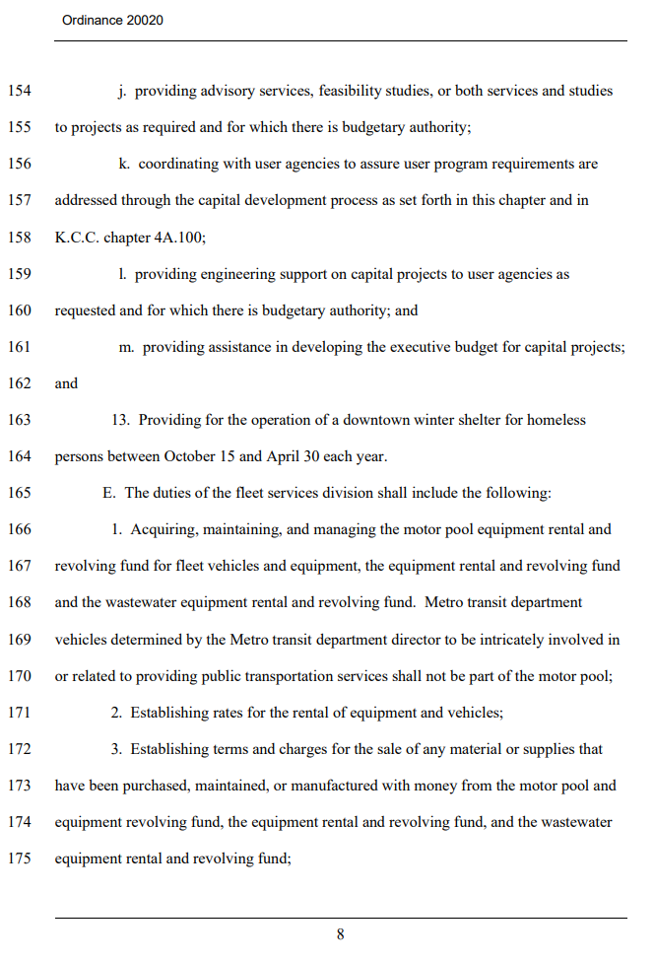
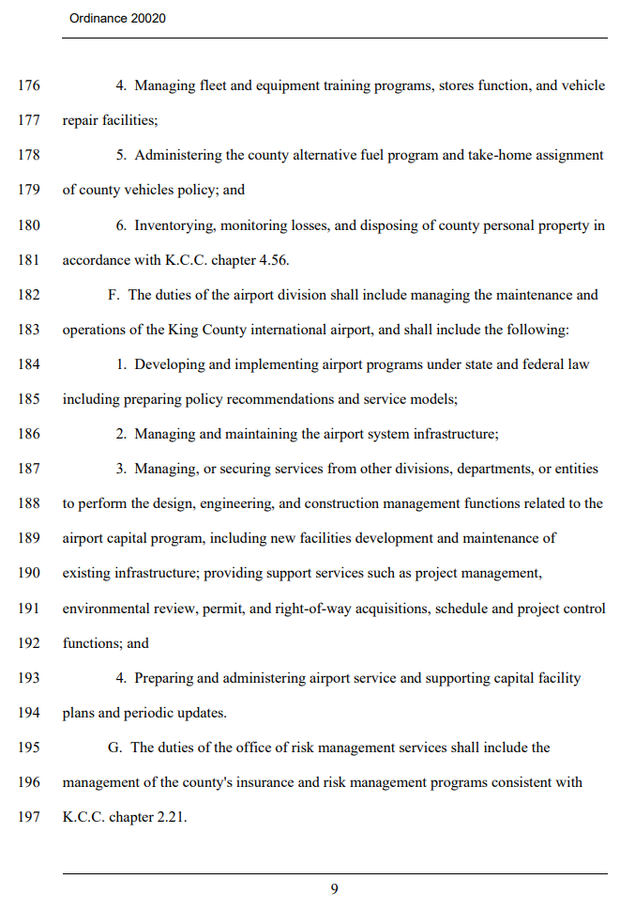
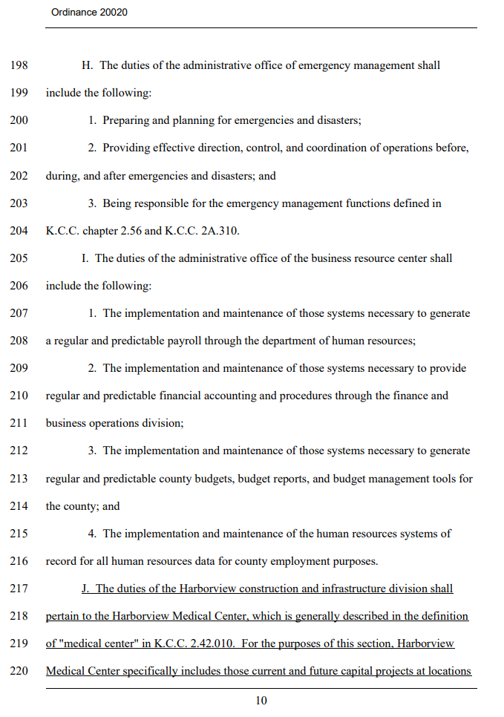
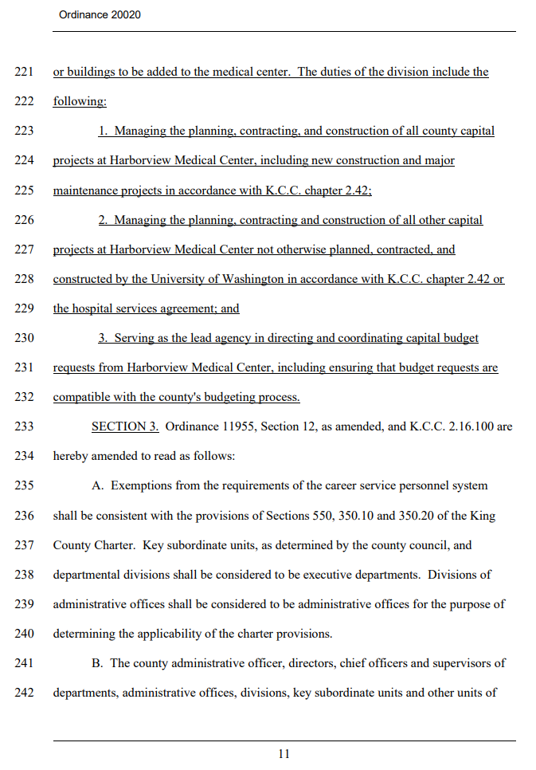
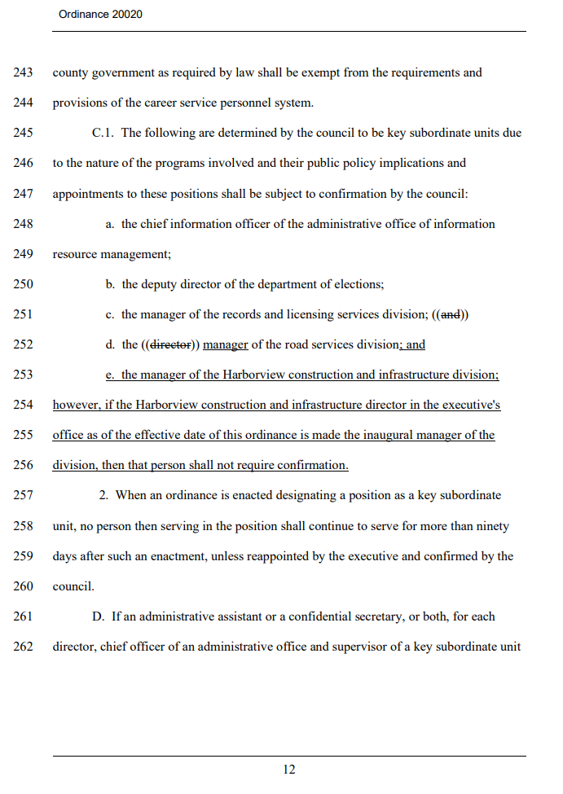
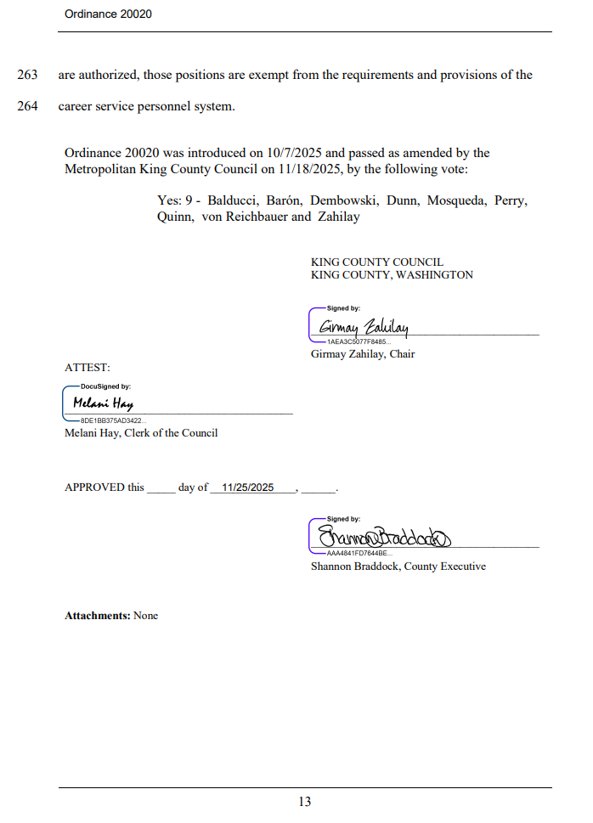
Appendix S – Ordinance 19991
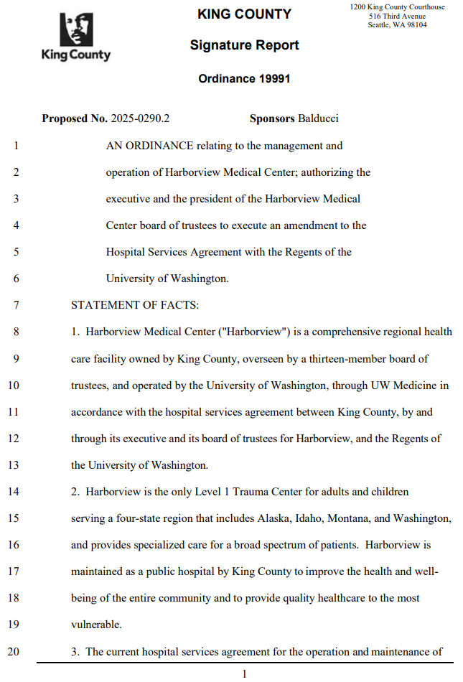
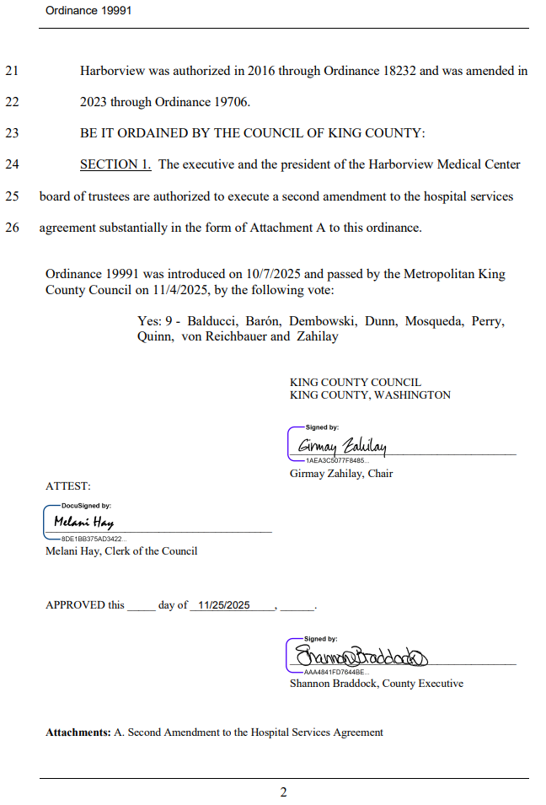

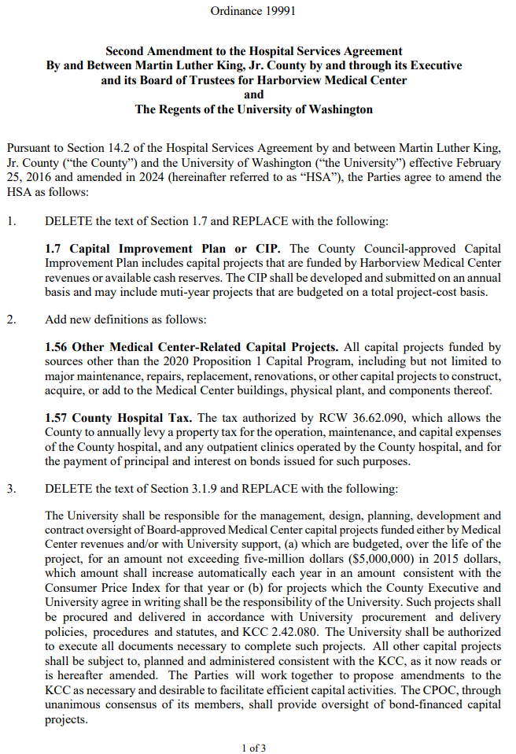
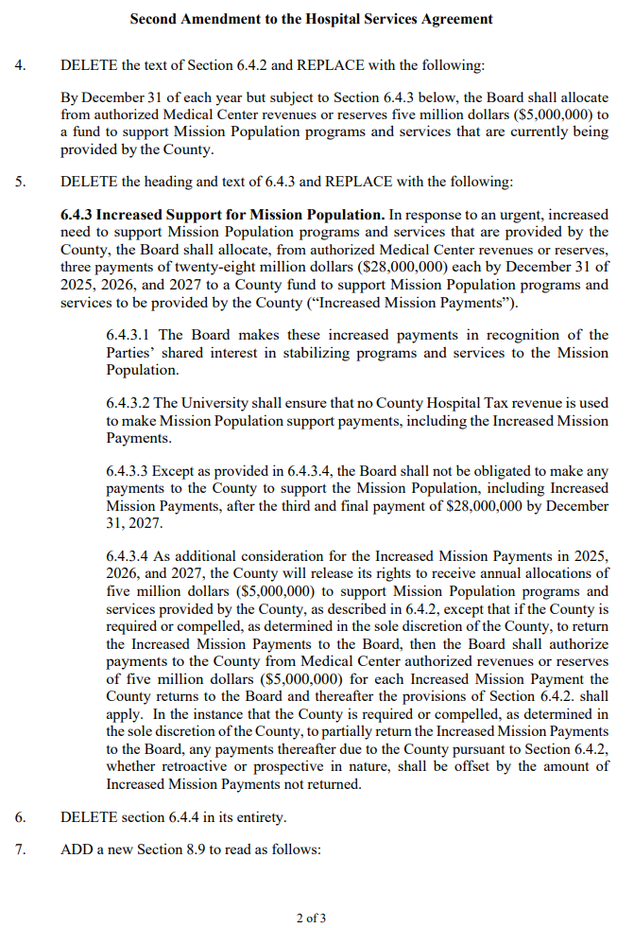
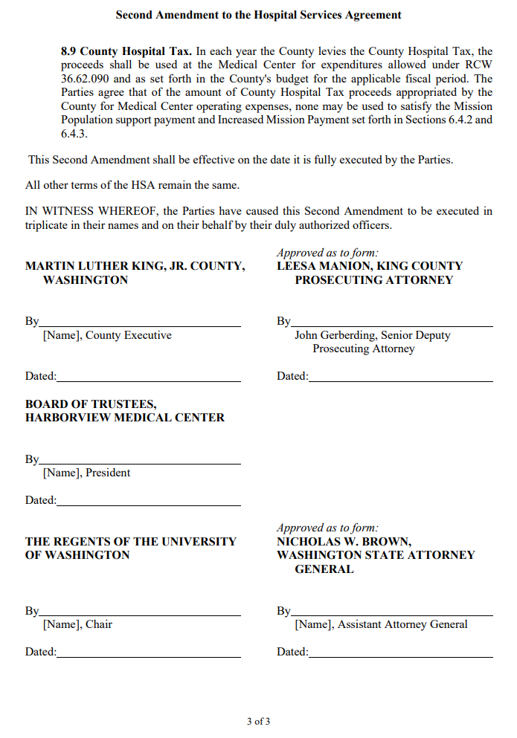

Appendix T – Ordinance 20023
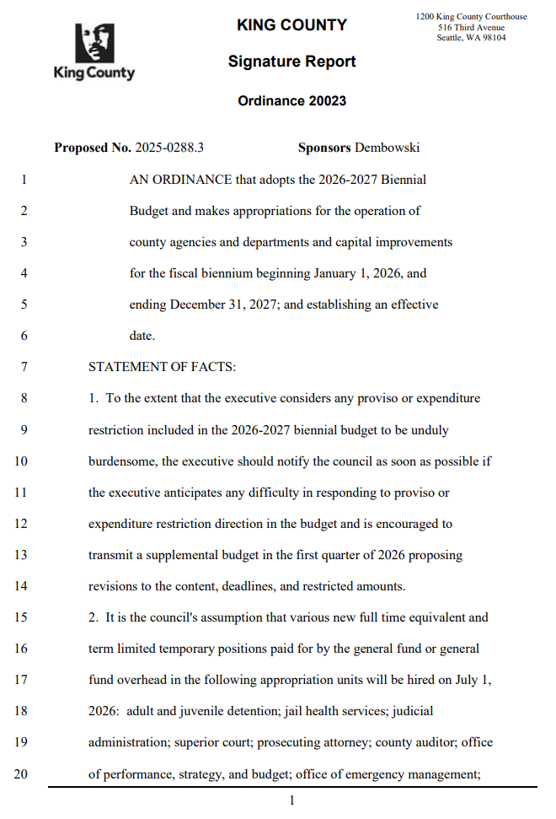
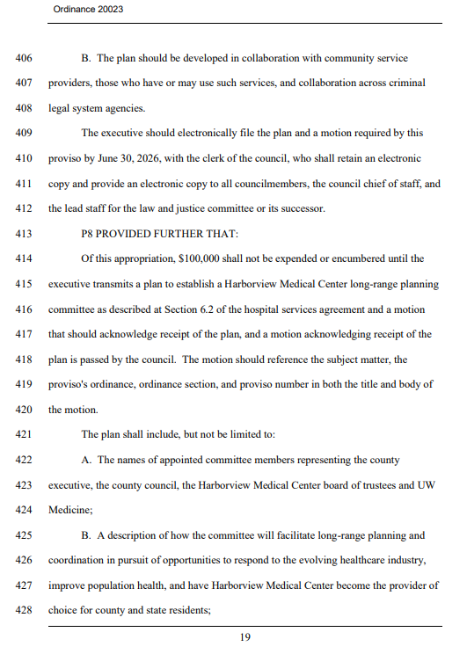
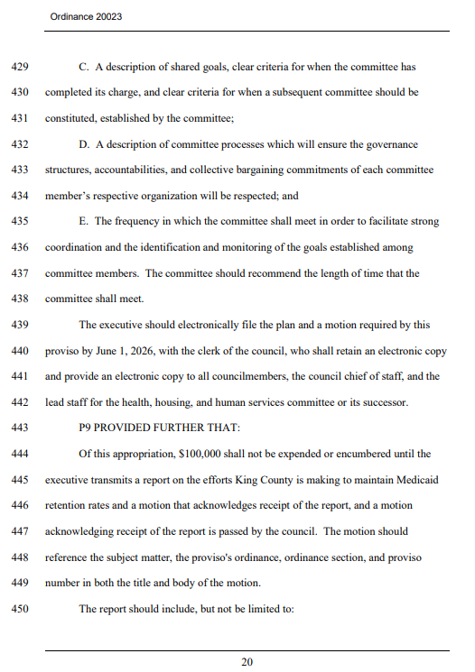
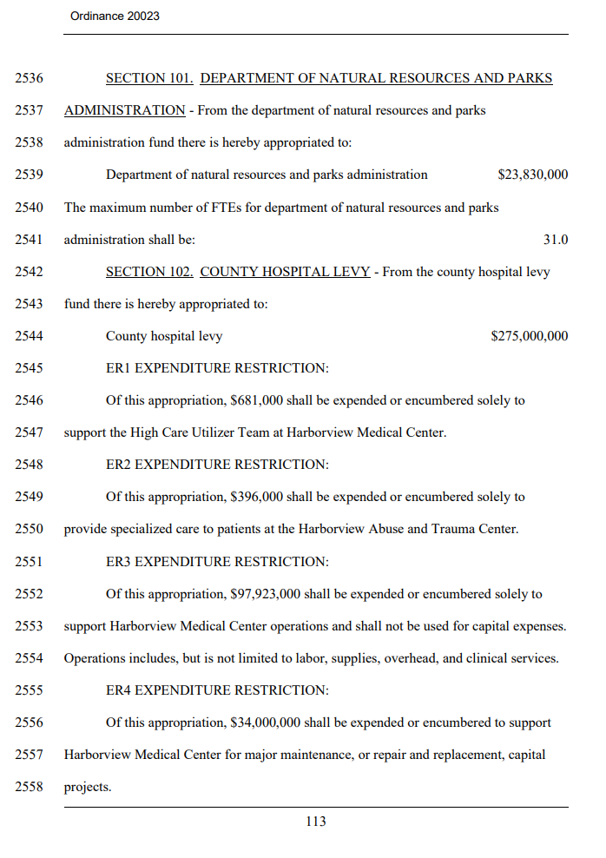
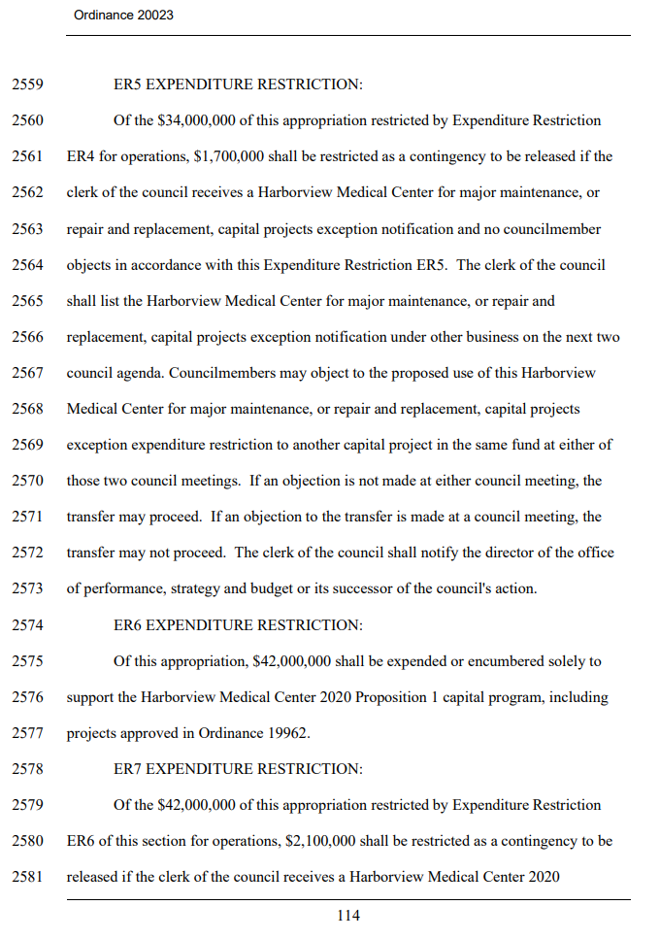
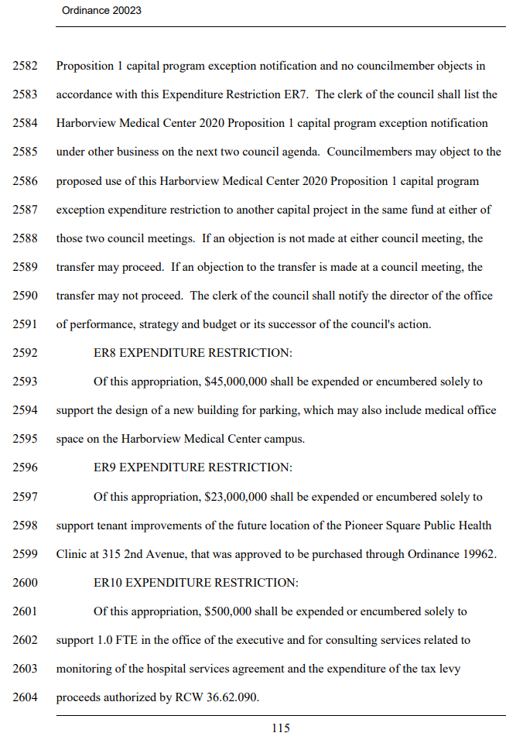
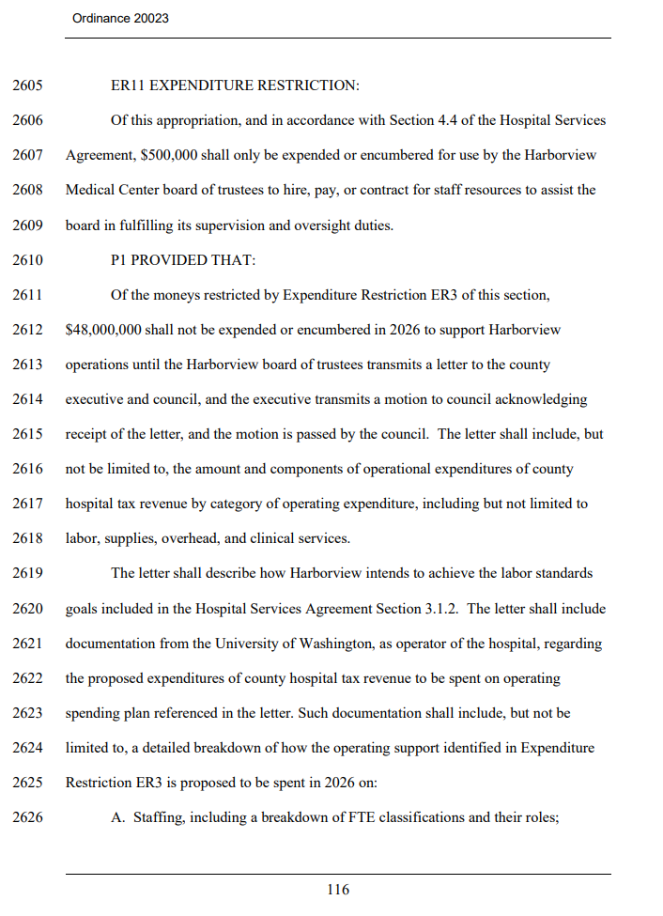
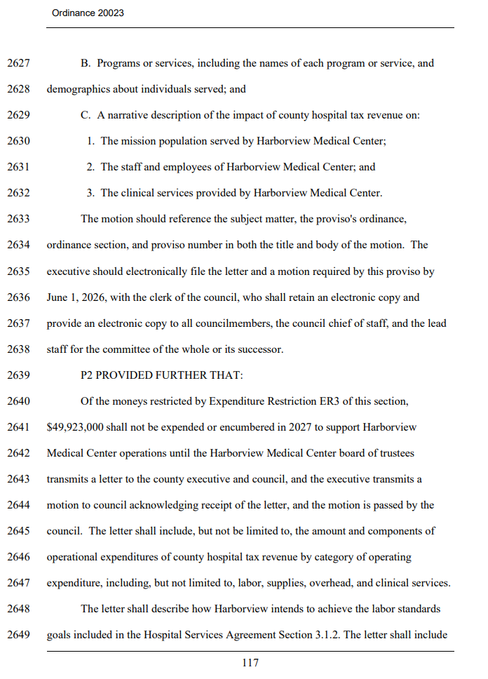
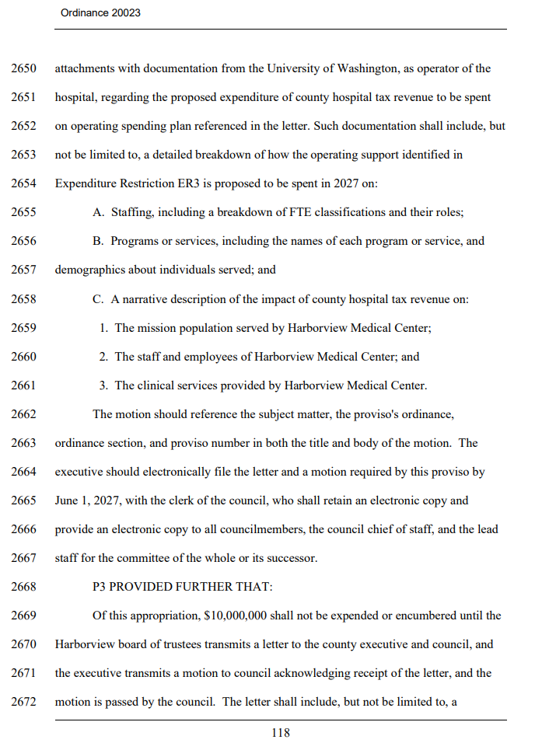
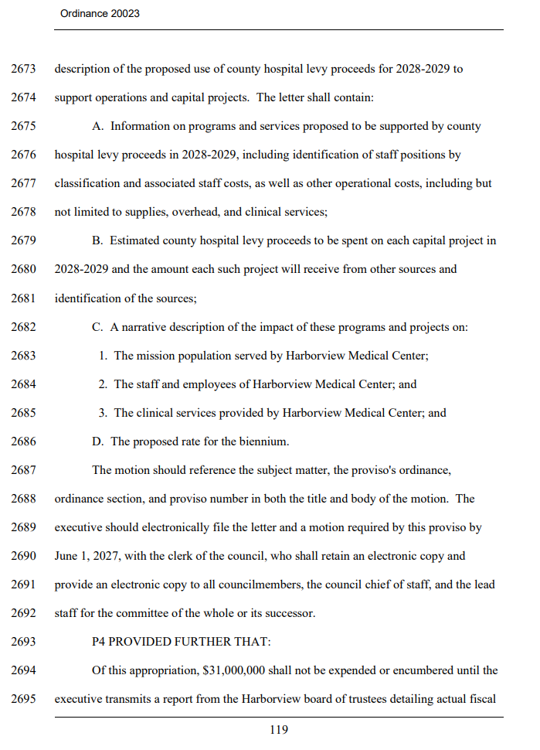
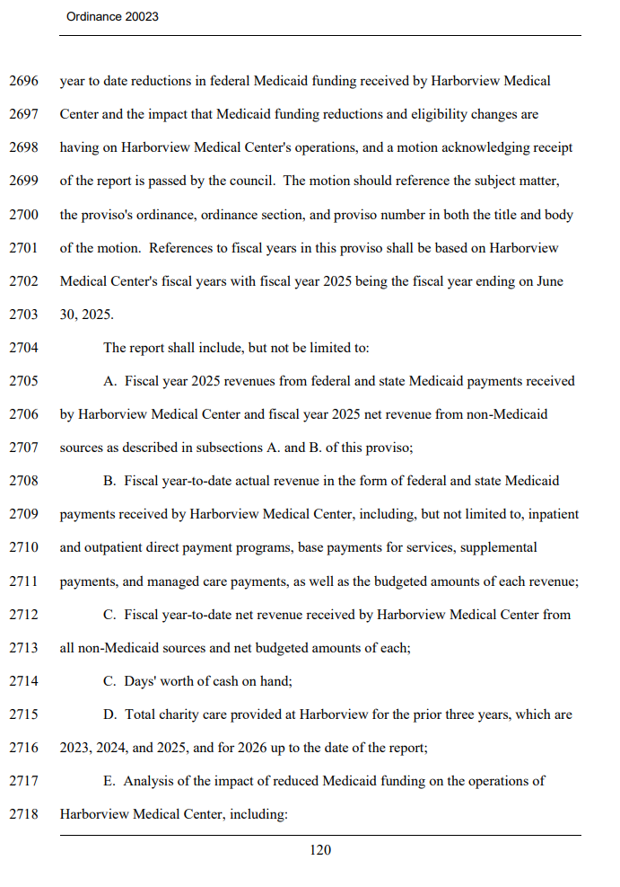
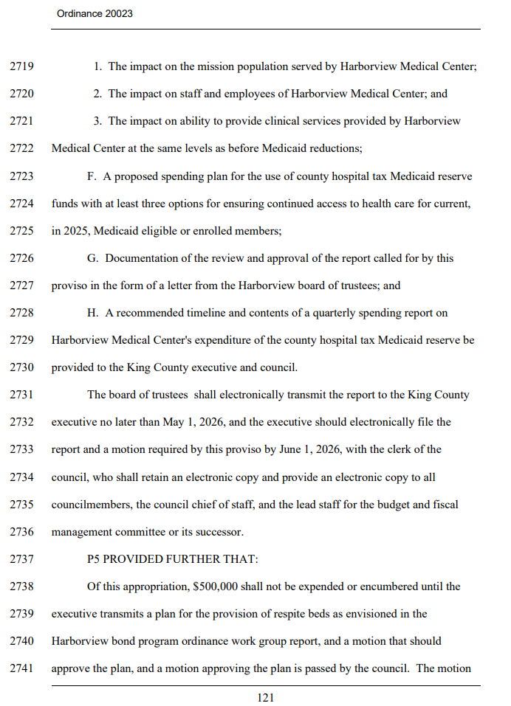
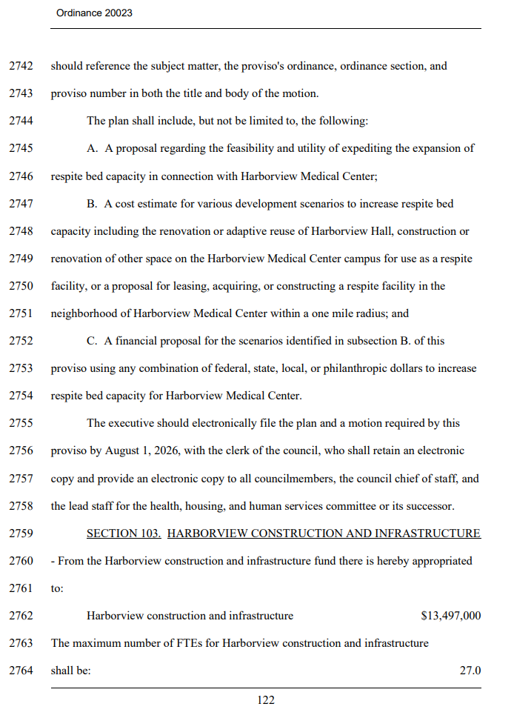
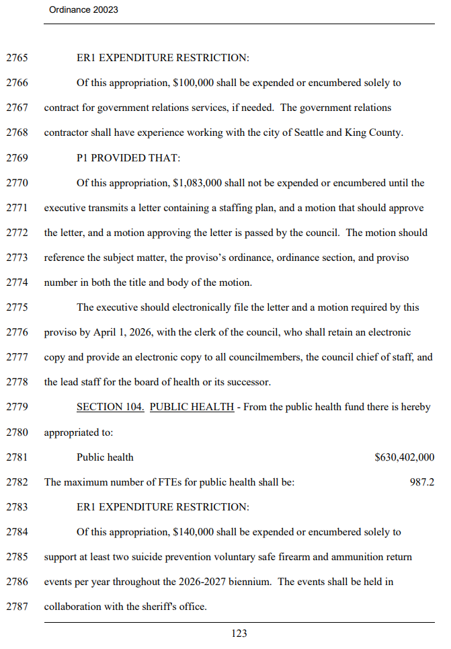
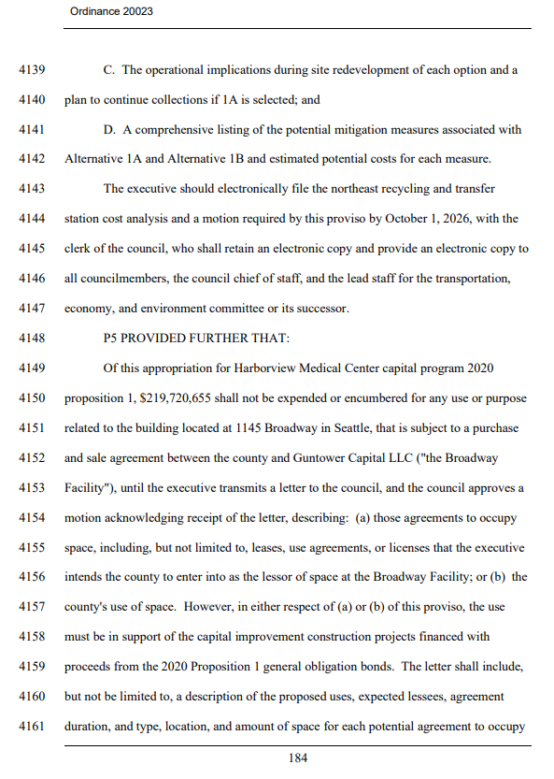
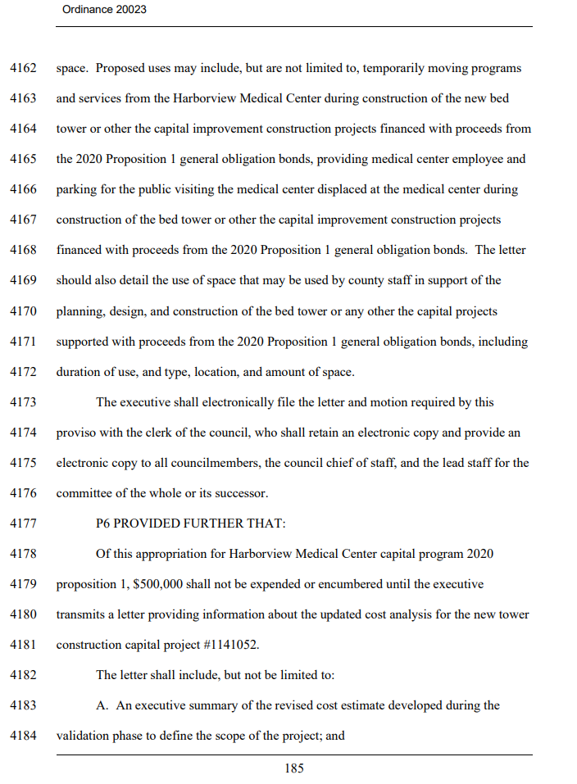
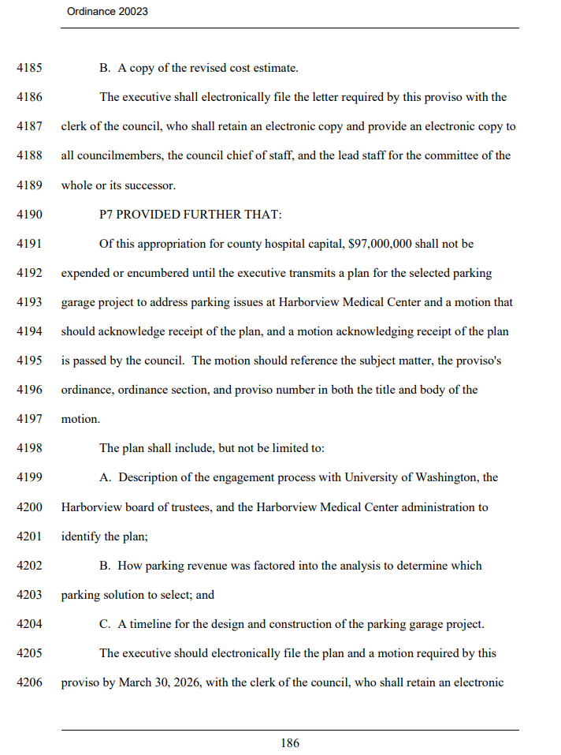
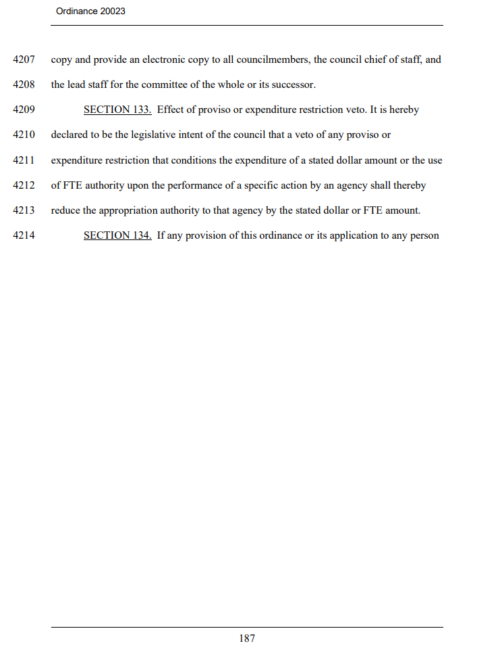
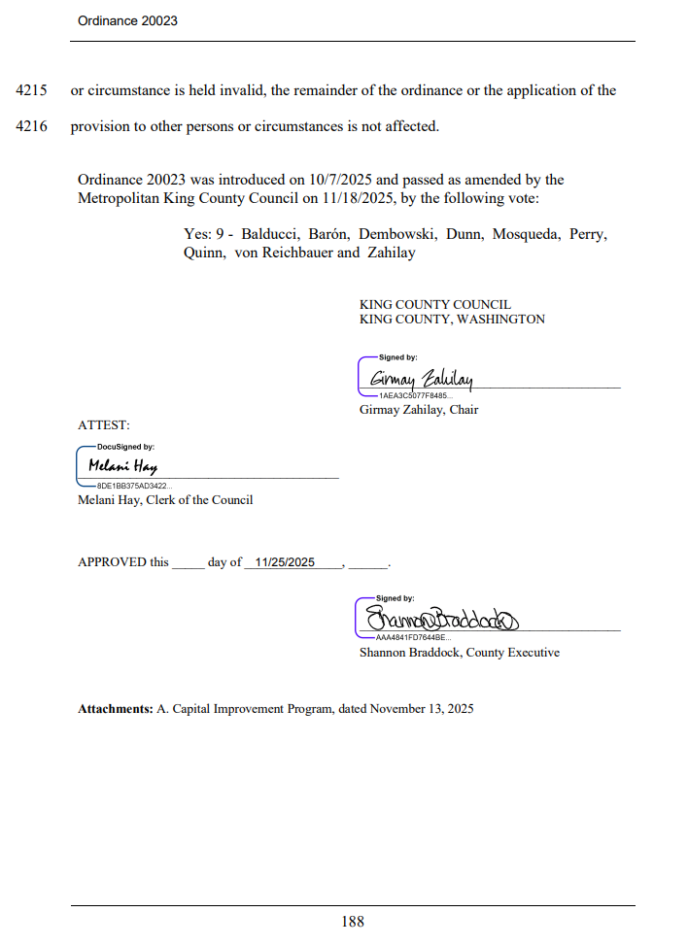

Appendix B – Harborview Medical Center Mission Statement
Appendix N – King County Motion 15183
This report does not use the term “recommended” to describe the Program Plan, as the Council approved the Workgroup’s recommended Program Plan via Motion 16435 in October 2023.
Appendix E Motion 16435
Appendix R – Ordinance 20020
Harborview’s licensed number will increase to 540 when the Maleng Single Patient Bed Project is completed. The project will deliver up to 40 new single patient rooms by converting two floors in the Maleng Building into inpatient units. Bond funds are not used for the Maleng Project.
The County-approved mission statement is incorporated into the Hospital Services Agreement via Ordinance 18232.
The ITA Court at HMC handles petitions for court-ordered mental health treatment which is not part of a criminal case.
Appendix P – Ordinance 19117
For further information, please see the biannual Harborview Bond Program reports transmitted to the King County Council for June 2021, December 2021, June 2022, and December 2022. Please note that these reports are replaced by this monthly report.
Shelled Floor: An unfinished/non-occupiable floor with basic flooring, windows, and walls. It may also have some basic HVAC, plumbing, and electrical.
Appendix L – Ordinance 19841
Appendix T – Ordinance 20023
Outside of describing the recommendation and approval process for the OWG recommendations, this report does not use the term “recommended” to describe the Program Plan, as the Council approved the Workgroup’s recommended Program Plan via Motion 16435.
Infrastructure analysis started in August 2023, and a plan developed in 2024.
These estimates are based on the data currently available. More detailed space needs calculations and analysis will be developed as part of the Bond program phasing and sequencing, and these numbers may change. Changes will be communicated in this report along with other established meetings and formats, such as the Capital Projects Oversight Committee (CPOC).
This work is in progress, with the City DON Implementation Advisory Committee meeting since February 2023. Staff work has been ongoing.
Harborview Medical Center Parking Alternatives Analysis – Ordinance 19956, Section 65, Proviso 2 [LINK]
As noted in the report transmitted to the Council on August 1, 2023, this schedule is predicated on working with the City of Seattle to expedite its MIMP and permitting processes, particularly items denoted with * in Table 4.
NOI follows the IAC recommendations submitted in September (3Q) resulting in the plan for a 4Q NOI submittal to the City of Seattle
Appendix A - Ordinance 19583 lines 142-143
The $63 million includes the $21 million from Ordinance 19861, and the $42 million from Ordinance 20023.
Budget Adopted Ordinance: - Ordinance No. 19293=$22,539,969_6/17/2021 - Ordinance No. 19546=$44,800,000_11/29/2022 - Ordinance No. 19790=$52,065,500_7/26/2024 (9th and Alder property acquisition merged under New Tower) - Ordinance No. 19861=$121,490,636_12/2/2024 - Ordinance No. 20023=$219,720,655_11/25/2025
The April 2026 report projected $4,152,099 in expenditures for the March 2026 reporting period. The actual expenditures in March 2026 are $2,884,706. The variance in projected actual expenditures is due to contract/vendor estimate, actual payment amount difference, and date of submission.
Appendix H – Ordinance 19790

