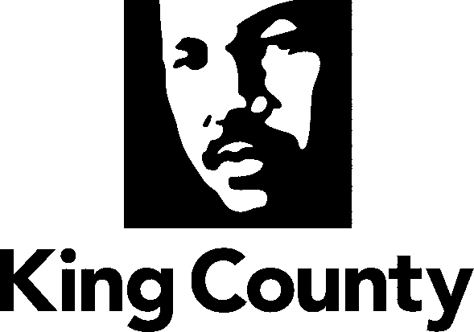

Metropolitan King County Council
Committee of the Whole

STAFF REPORT
AGENDA ITEM: DATE: November 10, 2008
PROPOSED ORDINANCE: 2008-0605 PREPARED BY: Clifton Curry
SUBJECT: AN ORDINANCE relating to no shooting areas; and amending Ordinance 1454, Sections 1 through 3, and K.C.C. 12.68.010.

SUMMARY: This ordinance clarifies the intent of the council that law enforcement and others using the King County Code Sections detailing no shooting zones should rely on the geographic descriptions of the areas not the name of a voter precinct associated with the area.

Background. In the unincorporated areas of King County that are not designated by ordinance as "no shooting areas," residents may discharge firearms on their own property or with the permission of the owner of the property—with certain restrictions related to the potential for harm from the discharge of weapons. Currently, there are 89 separate locations within the county have been established as no shooting areas. As established in 1972, the King County Code delineates the process for establishing a no shooting area. However, the county has recognized no shooting areas since 1944.

The code contains three steps. First, the residents seeking to establish a no shooting area must develop a petition, map, and legal definition of the area to that would be defined as the no shooting area. The residents then must seek at least ten si on the petition from "elector-residents" in the area. When the petitioners have sufficient signatures, they are required to submit the petition to the clerk of the King County council. The second step requires the certification of the petition and the elector-resident signatures from the King County elections division. Finally, the county is required to advertise the ordinance for the potential establishment of the no shooting area for at least ten days prior to the hearing of the ordinance. The council may then establish the no shooting area by ordinance.

The King County Code has traditionally identified each no shooting area using several methods. In the 1940s and 1950s, the areas were defined by nearby landmarks, such as lakes or hills. Later, the code described the no shooting areas by name of the locale. Since the implementation of the 1972 no shooting area process, the areas were identified by precinct name.

Use of the voter precinct names for no shooting zones has led to some confusion. State statute requires that the county regularly review voter precinct boundaries and redistrict areas when necessary. As result, many voter precincts boundaries have changed and no longer conform to the legal descriptions identified as no shooting areas. In some instances, the precinct names have also changed, creating confusion for some law enforcement staff and citizens.

While the King County Council uses the voter precinct as the means for the petition process to establish a no shooting area, it requires that the petitioners designate the area using maps and legal descriptions other than voting precincts. Therefore, the no shooting area is based on the geographic description in code, not the name of the voter precinct. This ordinance clarifies this issue by placing into code the statement that:

“It is the intent of the council that the geographic description of no shooting areas as defined in this chapter remain in effect even after voter precinct boundaries change.”

Thus explaining to those using the no shooting area descriptions, that they should rely on the geographic description, not the name of the voter precinct.

ATTACHMENTS:
- Proposed ORDINANCE 2008-0605

