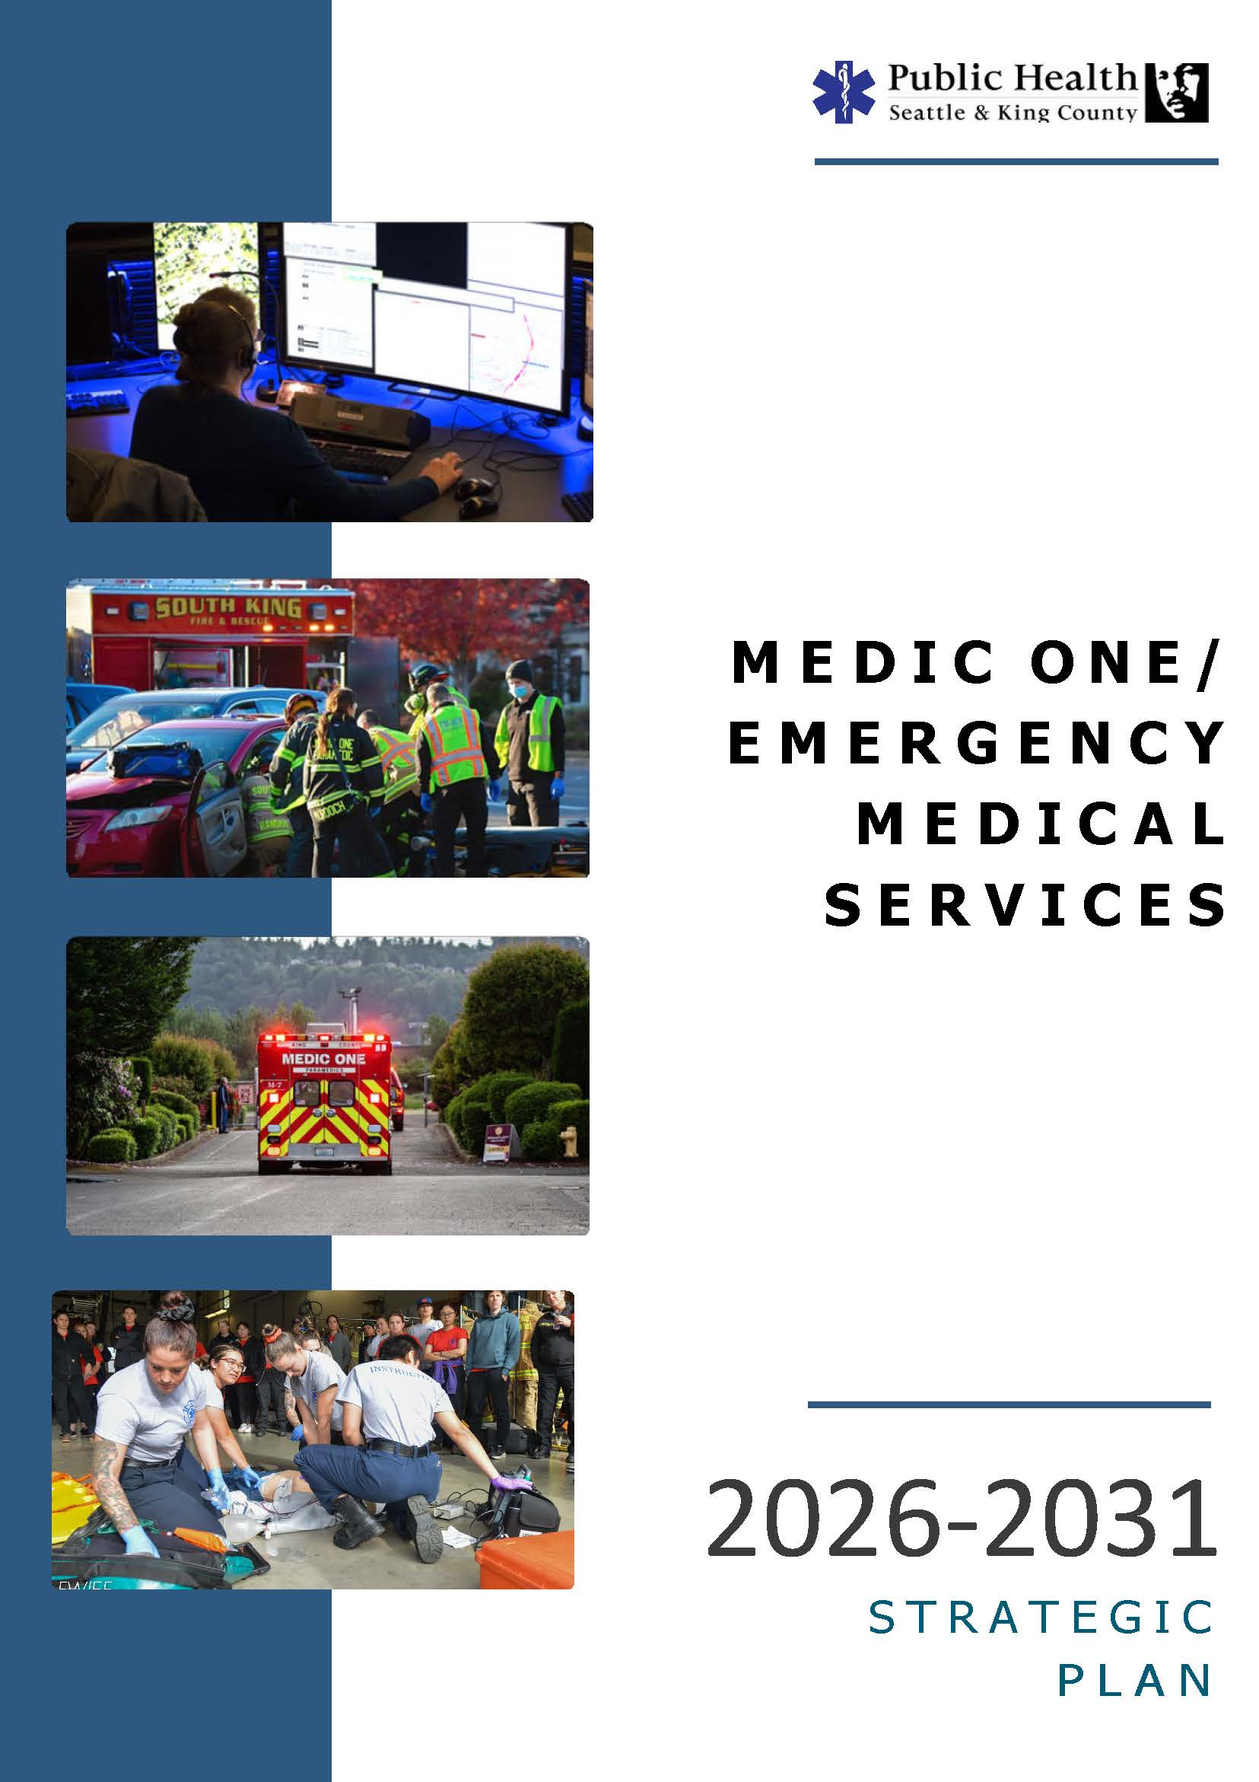
d
ATTACHMENT A
June 11, 2025
Acknowledgements
The EMS system in King County has a long history of collaboration, and this Medic One/EMS 2026-2031 levy planning process was no exception. The EMS Division, Public Health – Seattle & King County, would like to thank the EMS Advisory Task Force and the numerous participants who so willingly gave us their time, insight, and expertise to ensure our nationally-recognized system will continue to thrive far into the future. We appreciate your commitment to this undertaking.

King County Executive
Karan Gill Chief of Staff to Executive Dow Constantine; Task Force Chair

King County Council
Reagan Dunn Councilmember
Tom Goff Director of Local and Regional Affairs

Cities over 50,000 in Population
Angela Birney Mayor, City of Redmond; Regional Services Subcommittee Chair
Brian Carson Fire Chief, Puget Sound Regional Fire Authority, representing the City of Kent
Jim Ferrell Mayor, City of Federal Way
Karen Howe Deputy Mayor, City of Sammamish
Armondo Pavone Mayor, City of Renton; BLS Subcommittee Chair
Lynne Robinson Mayor, City of Bellevue; Finance Subcommittee Chair
Kevin Schilling Mayor, City of Burien
Harold Scoggins Fire Chief, City of Seattle
Keith Scully Councilmember, City of Shoreline; ALS Subcommittee Chair
Penny Sweet Councilmember, City of Kirkland
Brad Thompson Fire Chief, Valley Regional Fire Authority, representing the City of Auburn

Cities under 50,000 in Population
Catherine Cotton Councilmember, City of Snoqualmie
Vic Kave Mayor, City of Pacific
Sean Kelly Mayor, City of Maple Valley

King County Fire Commissioners
Don Gentry Fire Commissioner, Mountain View Fire & Rescue
Jenny Jones Fire Commissioner, Enumclaw Fire Department
Anita Sandall Fire Commissioner, Eastside Fire & Rescue

If you have questions about the Medic One/EMS 2026-2031 levy reauthorization process or Strategic Plan, please contact:
Helen Chatalas, Deputy Director
Emergency Medical Services Division
Department of Public Health - Seattle & King County
401 5th Ave., Suite 1200, Seattle, WA 98104
Email: Helen.Chatalas@kingcounty.gov Website: www.kingcounty.gov/health/ems

Levy Planning Process Partners

Will Aho, Eastside Fire & Rescue
Dan Alexander, Renton Regional Fire Authority
Eric Andrews, Sky Valley Fire
Marc Bellis, Bellevue Fire MPD
Rachel Bianchi, City of Sammamish
Nate Blakeslee, Renton Regional Fire Authority
Schon Branum, Seattle Fire
Matt Burrow, Bellevue Fire
Brant Butte, AMR
Jasmine Chau, Chinese Information & Service Center
Charles Chen, Burien Fire
Andrea Coulson, King County Medic One
Matt Cowan, Shoreline Fire
Kevin Crossen, South King Fire
Brian Culp, KCFD #27 – Fall City
Ben Davidson, Vashon Island Fire & Rescue
Tim Day, Valley Regional Fire Authority
Andrea DeCaro, Northeast KC Medic One
Lisa Defenbaugh, South King Fire
Marianne Deppen, NORCOM
Chuck DeSmith, Renton Regional Fire Authority
Alexa Dilhoff, Bellevue Fire
Larry Doll, Seattle Fire
Cody Eccles, King County Council
Maggie Eid, City of Kirkland
Scott Faires, Eastside Fire & Rescue
Jamie Formisano, Eastside Fire & Rescue
Greg Garat, Eastside Fire & Rescue
Rachel Garlini, Shoreline Fire
Matt Gau, Tri-Med Ambulance
Jason Gay, Burien Fire
Natasha Grossman, Bellevue Fire
Jay Hagen, Bellevue Fire
Maymuna Haji, Somali Health Board
Katie Halse, City of Bellevue
Steve Heitman, Renton Regional Fire Authority
Veronica Hill, City of Kirkland
Mark Horaski, Valley Regional Fire Authority
Cory James, NORCOM
Dawn Judkins, Mountain View Fire & Rescue
Raman Kaur, City of Seattle
Tony Kuzma, AMR
Ben Lane, Eastside Fire & Rescue
Eric Lee, Bellevue Fire
Herlinda Martin, St. Vincent de Paul
Lizbeth Martin-Mahar, King County
Rebeccah Maskin, King County
Vonnie Mayer, Valley Com
Doug McDonald, Eastside Fire & Rescue
Graham McGinnis, King County Medic One
Hendrika Meischke, University of Washington
Wayne Metz, Burien Fire
Stephanie Miller, Lake WA School District
Tania Mondaca, King County Council
Joan Montegary, Eastside Fire & Rescue
Amy Moorhead, Northeast KC Medic One
Mirya Munoz-Roach, St. Vincent de Paul
Bill Newbold, Kirkland Fire
Rick Olson, Valley Regional Fire Authority
Andres Orams, Shoreline Fire
Brian Parry, Sound Cities Association
Eric Perry, City of Renton
Steve Perry, King County Medic One
Mark Peterson, Shoreline Fire
Kaleigh Phillips, Redmond Fire
Drew Pounds, King County
Josh Pratt, Kirkland Fire
Michael Rogers, Seattle Fire
Chris Santos, Seattle Fire
Mark Sawdon, King County Medic One
Cal Schlegel, King County Medic One
Susan Schoeld, King County
Adrian Sheppard, Redmond Fire
Mohamed Shidane, Somali Health Board
Pete Simmons, Sky Valley Fire
Scott Symons, Bellevue Fire
Dave Tait, Bellevue Fire
Eric Timm, Paramedic Training Program
Kenney Tran, Seattle OEM
Liz Tusing, Redmond Fire
Aaron Tyerman, Puget Sound Regional Fire Authority
Evan Van Otten, King County Medic One
Dave Van Valkenburg, South King Fire
Melissa Vieth, NORCOM
Simon Vila, King County
Matt Vinci, Vashon Island Fire & Rescue
Brian Wallace, Seattle Fire
Jimmy Webb, South King County Fire Training Consortium
Jim Whitney, Redmond Fire
Todd Wollum, Shoreline Fire
Kwan Wong, City of Bothell
Ryan Woodey, Kirkland Fire
Mei Po Yip, Chinese Information & Service Center
EMS Division, Public Health – Seattle & King County
Mary Alice Allenbach Jason Hammond
Jen Blackwood Kristine Mejilla
Cynthia Bradshaw Laura Miccile
Juan Diaz Kelly O’Brien
Markisha Dixon Michele Plorde
Leah Doctorello Dr. Tom Rea
Chris Drucker Amy Warrior
Becky Ellis Rose Young

CONTENTS

Executive Summary 7
Key Components 8
Medic One/EMS System Overview 10
System Oversight 12
EMS Levy Statute 13
The Strategic Plan & Levy Planning Process 14
2026-2031 Strategic Plan Overview 16
2026-2031 Strategic Plan Highlights 19
Program Areas Recommendations
Advanced Life Support (ALS) 21
Basic Life Support (BLS) 28
Regional Services & Strategic Initiatives 33
Finance 39
Financial Plan Overview & Assumptions 43
Appendices
Appendix A: Proposed 2026-2031 Regional Services 54
Appendix B: Advanced Life Support (ALS) Units 56
Appendix C: Comparisons Between Levies 57
Appendix D: EMS Citations 60
Appendix E: Financial Plan 63

For over 40 years,
the region has worked together to create
a system with patient outcomes
that people from all corners of the world
seek to replicate.

This speaks to the strength of its partnerships,
and the ability for King County jurisdictions
to collectively recognize these regional benefits
and consider needs beyond
their local boundaries and interests.

The expertise shared, and
efforts expended, by our partners
during this levy planning process
are constant reminders of exactly why
the Medic One/EMS system of
Seattle and King County
continues to succeed and serve
as an international model.
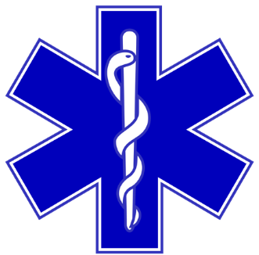

EXECUTIVE SUMMARY
The Medic One/Emergency Medical Services (EMS) system serving Seattle and King County is known worldwide for its excellent medical results. By simply dialing 9-1-1, all residents have immediate access to the best possible medical care, regardless of location, circumstances, or time of day. For 45 years, the system’s commitment to medicine, science, innovation, and partnerships has resulted in thousands of lives saved and an EMS program that is second to none.
The system is primarily funded by a countywide, voter-approved EMS levy (per RCW 84.52.069). Mandated by state law to be exclusively used to support emergency medical services, the levy is a reliable and secure source for funding our successful and highly acclaimed system.
The current six-year levy expires December 31, 2025. To ensure continued emergency medical services in 2026 and beyond, King County undertook an extensive planning process in 2024 to develop a Strategic Plan and finance plan (levy) for King County voters to consider renewing in 2025. This process brought together regional leaders, decision-makers, and partners to assess the needs of the system and collectively develop recommendations to direct the system into the future. As in past years, the EMS Advisory Task Force, comprised of regional elected officials, oversaw the development of the recommendations and was responsible for endorsing broad policy decisions including the levy rate, length, and ballot timing.
As the EMS system’s primary policy and financial document, the Strategic Plan defines the roles, responsibilities, and programs for the system and establishes a levy rate to fund these approved functions. On September 26, 2024, the Task Force endorsed the programmatic and financial recommendations that form the basis of this Medic One/EMS 2026-2031 Strategic Plan.
The 2026-2031 Medic One/EMS Strategic Plan includes the following key elements:
- A six-year Medic One/EMS levy at $.25 per $1,000 Assessed Value (AV);
- Fully funding eligible Advanced Life Support (referred to as ALS, or paramedic services) costs;
- Including an ALS unit “placeholder” should service demands increase beyond what is anticipated and new units are required;
- Increasing funding for Basic Life Support (referred to as BLS, or first responders);
- Continued commitment to Mobile Integrated Healthcare (MIH) to support community needs;
- Sustained funding and enhancements for regional programs that provide essential support to the Medic One/EMS system and are critical for providing the highest emergency medical care possible;
- Initiatives that encourage efficiencies, innovation, and leadership and build upon previous efforts to improve patient care and outcomes;
- Reserve funding that provides additional protection and flexibility against unforeseen financial risks;
- Carrying forward $64 million of 2020-2025 reserves to help reduce the initial levy rate; and
- Placement of an EMS levy on the November 2025 general election ballot in King County.
The proposed levy rate of 25.0 cents /$1,000 AV means that an owner of a $844,000 home in King County will pay $211 in 2026 for some of the nation’s most highly-trained medical personnel to arrive within minutes of an emergency – at any time of day or night, no matter where in King County.
This Medic One/EMS Strategic Plan is designed to meet the needs of the EMS system, its users, and the community. The proposals incorporated within this Plan support the Medic One/EMS system’s strong tradition of service excellence, effective leadership, and regional collaboration. The well-balanced approach outlined in this plan will allow the system to meet the needs and expectations of residents now and in the future.
KEY COMPONENTS

Survival from cardiac arrest is an EMS system benchmark condition used throughout the nation. This is due to the discrete nature of a cardiac arrest: a patient has stopped breathing, and their heart is not pumping. Because a patient who is discharged alive from the hospital following a cardiac arrest is identifiable and measurable, it is an easily comparable metric across systems and communities. The survival rate of cardiac arrest patients is a gold standard for measuring the overall functionality and quality of an EMS system.
In 2023, the survival rate for witnessed ventricular fibrillation (VF) cardiac arrest throughout King County was 51 percent. Because of the system’s strong collaborative and standardized programs, cardiac arrest patients in the region are two to three times more likely to survive, compared to other communities. This resuscitation success is a tribute to the immense dedication and efforts by all the partners of the regional EMS system.
As a result of these findings, the Medic One/EMS system serving Seattle and King County has earned an international reputation for innovation and excellence, and regularly hosts visitors from all over the world seeking to learn more about how the system works. The system’s success can be traced to its design which is based on the following:
Regional System Based on Partnerships
The Medic One/EMS system in King County is built on partnerships that are rooted in regional, collaborative, and cross-jurisdictional coordination. While each provider operates individually, the care provided to the patient operates within a “seamless” system. It is this continuum of consistent, standardized medical care and collaboration between 23 fire agencies, five paramedic agencies, four EMS dispatch centers, more than 20 hospitals, the University of Washington, and the residents throughout King County that allows the system to excel in pre-hospital emergency care. Medical training is provided on a regional basis to ensure that, no matter the location within King County, whether at work, play, home, or traveling, medical triage and delivery of medical care is consistent and equitable.
Tiered Medical Model
Medicine is the foundation of the Medic One/EMS system. The services provided by EMS personnel are derived from the highest standards of medical training, clinical practices and care, scientific evidence, and close supervision by physicians experienced in EMS care. The system uses a tiered response model which is centered on having BLS agencies respond to every incident to stabilize the patient. This allows reserving the more limited resource of ALS (known locally as paramedic service) to respond to serious or life-threatening injuries and illnesses. Reserving the number of calls to which paramedics respond helps ensure that paramedic services will be readily available when needed for those serious calls, keeping paramedics well practiced in the life-saving patient skills required for critical incidents.
Compared to systems that send paramedics on all calls, the Medic One/EMS system in King County provides excellent response and patient care with fewer paramedics. It is this tiered medical model response system, working hand-in-hand with the regional medical program direction, intensive dispatch, and evidence-based EMT and paramedic training and protocols, that has led to great success in providing high-quality patient care throughout the demographically diverse King County region.

Equity Led
The Medic One/EMS system In King County is equity-driven and committed to care that uplifts and safeguards the well-being of all King County communities. Recognizing that measurable outcomes in public health are negatively imbalanced due to racial and other demographic factors, the EMS system is committed to ensuring equity, racial, and social justice (ERSJ) principles influence decision making processes in the delivery of pre-hospital care throughout the region. Partners support organizational equity and inclusion efforts so that the communities served feel valued and included in the vision for a healthy and safe King County.

Programs & Innovative Strategies
Programmatic leadership and state-of-the-art science-based strategies have allowed the Medic One/EMS system serving Seattle and King County to obtain superior medical outcomes. Rather than focusing solely on ensuring a fast response by EMTs or paramedics, the system is comprised of multiple elements – including a strong, evidence-based medical approach. Continual quality improvement activities to systematically identify how patient care can be improved across the region help support the best possible outcomes of care. Testing advanced medical treatments, like the administering of whole blood for hemorrhagic shock and the offering of buprenorphine for opioid use disorder, has allowed the EMS system to adapt to meet the needs and expectations of its varied communities and users.
Focus on Effectiveness and Efficiencies
The Medic One/EMS system has maintained financial viability and stability due to the region’s focus on operational and financial efficiencies. The tiered response improves the efficiency and effectiveness of the Medic One/EMS system by ensuring the most appropriate level of services is sent to the incident. Transferring non-emergent 9-1-1 calls to a 24-hour consulting nurse line for medical advice effectively helps keep resources available for higher acuity medical emergencies. Programs focus on better understanding and serving complex, diverse, and lower-acuity patients in the field, improving the quality of care, and contributing to the overall efficiency of service delivery. Streamlining contract administration within the EMS Division of Public Health – Seattle & King County eliminates inefficiencies and reduces costs for executing separate program agreements. Strategies that address operational and financial efficiencies are continually pursued and practiced.
Maintaining an EMS Levy as Funding Source
The Medic One/EMS system is primarily funded with a countywide, voter-approved EMS levy. Authorized by RCW 84.52.069 which mandates that levied funds be exclusively used to support emergency medical services, the levy is a reliable and secure source for funding this world-renowned system. The EMS levy falls outside the statutory limits with senior and junior taxing districts and therefore does not “compete” for capacity, alleviating a significant concern for the region.

The proposed starting rate for the 2026-2031 span is 25.0 cents per $1,000 of assessed value (AV), which is less than the starting rate of the expiring levy. This rate means that the owner of a $844,000 priced home would pay $211 a year to know that at any time of day or night, no matter where in the county, some of the most highly trained medical personnel will be there within minutes to treat any sort of medical emergency.
MEDIC ONE/EMS SYSTEM OVERVIEW
Any time you call 9-1-1 in King County for a medical emergency, you are using the Medic One/EMS system. The Medic One/EMS system serving Seattle and King County is distinct from other EMS systems in that it is a regional, medically based, and tiered out-of-hospital response system. Its successful outcomes depend upon community involvement and extensively trained dispatchers, firefighter/emergency medical technicians (EMTs), and highly specialized paramedics. Strong and collaborative partnerships provide a continuum of consistent, standardized medical care that allows the system to excel and achieve the best possible patient outcomes.
The response system is tiered to ensure 9-1-1 callers receive medical care by the most appropriate care provider. There are five major components in the tiered regional Medic One/EMS system.
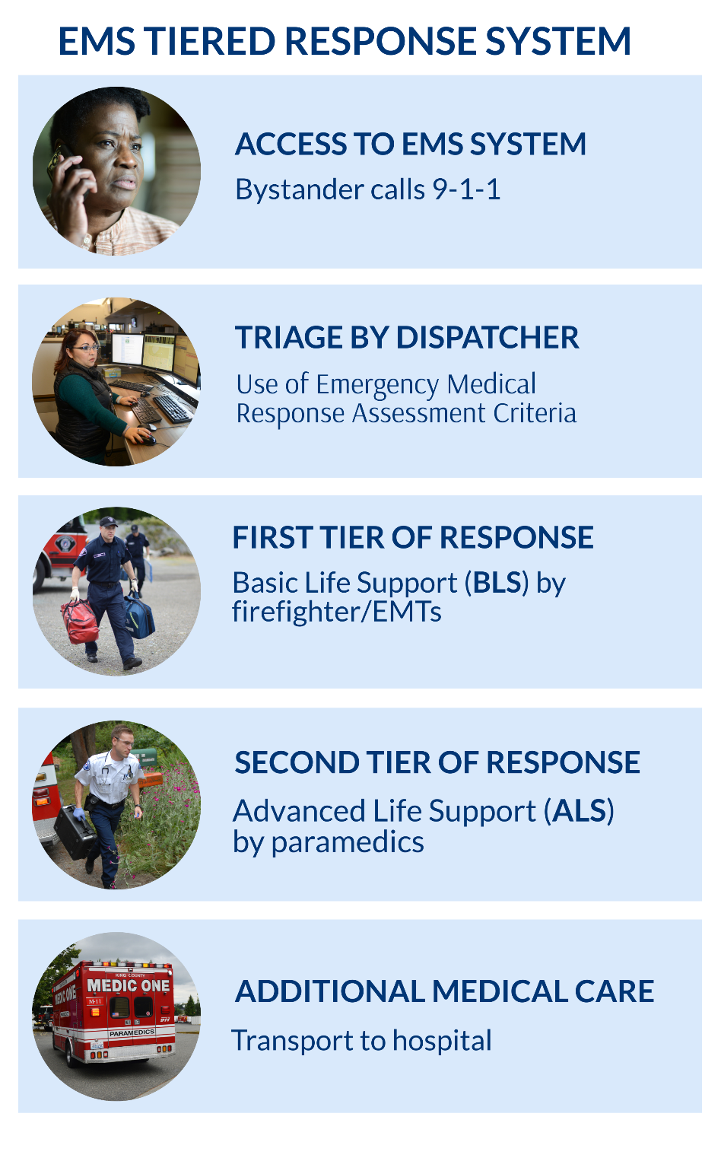

ACCESS TO EMS SYSTEM: A patient or bystander accesses the Medic One/EMS system by calling 9-1-1 for medical assistance. Bystanders’ reactions and rapid responses to the scene can greatly impact the chances of patient survival – studies have shown that survival rate increases from 10 percent to 43 percent if cardiopulmonary resuscitation (CPR) is given within four minutes, and defibrillation in less than eight minutes. The EMS Division offers programs to King County residents so that they can administer life-saving treatments on the patient until providers arrive at the scene. Comprehensive CPR classes train thousands of secondary school students in CPR and automated external defibrillator (AED) use each year. The regional coordinated AED program registers and places devices in the community within public facilities, businesses, and even private homes of high-risk patients, and provides training in AED use. Because of this program, the number of registered AEDs is nearing 7,000 in King County.
TRIAGE BY DISPATCHER: 9-1-1 calls are received and triaged by telecommunicators at one of four dispatch centers. Dispatchers are the first point of contact with the public, asking medically based questions to determine the appropriate level of care to be sent. Amid a wide range of needs, they provide pre-hospital instructions and even guide callers through providing life-saving steps such as CPR and using a defibrillator until the Medic One/EMS providers arrive. The medical dispatch triage guidelines that King County dispatchers follow were developed by the EMS Division and have been internationally recognized as an innovative approach to emergency medical dispatching.
FIRST TIER OF RESPONSE - BASIC LIFE SUPPORT (BLS) SERVICES: BLS personnel are the first responders to an incident, providing immediate basic life support medical care (e.g. first aid, CPR, defibrillation) and stabilizing the patient. Staffed by firefighters trained as emergency medical technicians (EMTs) aboard fire trucks and aid cars, BLS arrives at the scene in less than five minutes (on average). Some non-emergent calls qualify to be referred to a nurse line for medical advice and care instructions in lieu of dispatching EMS resources. The 4,300 EMTs in Seattle and King County receive 190 hours of quality BLS training and continuing education. The EMS levy provides some funding to BLS providers to help ensure uniform and standardized patient care and enhance BLS services to reduce the impact on ALS resources. However, the great majority of BLS funding is provided by local fire departments.
SECOND TIER OF RESPONSE - ADVANCED LIFE SUPPORT (ALS) SERVICES: Paramedics provide out-of-hospital emergency medical care for critical or life-threatening injuries and illnesses. As the second on scene, they provide airway control, heart pacing, the dispensing of medicine, and other life-saving procedures. ALS is provided by highly trained paramedics who have completed an extensive program at Harborview Medical Center in conjunction with the University of Washington School of Medicine and are certified by the state. These paramedics remain well practiced and use their skills routinely to provide effective care when it is needed most. Paramedics operate in teams of two on medic units. There are 27 medic units strategically placed across King County that are deployed regionally to critical or life-threatening emergencies. A contract with Sky Valley Fire (Snohomish County Fire District 26) provides ALS services to the Skykomish and King County Fire District 50 area, from Baring to Stevens Pass. ALS is the primary recipient of regional funding and is the first commitment for funding within the EMS system. The EMS levy provides virtually 100 percent of support for paramedic services in the regional system.
ADDITIONAL MEDICAL CARE: Once a patient is stabilized, EMS personnel determine whether transport to a hospital or clinic for further medical attention is needed. Transport is provided by an ALS or BLS agency, private ambulance, or taxi/ride-share options for lower-acuity situations.

SYSTEM OVERSIGHT
Statutes and policies at the state, County, and local levels standardize and influence the Medic One/EMS system of Seattle and King County.
The Medic One/EMS Strategic Plan is the primary policy and financial document directing the Medic One/EMS system in its work. Defining the responsibilities, functions, and programs of the successful EMS system, the Plan presents a comprehensive strategy to ensure the system can continue to meet its commitments. It documents the system’s current structure and priorities and summarizes the services, programs, and initiatives supported by the countywide, voter-approved EMS levy. While the Plan outlines the necessary steps to direct the system into the future, it still allows for flexibility in addressing emerging community health needs.
The EMS Division of Public Health - Seattle & King County works with its regional partners to implement the Strategic Plan. The EMS Division manages core support functions that tie together the regional model, providing consistency, standardization, and oversight of the direct services provided by the system’s numerous partners. It is more cost-efficient for the EMS Division to produce, administer, and share initial training, continuing education, and instructor education for 4,300 EMTs; to manage the certification process for EMTs countywide; and to provide medical oversight, quality improvement, and performance standards for the system as a whole than to have each local response agency develop, implement, and administer its own such programs. Regional support services managed by the EMS Division can be found in Appendix A: Proposed 2026-2031 Regional Services on page 54.
Since 1997, the EMS Advisory Committee (EMSAC) has provided guidance to the EMS Division about regional Medic One/EMS policies and practices in King County. The group, comprised of regional EMS partners, convenes on a quarterly basis to review implementation of the Strategic Plan as well as other proposals including strategic initiatives and medic unit recommendations.
Consistent with Ordinance 12849, the EMS Division submits an Annual Report to the King County Council highlighting the status and progress of items identified in the Medic One/EMS Strategic Plan. In the 2026-2031 levy period, the EMS Division will include an update on the next levy development in the Annual Report, as appropriate, and, upon written request by members of the Regional Policy Committee by June 1, will provide data on the levy such as expenditures, services provided, needs, and revenues by city. The Annual Report will be transmitted to the King County Council and the Regional Policy Committee.
Regional System Policies ratified by Public Health – Seattle & King County document the general framework for medical oversight and management of EMS in King County, and financial guidance of the EMS levy.
The Revised Code of Washington (RCW), the Washington Administrative Code (WAC), and King County Code regulate different aspects of EMS, from defining “emergency medical services” to financing service delivery. Appendix D: EMS Citations on page 60 compiles the different codes that govern EMS.
RCW 84.52.069 allows jurisdictions to levy a property tax “for the purpose of providing emergency medical services.” The levy is subject to the growth limitations contained in RCW 84.55.010 of one percent per year plus the assessment on new construction, even if assessed values increase at a higher rate.
Specifically, RCW 84.52.069:
- Allows a jurisdiction to impose an additional regular property tax up to $0.50 per $1,000 Assessed Value (AV);
- Allows for a six-year, 10-year, or permanent levy period;
- Mandates for a countywide levy that the legislative bodies of King County and 75 percent of cities with populations in excess of 50,000 authorize the levy proposal prior to placement on the ballot; and
- Requires a simple majority vote for the “subsequent renewal” of a previously imposed EMS levy.
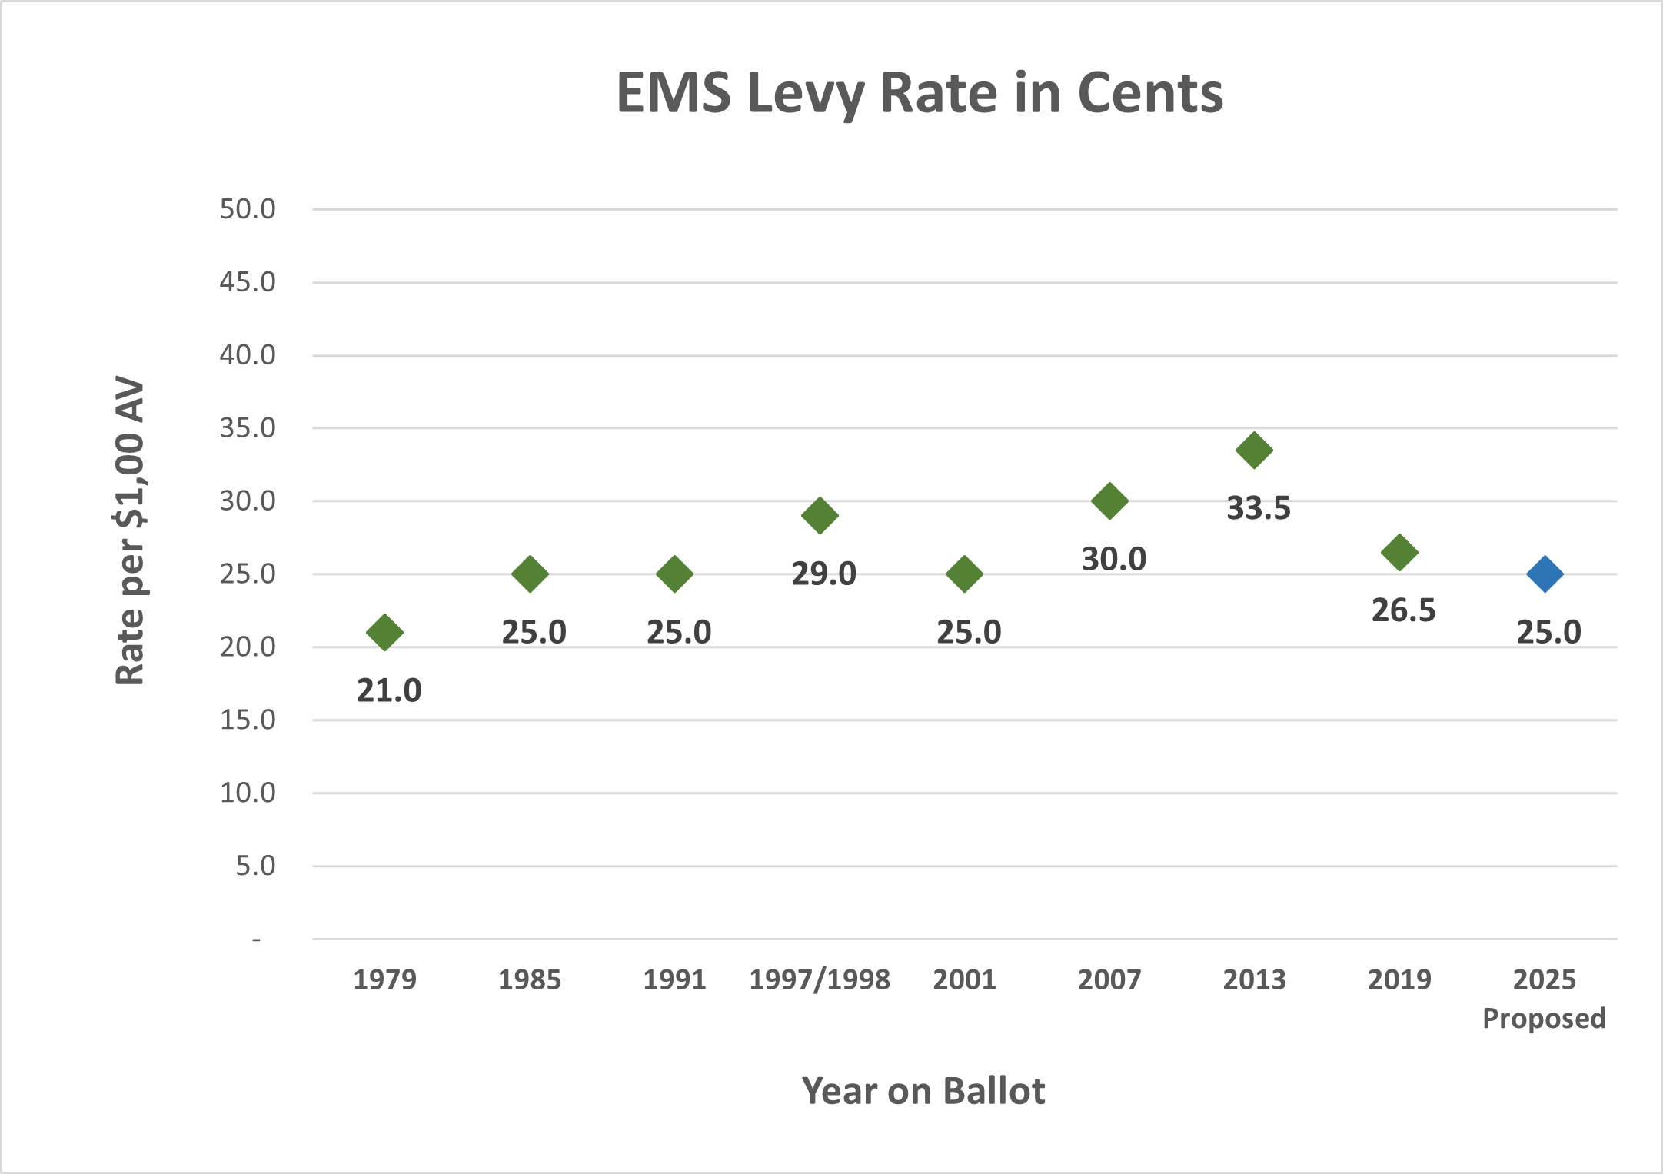
EMS LEVY STATUTE
The maximum levy rate ever approved by voters in King County was 33.5 cents per $1,000 AV in 2013. The proposed rate for 2026 is 25.0 cents per $1,000 AV. EMS levies require voter approval every levy period.

As stated previously, RCW 84.52.069 requires 75 percent of cities with 50,000 or more in population to approve placing a countywide EMS levy on the ballot. Since King County currently has 11 such cities - Auburn, Bellevue, Burien, Federal Way, Kent, Kirkland, Redmond, Renton, Sammamish, Seattle, and Shoreline - it would need to gain the approval from at least nine out of the 11 cities, as well as the King County Council.
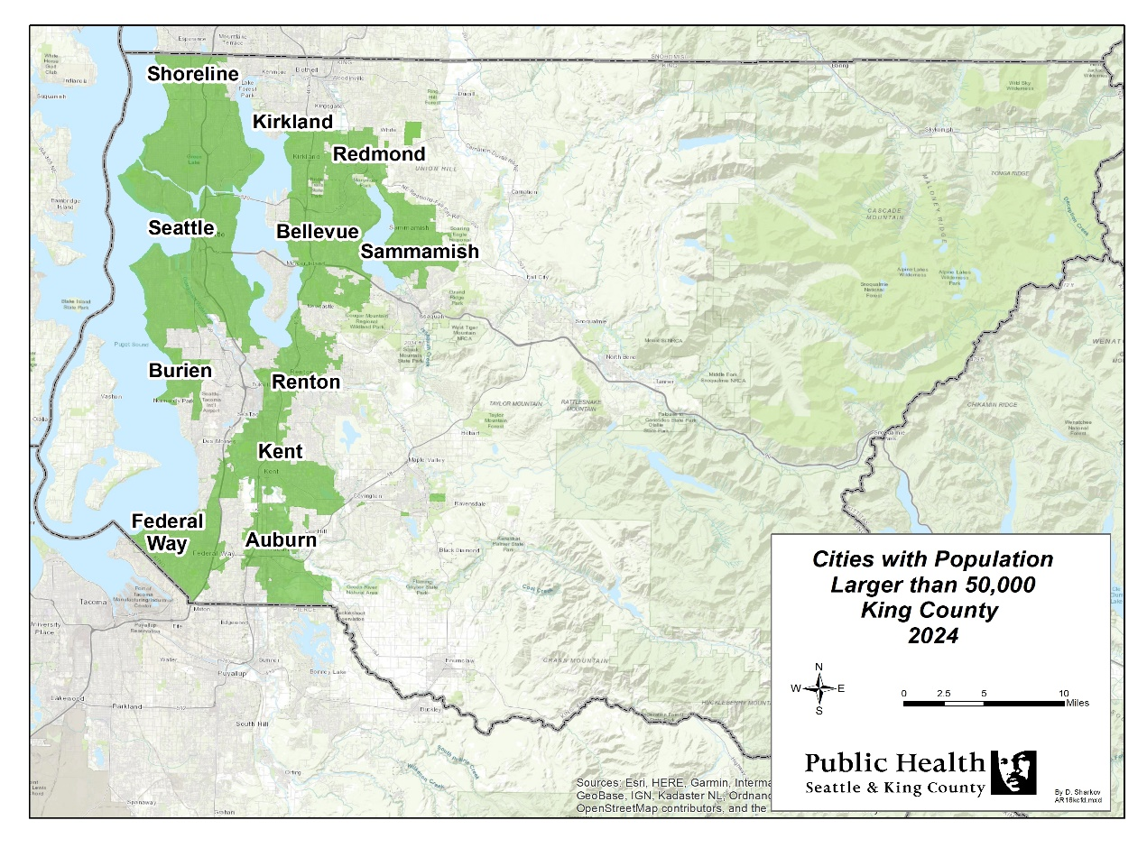

Per an agreement in place since the creation of the countywide EMS levy, Seattle receives all Medic One/EMS levy funds raised within the city limits. County funds are placed in the King County (KC) EMS Fund and managed regionally by the EMS Division based on EMS system and financial policies ratified by Public Health – Seattle & King County, Strategic Plan guidelines, and EMSAC recommendations.
THE STRATEGIC PLAN & LEVY PLANNING PROCESS
With the 2020-2025 EMS levy expiring December 31, 2025, a new strategic plan to outline the roles, responsibilities, and programs for the system and a levy rate to fund these approved functions, needed to be developed. This would entail not just a detailed review of the concepts and operations of the Medic One/EMS system, but also an all-inclusive planning process to secure consensus for the plan among Medic One/EMS providers in the region.

The EMS Advisory Task Force
The region assembled the EMS Advisory Task Force to oversee the development and vetting of this Strategic Plan and levy. Consisting of elected officials from the County, cities, and fire districts, the group was charged with reviewing and approving Medic One/EMS program recommendations and a supporting levy rate to be put before King County voters. While not every member of the Task Force was an EMS expert, each had a stake in ensuring the continuity in the provision of EMS services in King County. Its membership collectively represented a balanced geographic distribution of those jurisdictions that are required to endorse the levy proposal prior to its placement on the ballot, per RCW 84.52.069.
Responsibilities of the Task Force included evaluating and endorsing recommendations regarding:
- Current and projected EMS system needs;
- A financial plan based on those needs; and
- Levy type, levy length, and when to run the levy ballot measure.

Current and Projected EMS System Needs
The Strategic Plan is designed to reflect the regional system’s commitment to providing cohesive, medically based patient care, using a tiered response system designed to ensure the highest level of patient care through the coordination and collaboration of all Medic One/EMS partners.

Financial Plan to Meet Those Needs
The financial plan proposes adequate funding to support the programmatic needs of the system. However, the Plan also recognizes individual jurisdictions’ needs for local autonomy to meet their communities’ expectations and Medic One/EMS services.

Levy Type, Length, and Ballot Timing
Levy Type: While the Medic One/EMS system has historically been funded through a Medic One/EMS levy, other potential options exist to support the system, such as King County General Fund property tax levy lid lifts. These alternatives do not require that cities with over 50,000 in population approve placing the levy on the ballot, nor are they subject to the one percent growth limitation ratified by Initiative 747, but they could negatively impact junior taxing districts.
Levy Length: State law offers three levy length options for a Medic One/EMS levy: six years, 10 years, or permanent. The Medic One/EMS levy in King County has historically been approved by voters for six-year levy periods. This allows EMS partners to periodically gather to strategically plan for emerging regional needs. Six-year periods help reduce the range of financial risk because the longer the projection period, the greater the variability.
Levy Timing: EMS levy validation requirements at the state level were amended in 2018, opening up the option of running the levy measure at a primary election. Task Force members were willing to consider this contingent upon what other issues may be on the same ballot.

Levy Planning Process
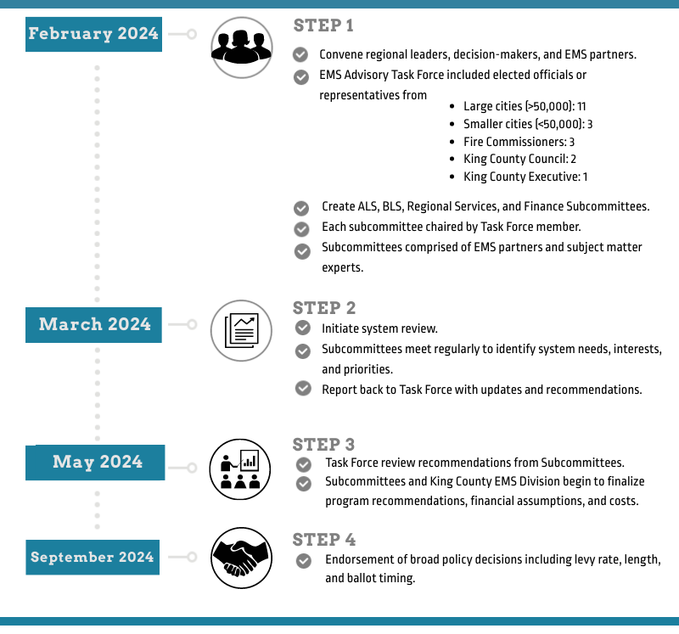
The EMS Advisory Task Force convened on February 15, 2024, officially launching the start of the 2026-2031 Medic One/EMS levy planning process. Regional leaders, decision-makers, and EMS/Medic One partners came together to assess the needs of the system and develop recommendations to direct the system into the future. The Task Force formed four subcommittees organized around the primary service areas to conduct the bulk of the program and cost analysis. Each subcommittee was chaired by an EMS Advisory Task Force member, included subject matter experts from all aspects of the Medic One/EMS system, and met regularly to review system needs and priorities.

Subcommittees met 17 times in total over eight months and generated recommendations that came to the Task Force for approval. True to the ethos of the Medic One/EMS system, partners reviewed current and future system needs through a lens of science, innovation, equity, and effectiveness. Ideas were evaluated by balancing their merits of furthering the goals of the system against the challenges of constrained revenues. In late September 2024, the Task Force adopted the subcommittees’ finalized programmatic and financial recommendations which then became the basis of this Medic One/EMS 2026-2031 Strategic Plan.
2026-2031 STRATEGIC PLAN OVERVIEW
The Medic One/EMS 2026-2031 Strategic Plan builds upon the system’s successful medical model and regional approach. It commits to innovative strategies, leadership, and equity while remaining focused on effectiveness and efficiencies. In outlining the roles and responsibility of EMS providers, it further strengthens the foundation for ongoing coordination and regionalization.

FUNDING
As mentioned, the City of Seattle receives all Medic One/EMS levy funds raised within the city limits and manages its own funding. This Strategic Plan recommends spending the KC EMS Fund in these four main areas:
ADVANCED LIFE SUPPORT (ALS) SERVICES
Funding ALS services has been, and continues to be, the priority of the Medic One/EMS levy, which fully funds ALS services primarily through the ALS unit allocation model. ALS services are provided by five agencies: Bellevue, Redmond, Seattle, Shoreline, and King County Medic One. Exceptions to the unit allocation model are sometimes required, as in the case of Sky Valley Fire (Snohomish County Fire District #26) for service in the Skykomish/Stevens Pass area and are made based on the specifics of the service issue. ALS is proposed to account for 56 percent of KC EMS expenditures in the 2026-2031 levy.
BASIC LIFE SUPPORT (BLS) SERVICES
BLS providers receive an annual distribution of levy revenue to help offset the costs of providing EMS services. The level of funding is based on a combination of the volume of responses to calls for EMS services and assessed property values within fire agencies’ jurisdictions. The allocation was developed as a way to recognize and support BLS for its significant contribution to the success of the EMS system and not intended to fully fund BLS. Local jurisdictions cover the majority of BLS costs – a strategy which has helped King County seek a lower levy rate. BLS services are provided by 23 fire agencies, including Seattle. BLS, including Mobile Integrated Healthcare (MIH), is proposed to account for 30 percent of KC EMS expenditures in the 2026-2031 levy.
REGIONAL SUPPORT (RS) SERVICES
The EMS Division of Public Health – Seattle & King County manages core regional Medic One/EMS programs critical to providing the highest quality out-of-hospital emergency care available. The programs and services emphasize uniformity of medical care across jurisdictions, consistency in excellent training, medical quality assurance, centralized data collection, and contract and financial management. Centrally delivering these services on a regional basis is more effective and efficient because it avoids unnecessary duplication of effort. Regional services are proposed to account for 13 percent of KC EMS expenditures in the 2026-2031 levy.
STRATEGIC INITIATIVES (SI)
Strategic initiatives are pilot programs designed to improve the quality of Medic One/EMS services and help manage the growth and costs of the system. Initiatives that achieve their intended outcomes or demonstrate efficiency may be incorporated into regional services as ongoing programs. Strategic initiatives are proposed to account for one percent of KC EMS expenditures in the 2026-2031 levy.
Contingencies and reserves fund unanticipated/one-time costs. EMS reserves follow use and access policies included in the Medic One/EMS Strategic Plan. For additional information about contingencies and reserves, please see page 41.

ALIGNMENT WITH GOALS AND OBJECTIVES

The 2026-2031 Strategic Plan aligns with the objectives, policies, and goals of the regional EMS system and King County government as outlined below.

Alignment with Regional EMS System Global Objectives
The Plan is built upon the system’s current configuration and strengths, advancing the following global objectives to ensure the EMS system remains tiered, regional, cohesive, and medically based:
- Maintaining the Medic One/EMS system as an integrated regional network of basic and advanced life support services provided by King County, local cities, fire authorities, and fire districts.
- Emergency Medical Dispatchers receive 9-1-1 calls from residents and rapidly triage the call to send the most appropriate level of medical aid to the patient while providing pre-arrival instructions to the caller.
- Firefighters, trained as Emergency Medical Technicians (EMTs), provide rapid, first-on-scene response to emergency medical service calls and deliver immediate basic life support services.
- Paramedics, trained through the Paramedic Training Program at Harborview Medical Center in conjunction with the University of Washington School of Medicine, provide out-of-hospital emergency medical care for serious or life-threatening injuries and illnesses. As has been adopted in prior Medic One/EMS strategic and master plans and confirmed by an independently conducted ALS Study, advanced life support services will be most cost effective through the delivery of paramedic services on a sub-regional basis with a limited number of agencies.
- Regional programs emphasize uniformity of medical care across jurisdictions, consistency and excellence in training, and medical quality assurance.
- Making regional delivery and funding decisions cooperatively and balancing the needs of Advanced Life Support (ALS), Basic Life Support (BLS), and regional programs from a system-wide perspective.
- Developing and implementing strategic initiatives to provide greater system efficiencies and effectiveness to:
- Maintain or improve current standards of patient care;
- Improve the operational efficiencies of the system to help contain costs; and
- Manage the rate of growth in the demand for Medic One/EMS services.

EMS System Policies
This Medic One/EMS 2026-2031 Strategic Plan reinforces EMS System and Financial Policies which provide a general framework for medical oversight and financial management of emergency medical services in King County. The EMS System Policies underscore the regional commitment to the medical model and tiered system, while the EMS Financial Policies provide guidance and oversight for all components related to financial management of the EMS levy fund. In addition, policies regarding ALS services outside King County establish the formation of a service threshold for the purpose of cost recovery.
Summary of EMS System Policies (PHL 9-1 and PHL 9-3)
The EMS Division will work in partnership with regional EMS agencies to regularly review and assess EMS system needs and develop financial and programmatic policies and procedures necessary to meet those needs.
The EMS Division will ensure the EMS system in King County remains an integrated regional system that provides cohesive, medically based patient care within a tiered response system to ensure the highest level of patient care.
The EMS Division will ensure the EMS system in King County provides paramedic training through the UW/HMC-based educational program that meets or exceeds the standards.
The EMS Division will maintain a rigorous and evidence-based system with medical oversight of the EMS system to ensure the provision of quality patient care.
The Medical Program Director will adhere to the principles of regional medical oversight of EMS personnel.
The EMS Division recognizes the existence of automatic aid between agencies within King County and between counties; however, should established service thresholds be reached, affected EMS agencies will review options and establish terms for reasonable cost recovery.
2026-2031 STRATEGIC PLAN OVERVIEW
Alignment with King County Government Values
The Medic One/EMS 2026-2031 Strategic Plan is consistent with King County’s commitment to provide fiscally responsible, quality driven local and regional services, and embodies the County’s values of operating efficiently and effectively and being accountable to the public. Working with cities and EMS partners to provide services more efficiently; pursuing technologies that improve patient outcomes while reducing delivery cost; and managing assets in a way that maximizes their productivity and value exemplify the EMS system’s commitment to delivering high-quality services with sound financial management.
EMS programs are also guided by shared values of being inclusive and collaborative, diverse and people-focused, responsive and adaptive, transparent and accountable, racially just, and focused where needs are greatest so every person can thrive. The ongoing centering of equity and underrepresented communities through local area partnerships was embedded in the most recent EMS levy planning process and reflects the alignment between EMS and County’s values.
The EMS system’s mission also aligns with the core values and priorities of Public Health – Seattle & King County. Public Health’s focus is to protect and improve the health and well-being of all people in King County. The provision of EMS services is an integral part of achieving optimum health, helping Public Health meet its goal of increasing the number of healthy years lived. EMS priorities align with those of the Public Health — Seattle & King County 2024–2029 Strategic Plan which is rooted in anti-racism and equity. Specific programs that support communities with less than equitable access to healthcare have resulted in strengthening these partners’ voices, which is a key priority of the Strategic Plan. With additional focus on information, impact, and innovation, as well as workforce and infrastructure, EMS continues to value the input of its employment community in creating policy.

2026-2031 STRATEGIC PLAN HIGHLIGHTS

Operational and Financial Proposals for the
Medic One/EMS 2026-2031 Levy
The EMS Advisory Task Force endorsed the following at its September 26, 2024, meeting:

Reauthorize a six-year EMS levy to fund the EMS system for the years 2026-2031 per RCW 84.52.069.
Enact a levy rate of 25.0 cents/$1,000 Assessed Valuation to fund projected expenditures and reserves of $1.5 billion over 2026-2031. This levy rate means that an owner of an $844,000 home will pay $211 a year in 2026 for highly trained medical personnel to arrive within minutes of an emergency, any time of day or night, no matter where in King County.
Renew the EMS levy in 2025 preferably at the General election, unless there are competing levy measures; in that case, renew the levy at the Primary election.
Continue using financial policies guiding the most recent levy. Such policies have provided a very strong foundation for the upcoming levy and should meet the needs of the 2026-2031 levy span.
Continue services from 2020-2025 levy through the 2026-2031 levy. The next levy should fully fund and continue operations with the current ALS units in service; partially fund first responder services for local fire and emergency response departments; help support MIH programs to assist lower acuity and complex patients; maintain programs that provide essential support to the system; and pursue initiatives that encourage efficiencies, innovation, and leadership.
Meet future demands over the span of the 2026-2031 levy. Services include enhancing programs to meet increased EMT hiring, low-acuity patients and community needs, and existing data and e-learning technology; strengthening community interactions and partnerships; and including a “placeholder” for the equivalent of a new medic unit, should service demands be higher than originally anticipated.

Operational and Financial Fundamentals of the
Medic One/EMS 2026-2031 Levy
Endorsed by the EMS Advisory Task Force on 9/26/2024
CONTINUE with EMS levy:
- Six-year EMS levy, per RCW 84.52.069
- Levy rate of 25.0 cents/$1,000 Assessed Valuation
- Forecasted revenues and reserves of $1.5 billion over six-year span (including Seattle)
- Run at the 2025 General election, unless there are competing ballot measures; if so, run at Primary
ADVANCED LIFE SUPPORT (ALS) RECOMMENDATIONS*
- CONTINUE using the unit allocation to fund ALS; slightly revise to better ensure full funding and prevent cost shifting to providers
- MAINTAIN the current level of ALS service; INCLUDE a “place holder” in the financial plan to protect the system, should service demands require additional units over the span of the 2026-2031 levy
- MAINTAIN contingencies and reserves to cover unanticipated and one-time expenses
- CONTINUE support for ALS-based programs (ALS Support for BLS Activities; having paramedics train paramedic students) that benefit the region

BASIC LIFE SUPPORT (BLS) RECOMMENDATIONS*
- INCREASE total BLS funding to help offset costs of providing EMS services
- INCORPORATE the BLS Training & QI funding into the BLS Allocation; REMOVE requirement that this funding be spent on training and QI activities
- INCREASE funding support for Mobile Integrated Healthcare (MIH) that addresses community needs
- DISTRIBUTE new BLS and MIH funding and annual increases using a more equitable methodology that is more weighted toward service level and need over assessed value
- SUPPORT mental wellness and DEI/ERSJ efforts proposed by the King County Fire Chiefs Association
REGIONAL SERVICES & STRATEGIC INITIATIVES (RS/SI) RECOMMENDATIONS*
- CONTINUE delivering programs that provide essential support to the system
- ENHANCE programs to meet regional needs
- CONTINUE AND DEVELOP strategic initiatives that leverage previous investments made by the region to improve patient care and outcomes
FINANCE RECOMMENDATIONS**
BASE financial plan on financial policies that provide stability to the system by:
- Incorporating sufficient reserves to mitigate unforeseen financial risk
- Ensuring additional protection and flexibility to meet emerging needs

* Program recommendations apply to King County outside the City of Seattle
** Finance recommendations include the City of Seattle
Advanced Life Support (ALS)
LEVY PROGRAM AREAS
As discussed throughout this document, paramedics provide out-of-hospital emergency care for serious or life-threatening injuries and illnesses. As typically the second on scene for critically ill patients, paramedics deliver Advanced Life Support (ALS) to patients including airway management, heart pacing, the dispensing of medicine, and other lifesaving out-of-hospital procedures under the medical supervision of the Medical Program Director. Paramedic interns receive more than 2,100 hours of highly specific and intensive emergency medical training through the Paramedic Training Program at Harborview Medical Center in conjunction with the University of Washington School of Medicine, which is nearly double the required number of hours for Washington State paramedic certification.
In King County, a paramedic unit is typically staffed by two paramedics and provides service 24-hours per day, 365 days per year. The two-paramedic provider model was developed in Seattle in the early 1970s and has proven to be the most effective model for enhanced patient care outcomes when incorporated into a regionally coordinated tiered response system that includes dispatch and Basic Life Support (BLS).
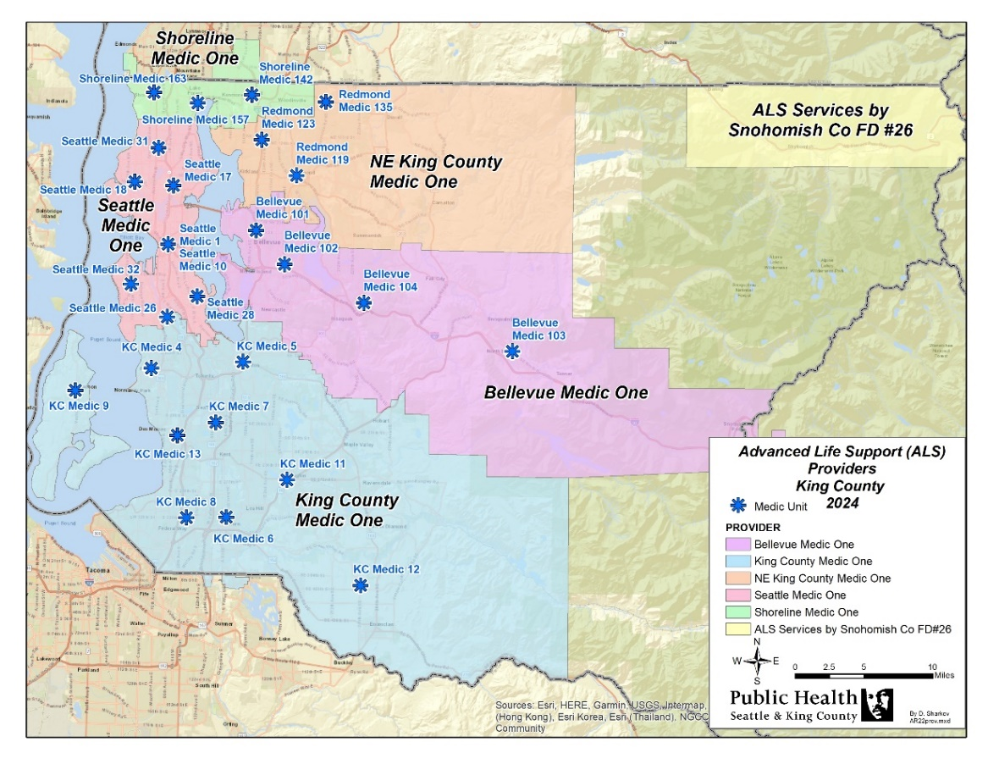
Medic units are positioned throughout the region to best respond to service demands. As of 2024, there are 27 units in Seattle and King County managed by five agencies: Bellevue Medic One, King County Medic One, Northeast King County Medic One (Redmond), Seattle Medic One, and Shoreline Medic One. Of these five agencies, four are fire-based with firefighters trained as paramedics, and King County Medic One operates as a paramedic-only agency. Paramedic service is provided to the Skykomish area through a contract with Sky Valley Fire (formerly known as Snohomish Fire District #26). Units may respond to areas where the municipal boundaries or the fire agency’s response district crosses into neighboring counties. If service into these areas exceeds established levels, the receiving jurisdictions reimburses for such services as outlined in EMS policies.
Adding a medic unit to maintain critical service levels and address service challenges is a complex undertaking. Prior to adding a unit, the region conducts a thorough analysis, considering a variety of elements including workload (call volumes), response time, availability in primary service area, frequency and impact of multiple alarms, and medic exposure to critical skills. Analysis also includes possible dispatch criteria revisions and an assessment of whether medic units could be moved to other locations to improve workload distributions and response times. The decision to add or relocate units relies on obtaining regional consensus. Appendix B: Advanced Life Support (ALS) Units on page 56 provides a complete history of medic units in King County, highlighting when and where units were added.
ALS
In 2023, paramedics responded to more than 51,000 calls for emergency medical care throughout the region. The median response time of medic units is 7.7 minutes, with units responding to 94 percent of the calls in less than 14 minutes. These response times have remained stable over the past three levy periods despite increases in King County’s overall population. EMS data shows that paramedics respond to cardiac conditions (16 percent of ALS calls) and attend to older patients (33 percent of ALS calls are for people 65+ years of age).

ALS SUBCOMMITTEE
Chair: The Honorable Keith Scully, Shoreline City Councilmember
The ALS Subcommittee recognized its tasks as determining the number of medic units needed in the upcoming levy period and establishing the cost of each unit. Workload, service trends, and demographics were all factors considered by the group as it assessed future service demands and system needs. The Subcommittee reviewed in depth the standard medic unit allocation, analyzing actual expenditures for providing ALS services and comparing costs and trends across agencies. Revisiting the unit allocation resulted in slight revisions to the methodology that will help ensure sufficient funding for program oversight and support. Subcommittee participants weighed in on the benefits and costs of ALS-specific programs that support the entire regional system.
The ALS Subcommittee recommendations are as follows:
ALS RECOMMENDATION 1:
CONTINUE using the unit allocation methodology to determine costs. Update methodology to help ensure sufficient funding for program oversight and support.
The standard unit allocation is the basis for funding each full-time, 24-hour medic unit in King County. This allocation methodology is based on fully covering eligible ALS-related expenses to prevent cost-shifting to agencies. This cost model calculates the average annual costs across all ALS agencies to run a two-paramedic, 24-hour medic unit. Each individual paramedic agency’s annual ALS funding is determined by multiplying the number of operating medic units by the unit allocation.
The unit allocation is an average of agency expenditures and was developed to ensure a fair and equitable distribution of funds across agencies. It provides a set amount of funding to each agency with the flexibility to manage funds based on its specific cost structure and needs. Annual comparison of costs on a unit basis allows the region to understand differences between agencies, share efficiencies, and identify potential new costs being experienced early by one or two agencies. These annual reviews help document and justify ALS allocation costs and evaluate if the allocation is covering 100 percent of eligible ALS costs.
During the 2020-2025 levy planning process, the unit allocation methodology was revised to simplify and better accommodate different types of costs. The Subcommittee agreed to maintain this current methodology for the 2026-2031 levy which breaks the overall unit allocation into four parts:
The Medic Unit Allocation includes direct paramedic services costs, such as paramedic salaries and benefits, medical supplies, pharmaceuticals, vehicle and facility operating and maintenance costs, communications, and other costs associated with direct paramedic services.
The Program/Supervisory Allocation (previously referred to as the Program Administration Allocation) includes costs related to the management and supervision of direct paramedic services such as the management, administration, supervision, finances, and analysis (including quality improvement) of direct paramedic services.
ALS

The ALS System Allocation addresses costs that vary significantly between providers or are anticipated to vary during the levy period. This allocation is intended to reimburse agencies for highly mutable costs associated with paramedic students as well as costs associated with the paramedic recruitment cycle and any changes in program medical direction. Costs that vary between agencies include dispatch, whole blood, and medical direction. While the funds budgeted are shown on a per unit basis, agencies are reimbursed for actual costs incurred, with the EMS Division tracking costs against overall funding. Use of funds are monitored and reported.
The Equipment Allocation covers expenses related to equipment. Included are medic units, Medical Services Officer (MSO) and staff vehicles, defibrillators, stretchers, radios and communications equipment, stretcher systems, and other equipment with a lifespan of more than one year. This allocation includes items such as radios and mobile data computers that could be classified as operating by individual agencies.
The Subcommittee endorsed making slight adjustments to the Equipment and System Allocations to help cover vehicle and defibrillator costs that were increasing higher than inflation, and to accommodate the increased number of paramedic students. The distribution methodology for the Program/Supervisory Allocation was amended to distribute fixed costs by agency and more variable costs by unit, with no change to the total funding level.

ALS RECOMMENDATION 2:
CONTINUE INFLATING annual ALS operating allocation costs using CPI-W + 1% inflator; inflate equipment costs using equipment inflator.
During the 2020-2025 levy span, ALS allocations were inflated by the Consumer Price Index for Urban Wage Earners and Clerical Workers (CPI-W) +1 percent. For 2026-2031, the Subcommittee supported continuing with the identified inflators and assessing them throughout the levy period. For additional information on financial assumptions used in the 2026-2031 levy financials, please see the Finance Key Assumptions Section on page 45.

ALS RECOMMENDATION 3:
MAINTAIN the current level of ALS service. The regional system has sufficient capacity to address current demand but should continue to monitor medic unit performance on an annual basis to ensure continued high performance.
ALS Capacity Analysis
ALS capacity analysis assesses the ability of current medic units to accommodate anticipated future demand for services, specifically through to the end of the levy period. This assessment includes consideration of unit performance trends and critical factors driving demand in addition to mitigation techniques such as the review of Criteria Based Dispatch (CBD) guidelines to reduce unnecessary ALS responses or relocation of units to better
distribute calls among the units. Discussing the relocation of medic units to new locations is an important function of a regional system.
The ALS Subcommittee reviewed five-year (2018-2022) unit performance trends and exposures to critical skills and noted an innate challenge to interpreting the data and projecting demand for future services due to the 2020 pandemic’s impact on call volumes and response times. The group concluded that while there was sufficient current capacity within the region, they strongly advocated for a CBD guideline review process to mitigate any potential growth in calls (CBD guideline review is anticipated in 2025) and to include a medic unit placeholder in the financial plan to ensure access to funds if needed.

ALS
Medic Unit Analysis
The ALS Subcommittee concluded there was currently sufficient medic unit capacity (outside the City of Seattle) and supported continuing the annual review of medic units to ensure continued high performance. The regional medic unit analysis considers the following key performance indicators: unit workload (call volumes), median unit response times, availability in the primary service area and responses from units outside of the primary service area; and paramedic exposure to critical skills (e.g. intubations, response to cardiac arrest events).
While performance indicators do not serve as automatic prompts for adding new paramedic services, they do help with assessment of overall performance and direct attention to a geographical area of the Medic One/EMS system that may need further examination. This approach to medic unit analysis is useful since some units operate in small, highly dense areas with high call volumes and short response times, while others operate in larger, more rural areas with lower call volumes and longer response times. Monitoring unit performance in rolling five-year increments allows the region to identify both individual unit and overall trends to better understand the magnitude of service gaps and ascertain the need for additional service.
As noted, prior to implementation of new paramedic service, the region outside the City of Seattle conducts a thorough analysis of medic unit performance to assess whether mitigation strategies could address increasing stress on the system, including revisions to the CBD guidelines or medic unit relocations. If the regional review concludes that additional medic unit service is the only option remaining, a process of review and approval by the EMS Advisory Committee and the King County Council ensues through the budget process.

ALS RECOMMENDATION 4:
CONTINUE having a medic unit placeholder (reserve) in the financial plan to ensure access to resources should demand analysis support the addition of a medic unit during the 2026-2031 levy span.
Establishing a placeholder in a reserve fund provides access to funds to support additional medic unit service should mitigation attempts fail to improve ALS response capacity. The financial plan shows reserve funding of $15.8 million to potentially fund a 12-hour unit in the third (2028) and fifth (2030) years of the levy period. This is a resource to be used only if demand for ALS services exceeds existing available capacity despite mitigation attempts. It is not included as a definitive plan for adding medic units.
Prior to any request for access to this reserve fund, a comprehensive medic unit analysis and discussion with regional partners would occur to consider alternative options. Per EMS Financial Policies, the use of reserves requires review by the EMS Advisory Committee Financial Subcommittee, and the EMS Advisory Committee. If additional appropriation authority is needed, the County’s budgeting process would be followed.

ALS RECOMMENDATION 5:
CONTINUE to use contingencies and reserves to cover unanticipated/one-time expenses. Contingencies and reserves are appropriate mechanisms to cover unanticipated and one-time expenses.
Contingencies can be used to cover increases in operating costs that cannot be covered by the ALS allocation or program balances. This includes paid time off (PTO) above amounts included in the allocation, and other potential cost increases above amount included in allocations. Contingency funding may also cover unplanned expenses
ALS

related to regional services and initiatives. In the 2020-2025 levy span, contingency funding was used to expand initial EMT training to accommodate the significant increase in new EMT hires and to create the ALS support for BLS activities program.
Analysis conducted within the ALS Subcommittee resulted in a funding recommendation of $1.3 million a year for the 2026-2031 levy span.
Programmatic reserves can be used for other ALS expenses that may not be covered by allocations, program balances, or contingencies. Like in the previous levy span, the ALS Subcommittee recommended the 2026-2031 levy include programmatic reserves related to ALS equipment and ALS capacity (including a “placeholder for a potential new unit(s)” as outlined in ALS Subcommittee Recommendation #4). The group proposed that the levy fund’s Rainy Day Reserve be accessed for risk issues including responses to major events and other issues as appropriate.
EQUIPMENT RESERVES
The ALS Subcommittee recommended funding ALS Equipment Reserves at $1.3 million. This could cover ALS equipment costs such as new technology not currently included or accommodated within the equipment allocation or contingencies.

CAPACITY RESERVES
The ALS Subcommittee recommended funding the ALS Capacity Reserve at a total of $17.4 million. This includes $1.6 million for facility renovations to accommodate moving a medic unit into a station, investments needed at the current location, and temporary capacity increases. The remainder, approximately $15.8 million, is set aside as a placeholder for a potential new unit, per ALS Subcommittee Recommendation #4. For more information on Contingencies and Reserves, please see Finance Subcommittee Recommendation #2 on page 40.

ALS RECOMMENDATION 6:
CONTINUE to address service challenges presented in outlying areas through a regional approach.
The provision of paramedic services in the Skykomish region in the northeast corner of King County offers an example of the challenge serving outlying areas. This isolated area of King County is accessible only via Snohomish County and US-2 highway. The King County border starts just before the town of Baring and continues through Stevens Pass to the border with Chelan County. This area is primarily forest service land and includes the town of Skykomish and Stevens Pass Ski Resort.
There are a number of unique aspects in the Skykomish region relative to other provider areas, including required passage through Snohomish County in order to access to the region, call volumes less than 100 per year, seasonal demand for services peaks during the wintertime, a high percentage of trauma patients, and response and transport times that exceed the average urban and suburban times.
Since 2006, Sky Valley Fire (Snohomish County Fire District 26) has provided paramedic services to the adjacent areas in Snohomish County with a fire station located approximately 15 minutes from the King County border. Sky Valley Fire has worked closely with King County Fire District 50 to create an approach that provides excellent patient care to those living in or visiting the Skykomish Valley. After a detailed review, EMS partners determined that Sky Valley Fire remained in the best position to be able to provide consistent service to the isolated area and
ALS

recommended that it continue providing contract services for that area. EMS partners also agreed to review and update the terms and conditions of the EMS policy regarding ALS service to outlying areas in advance of the 2026-2031 levy period.

ALS RECOMMENDATION 7:
CONTINUE to support two ALS-based programs that benefit the regional system.
Paramedics play a number of roles outside of first response duties that contribute to the quality of the regional system. These roles include instruction, training, and quality assurance/quality improvement (QA/QI). These activities support all tiers of the EMS system and foster improvements in patient outcomes. Conducting these activities on a regional basis ensures greater integration and participation and supports cohesive and consistent countywide training.
- The ALS Support of BLS Activities program assists ALS agencies in conducting BLS Run review, enhanced training, and activities focused on improving interaction between the ALS and BLS tiers in the EMS system. Fire agencies’ BLS Training & QI funding supplemented this program during the 2020-2025 levy span. The recommendations for 2026-2031 support sufficiently funding this program without these moneys, thereby “returning” this funding to BLS agencies to use as needed.
- There is value in incorporating certified field paramedics in the development of up-and-coming student interns at the Paramedic Training program at Harborview. This support helps students rise to the challenge befitting their duty as medical providers in the community, but also reinforces their field skills and commitment to the regional system. The recommendations for 2026-2031 support continuing this collaborative arrangement with the Paramedic Training program.
ALS

ALS Programmatic Comparison Between Levies
2020-2025 Levy | 2026-2031 Levy
Maintain current level of ALS service | Maintain current level of ALS service
0 planned additional units  $11.6 million “placeholder”/reserve should service demands require additional units over the span of the 2020-2025 levy | 0 planned additional units  $15.8 million “placeholder”/reserve should service demands require additional units over the span of the 2026-2031 levy
Determine costs using the unit allocation methodology | Determine costs using the unit allocation methodology
Average Unit Allocation over span of levy (KC):  $3.2 million | Average Unit Allocation over span of levy (KC):  $4.1 million
2 Reserve/Contingency categories to cover ALS-specific unanticipated/one-time expenses  - Operational Contingencies  - Expenditure Reserves | 2 Reserve/Contingency categories to cover ALS-specific unanticipated/one-time expenses  - Operational Contingencies  - Programmatic Reserves
Operating Allocation Inflator: CPI (using CPI-W + 1%) to inflate annual costs  Equipment allocation: Transportation Equipment PPI | Operating Allocation Inflator: CPI (using CPI-W + 1%) to inflate annual costs  Equipment allocation: Transportation Equipment PPI
Piloted two ALS-based programs that benefit the regional system in 2024-2025  - ALS Support of BLS Activities  - Having paramedics guide and train students at Harborview’s Paramedic Training Program | Support two ALS-based programs that benefit the regional system  - ALS Support of BLS Activities  - Having paramedics guide and train students at Harborview’s Paramedic Training Program

BASIC LIFE SUPPORT (BLS)

Basic Life Support (BLS) personnel are the first responders to an incident, providing immediate basic life support medical care that includes advanced first aid, High Performance CPR, and AED use to stabilize the patient. Provided by approximately 4,300 EMTs throughout the region, BLS is the foundation of all medical responses within the EMS system serving Seattle and King County.
EMTs in this regional system are among the most trained in the nation, receiving approximately 190 hours of emergency medical response training and hospital experience with additional training in CPR, cardiac defibrillation (electrical shocks given to restore a heart rhythm), and airway management. EMTs are certified by the State of Washington and must complete ongoing continuing education and quarterly trainings to maintain their certification. Like their ALS counterparts, EMTs are highly practiced and use their BLS skills daily.
As the first-on-scene provider, BLS contributes significantly to the success of the Medic One/EMS system. BLS agencies must arrive quickly, assess each situation, and provide effective and precise medical care. Although BLS receives limited funding through the EMS levy, it is an integral piece of the interdependency on which the entire EMS response system in King County is built.
Regional data shows that in 2023, EMTs responded to over 205,000 calls for emergency medical care throughout the region. The median response time of BLS units in Seattle and King County is 5.2 minutes. EMTs are more likely to respond to incidents involving trauma (57 percent), and younger patients (57 percent of BLS calls are for people 25-64 years of age).
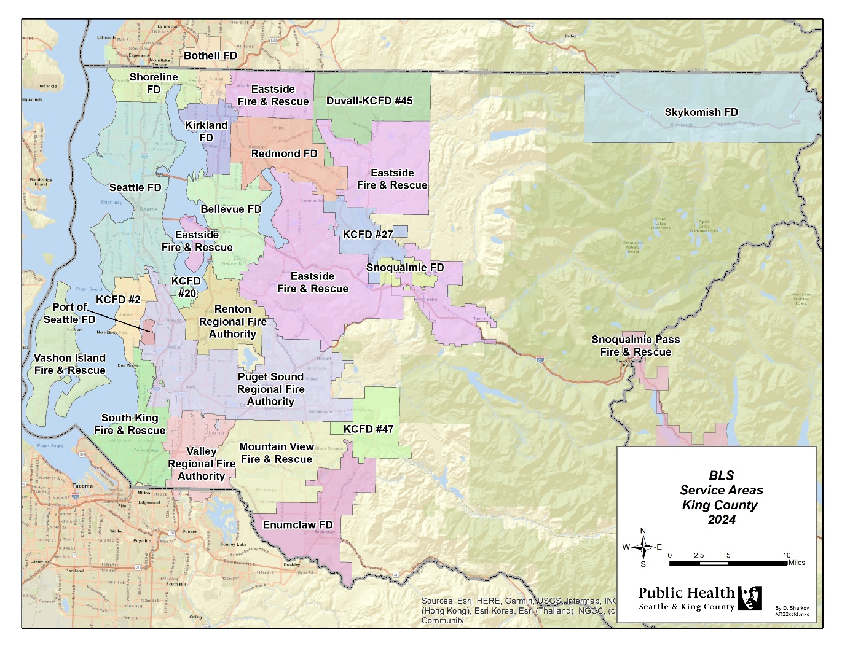

BLS

BLS SUBCOMMITTEE
Chair: The Honorable Armondo Pavone, Mayor of Renton
Total BLS funding, its distribution methodology, and addressing community needs were core topics of discussion for the BLS Subcommittee. Members endorsed modifying the BLS funding formula to help address equity and need, as well as increasing total BLS funding to reflect the growth in inflation, population, and BLS responsibilities. Mobile Integrated Healthcare (MIH) remained a regional priority, and the Subcommittee directed new funding into the program over the next levy span.
The BLS Subcommittee recommendations are described on the following pages.
BLS RECOMMENDATION 1:
INCREASE total BLS funding by at least $3 million in the first year of the new levy, and up to $5 million if that can be done within a 26.5-cent levy rate.
The BLS Subcommittee discussed five scenarios of possible funding levels. These options ranged from a 30 percent increase over 2020-2025 to a 50 percent increase over 2020-2025 levels. They acknowledged the need to balance the desire for increased funding with concerns about voter tax fatigue. Partners settled on $3 million in new funding but requested that it be increased to $5 million if it could fit within a 26.5 cent levy rate.

The August 2024 financial forecast showed that $5 million in new funds could be accommodated within the proposed 25 cent levy rate.

BLS RECOMMENDATION 2:
- ATTRIBUTE 60 percent of this new funding to the BLS Basic Allocation.
Since its inception, the regional Medic One/EMS levy has provided BLS agencies with an allocation to help offset costs of providing EMS services. The allocation was developed as a way to recognize and support BLS for its significant contribution to the success of the EMS system but was never intended to fully fund BLS. The Subcommittee directed $3 million of this new $5 million into the basic allocation for agencies to use on a variety of EMS-specific items including personnel, equipment, and supplies.

- ATTRIBUTE 40 percent of this new funding to Mobile Integrated Healthcare (MIH).
The Subcommittee was adamant about the need to maintain support for the MIH program over the next levy span. Members endorsed a proposal that includes increasing connections with service providers, expanding MIH’s role to help mitigate the opioid epidemic’s impact on communities, supporting MIH ground-level personnel mental wellness, and leveraging proven tools (such as Julota software) to further refine how MIH programs collect data. They directed $2 million of this new $5 million into MIH for 2026 and beyond.
BLS

BLS RECOMMENDATION 3:
INFLATE annual costs using CPI-W + 1%. This inflator will be based on the forecast from the King County Office of Economic and Financial Analysis.
BLS agencies use the Medic One/EMS levy allocation to pay for different EMS-specific items. Since these items have differing inflationary trends, no one specific inflator would accurately reflect their increasing costs. However, since most BLS costs are related to wages and benefits, the BLS Subcommittee determined that using a standard CPI inflator tied to wages (CPI-W) as forecast by the King County Office of Economic and Financial Analysis was preferable.

BLS RECOMMENDATION 4:
INCORPORATE the BLS Training & QI program funding into the BLS Basic Allocation. Remove requirements that this funding be spent on training and QI activities.
The BLS Training & QI program provides BLS agencies with funding to pay paramedics and certified competency-based training (CBT) instructors for conducting run review and related EMT training. In 2023, the region initiated the ALS Support of BLS Activities program which provides funding directly to ALS agencies to conduct those training and QI activities that were previously funded by BLS training and QI moneys. The BLS Subcommittee supported folding the BLS Training and QI funding into the Basic Allocation so that it is no longer earmarked specifically for QI and agencies can use the funds at their discretion.

BLS RECOMMENDATION 5:
DISTRIBUTE NEW BLS funding and annual increases using a more equitable distribution methodology of 60 percent call volume/40 percent Assessed Value (AV). Do not reset the first year of levy funding.
The current distribution methodology, in use since the 2008-2013 levy span, allocates funding to agencies based 50 percent on call volume, and 50 percent on AV. This methodology acknowledges and balances jurisdictions’ services needs with financial investment. When examining different funding alternatives and distribution options, the conversation focused on finding a more equitable way to distribute the funds. Identifying that call volumes are associated with need, and need is often a reflection of inequitable access to care in the community, the Subcommittee revised the distribution methodology to be more weighted toward call volumes. This new ratio better balances the financial contribution with calls for service.
For the 2020-2025 levy span, the first year’s total funding levels were reset which distributed the full allocation based on the most updated call volume and AV data. The Subcommittee opted against initiating a reset for the 2026-2031 levy span as resetting models showed large deviations to agency allocations.

BLS
BLS RECOMMENDATION 6:
SUPPORT King County Fire Chiefs Association Mental Wellness and Equity, Racism & Social Justice/Diversity, Equity & Inclusion proposals.
The King County Fire Chiefs Association (KCFCA) has partnered with the King County EMS Division to develop strategies that address mental wellness for all first responders and advance equity in EMS organizations and the diverse communities they serve. The Subcommittee endorsed continuing these efforts that further advance such causes for the 2026-2031 levy span:

Mental Wellness:
KCFCA proposes to create and implement a comprehensive approach across King County to support the health of our region’s first responders, medics, and dispatchers. This will focus on a regional system of support, reflect the needs of frontline workers, and garner the expertise of leaders in the mental wellness field. It includes consulting authorities in first responder mental wellness, continuing peer support training, and organizing other learning opportunities for EMS personnel.
Diversity, Equity and Inclusion/Equity, Racial and Social Justice:
This proposal would evenly divide resources between fire agencies and the EMS Division to pursue parallel DEI and ERSJ priorities. For EMS agencies, this entails investing in continued recruitment and hiring workshops and partnering with the frontline-led DEI Network. For the EMS Division, this will focus on integrating ERSJ efforts within the Division with Public Health - Seattle & King County business and supporting outward facing work that connects communities to EMS skills and knowledge. This includes the community-based Vulnerable Populations Strategic Initiative along with the Strategic Training and Recruitment (STAR) program and the Future Women in EMS/Fire recruitment programs.

BLS RECOMMENDATION 7:
DEVELOP exceptions for the use of MIH restricted funds for those agencies unable to fully expend their MIH funding.
There are some BLS agencies, particularly in rural areas, that cannot implement a traditional MIH program. They may lack a sufficient volume of MIH-type calls; the levy funding available to them may not sustain an MIH program; or their location may exclude partnering with an existing MIH program. The EMS Division proposed authorizing these agencies to use their MIH funding in other ways to provide flexibility in meeting the needs of their communities. This would be discussed and determined on a case-by-case basis with regional review and consensus.

BLS

BLS Programmatic Comparison Between Levies
2020-2025 Levy | 2026-2031 Levy
Consolidate the funding for the BLS Core Services program and the BLS Training and QI Initiative with the allocation to simplify contract administration; maintain designated programmatic funding and usage requirements. | Consolidate BLS Training & QI funding into the Basic BLS allocation; remove requirements that it be spent on QI activities.
For the first year, distribute full funding amount across all agencies using BLS allocation methodology of 50% AV and 50% call volumes; reset the first year using updated data; increase funding to ensure consistency in the first year. | Allocate new funding and annual increases to BLS agencies using methodology that is based on 60% Call Volumes and 40% Assessed Valuation.
Inflate costs at CPI-W + 1% | Inflate costs at CPI-W + 1%

Mobile Integrated Healthcare (MIH) Programmatic Comparison Between Levies
2020-2025 Levy | 2026-2031 Levy
Provide $26 million over 6 years for MIH. | Provide $50 million over 6 years for MIH.
For the first year, distribute full funding amount across all agencies using BLS allocation methodology of 50% AV and 50% call volumes. | For the first year, distribute new funding across all agencies using new BLS allocation methodology of 60% Call Volumes and 40% Assessed Valuation.
Inflate each agency’s funding in subsequent years of levy by CPI-W + 1%. | Inflate costs annually at CPI-W + 1%.  Distribute subsequent years’ funding using 60% CV/40% AV methodology.

REGIONAL SERVICES/STRATEGIC INITIATIVES

Regional Services are programs that support the direct service activities and key elements of the Medic One/EMS system. They are critical to providing the highest quality out-of-hospital emergency care available. Helping to tie together the regional medical model components, these programs support the system by providing uniform regional medical direction, standardized EMT and emergency dispatch training, EMT and paramedic continuing education, centralized data collection and expert analysis, collective paramedic service planning and evaluation, and administrative support and financial management of the regional EMS levy fund.
Strategic Initiatives are innovative pilot programs and operations aimed to improve the quality of Medic One/EMS services and manage the growth and cost of the system. Testing new approaches, strategic initiatives are continually assessed and may be reconfigured, if needed, to broaden the reach, advance their objectives, or meet emergent needs. Once completed and having achieved their intended outcomes or demonstrated efficacy to partners in the community, they may be transitioned into regional services as ongoing programs. Strategic initiatives have not only allowed the Medic One/EMS program throughout King County to maintain its role as a national leader in the field of emergency medical services but have also been instrumental in the system’s ability to manage its costs.
Regional services and strategic initiatives contribute to the regional system’s medical effectiveness. These programs extend across the segments of the Medic One/EMS system and are not centered solely on fast EMT or paramedic responses. For example, the system provides injury prevention programs to help ensure the safe use of car seats for infants and prevent falls among the elderly. These are important programs in managing the occurrence of medical emergencies that impact the system. CPR and automated external defibrillator (AED) programs help ensure bystander witnesses to cardiac arrests have the necessary training to assist by notifying 9-1-1 quickly and providing initial care at the scene until EMTs and paramedics arrive to provide patient care and transport. Revising the region’s criteria based guidelines which determine the appropriate level of EMS response has resulted in delays of adding new medic units and helped the system defray additional expenses. By forwarding lower-acuity calls to a Nurseline instead of sending a BLS response allows for BLS resources to be available for more acute patients. Having these programs coordinated at the regional level ensures prehospital patient care is delivered at the same standards across the system; policies and practices that reflect the diversity of needs are maintained; and local area service delivery is balanced with regional interests.
The EMS Division oversees these regional services and strategic initiatives and plays a significant role in developing, administering, and evaluating critical EMS system activities.

REGIONAL SERVICES SUBCOMMITTEE
Chair: The Honorable Angela Birney, Redmond Mayor
The Regional Services Subcommittee systematically reviewed core programs and strategic initiatives to assess how well the activities were reaching their audiences and accomplishing intended goals. Partners discussed the benefits of the programs and attested to how the activities undertaken are making a difference in the community. This detailed review identified EMS system emergent needs and generated ideas to bring greater benefits to the system.
The concerns brought forth to this Subcommittee such as hiring issues; increased training for first responders; continued ALS/BLS interactions and quality improvement; and mental wellness support, were similar to issues identified by the other subcommittees, reiterating the need for a regional solution to these shared issues. The EMS Division worked with various partners to develop ideas and proposals for review by the Regional Services Subcommittee.
REGIONAL SERVICES/STRATEGIC INITIATIVES
The Regional Services Subcommittee recommendations are as follows:

RS/SI RECOMMENDATION 1:

CONTINUE delivering programs that provide essential support to the system.
The Regional Services Subcommittee recommended continuing core regional services that support the key elements of the Medic One/EMS system. Such programs and services are the foundation of the direct services provided by EMS personnel, ensuring consistency and standardization throughout the system. These programs focus on superior medical training, quality improvement, and innovation, as well as strengthen community interactions and partnerships. Following are descriptions of these services. Please see Appendix A: Proposed 2026-2031 Regional Services on page 54 for a full list.

Regional Medical Control
Best medical practices drive every aspect of the Medic One/EMS system and are a main component of the system’s success. Vital to this is a strong Medical Program Director to oversee all aspects of medical care and hold people within the system accountable. Responsibilities for this role include: writing and approving the patient care protocols for paramedics and EMTs; approving initial and continuing EMT medical education; approving criteria based dispatch (CBD) guidelines; developing new and updating existing medical quality improvement activities; and initiating disciplinary actions.
Regional Medical Quality Improvement
At the heart of quality patient care is the practice of quality improvement, or QI. EMS medical QI is the on-going programmatic and scientific review of the EMS system’s performance to assure excellence in patient care. Impacting all components of the regional system, QI projects and programs require collaboration across both the academic and operational Medic One/EMS community. For example, evaluating the use of administering whole blood for hemorrhagic shock, the efficiencies of an updated nurse line for lower acuity calls, and the role of different CPR strategies for patients in cardiac arrest will help to advance the science of EMS care throughout the region.
Training
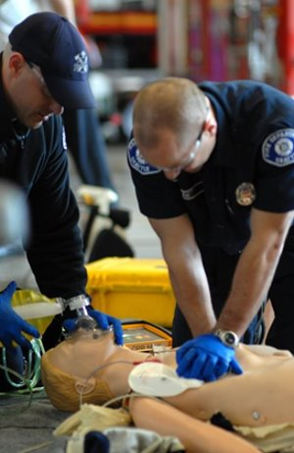
EMT Training: The EMS Division provides initial training, continuing education, and instructor/evaluator education for EMTs in King County. Through research, coordination, and communication among Medic One/EMS stakeholders and the regional Medical Program Directors, the Division develops curricula so that the training and educational programs meet individual agency, Washington State Department of Health, and national requirements. The Division is the liaison between the Washington State Department of Health and the 23 EMS/fire agencies in King County. It oversees the recertification and regulatory and policy changes to Medic One/EMS agencies.
Dispatch Training: Sending the appropriate resource in the appropriate manner is a critical link in the EMS system. The EMS Division provides comprehensive initial and continuing education training to dispatchers in King County outside the City of Seattle. King County dispatchers follow medically approved emergency triage CBD guidelines. These guidelines were developed by the EMS Division. CBD uses specific medical criteria based on signs and symptoms to send the appropriate level of care with the proper urgency.

REGIONAL SERVICES/STRATEGIC INITIATIVES
CPR/AED Training: The EMS Division of Public Health – Seattle and King County offers educational programs to King County residents, teaching them to administer life- saving techniques until EMS agencies arrive at the scene. This includes CPR classes with an emphasis on training teachers and students. Thousands of secondary school students receive instruction on CPR and AED use each year. In addition, regionally coordinated AED programs register and place automated defibrillators in the community within public facilities, businesses, and even private homes for high-risk patients, along with providing training in their use.
Community Centered Programs
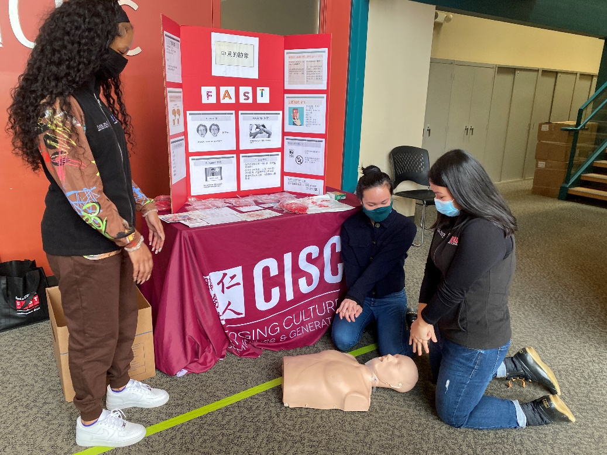
The complex health needs of King County’s residents can be as diverse as its communities. The EMS Division and its partners offer a wide variety of community centered services and programs to ensure emergency medical services provided are equitable, appropriate, and of the highest quality. This includes targeted community interventions to help manage the rate of call growth in the EMS system and address the demand for services. Programs like the Communities of Care and the Vulnerable Populations Strategic Initiative provide community-specific education and training about the appropriate use of EMS services and how to receive the proper level of care. The Taxi Voucher Program, Nurseline, and Mobile Integrated Healthcare programs offer alternative, high-quality care to 9-1-1 patients with lower acuity medical needs. The region reviews and revises dispatch guidelines so that specific types of calls are receiving the most appropriate level of response. In addition, the EMS Division works with its partners on efforts preventing the need to call 9-1-1 in the first place, with programs designed to appropriately install child seats and mitigate potential falls among older adults.
Regional Leadership and Management
The EMS Division provides financial and administrative leadership and support to both Public Health – Seattle & King County government as well as external EMS partners, bringing expertise, knowledge, and stability to the system, thereby preserving the integrity and transparency of the entire system. The EMS Division actively engages with regional partners to implement the Medic One/EMS Strategic Plan; manage EMS levy funds; monitor contract and medical compliance and performance; identify and participate in countywide business improvement processes; facilitate the recertification process for the 4,300 EMTs in King County; and maintain the continuity of business in collaboration with Medic One/EMS partners. This also includes regional planning for the Medic One/EMS system which monitors medic unit performance, the periodic assessment of medic unit placement, and other system parameters. Regional planning analyzes medic unit demand projections and measures the impacts of regional programs, supported by ongoing data quality improvement activities.

REGIONAL SERVICES/STRATEGIC INITIATIVES

Center for the Evaluation of Emergency Medical Services (CEEMS)
CEEMS conducts research aimed at improving the delivery of pre-hospital emergency care and advancing the science of cardiac arrest resuscitation. It is funded by grants from private foundations, state agencies, and federal institutions. CEEMS is a collaborative effort between the EMS Division and academic faculty from the University of Washington who are recognized nationally for their contributions in the care and treatment of cardiac emergencies. Achievements made by this collective effort continue to improve outcomes from sudden cardiac arrest and advance evidenced-based care and treatment.

RS/SI RECOMMENDATION 2:
ENHANCE programs to meet regional needs.
- The region continues to see a record number of EMT hires throughout the EMS system. Increasing the number of initial EMT training classes is required to get these new hires certified and meet the growing demands of EMS in the county.
- When the Telephone Referral Program, or Nurseline, contract was discontinued in 2023, the region supported finding a way to preserve this critical service. An even more comprehensive Nurse Navigation program was initiated in late 2024 which will help decrease non-emergent dispatches and improve the overall efficiency of the EMS system. Maintaining this renovated program is a priority for the 2026-2031 levy span.
- The STRIVE Initiative, implemented during the 2020-2025 levy period, modernized the EMS Division’s online continuing medical education platform, EMS Online. Converting STRIVE’s ongoing operations and maintenance into regional support services and providing funding for 2026-2031 will help ensure the EMS Division can meet the region’s changing educational, data, and technological needs of the eLearning environment.

RS/SI RECOMMENDATION 3:
MAINTAIN AND DEVELOP Strategic Initiatives that leverage previous investments made by the region to improve patient care and outcomes.
Areas identified by the Regional Services Subcommittee include continued focus on vulnerable populations, enhancing quality improvement capabilities, and supporting mental wellness and equity and social justice efforts.

Vulnerable Populations Strategic Initiative (VPSI) – CONTINUING AS EMS Community Health Outreach (ECHO)
VPSI was launched during the 2014-2019 levy period to improve interactions between EMS and historically underserved communities. Continued support for VPSI efforts throughout the 2026-2031 levy span will further enable communities to remain actively engaged with EMS agencies and continue to address disparities in access to services. This includes expanding community partnerships, connecting local EMS agencies to community-led organizations, and introducing new education and outreach topics to meet the evolving needs of the communities. To better represent this work and align with the commitment to equity and social justice, VPSI will be renamed EMS Community Health Outreach (ECHO) for the 2026-2031 levy span.
REGIONAL SERVICES/STRATEGIC INITIATIVES

- Accelerating Evaluation and Innovation: an Opportunity for Unprecedented Quality Improvement (AEIOU) Strategic Initiative - CONTINUING AS Pioneering Research for Improved Medical Excellence (PRIME) Strategic Initiative
AEIOU built upon the technological work between regional partners from all parts of the EMS system to bolster the region’s quality improvement abilities, capacity, and efforts. It included creating standardized systems for data analysis, updating data-sharing mechanisms, and contributing toward advancements of medical research. PRIME is the next iteration in upgrading current data processes and enhancing overall data management capabilities, contributing to medical quality improvement efforts. It includes improvements to the patient care records software (ESO Solutions), data sharing, standardization, and data automation; improving integration pertaining to data systems with Public Health, ESO, and agencies; and conducting pilot projects to foster innovation.

- Emergency Medical Dispatch Strategic Initiative - NEW
This initiative invests in emergency medical dispatch (EMD) improvements, including identification of an external vendor to host the electronic criteria based dispatch (eCBD) guidelines used to determine the appropriate level of care and response type. Using an outside vendor brings greater security, more rapid eCBD updates, and increased interoperability between systems that exchange information. It also provides funding to explore EMD-focused pilots for continuous quality assurance/quality improvement activities during and after 9-1-1 calls.
- King County Fire Chiefs Association Mental Wellness & Equity, Racism & Social Justice/Diversity, Equity & Inclusion proposals
The King County Fire Chiefs Association (KCFCA) has partnered with the EMS Division to develop strategies to address mental wellness for all first responders and advance equity in EMS organizations and the diverse communities they serve. Like the BLS Subcommittee, the Regional Services Subcommittee endorsed continuing these efforts that further advance such causes for the 2026-2031 levy span:
Mental Wellness:
KCFCA proposes to create and implement a comprehensive mental wellness approach across King County to support the health of our region’s first responders, medics, and dispatchers. This effort will focus on a regional system of support, reflect the needs of frontline workers, and garner the expertise of leaders in the mental wellness field. It will include consulting authorities in first responder mental wellness, continuing peer support training, and organizing other learning opportunities for EMS personnel.
Diversity, Equity and Inclusion/Equity, Racial and Social Justice:
This proposal would evenly divide resources between fire agencies and the EMS Division to pursue parallel DEI and ERSJ priorities. For EMS agencies, this entails investing in continued recruitment and hiring workshops and partnering with the frontline-led DEI Network. For the EMS Division, this will focus on integrating ERSJ efforts within the Division with Public Health - Seattle & King County business and supporting outward facing work that connects communities to EMS skills and knowledge. This includes the community-based Vulnerable Populations Strategic Initiative along with the Strategic Training and Recruitment (STAR) program and the Future Women in EMS/Fire recruitment programs.
REGIONAL SERVICES/STRATEGIC INITIATIVES

Programmatic Comparison Between Levies
2020-2025 Levy | 2026-2031 Levy
Regional Services (RS)
Fund regional services that focus on superior medical training, oversight, and improvement; innovative programs and strategies; regional leadership, effectiveness and efficiencies. | Fund regional services that focus on superior medical training, oversight, and improvement; innovative programs and strategies; regional leadership, effectiveness and efficiencies; and strengthening community interactions and partnerships.
Move BLS Core Services program out of Regional Services budget and into BLS allocation. | Enhance programs to meet regional needs.
Inflate costs at CPI-W + 1% | Inflate costs at CPI-W + 1%
Strategic Initiatives (SI) and other programs
Convert or integrate five strategic initiatives with other programs to supplement system performance. Explore a Mobile Integrated Healthcare (MIH) model to address community needs.
- Convert BLS Efficiencies into ongoing programs
- Transition CMT and E&E into MIH exploration
- Convert RMS into ongoing programs
- Integrate the BLS Training and QI SI into the BLS
Allocation
Support existing and new strategic initiatives that leverage previous investments made to improve patient care and outcomes.  - Continue implementing next stages of Vulnerable Populations  - Develop two new Initiatives: 1) AEIOU and 2) STRIVE  - Transition Community Medical Technician into MIH exploration  Provide regular updates to past audit recommendations  Inflate costs at CPI-W + 1% | Support existing and new strategic initiatives that leverage previous investments made to improve patient care and outcomes.  - Continue implementing next stages of Vulnerable Populations -> ECHO and AEIOU -> PRIME  - Develop one new Initiative focused on Emergency Medical Dispatch  - Support KCFCA proposals promoting mental wellness and ERSJ/DEI  Inflate costs at CPI-W + 1%

FINANCE

ECONOMIC FORECAST
The Medic One/EMS Levy financial plan is based on a post-pandemic economic recovery, which stabilized the economy after a period of high inflation and increased mortgage rates. Based on projections from the King County Office of Economic and Financial Analysis (OEFA), the financial plan assumes lower inflation with rates stabilizing at less than three percent in the second and third years of the levy period and the gradual lowering of mortgage rates. King County inflation is projected to remain higher than the national average.
In addition, residential assessed value (AV), particularly for single-family homes, is increasing at rates higher than commercial and industrial properties both in Seattle and King County. Commercial AV outside of the City of Seattle has remained more stable. As a result, OEFA has forecast a reduction in the City of Seattle’s percentage of property tax relative to levels prior to 2022.
Given the experience of the 2020-2025 levy period with high inflation and dynamics affecting both AV projections and the distribution of AV between the City of Seattle and the KC EMS Fund (remainder of King County), it was deemed prudent by the Finance Subcommittee to continue to include economic/supplemental reserves to cover the potential of reduced property taxes or increased expenses related to inflation.

FINANCE SUBCOMMITTEE
Chair: The Honorable Lynne Robinson, Mayor of Bellevue
The Finance Subcommittee assessed the programmatic recommendations developed by the other subcommittees and provided financial perspective and advice to the Task Force. As the ALS, BLS, and Regional Services Subcommittees each developed its own set of recommendations specific to its program areas, the Finance Subcommittee reviewed the proposals as a whole package, rather than as individual and independent pieces, to ensure the financial plan was well balanced and financially prudent.
The Subcommittee also looked at the recommendations within the perspective of the levy planning economic environment, economic forecasts, and the potential for changes in the economic forecast. Significant efforts went toward analyzing financial implications of changes in economic conditions to develop appropriate contingency and reserve levels.
The Finance Subcommittee recommendations are as follows:
FINANCE RECOMMENDATION 1:
CONDUCT A RISK ANALYSIS to determine appropriate reserve funding to help safeguard the Medic One/EMS system from unforeseen financial risk.
To better understand the level of risk for the next levy span, the Subcommittee requested that King County staff prepare different “what-if” scenarios (sensitivity analyses) to evaluate how changes to the proposed revenue and expenditures could impact the financial plan. The scenarios assumed:
- Potential of reduced property taxes, and
- Potential of higher inflation that could increase costs of planned services.

FINANCE

The revenue scenarios considered three different ways property taxes could be less than planned: reduced AV, reduced new construction, and a change in the proportion of funds between the City of Seattle and the King County EMS Fund. The expenditure scenarios looked at potential increased inflation and evaluated inflation increases from 0.5 percent to 1.5 percent higher than planned. Each scenario contained a least and worst case situation for the Subcommittee to consider.
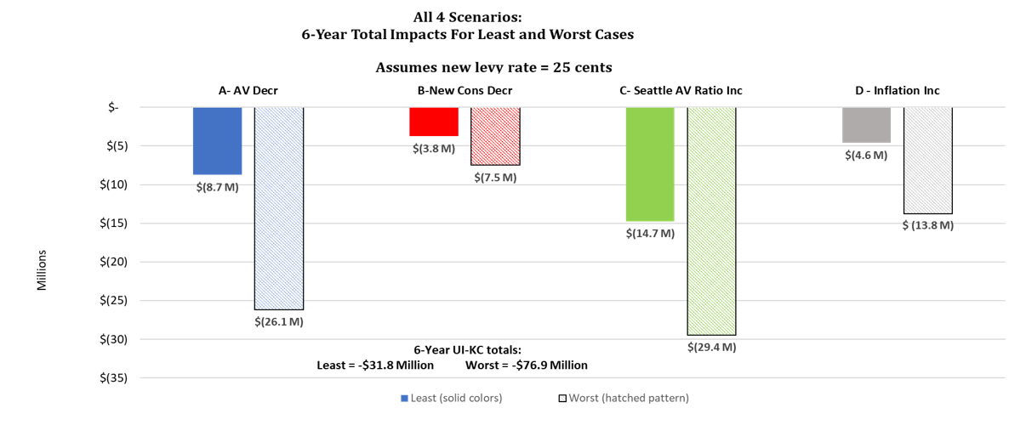

Subcommittee members used this information to determine whether the planned reserves could accommodate a potential change in economic conditions. Since the City of Seattle funds reserves separately from EMS levy funds, the Subcommittee focused on appropriate reserves for the King County EMS Fund. The potential impacts on the King County EMS Fund ranged from a decrease of $31.8 million to a decrease of $76.9 million. The financial plan includes approximately $47.0 million for Economic/Supplemental Reserves. These reserves allow the EMS levy to remain whole even if many of these scenarios occur. Based on the potential for economic volatility, the Subcommittee recommended fully funding reserves and placing any additional funds into supplemental reserves.

FINANCE RECOMMENDATION 2:
INCORPORATE sufficient reserves and contingencies, with appropriate access policies, to mitigate financial risk and provide flexibility; adapt policies as needed for alignment with King County financial policies.
Reserves were first explicitly included in the 2008-2013 Medic One/EMS financial plan when regional partners wanted to ensure that funds were available to address emerging needs, particularly larger one-time expenses and unexpected/unplanned expenses. Now an integral and expected part of the levy’s financial plan, EMS reserves are routinely reviewed and adjusted to better meet the needs of the regional system and consistency with updated King County Financial Policies.
FINANCE

2026-2031 Proposed Contingencies and Reserves
Subcommittee members agreed that the financial plan should include adequate and reasonable reserves and contingencies to fund unanticipated or one-time costs. The group supported fully funding programmatic and King County-required rainy day reserves (90-day funding). In addition, Subcommittee members prioritized placing remaining funds in the Economic/Supplemental Reserves to protect the system should the economy change. Revenues received that are not needed to cover program and reserve needs will be placed in the Economic/Supplemental Reserves to supplement existing reserves, and/or be used to buy down a future levy rate. Reserves and contingencies would continue to have appropriate access and usage policies and would be consistent with King County financial policies.

Based on the system’s programmatic needs as determined in the other three subcommittees and the desire to be prepared in the event of an economic downturn, the Finance Subcommittee recommended the following for Contingencies and Reserves.
- Fund Contingencies at $1.3 million a year to cover significant increases in operating costs that cannot be accommodated by the ALS allocation or program balances. An example is paid-time-off above amounts included in the allocation (due to the need to backfill paid-time-off). On a limited basis, allow contingency funding to be available to cover unplanned expenses related to regional services and initiatives.
- Fund Programmatic Reserves that include:
$1.3 million for ALS equipment – covers unplanned costs related to equipment including potential addition of new equipment, decreased lifespans of equipment or need for early replacement, and increased costs not accommodated within the Equipment Allocation, and
$17.4 million for ALS Capacity – includes $1.6 million to accommodate moving a medic unit to a new location or cover significant investments needed at current locations, and temporary capacity increases; and $15.8 million as a placeholder for new units. This is consistent with ALS Subcommittee Recommendations #4 and #5.
- Funding the Rainy Day Reserve consistent with King County policy (currently 90-days). This is estimated at $41.2 million.
- Placing any other available funds in the Economic/Supplemental Reserve to accommodate potential economic downturn. The current estimate is $47 million.

Total Contingencies & Reserves Budget
for the 2026 - 2031 Levy Period
 | 2026-2031 Total
Contingencies & Programmatic Reserves | $26.5 million
Rainy Day Reserve | $41.2 million
Total Programmatic Reserves | $67.7 million
Economic/Supplemental/Rate Stabilization | $47.0 million

FINANCE RECOMMENDATION 3:
FINANCE
EXPENDITURES AND RESERVES projected at $1.5 billion over the six-year span. The budget supports maintaining current services and meeting anticipated future demand.
The proposed budget maintains funding for the system’s key services of ALS, BLS, regional programs, and initiatives. An increase in BLS funding reflects the growth in inflation, population, and BLS responsibilities, while a revised BLS basic allocation helps address equity and need. There is enhanced support for the MIH program, two reconfigured strategic initiatives, and a new initiative focused on dispatch.
The 2026-2031 levy financial plan maximizes savings from the current levy period to fund future reserves. It assumes that a total of $64.4 million from 2020-2025 levy reserves will carry forward to the 2026-2031 levy period to reduce the need to raise funds in the next levy span to fund reserves. This $64.4 million is comprised of $34.7 million from the rainy day fund, and $29.7 million from the economic/supplemental reserves, and helps to reduce the starting levy rate.
The following chart compares projected revenues to expenditures for the 2026-2031 levy.

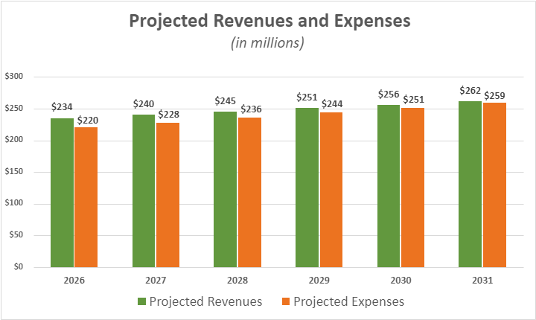

FINANCE

FINANCIAL PLAN OVERVIEW & ASSUMPTIONS
The 2026-2031 financial plan endorsed by the EMS Advisory Task Force meets the programmatic needs identified in the subcommittees, maintains financial policies used during previous levy spans, and provides adequate reserves to ensure continuation of essential EMS services in the case of an economic downturn.
It was developed based on widely understood and accepted regional principles of the tiered system:
- The Medic One/EMS levy will continue to support the delivery of quality pre-hospital emergency medical services and supply adequate funding to provide these services;
- Advanced Life Support (ALS) services will remain the priority of the Medic One/EMS levy;
- Basic Life Support (BLS) services will be funded through a combination of local taxes and Medic One/EMS levy funds;
- The EMS Division is responsible for:
    - coordinating and convening regional partners to facilitate collaborative activities necessary to assure the success of the regional strategic and financial plans;
    - managing and ensuring the transparency of system finances; and
    - continuing to innovate and evaluate the efficacy and funding of programs from a system-wide perspective.

Financial Oversight and Management
The EMS Division is responsible for managing the levy fund in accordance with the Medic One/EMS Strategic Plan, the EMS financial plan, EMS Financial Policies PHL 9-2 (see below), and adopted King County Ordinances. Public Health - Seattle & King County’s Chief Financial Officer provides general oversight of the EMS Division financial plan. Financial policies will continue to be updated to document and meet system needs including adapting to updated King County Financial Policies (within funding limits of the levy) and reflect financial decisions and recommendations from the adopted Medic One/EMS 2026-2031 Strategic Plan. EMS Division responsibilities include the review and evaluation of allocations, and the management of regional services and strategic initiatives, Contingencies and Reserves as reflected in the Plan, the EMS financial plan and associated King County ordinances.
EMS Financial Policies – PHL 9-2
Oversight and management of EMS levy funds;
Methodology for appropriately reimbursing ALS agencies for eligible costs, including responsibilities by both the EMS Division and ALS agencies related to Operating and Equipment Allocations;
Required reporting by ALS agencies with review and analysis by EMS Division;
Methodologies for BLS, regional services, and strategic initiatives funding;
Regional services and strategic initiatives management, and
Review and management of reserves and designations including program balances.

FINANCE

Considerations & Drivers
This financial plan is based on key regional priorities outlined in this document to aggressively manage resources and the growth of services, create efficiencies, address uncertainty, and build on previous investments. Although experiencing a strong economy, the region was concerned about potential economic changes during the span of the next levy. Steps taken to help address uncertainties include continuing the ALS allocation structure with subtle updates, using the more conservative 65 percent confidence level in forecasting revenues (per King County policy) and ensuring sufficient contingencies and reserves. Reserve recommendations include fully funding programmatic and rainy day reserves plus directing any additional funds available in a 25.0 cent levy into an Economic/Supplemental reserve that could be used in the case of an economic downturn. In determining Economic/Supplemental reserve levels, King County prepared four different scenarios to evaluate how changes to the proposed AV, new construction, inflation, and City of Seattle AV could impact the EMS levy financials.
Primary cost drivers relate to increases in the costs of providing services, demand for services, and changes in the types of services to meet community needs. Primary revenue drivers include 2026 starting AV and assumptions related to new construction.
Expenditures are based on Subcommittees’ recommendations and are inflated yearly based on forecasts from the King County Office of Economic and Financial Analysis. Reserves and contingencies are based on programmatic needs and updated for compliance with King County Financial Policies, including a 90-day rainy ray reserve requirement for all levy supported funds. Economic/Supplemental reserves are consistent with the rate stabilization reserve category in the financial policies.
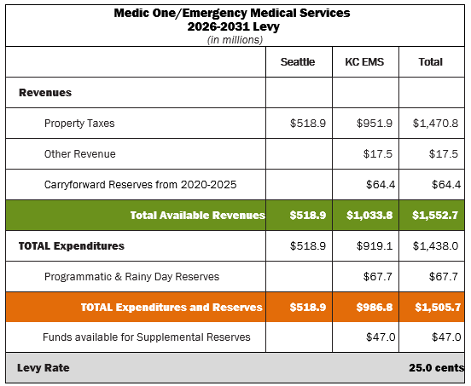
Revenues are planned to cover expenditures across the 2026-2031 levy period. Revenue needs were reduced by carrying forward approximately $64.4 million from the 2020-2025 levy. The recommended 25.0 cent per $1,000 AV levy rate allows supplemental reserves of $47 million that could be available in an economic downturn.

FINANCE
FINANCIAL PLAN ASSUMPTIONS
The 2026-2031 financial plan, like other financial plans, is based on numerous assumptions and acknowledges that actual conditions may differ from the original projections. The objective is to have a financial plan flexible enough to handle changes as they occur. Key financial assumptions provided by the King County Economist include new construction growth, assessed value, inflation, and cost indices. Actuals are through 2023. Most of the assumptions for the 2026-2031 financial plan include inflation and growth assumptions for 2025 as well as 2026-2031.
This section documents key assumptions and shows projected costs related to inflation increases and distribution of property taxes. It also outlines estimated revenues, expenditures, and reserves that constitute the 2026-2031 financial plan. Note that when numbers are rounded to millions for presentation purposes, some rounding errors will occur.
Total expenditures are projected to be $1.4 billion over the 2026-2031 levy period, with $919 million projected for the King County EMS Fund. The financial plan includes carrying forward $64.4 million in rainy day and economic/supplemental reserves from the 2020-205 levy which reduces the funding and levy rate needed for the 2026-2031 levy. A 25.0 cent per $1,000/AV rate is proposed to fund the 2026-2031 levy period.

KEY ASSUMPTIONS

Revenues
The 2026-2031 financial plan is based on an EMS property tax levy as the primary source of funding. The revenue forecast is built on assumptions including the AV at the start of the levy period, AV growth, and new construction AV, as forecast by the King County Office of Economic and Financial Analysis (OEFA). Other considerations include the division of property tax revenues between the City of Seattle and the King County EMS Fund, interest income on fund balance, and other revenues received by property tax funds at King County. While previous levy periods assumed a one percent delinquency rate, King County now forecasts without it.
The plan is based on increases in King County AV from 2020 to 2025 followed by a forecast of more moderate increases between 2026 and 2031. The forecast assumes growth of new construction AV from $10.4 billion in 2026 (the first year of the levy) and end the levy period at $11.8 billion in 2031. The EMS levy does not receive new construction funds in the first year of the levy.

Key Assumptions: 2026 - 2031 Forecast
Rate of Growth | 2026 | 2027 | 2028 | 2029 | 2030 | 2031
New Construction |  | 3.57% | 2.00% | 2.48% | 2.19% | 2.48%
Growth in Existing AV | 5.87% | 4.64% | 4.43% | 4.45% | 4.77% | 4.52%

FINANCE

Assessment (Property Taxes):
Per RCW 84.55.010, increases in assessments (property taxes) are limited to one percent plus assessments on new construction. Forecast property tax increases exceeding one percent are due to new construction. The following chart and table show the relationship between assessed value, levy assessment (property taxes), and levy rate as currently forecasted. While the growth in AV from 2026 to 2031 averages just under five percent per year, projected property taxes (property taxes/assessment) are projected to average just over two percent per year. Assessment includes a one percent increase on existing properties and the addition of new construction. Based on these increases, the levy rate is projected to decline from 25.0 cents to 22.4 cents per $1,000 AV in the last year of the levy (2031).
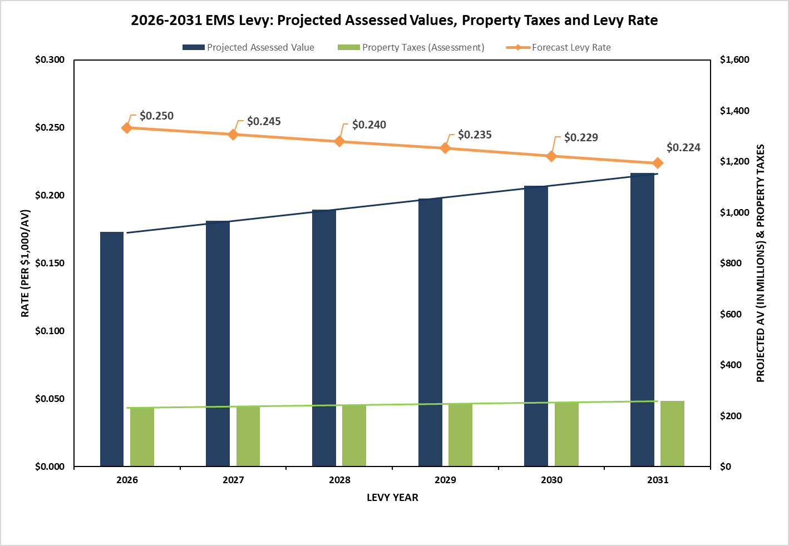

Levy Year | Projected AV | Property Taxes (Assessment) | Forecast  Levy Rate | Growth  in AV | Growth in Assessment
2026 | $924,584,361,939 | $231,146,090 | $0.250
2027 | $967,445,977,367 | $237,045,806 | $0.245 | 4.64% | 2.55%
2028 | $1,010,332,965,793 | $242,414,877 | $0.240 | 4.43% | 2.26%
2029 | $1,055,291,690,277 | $247,862,021 | $0.235 | 4.45% | 2.25%
2030 | $1,105,597,146,946 | $253,383,158 | $0.229 | 4.77% | 2.23%
2031 | $1,155,558,905,321 | $259,007,621 | $0.224 | 4.52% | 2.22%

FINANCE

Division of Revenues:
Revenues raised within the City of Seattle are sent directly to the City by King County; revenues for the remainder of King County are deposited in the King County EMS Fund. The percentage of overall AV in the City of Seattle has decreased during the current levy period from 40.1 percent in 2020 to 35.5 percent in 2025 but is forecast to increase slightly over the 2026-2031 levy period.
The following table shows AV trends for the 2026-2031 levy:
Estimated Value of Assessments
for the 2026 - 2031 Levy Period (in millions)
 | Average % of Assessed Value | Estimated Tax Revenue | Estimated Other Revenue | Estimated Total
City of Seattle | 35.27% | $518.9 |  | $518.9
KC EMS Fund | 64.73% | $951.9 | $17.5 | $969.4

The following table shows forecast property tax assessments based on the forecast division of property taxes by King County OEFA. Forecast levy revenue above one percent is due to new construction.

Forecast Property Tax Assessment 2026 - 2031 (in millions)
 | 2026 | 2027 | 2028 | 2029 | 2030 | 2031 | 2026-2031  Total
City of Seattle | $80.7 | $83.0 | $85.3 | $87.7 | $89.9 | $92.3 | $518.9
Growth in City of Seattle |  | 2.85% | 2.77% | 2.81% | 2.51% | 2.67%
KC EMS Fund | $150.5 | $154.0 | $157.1 | $160.1 | $163.5 | $166.7 | $951.9
Growth in KC EMS Fund |  | 2.36% | 1.97% | 1.95% | 2.10% | 1.96%

Other Revenues:
In addition to property taxes from the Medic One/EMS levy, the KC EMS Fund receives interest income on its fund balance, and other miscellaneous King County revenues distributed proportionately to property tax funds (such as lease and timber taxes).

Other Revenue Assumptions KC EMS Fund
Revenues | Estimate | % of Total Revenue
Interest Income | $15,127,000 | 86.3%
Other Revenue Sources | $2,400,000 | 13.7%
Total Other Revenue | $17,527,000 | 100.0%

FINANCE

Expenditures
Total expenditures, including both City of Seattle and KC EMS Fund are estimated at $1.4 billion with $519 million estimated for the City of Seattle and $919 million estimated for the King County EMS Fund. The remainder of this section covers KC EMS Fund expenditures.
The KC EMS Fund finances four main program areas related to direct service delivery or support programs:
- Advanced Life Support (ALS)
- Basic Life Support (BLS), including Mobile Integrated Healthcare (MIH)
- Regional Services (RS)
- Strategic Initiatives (SI)
In addition, funding for contingencies and reserves is allocated within the financial plan.
Program budgets are increased yearly with inflators appropriate to the program. All programs, except for the ALS equipment allocation, are proposed to be increased by the local CPI-W + 1%. The one percent accommodates benefits and other costs, such as pharmaceuticals, that often increase at rates higher than CPI-W. The CPI assumptions used in this financial plan were provided by King County OEFA. Expenditures are inflated by the previous year’s actuals (through June).

CPI Assumptions – CPI-W
Levy Year | 2025 | 2026 | 2027 | 2028 | 2029 | 2030 | 2031
CPI-W | 3.63% | 3.46% | 2.96% | 2.62% | 2.84% | 2.60% | 2.49%

The current CPI-W for the Seattle area is CPI-W Seattle-Tacoma-Bellevue. The ALS equipment allocation is inflated by the Producer Price Index for transportation equipment: other trucks and vehicles, complete, produced on purchased chassis, except upfitting trucks. If the definition of these indices is updated or discontinued, EMS will use the updated indices (such as the change in the PPI for transportation equipment in the past levy period) or choose a closely aligned index as reviewed by the King OEFA. If needed, an alternative index could be proposed and reviewed by the EMS Advisory Committee and King County OEFA.
Programmatic expenditure levels for the 2026-2031 levy period are based on increases using the identified inflator for the program, the timing of new services, and cash flow projections for individual strategic initiatives. The actual allocation will differ slightly based on actual (rather than forecast) economic indices.

FINANCE

Expenditures by Program Areas
The following table includes the expenditures by program area for the KC EMS Fund.

Program Area Expenses | King County
Advanced Life Support (ALS) | $511,807,522
Basic Life Support (BLS & MIH) | $273,916,796
Regional Support Services | $124,933,604
Strategic Initiatives | $8,493,623
Sub-Total | $919,151,545
Reserves | $67,686,382
Total Programmatic Proposal | $986,837,927
Economic/Supplemental Reserves | $46,974,700

Advanced Life Support (ALS) Services
Since the first Medic One/EMS levy in 1979, regional paramedic services have been largely supported by, and are the funding priority of, the Medic One/EMS levy. Costs have been forecasted as accurately as feasible; but should the forecasts prove insufficient, ALS remains the first priority for any available funds. Contingency and reserve funds are available if needed. Funding levels for Bellevue Medic One, Northeast King County Medic One (Redmond), Shoreline Medic One, and King County Medic One are allocated on a per unit cost basis, as shown in the chart below.

Advanced Life Support (ALS) Standard Unit Cost: 2026 Allocations
Category | Average Costs | %
Medic Unit Allocation | $2,821,501 | 69.51%
Supervisory/Program Allocation | $711,281 | 17.52%
System Allocation | $375,176 | 9.24%
Subtotal Operating Allocations | $3,907,958 | 96.27%
Equipment Allocation | $151,271 | 3.73%
ALS Per Unit Total | $4,059,229 | 100.00%

The equipment allocation is based on average cost of equipment purchases, the expected lifespan of the equipment, and the number needed per unit. Each medic unit is budgeted to have two vehicles – primary and back-up for when the primary is out-of-service, there is an overlap between shifts, and times when an extra response unit may be needed (such as in the event of a storm or flood).
ALS operating allocations are proposed to increase yearly by CPI-W + 1%. The equipment allocation will remain inflated using a PPI related to transportation equipment, as recommended by the King County Auditor’s Office. The King County Economist recommends using a 40-year average of that PPI for forecast purposes.
FINANCE

ALS Allocation - Inflation Assumptions
Inflation  Assumption | Calculation Basis | Source | 2026 | 2027 | 2028 | 2029 | 2030 | 2031
Operating Allocation | Local CPI-W +1%  (CWURS49DSAO) | KC OEFA | 4.46% | 3.96% | 3.62% | 3.84% | 3.60% | 3.49%
Equipment Allocation | WPU14130294 | KC OEFA | 3.00% | 3.00% | 3.00% | 3.00% | 3.00% | 3.00%

The following table shows estimated ALS costs for the KC EMS Fund.

Total Projected ALS Service Expenses During the 2026-2031 Levy Period
 | 2026 | 2027 | 2028 | 2029 | 2030 | 2031 | 2026-2031  Total
KC EMS Fund | $77,669,176 | $80,720,142 | $83,626,832 | $86,815,477 | $89,925,097 | $93,050,798 | $511,807,522

The 2026-2031 financial plan recommends an annual review of ALS costs to minimize cost-shifting to agencies. As has been the practice, a group that includes representatives from the different ALS agencies will meet annually or as appropriate to review costs and provide recommendations on the adequacy of the allocations.

Basic Life Support (BLS) Services
FINANCE
Total BLS funding, including Mobile Integrated Healthcare (MIH), for 2026-2031 is estimated at $273 million.
Basic Life Support Funding: While there are 23 fire agencies that provide BLS services throughout the region, the levy provides partial funding to 21 BLS agencies (excluding the City of Seattle and the Port of Seattle Fire Departments) to help ensure uniform and standardized patient care and enhance BLS services. BLS funding is inflated at CPI-W + 1% per year. In addition, $3 million will be added to the baseline 2026 allocation and will be allotted in the first year using the newly revised BLS allocation distribution methodology. The one percent added to CPI acknowledges expenses, such as step increases, benefits, and other expenses such as pharmaceuticals that typically increase at rates higher than the inflationary assumptions included in the regional CPI-W.

Total Projected BLS Service Expenses During the 2026-2031 Levy Period
 | 2026 | 2027 | 2028 | 2029 | 2030 | 2031 | 2026-2031  Total
King County | $33,962,126 | $35,307,026 | $36,585,141 | $37,990,010 | $39,357,652 | $40,731,235 | $223,933,190

MIH Funding: The 2026-2031 levy includes funding the MIH program to address community needs. MIH allocations inflate at CPI-W +1%. In addition, $2 million will be added to the baseline 2026 allocation and will be distributed the first year using the same methodology as the BLS allocation. For additional information on MIH, please refer to page 29.

Total Projected Annual MIH Expenses During the 2026-2031 Levy Period
 | 2026 | 2027 | 2028 | 2029 | 2030 | 2031 | 2026-2031  Total
King County | $7,580,607 | $7,880,799 | $8,166,084 | $8,479,662 | $8,784,930 | $9,091,524 | $49,983,606

Regional Services
The EMS Division is responsible for managing regional Medic One/EMS programs and services that support critical functions that are essential to providing the highest quality out-of-hospital emergency care available. Funds to support overall infrastructure and expenses related to managing the regional system are budgeted in Regional Services. Regional services are inflated at CPI-W + 1% per year. For additional information on regional services, please refer to page 33.

Total Projected Regional Services Expenses for 2026-2031 Levy Period
 | 2026 | 2027 | 2028 | 2029 | 2030 | 2031 | 2026-2031  Total
King County | $18,947,663 | $19,697,991 | $20,411,058 | $21,194,843 | $21,957,859 | $22,724,190 | $124,933,604

Strategic Initiatives
FINANCE
Strategic initiatives are pilot projects geared to improve the quality of EMS services, contain costs, and/or manage the rate of system growth. Strategic initiatives are funded with lifetime budgets that include inflationary assumptions similar to those used by regional services. Increased funding for the programs and new projects is reviewed and recommended by the EMS Advisory Committee and the King County Council through the normal County budget process. For additional information on strategic initiatives, please refer to page 33.

Total Projected Strategic Initiatives Expenses for the 2026-2031 Levy Period
 | 2026 | 2027 | 2028 | 2029 | 2030 | 2031 | 2026-2031  Total
ECHO | $482,988 | $559,292 | $638,787 | $663,316 | $687,195 | $711,179 | $3,742,757
PRIME | $247,500 | $257,301 | $266,616 | $276,854 | $286,820 | $296,828 | $1,631,919
EMD SI | $275,000 | $224,356 | $229,491 | $235,136 | $240,631 | $246,149 | $1,450,763
Mental Wellness | $176,000 | $182,970 | $189,593 | $196,873 | $203,961 | $211,079 | $1,160,476
ERSJ/DEI | $77,000 | $80,049 | $82,947 | $86,132 | $89,233 | $92,347 | $507,708
TOTAL King County | $1,258,488 | $1,303,968 | $1,407,434 | $1,458,311 | $1,507,840 | $1,557,582 | $8,493,623

Reserves and Contingencies
Reserves were added during the 2008-2013 levy planning process and continue to be refined for this levy period. The reserve levels proposed are consistent with updated King County Financial Policies requiring 90-day reserves for levy funds and reflect the Task Force’s concerns about being sufficiently resilient and able to provide services during a potential economic downturn.
Categories include programmatic, rainy day, and economic/supplemental reserves. Contingency funding, while technically not a reserve, is rolled into the programmatic category. Programmatic reserves are designed to cover potential ALS costs related to equipment and expanding capacity (including $15.8 million “placeholder” that could cover costs related to adding up to two 12-hour ALS units). The plan includes a 90-day rainy day reserve, in adherence with King County financial policies. To ensure resiliency, funds above the amount needed to cover programmatic needs (expenditures, contingencies, and reserves) will be placed in an economic/supplemental reserve. These funds will be available to address funding if there is an economic downturn and can replenish other reserves during the levy period. If not used during the levy period, these reserves and contingency are intended to buy down a future levy rate. Use of programmatic reserves and contingency will be reviewed by the EMSAC Financial Subcommittee and the EMS Advisory Committee. The funds would also require appropriation by King County.
If needed to address emerging conditions, changed economic circumstances and/or King County policies, changes to reserves can be implemented during the 2026-2031 levy period. Such changes would require review and approval by the EMS Advisory Committee, the Executive, and the King County Council.
Reserves included in the 2026-2031 levy plan are shown in the following table.
FINANCE
Projected Annual Reserves Levels: 2026-2031 Levy
 | 2026 | 2027 | 2028 | 2029 | 2030 | 2031
Programmatic Reserves | $26,470,000 | $26,470,000 | $26,470,000 | $26,470,000 | $26,470,000 | $26,470,000
Rainy Day Reserve | $34,377,056 | $35,731,215 | $37,034,766 | $38,450,541 | $39,830,148 | $41,216,382
Total Programmatic  Reserves | $60,847,056 | $62,201,215 | $63,504,766 | $64,920,541 | $66,300,148 | $67,686,382
Economic/ Supplemental Reserves | $17,935,149 | $28,730,755 | $37,075,300 | $42,643,462 | $46,020,165 | $46,974,700
Note: Reserves roll over year-to-year; total budget dedicated to programmatic reserves is $67.7 million

To encourage cost efficiencies and allow for variances in expenditure patterns, program balances were added during the 2002-2007 levy and have remained in practice. Program balances allow agencies to save funds from yearly allocations to use for variances in expenditures in future years. They are primarily used by ALS agencies to accommodate cashflow peaks related to completing labor negotiations – particularly related to back wages. Within the Regional Services budget, use of program balances may be related to the timing of special projects (particularly projects supporting ALS or BLS agencies). Program balances are proposed to continue in the 2026-2031 levy period. Program balances are not shown in the proposed levy financial plan but are reviewed on a regular basis.

Appendix A: Proposed 2026-2031 Regional Services
Regional services planned in the 2026-2031 levy, including converted strategic initiatives are as follows:
TRAINING AND EDUCATION
EMT TRAINING
- Basic Training: Entry-level training to achieve WA State certification
- EMS Online Continuing Education (CE) Training: Web-based training to maintain/learn new skills and meet state requirements
- CBT Instructor Workshops: Training for Senior EMT instructors
- Regionalized Initial Training: Condensed training conducted zonally
- EMT Certification Recordkeeping: Monitor and maintain EMS certification records
- Strategic Training and Research (STAR) program: Training opportunities for traditionally underrepresented students
- STRIVE: The modernized EMS Online teaching platform supporting a Learning Management System (LMS) and Learning Records Store (LRS) for enhanced reporting capabilities
PARAMEDIC TRAINING
- EMS Online Continuing Education modules: Web-based training to maintain skills, developed in coordination with UW Harborview Paramedic Training program
- Paramedic Training: Certified paramedics support students at the UW Harborview Paramedic Training program
- Harborview Series: Posting of “Tuesday Series” on EMS Online
EMERGENCY MEDICAL DISPATCH (EMD) TRAINING
- Basic Training: 40 hours entry level Criteria Based Dispatch training
- Continuing Education: Eight-hour hybrid (in-class and EMS online web-based) instruction to reinforce training/learn new skills
- Advanced EMS Training: Enhanced medical dispatching concepts
- EMS Instructor Training: Instructor training for Basic Dispatch
CPR/AED TRAINING: Secondary School Students: Conduct CPR instructor training, purchase training supplies and equipment, train students
COMMUNITY BASED PROGRAMS
INJURY PREVENTION
- Fall Prevention for Older Adults: Home fall hazard mitigation and patient assessment
- Shape-up 50+ for a Healthy & Independent Lifestyle: A community awareness campaign regarding exercise opportunities for seniors to prevent falls and injuries
- Child Passenger Safety Program: Proper car seat fitting and installation for populations not served by other
programs
- Targeted Age Driving: Safety interventions, include preventing driving and texting
TRP/NURSELINE: Divert low-acuity BLS calls to Nurseline for assistance in lieu of sending a unit response
TAXI TRANSPORT VOUCHER: Transport patients at lower costs using taxis as an alternative to private ambulances
COMMUNITIES OF CARE: Evaluate 9-1-1 calls for services and educate licensed care facilities on appropriate use of EMS resources
MOBILE INTEGRATED HEALTHCARE: Providing alternative yet still most appropriate care for lower-acuity and complex patients

REGIONAL MEDICAL QUALITY IMPROVEMENT (QI)
REGIONAL MEDICAL DIRECTION: Oversight of all medical care; approval of protocols, continued education, and quality improvement projects
PATIENT SPECIFIC MEDICAL QI: Review medical conditions to improve patient care
CARDIAC CASE REVIEW: Assessment and feedback re: cardiac arrest events throughout King County
EMERGENCY MEDICAL DISPATCH QI: Evaluation and improvement of medical 9-1-1 call handling and dispatch decisions
CRITERIA-BASED DISPATCH (CBD) GUIDELINES: CBD Revisions: Analysis to safely limit frequency that ALS is dispatched
DISPATCHER-ASSISTED CPR QI: Review of the handling of cardiac arrest calls; evaluate and provide feedback
PUBLIC ACCESS DEFIBRILLATION (PAD)
- PAD Registry: Maintain registry/ provide PAD location to dispatchers
- Project RAMPART: Funding to buy/place AEDs in public areas; provide CPR training to public sector employees
- PAD Community Awareness: Increase public placement and registration of AEDs (SI converted to RS for 2014-2019 levy
ALS/BLS PATIENT CARE PROTOCOLS: Development of EMT and Medic protocols/standards for providing pre- hospital care
REGULATORY COMPLIANCE: Ensure system-wide contractual/quality assurance compliance
EMS DATA MANAGEMENT
EMS DATA COLLECTION: Oversee collection/integration/use of EMS system data, including Medical Incident Reports
EMS DATA ANALYSIS: Analyze system performance and needs
REGIONAL RECORDS MANAGEMENT SYSTEM (RMS) /SEND: Improved network of data collection throughout the region with numerous EMS partners, including dispatch and hospitals
EMS SUPPORT FOR SMALL AGENCIES: Supports IT assistance and equipment purchases necessary for agencies to participate in the regional EMS system.
REGIONAL LEADERSHIP AND MANAGEMENT
REGIONAL LEADERSHIP, MANAGEMENT, AND SUPPORT: Provide financial and administrative leadership and support to internal and external customers; implement EMS Strategic Plans, best practices, business improvement process
MANAGE EMS LEVY FUND FINANCES: Oversee all financial aspects of EMS levy funding
CONDUCT LEVY PLANNING AND IMPLEMENTATION: Develop EMS Strategic Plan; implement programs
MANAGE HR, CONTRACTS, AND PROCUREMENT: Oversee contract compliance and continuity of business with EMS partners
INDIRECT AND INFRASTRUCTURE
INFRASTRUCTURE SUPPORT: Infrastructure costs to support EMS Division including leases, vehicles, copier, etc.
INDIRECT AND OVERHEAD (INCLUDES INFORMATION TECHNOLOGY & BUSINESS SYSTEMS): Costs
associated with EMS Division including payroll, human resources, contract support, other services, and overhead

Appendix B: Advanced Life Support (ALS) Units
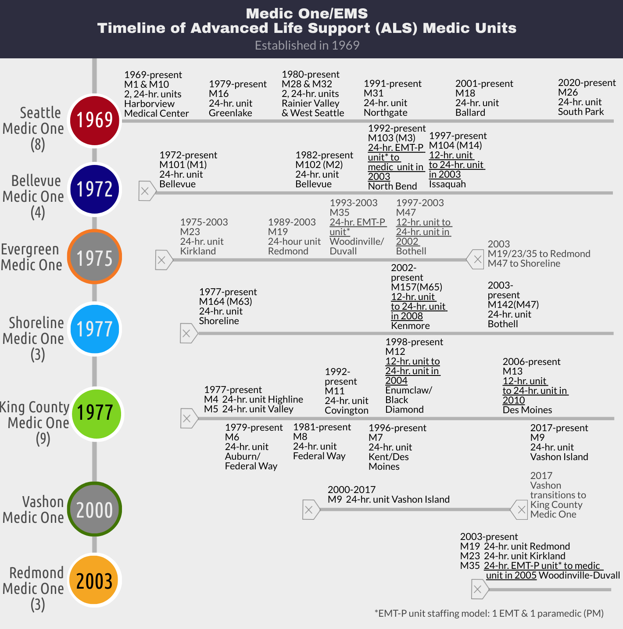
The Medic One/EMS system serving Seattle and King County is recognized as the first EMS system established in the United States in 1969. The timeline below identifies the year that each Medic One ALS Program was established and key dates when medic units were added into service or removed from service. Full-time medic units staffed with two paramedics provide 24-hour service. Half-time units staffed with two paramedics provide 12-hour service. EMT-P units were used primarily to provide service to outlying areas and were staffed with an emergency medical technician and paramedics.
Appendix C: Comparisons Between Levies
Program Area | 2020-2025 Levy | 2026-2031 Levy
Advanced Life Support (ALS) | Maintain current level of ALS service | Maintain current level of ALS service
Advanced Life Support (ALS) | 0 planned additional units  $11.6 million “placeholder”/reserve should service demands require additional units over the span of the 2020-2025 levy | 0 planned additional units  $15.8 million “placeholder”/reserve should service demands require additional units over the span of the 2026-2031 levy
Advanced Life Support (ALS) | Determine costs using the unit allocation methodology | Determine costs using the unit allocation methodology
Advanced Life Support (ALS) | Average Unit Allocation over span of levy (KC): $3.2 million | Average Unit Allocation over span of levy (KC): $4.1 million
Advanced Life Support (ALS) | 2 Reserve/Contingency categories to cover ALS-specific unanticipated/one-time expenses  - Operational Contingencies  - Expenditure Reserves | 2 Reserve/Contingency categories to cover ALS-specific unanticipated/one-time expenses  - Operational Contingencies  - Programmatic Reserves
Advanced Life Support (ALS) | INFLATORS  Operating Allocation Inflator: CPI (using CPI-W + 1%) to inflate annual costs  Equipment allocation: Transportation Equipment PPI | INFLATORS  Operating Allocation Inflator: CPI (using CPI-W + 1%) to inflate annual costs  Equipment allocation: Transportation Equipment PPI
Advanced Life Support (ALS) | Support two ALS-based programs that benefit the regional system  - ALS Support of BLS Activities  - Having paramedics guide and train students at Harborview’s Paramedic Training Program | Support two ALS-based programs that benefit the regional system  - ALS Support of BLS Activities  - Having paramedics guide and train students at Harborview’s Paramedic Training Program
BASIC LIFE SUPPORT (BLS) | Consolidate funding for the BLS Core Services program and the BLS Training and QI Initiative with the allocation to simplify contract administration; maintain designated programmatic funding and usage requirements | Consolidate BLS Training & QI funding into the Basic BLS allocation; remove requirements that it be spent on QI activities
BASIC LIFE SUPPORT (BLS) | Allocate funds to BLS agencies using methodology that is based on 50% Call Volumes and 50% Assessed Valuation; reset the first year using updated data that better reflects agencies’ current Assessed Valuation and service levels; increase funding to ensure consistency in the first year | Allocate new funding and annual increases to BLS agencies using methodology that is based on 60% Call Volumes and 50% Assessed Valuation
BASIC LIFE SUPPORT (BLS) | Inflate costs at CPI-W + 1% | Inflate costs at CPI-W + 1%

MOBILE INTEGRATED HEALTHCARE (MIH) | Provide $26 million over 6 years for MIH | Provide $50 million over 6 years for MIH
MOBILE INTEGRATED HEALTHCARE (MIH) | Distribute first year of funding across all agencies using BLS allocation methodology of 50% AV and 50% call volumes | Distribute new funding in the first year across all agencies using new BLS allocation methodology of 60% Call Volumes and 40% Assessed Valuation
MOBILE INTEGRATED HEALTHCARE (MIH) | Inflate each agency’s funding in subsequent years of the levy by CPI-W + 1% | Inflate costs annually at CPI-W + 1%. Distribute subsequent years’ funding using 60% CV/40% AV methodology
Regional Services (RS) | Fund regional services that focus on superior medical training, oversight and improvement; innovative programs and strategies; regional leadership, effectiveness and efficiencies | Fund regional services that focus on superior medical training, oversight and improvement; innovative programs and strategies; regional leadership, effectiveness and efficiencies; and strengthening community interactions and partnerships
Regional Services (RS) | Move BLS Core Services program out of Regional Services budget and into BLS allocation | Enhance programs to meet regional needs
Regional Services (RS) | Inflate costs at CPI-W + 1% | Inflate costs at CPI-W + 1%
Strategic Initiatives (SI) | Convert or integrate five strategic initiatives with other programs to supplement system performance. Explore a Mobile Integrated Healthcare, or MIH, model to address community needs  - Convert BLS Efficiencies into ongoing programs  - Transition CMT and E&E into MIH exploration  - Convert RMS into ongoing programs.  - Integrate the BLS Training and QI SI into the BLS allocation
Strategic Initiatives (SI) | Support existing and new strategic initiatives that leverage previous investments made to improve patient care and outcomes  - Continue implementing next stages of Vulnerable Populations  - Develop 2 new Initiatives: 1) AEIOU and 2) STRIVE | Support existing and new strategic initiatives that leverage previous investments made to improve patient care and outcomes  - Continue implementing next stages of Vulnerable Populations -> ECHO and AEIOU -> PRIME  - Develop 1 new Initiative focused on Emergency Medical Dispatch  Support King County Fire Chiefs Association proposals promoting Mental Wellness and ERSJ/DEI
Strategic Initiatives (SI) | Transition Community Medical Technician into MIH exploration
Strategic Initiatives (SI) | Provide regular updates to past audit recommendations
Strategic Initiatives (SI) | Inflate costs at CPI-W + 1% | Inflate costs at CPI-W + 1%

Citation | Chapters
Chapter 18.71 RCW | Defining EMS personnel requirements: Physicians
18.71.021 | License required.
18.71.030 | Exemptions.
18.71.200 | Emergency medical service personnel -- Definitions.
18.71.205 | Emergency medical service personnel -- Certification.
18.71.210 | Emergency medical service personnel -- Liability.
18.71.212 | Medical program directors -- Certification.
18.71.213 | Medical program directors -- Termination -- Temporary delegation of authority.
18.71.215 | Medical program directors -- Liability for acts or omissions of others.
18.71.220 | Rendering emergency care -- Immunity of physician or hospital from civil liability.
Chapter 18.73 RCW | Defining EMS practice: Emergency medical care and transportation  services
Chapter 35.21.930 RCW | Community Assistance Referral and Education Services program (CARES)
Chapter 36.01.095 RCW | Authorizing counties to establish an EMS System: Emergency medical services — Authorized — Fees
Chapter 36.01.100 RCW | Ambulance service authorized — Restriction
Chapter 70.05.070 RCW | Mandating public health services by requiring the local health officer to  take such action as is necessary to maintain the health of the public  Local health officer — powers and duties
Chapter 70.46.085 RCW | County to bear expense of providing public health services
Chapter 70.54 RCW  70.54.060 RCW  70.54.065 RCW  70.54.310 RCW  70.54.430 RCW | Miscellaneous health and safety provisions  Ambulances and drivers.  Ambulances and drivers—Penalty.  Semiautomatic external defibrillator–duty of acquirer—immunity from civil  liability.  First responders—Emergency response service—Contact information
Chapter 70.168 RCW  70.168.170 RCW | Revising the EMS & trauma care system: Statewide trauma care system  Patient transportation—Mental health or chemical dependency services
Chapter 74.09.330 RCW | Reimbursement methodology for ambulance services—Transport of a medical assistance enrollee to a mental health facility or chemical dependency program
Chapter 84.52.069 RCW | Allowing a taxing district to impose an EMS levy: Emergency medical care and service levies
Appendix D: EMS Citations

Title 246-976 WAC | Establishing the trauma care system: Emergency medical services and trauma care systems
 | TRAINING
246-976-022 | EMS training program requirements, approval, reapproval, discipline.
246-976-023 | Initial EMS training course requirements and course approval.
246-976-024 | EMS specialized training.
246-976-031 | Senior EMS instructor (SEI) approval.
246-976-032 | Senior EMS instructor (SEI) reapproval of recognition.
246-976-033 | Denial, suspension, modification, or revocation of SEI recognition.
246-976-041 | To apply for EMS training.
 | CERTIFICATION
246-976-141 | To obtain initial EMS agency certification following the successful completion  of Washington state approved EMS course.
246-976-142 | To obtain reciprocal (out-of-state) EMS certification, based on a current out- of-state or national EMS certification approved by the department.
246-976-143 | To obtain EMS certification by challenging the educational requirements,  based on possession of a current health care providers credential.
246-976-144 | EMS certification.
246-976-161 | General education requirements for EMS agency recertification.
246-976-162 | The CME method of recertification.
246-976-163 | The OTEP method of recertification.
246-976-171 | Recertification, reversion, reissuance, and reinstatement of certification.
246-976-182 | Authorized care -- Scope of practice.
246-976-191 | Disciplinary actions.
 | LICENSURE AND VERIFICATION
246-976-260 | Licenses required.
246-976-270 | Denial, suspension, revocation.
246-976-290 | Ground ambulance vehicle standards.
246-976-300 | Ground ambulance and aid service -- Equipment.
246-976-310 | Ground ambulance and aid service -- Communications equipment.
246-976-320 | Air ambulance services.
246-976-330 | Ambulance and aid services -- Record requirements.
246-976-340 | Ambulance and aid services -- Inspections and investigations.
246-976-390 | Trauma verification of pre-hospital EMS services.
246-976-395 | To apply for initial verification or to change verification status as a pre-  hospital EMS service.
246-976-400 | Verification -- Noncompliance with standards.

 | TRAUMA REGISTRY
246-976-420 | Trauma registry -- Department responsibilities.
246-976-430 | Trauma registry -- responsibilities.
 | DESIGNATION OF TRAUMA CARE FACILITIES
246-976-580 | Trauma designation process.
246-976-700 | Trauma service standards.
246-976-800 | Trauma rehabilitation service standards.
 | SYSTEM ADMINISTRATION
246-976-890 | Inter-hospital transfer guidelines and agreements.
246-976-910 | Regional quality assurance and improvement program.
246-976-920 | Medical program director.
246-976-930 | General responsibilities of the department.
246-976-935 | Emergency medical services and trauma care system trust account.
246-976-940 | Steering committee.
246-976-960 | Regional emergency medical services and trauma care councils.
246-976-970 | Local emergency medical services and trauma care councils.
246-976-990 | Fees and fines.
Title 296-305-02501 WAC | Emergency medical protection
Title 458-19-060 WAC | Emergency medical service levy
King County Code Section 2.35A.030 | Establishing the Emergency Medical Services Division within the Department of Public Health and describing the duties of the division.  The duties of the EMS division shall include the following:  - Tracking and analyzing service and program needs of the EMS system in the county, and planning and implementing emergency medical programs, services and delivery systems based on uniform data and standard emergency medical incident reporting;  - Providing medical direction and setting standards for emergency medical and medical dispatch training and implementing EMS personnel training programs, including, but not limited to, public education, communication and response capabilities and transportation of the sick and injured;  - Administering contracts for disbursement of Medic One EMS tax levy funds for basic and advanced life support services and providing King County Medic One advanced life support services;  - Coordinating all aspects of emergency medical services in the county with local, state, and federal governments and other counties, municipalities, and special districts for the purpose of improving the quality of emergency medical services and disaster response in King County; and  - Analyzing and coordinating the emergency medical services components of disaster response capabilities of the department. (Ord. 17733 § 5, 2014).

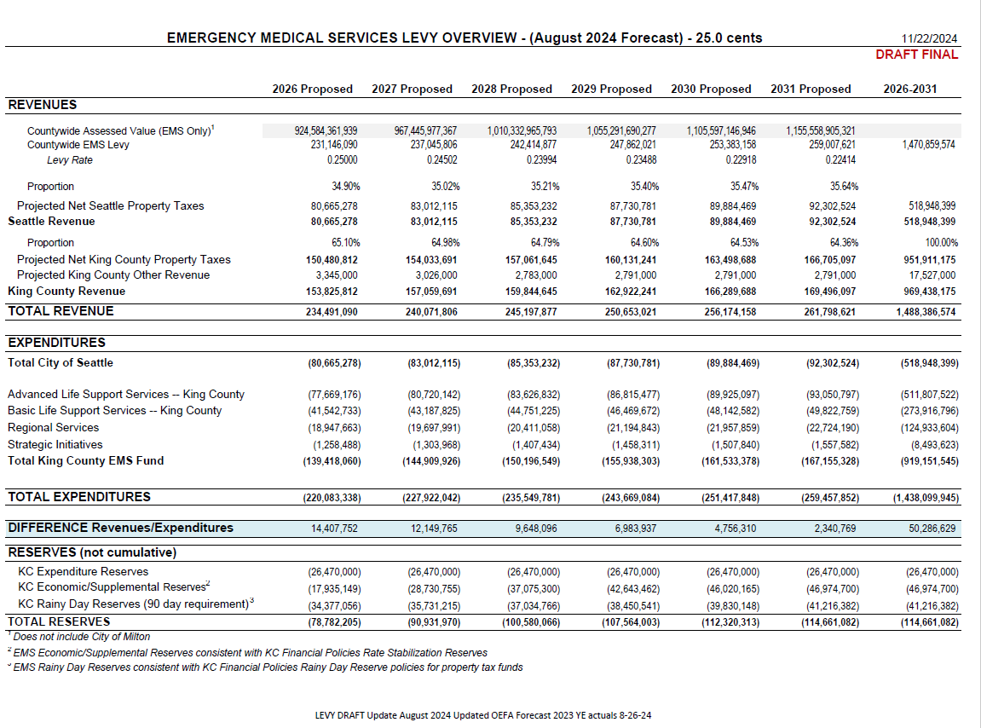
Appendix E: Financial Plan

Participant titles are representative of the titles held during the levy planning process
Mickey S. Eisenberg, Resuscitate: How Your Community Can Improve Survival from Sudden Cardiac Arrest (Seattle: University of Washington Press, 2009)
McBride O, et al. "Temporal Patterns in Out-of-Hospital Cardiac Arrest Incidence and Outcome: A 20 Year King County Experience". In Press. JAMA Cardiology
Amended approval and validation requirements effective June 7, 2018, per SHB 2627.
Emergency Medical Services Division 2024 Annual Report
Emergency Medical Services 2024 Annual Report

