STAFF REPORT

Agenda Item: | 7 | Name: | Mary Bourguignon
Proposed No.: | 2023-B0041 | Date: | May 17, 2023

SUBJECT

Today’s briefing will provide an update on Metro’s flexible mobility services, including how flexible services are planned, piloted, and evaluated.

SUMMARY

Flexible services are defined as transportation services that are tailored to meet specific community needs and operate without a fixed route. These types of services may or may not serve designated stops or hubs, depending on service design. They are typically deployed in communities that lack the infrastructure, density, or land use to support fixed-route bus service.

Metro’s flexible services are planned and implemented following criteria outlined in the adopted Service Guidelines. Specifically, the Service Guidelines provide guidance on planning flexible services, adding flexible services, evaluating flexible services, and reducing flexible services.

Earlier this year, Metro’s flexible services were consolidated into Metro Flex, replacing Community Ride, Ride Pingo to Transit, and Via to Transit. Metro Flex services operate in the Juanita, Kent, Othello, Rainier Beach, Renton Highlands, Sammamish, Skyway, and Tukwila areas. Passengers in those service areas can book a Metro Flex ride using a phone app, which will respond with a pickup location and an approximate arrival time. Metro Flex services have the same fare as a Metro bus and allow free transfers to fixed-route buses, Link light rail, or Sounder commuter rail using an ORCA card.

During today’s briefing, Metro staff will provide an update on Metro Flex services, including locations, performance, marketing, innovative and new features, evaluation, and decision-making on pilot services.

BACKGROUND

Metro’s flexible services are defined in its adopted policy documents as transportation services tailored to meet specific community needs that operate without a fixed route. Flexible services may or may not serve designated stops or hubs, depending on service design. They are typically deployed in communities that lack the infrastructure, density, or land use to support fixed-route bus service.

Flexible services are identified in Metro’s adopted policy documents as one of the categories of service Metro offers. These “service types,” which are defined based on the level of service a route provides, are Very frequent/RapidRide, Peak Frequent, Local, Hourly, Peak-only, and Flexible services.

Flexible services are planned and implemented by Metro following criteria outlined in the adopted Service Guidelines. Specifically, the Service Guidelines provide guidance on planning flexible services, adding flexible services, evaluating flexible services, and reducing flexible services.

Figure 1, below, which is from the adopted Service Guidelines, outlines the process through which a flexible service is identified, developed, piloted, and evaluated.

Figure 1.
Life Cycle of a Pilot Project

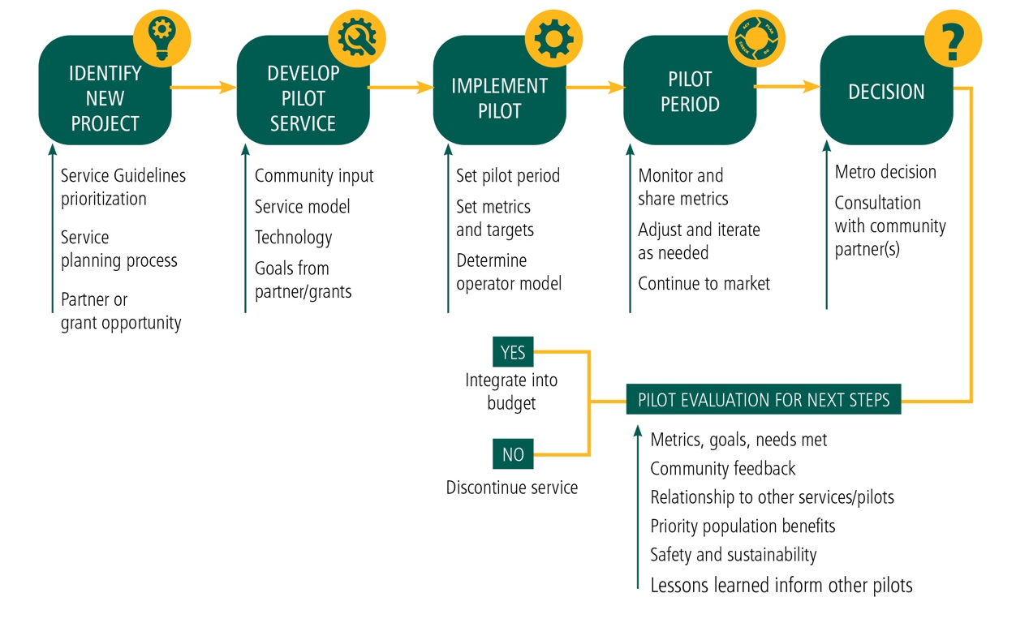

Metro notes that flexible services are prioritized based on:

- Equity, to serve those who need access the most
- Partnership, in response to opportunities to leverage resources
- Access, to reach jobs and community assets
- Density, to serve areas with adequate ridership and without high quality fixed-route service

After the pilot process for a flexible service shown in Figure 1, above, Metro conducts an evaluation, which measures:

- Equity, productivity, efficiency
- Community feedback
- Alignment with Metro’s priorities, goals, and plans
- Other mobility solutions in the area
- Available resources, including staff capacity

Metro Flex. On March 6, 2023, Metro’s Community Ride, Ride Pingo to Transit, and Via to Transit services were consolidated into Metro Flex. Metro Flex services operate in the Juanita, Kent, Othello, Rainier Beach, Renton Highlands, Sammamish, Skyway, and Tukwila areas. Service times for Metro Flex are shown in Table 1, below.

Table 1.
Metro Flex Service Times

Service Area | Weekdays | Saturdays | Sundays
Juanita | 7am-7pm | -- | --
Sammamish | 7am-7pm | 9am-6pm | --
Kent | 5am-7pm | 7am-7pm | 7am-7pm
SE Seattle, Renton, Tukwila | 5am-1am | 5am-1am | 6am-12am

Metro Flex is open to the general public. Riders can request a ride on-demand using a phone app or through Metro’s call center or web site. The rider provides a start/end to their trip anywhere within the service area and receives a pick-up location and estimated arrival time. The rider then walks to the pick-up location and joins a shared ride with a 15-minute estimated time of arrival for the ride on average. Metro Flex services have the same fare as a Metro bus and provide for free transfers to fixed-route buses, Link light rail, or Sounder commuter rail using an ORCA card.

Metro states that Metro Flex, as currently configured:

- Provides operational efficiencies
- Builds on innovations from previous services, while preserving the innovations achieved by previous services
- Streamlines branding and reduces customer confusion
- Reduces staff demands
- Achieves cost savings

Table 2 shows performance levels from January 2, 2023, through March 5, 2023.

Table 1.
On-Demand Performance (1/2/23 – 3/5/23)

Measure | Othello | Rainier Beach | Skyway | Tukwila | Renton | Kent | Juanita | Samma-mish
Equity | 93% | 93% | 54% | 88% | 82% | 93% | 39% | 13%
Avg daily rides | 129 | 271 | 105 | 69 | 104 | 70 | 51 | 85
Productivity | 2.94 | 3.88 | 2.40 | 3.32 | 3.81 | 2.37 | 2.17 | 4.08
Efficiency | $18.34 | $13.89 | $22.43 | $16.23 | $14.14 | $26.01 | $32.48 | $17.32

Metro notes that ridership has been increasing since Metro Flex was launched, from 5,000 rides per week during the week of March 5 to nearly 6,200 rides per week during the week of April 23.

Community Van. Community Van provides local, shared community trips. Community Van operates in Algona-Pacific, Bothell-Woodinville, Duvall-Carnation, Kenmore-Kirkland, Sammamish, Shoreline-Lake Forest Park, Skyway, and Vashon, and will be launching in Redmond in June and in Tukwila in July.

Each Community Van program has a Community Transportation Coordinator (CTC) who recruits volunteer drivers, manages trips and vehicles, and promotes and maintains an info hub about the van. Metro provides vehicles, fuel, maintenance, insurance, staff funding, and monitoring. Community Vans are available 24/7, with flexibility to meet community needs.

Community Vans have been used for partnerships with King County Parks and ECOSS; local group trips to events and activities; medical appointments; food bank trips and meal deliveries, and youth trips for sports, scout troops, and after-school programs.

Trailhead Direct. Trailhead Direct operates as a partnership with King County Parks and the City of Seattle to provide seasonal transit-to-trails service. The program evolved from alleviating parking congestion and increasing equitable access to the outdoors. Trailhead Direct provides two routes as sustained services and two routes as pilots, though operations on most routes were suspended due to Metro’s operator shortage.

The 2023 season runs on weekends and holidays from May 13 through September 4, and will provide a route to the Mount Si, Mount Teneriffe, and Little Si trailheads. The route begins from the bus stop at Broadway and East Denny Way, across from the Link light rail Capitol Hill Station and concludes at a bus stop at East John Street and Broadway East, adjacent to the Link light rail Capitol Hill Station. Additional stops are offered on First Hill, on Fourth Avenue in Downtown Seattle near the Link light rail University Street Station, the Eastgate Freeway Station in Bellevue, and the North Bend Park-and-Ride. The fare for Trailhead Direct is the same as for fixed-route bus service.

Next steps. Metro will be conducting an end-of-pilot evaluation at the end of the year. Metro will also be exploring integration of flexible services with paratransit, working to advance work on achieving a zero-emission fleet, integrating flexible services into trip planners, providing non-dedicated service providers for high-demand times, and supporting families with children. Next identified expansion areas are Overlake, Auburn, and Federal Way.

During today’s briefing, Metro staff will provide updated information about Metro’s existing flexible services, as well as how flexible services are planned, piloted, marketed, and evaluated.

INVITED

- Chris O’Claire, Director, Mobility Division, Metro Transit Department
- Brian Henry, Transportation Planner, Service Planning, Metro Transit Department
- Allison Miskell, Transportation Planner, Mobility Services, Metro Transit Department

ATTACHMENTS

- Metro flexible services presentation

King County Metro Policy Updates, Technical Report A, July 2021 (transmitted as ancillary material to the policy documents adopted through Ordinance 19367) (link)
Ordinance 19367, Attachment B
Metro Flex web site (link)
King County Metro Policy Updates, Technical Report A, July 2021 (transmitted as ancillary material to the policy documents adopted through Ordinance 19367) (link)
Ordinance 19367
Ordinance 19367, Attachment B
Ordinance 19367, Attachment B, p. 30
Metro Flex web site (link)
Productivity = rides/hour
Efficiency = cost/ride
Community Van Program (link)
ECOSS provides urban redevelopment through education and technical assistance (link)
Trailhead Direct Program (link)

