WASTEWATER CONSTRUCTION
Analyst: Jenny Giambattista

 |  | 2025 Proposed |  | 2026-2027 Projected |  | 2028-2029 Projected
Revenues |  | $359,207,900 |  | $855,928,140 |  | $1,617,131,339
Expenditures |  | $359,207,900 |  | $855,928,140 |  | $1,617,131,704
Major Revenue Sources: Proceeds from Bond Sales, Revolving Fund/Public Works Fund loans, Commercial Paper etc.

Description

The Water Quality Construction capital budget of the Wastewater Treatment Division (WTD) finances construction, maintenance, upgrade, and expansion of the wastewater system physical plant, including treatment facilities and the conveyance system. Over recent biennia, the regional system has been focused on constructing the Combined Sewer Overflow (CSO) projects required by a consent decree between King County and the federal Environmental Protection Agency and Department of Justice, and the Washington State Department of Ecology. Additionally, the agency is continuing its work on the Conveyance System Improvement and Treatment Planning programs, to assure the capacity of the conveyance and treatment system to meet the demands of regional growth, and facility maintenance. However, as the system continues to age, the two larger regional plants (West Point and South Plant) and hundreds of miles of interceptor pipeline that were completed in the 1960s and expanded in the 1970s and 1990s, and the Brightwater regional plant that was completed in the 2010s, the need for maintenance, repair and upgrade of facilities is becoming more urgent. WTD is accelerating its Asset Management program in response, focusing on both treatment plant and interceptor pipeline evaluation, repair, upgrade, and replacement. Meanwhile, the Washington Department of Ecology has taken a regulatory action requiring wastewater generators of nitrogen, which is the chemical element that can accelerate the growth of algae in the marine environment, to limit discharges according to the terms of a state-issued permit.

Summary of Proposed Budget and Changes

The 2025 proposed budget includes 50 capital projects and an appropriation request of $359.2 million. The requested projects reflect a mix of new and continuing projects with most projects not seeking full appropriation. In June, the Council approved a rate increase of 5.75%, with substantial increases projected for future years; much of those increases are driven by expansion of the Water Quality Construction capital budget.

The Water Quality Construction budget is categorized according to major “portfolios” to delineate the primary functions that the budget addresses. The largest expenditures are for Asset Management (repair and upgrade of mechanical systems requiring rehabilitation) and Regulatory (responding to state and federal regulatory mandates or consent decrees) investments; others include Capacity Improvements (expanding pipelines and treatment facilities in anticipation of growing capacity needs), Resiliency (strengthening structures to withstand flooding, seismic events or other natural disasters), and Resource Recovery (capturing resources generated by wastewater processing such as biogas or recyclable water for productive use or sale).

Listed below are the 2025 proposed appropriations for selected CIP projects in each of the major WTD capital portfolios:

Asset Management $214.4 million Selected Projects
- West Point Electrical Improvements: $56.8 million
- West Point Critical Gate Refurbishment: $75.9 million
- Ovation Evergreen Control Systems Lifecycle Management Program: $16 million
- West Point EPS Isolation Gate Rehabilitation: $17 million
- Research Vessel Replacement: $1.1 million

Regulatory ($49.6 million) Selected Projects
- Elliott West CSO Control Planning and Alternatives: $18.3 million
- Mouth of Duwamish Facility Plan: $15.5 million
- CSO Control and Improvement: $4.1 million

Capacity Improvement ($24.8 million) Selected Projects
- Black Diamond Trunk Capacity Upgrade: $14.6 million
- Soos Creek Cascade Relief interceptor Upgrade: $6.1 million
- West Point Digestion Capacity Expansion $2.9 million

Operational Enhancements ($2.7 million) Selected Projects
- Technology Assessment and Innovation Project: $2.8

Resiliency ($22.1 million)
- Climate Adaptation Planning Program: $4.2 million
- West Point Primary Sedimentation Area Roof Structure: $8.4 million
- West Point Passive Weir for Emergency Bypass: $9.6 million

Resource Recovery ($43.2 millions) Selected Projects
- Brightwater Reclaimed Water Storage: $35.9 million
- West Point Biogas Utilization Project: $5.5 million

Key Issues

Issue 1 – Large Increase in Capital Project Spending

As shown in Figure 1 below, planned expenditures over the six-year CIP Spending forecast are increasing significantly. According to WTD, the 2024 estimated total capital expenditure will be $327.3 million; projected expenditures for 2025 are expected to be around $448 million an increase of 37% for the coming year. WTD reports it update its expenditure updates once 2024 expenditures are analyzed and project forecasts are updated.

Given the significant increase in WTD’s capital portfolio, Council staff asked for information on WTD’s capital oversight processes. WTD provided details on the processes in place to provide portfolio, program, and project oversight for CIP investments through a tiered internal governance structure.

Council staff analysis of the six-year CIP is ongoing.

Figure 1
Proposed 2025 Budget 6-Year Spending CIP

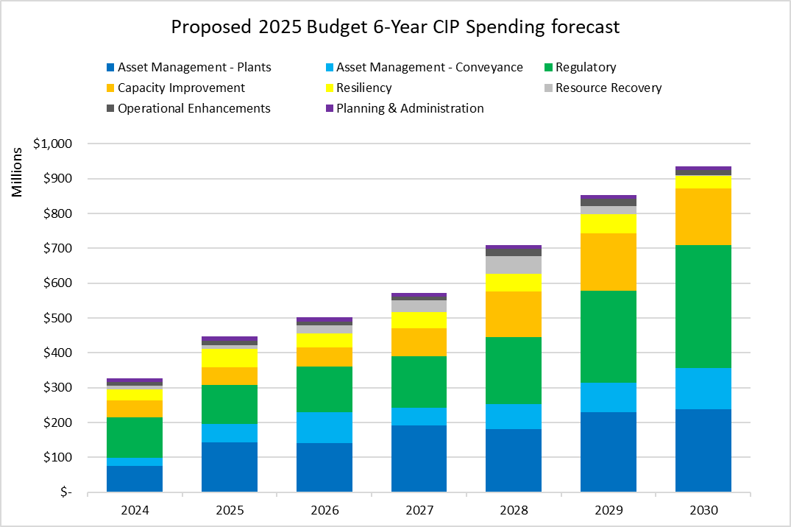

Issue 2 – High Risk Capital Projects

King County Code 4A.130.030 tasks the County Auditor with annually reviewing capital projects expected to cost over $25 million and recommending projects to be designated as “risk monitored projects (RMP)” to the County Council. The Auditor recommends projects to be designated RMP if they are at higher risk of being late or over budget at significant cost, or if delays to the project could have a significant impact. The County Council or the Executive may designate a capital project as “RMP” by letter to the County Council. For 2024, the Council has not yet designated projects as RMP.

According to the Auditor’s Office, designating a project as RMP enhances transparency on project performance by requiring project managers to provide additional project information for decision makers about project status and significant changes to scope, schedule, and budget. When a project is designated RMP, the Auditor can send updates to the Council and Executive on the status of the project. For 2024, the Auditor’s Office recommended four projects for risk monitoring. Two of the four projects are included in WTD’s proposed six-year CIP. The Auditor selected these WTD projects because of the potential impacts that delays could have on the community served by these projects. Below, council staff have included a summary of the two WTD projects recommended for Capital Project Risk Monitoring.

Sammamish Plateau Diversion Project (2025 Appropriation $417,000; Total expected cost $101 million). The Sammamish Plateau Diversion (SPD) project would add regional conveyance system capacity to manage some wastewater flows from the East Lake Sammamish area. The Wastewater Treatment Division (WTD) previously placed the project on hold for two years, resulting in the project completion date moving out from 2028 to 2030. Sammamish Plateau Water placed a development moratorium in a portion of the District for seven months in 2021. The District hired and WTD paid for a consultant study to identify interim improvements in the local system until the SPD can be constructed. WTD and the District entered into a cost-share agreement in 2021 to split the costs for funding the agreed upon interim improvements. While the SPD project has restarted, it faces barriers such as permitting in critical areas and land acquisition needs, which could further impact project delivery. Timely completion of the SPD project is necessary to ensure sufficient capacity in the regional wastewater system to serve new growth.

Black Diamond Trunk Capacity Upgrade (2025 Appropriation $14.6 million; Total expected cost $167 million). The Black Diamond Trunk Capacity Upgrade project would increase the capacity of the existing sewer trunk line to meet King County’s 20-year peak flow standard and serve significant new growth within the City of Black Diamond. Currently, the majority of pipe reaches within the Black Diamond trunk line have less than a 10-year level of service, which will continue to degrade as development occurs. Risks the project faces include the need for permitting for multiple stream crossings and lack of internal staff capacity. Timely completion of the capacity upgrade is necessary to ensure sufficient capacity in the regional wastewater system to serve growth in the City of Black Diamond.

King County Auditor’s Office Recommendations on Capital Project Risk Monitoring (June 26, 2024)

