License Property Summary
Photo of Healthpoint Midway Clinic

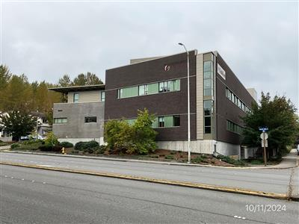

Property Owner: HealthPoint
Address: See Chart Below – Multiple Locations
Cost Per Sq. Ft.: No Cost – Mulitple Locations
Operational Costs: N/A – No Cost
Term: Five years
Square Footage: See Chart Below - Multiple Locations
Council District: See Chart Below – Multiple Locations
Funding Source: N/A – No Cost
Previous Location: N/A, extension of agreement at HealthPoint Midway Clinic, as well as formalizing Public Health Seattle & King County’s use of space at five other HealthPoint locations.

License Agreement Synopsis:
This proposed Ordinance supports a License Agreement for Public Health–Seattle King County (PHSKC) to continue to provide public health services at various HealthPoint (HP) clinics within King County. The License Agreement is at a zero-dollar cost to the County and encompasses the continued use of HP’s Midway, SeaTac, Auburn North, Bothell, Kent, and Auburn clinics. These locations allow PHSKC to provide parent/child health services such as Special Supplemental Nutrition program for Women Infants and Children (WIC), Maternity Support Services (MSS), and Infant Case Management (ICM) to underserved populations of King County.

Context
Rationale for transaction: PHSKC has been occupying space at the HealthPoint Midway clinic since 2017 under a no-fee license agreement. The original term of the license agreement was for two years, beginning January 1, 2017 through December 31, 2019. Since January 1, 2020 the Midway location has been on a month to month zero cost licensing agreement. Since that time, HP has partnered with PHSKC to provide additional space at no cost in SeaTac, Kent, Auburn, Auburn North, and Bothell.
The collaboration created by co-locating within HP clinics strengthens PHSKC’s mission to provide WIC, MSS, and ICM services to communities in need by offering high visibility and easy access to members of the community visiting HP clinics. HP is also able to provide additional community supportive services to the shared client base.

Building Name | Address | Council District | Square Footage Use
HealthPoint Auburn | 126 Auburn Ave | Council District - 7 | 128
HealthPoint Auburn North | 923 Auburn Way N | Council District - 7 | 128
HealthPoint Bothell | 10414 Beardslee Blvd | Council District - 1 | 128
HealthPoint Kent | 403 E Meeker St | Council District - 5 | 128
HealthPoint Midway | 26401 Pacific Hwy S | Council District - 5 | 128
HealthPoint SeaTac | 4040 S 188th St | Council District - 5 | 128

Policy considerations: This agreement supports PHSKC’s mission to provide health care services to marginalized, low-income, and underserved populations in King County. Partnership with HP at these locations helps PHSKC reach more clients and improves community access to PHSKC services.

Political considerations: N/A

Community considerations or partnerships: This agreement allows PHSKC to continue serving communities throughout the County. PHSKC’s longstanding partnership with HealthPoint to provides parent/child health wraparound services that complement HP’s medical, dental, obstetrics, and other services.

Fiscal considerations: Because this is a no-fee license agreement, the County avoids leasing costs and facilitates improved access to PHSKC services without additional lease costs.

Other considerations: N/A

CIP/operational impacts: The location of the HP Clinics provides easy access to major roads, highways and public transit, facilitating the provision of health care services to the surrounding County areas.

King County Strategic Plan impact: N/A

Equity and Social Justice impact: This agreement supports the County’s equity and social justice goals by providing health care services to populations that are marginalized, low-income, and underserved in the south and north parts of the County.

Energy Efficiency impact: HP has modernized its clinic facilities in all of these locations, or is in the process of doing so.

Use Agreement Alternatives Analysis
Summary: FMD conducted a comprehensive market search for available health clinics in the five municipalities of Auburn, Bothell, Des Moines, Kent and SeaTac. None of the available clinic properties are able to match free-rent and none of the available clinic spaces have the benefit of co-locating with a non-profit health services provider for a collaborative use of the property. All of these properties were ruled out due to the significant cost as compared to the HP clinics.

Vicinity View Map
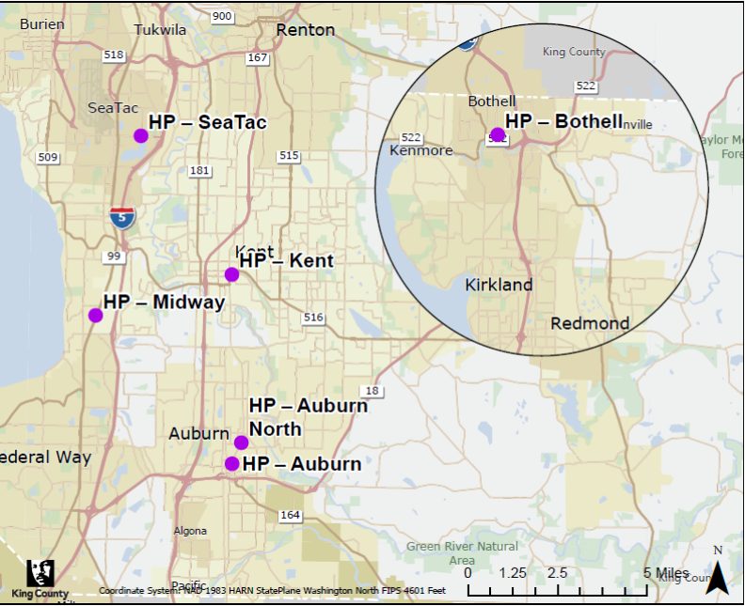

Parcel Map (HealthPoint Auburn)
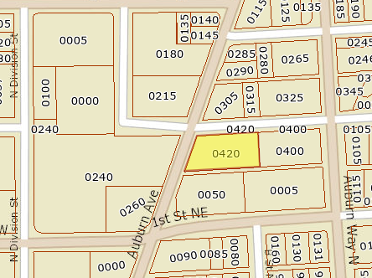

Parcel Map (HealthPoint Auburn North)
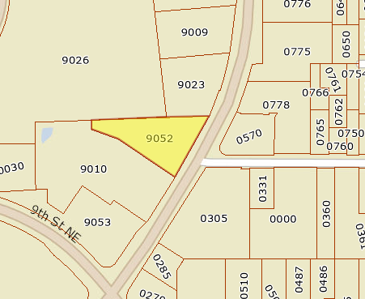
Parcel Map (HealthPoint Bothell)
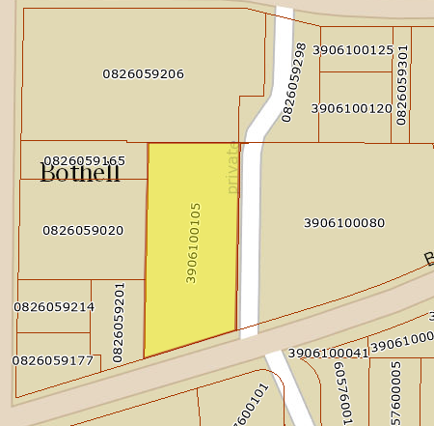

Parcel Map (HealthPoint Kent)
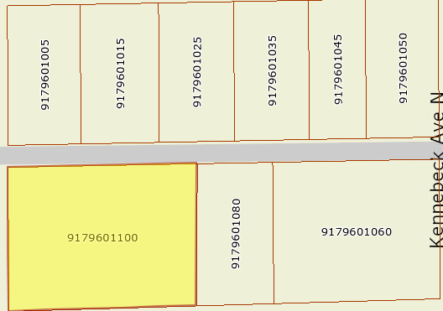

Parcel Map (HealthPoint Midway)
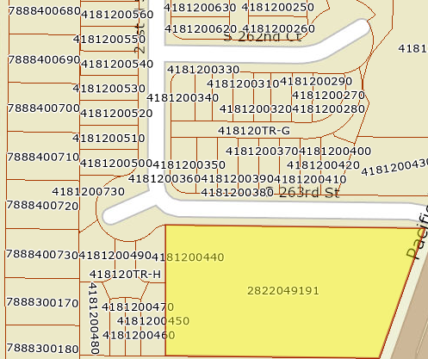
Parcel Map (HealthPoint SeaTac)
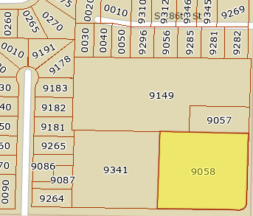

A written license agreement provides a framework similar to a facility use agreement and is needed in order to establish the legal relationship between HP and PHSKC for the County’s use of the space, especially as it relates to mutual indemnification and insurance requirements, and to protect King County employees while working in non-County owned facilities. Council approval is required when uninterrupted tenancy has exceeded five years.

