STAFF REPORT

Agenda Item: | 7 | Name: | Sam Porter
Proposed No.: | 2019-0346 | Date: | November 19, 2019

SUBJECT

A motion accepting the Mental Illness and Drug Dependency 2018 annual report as required by Ordinance 18407.

SUMMARY:

The Mental Illness and Drug Dependency (MIDD) 2018 Annual Report covers calendar year 2018. The requirements for the MIDD annual report are outlined in King County Code 4A.500.309 and include performance measurement statistics, utilization statistics, expenditure status updates, and progress reports on evaluation and implementation. A full list of the requirements can be seen in Figure 1 of this staff report. This motion is dually referred to the Regional Policy Committee, and the Health, Housing and Human Services Committee. The MIDD 2018 annual report appears to meet the requirements of K.C.C. 4A.500.309. This is the second MIDD Annual Report since the renewal of the MIDD tax in August 2016.

BACKGROUND:

In 2005, the Washington State Legislature authorized counties to implement a one-tenth of one percent sales and use tax to support new and expanded chemical dependency or mental health treatment programs and services and for the operation of new or expanded therapeutic court programs and services.

In 2007, the King County Council adopted Ordinance 15949 authorizing the first MIDD levy (MIDD 1) and collection of an additional sales and use tax of one-tenth of one percent for the delivery of mental health and chemical dependency services and therapeutic courts. Ordinance 15949 established the expiration date of MIDD 1 as January 1, 2017. Subsequent ordinances established the MIDD Oversight Committee (April 2008) and the MIDD implementation Plan and MIDD Evaluation Plan (October 2008).

In March 2015, the King County Council passed Ordinance 17998 setting requirements for a comprehensive review of the MIDD 1 strategies and recommendations for new strategies to be considered for a continued MIDD 2. Three deliverables were required by the ordinance:

- A comprehensive historical review and assessment of MIDD 1 – transmitted to council in June 2016 and approved by the Council on September 6, 2016 (Motion 14712);
- A MIDD service improvement plan to guide investments under a continued MIDD – Proposed Ordinance 2016-0427 was transmitted to council in August 2016 and approved by the Council on November 14, 2016 (Ordinance 18406); and
- A progress report on the first two deliverables – transmitted to Council in November 2015 (2015-RPT0164).

King County Council Approved Extension of the MIDD Sales Tax in August 2016 On August 22, 2016, the King County Council voted to approved Ordinance 18333, extending collections of the MIDD sales tax through January 1, 2026. MIDD 2 became effective on January 1, 2017 and will continue through 2025. The sales tax generated $136.5 million in the 2017/2018 biennium and is expected to generate $150 million in 2019/2020. The ordinance set forth the following five policy goals:

- Divert individuals with behavioral health needs from costly interventions such as jail, emergency rooms and hospitals;
- Reduce the number, length and frequency of behavioral health crisis events;
- Increase culturally-appropriate, trauma-informed behavioral health services;
- Improve the health and wellness of individuals living with behavioral health conditions; and,
- Explicit linkage with, and furthering the work of, King County and community initiatives.

ANALYSIS

The MIDD 2018 annual report appears to meet the requirements of K.C.C. 4A.500.309. The services and programs funded by MIDD are evaluated by staff in King County’s Department of Community and Human Services (DCHS) based on data submitted by providers. K.C.C. 4A.500.309.D.1 requires that the annual summary evaluation report include at a minimum the items in Column A below. As described in the transmittal letter, the pages of the 2018 Annual Report corresponding to the King County Code requirements are identified in Column B.

Table 1 Contents of the 2018 MIDD Annual Report and Page Numbers.
A | B
KCC 4A.500.309.D.1 | 2018 Annual Report
- Performance measurement statistics; | Pages 34-40
- Program utilization statistics; | Pages 14-31 and 34-40
- Request for proposal and expenditure status updates; | Pages 33 and 42-43
- Progress reports on evaluation implementation; | Pages 7-11
- Geographic distribution of the sales tax expenditures across the county, including collection of residential ZIP Code data for individuals served by the programs and strategies; | Pages 4, 14, 18, 24 and 30
- Updated performance measure targets for the following year of the mental illness and drug dependency initiatives, programs and services; | Page 41
- Recommendations on either program changes or process changes, or both, to the funded programs based on the measurement and evaluation data; and | Page 33
- Summary of cumulative calendar year data. | Pages 4-5 and 7-9

Highlights of the 2018 MIDD annual report:

- $71.3 million of MIDD funds were spent in 2018. In 2017, $60.6 million of the biennial budget for MIDD was spent. The ending undesignated fund balance for the biennium was $8.3 million according to the most recent financial plan from August 2019.

- 26,456 individuals received at least one MIDD-funded service in 2018. Of those, 47 percent were adults ages 18-54 and 34 percent were youth or children through age 17.

Geographic Distribution of People Served by MIDD, 2018
 | 2017 | 2018 | % change
North | 7% | 5% | 29% ↓
City of Seattle | 36% | 39% | 8%↑
South | 31% | 30% | 3%↓
East | 18% | 14% | 22%↓
Other/unknown | 8% | 11% | 38%↑
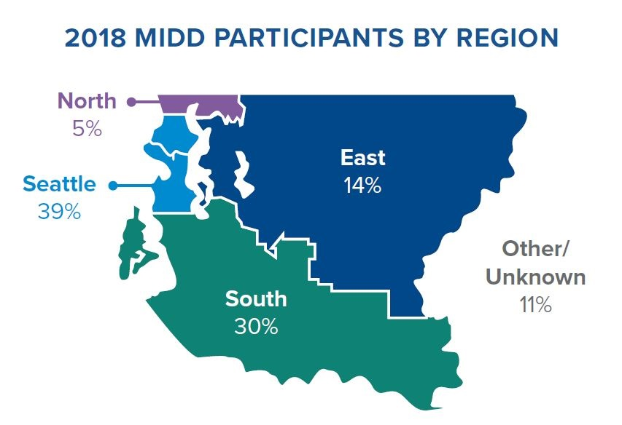

Policy Goal 1: Divert individuals with behavioral health needs from costly interventions such as jail, emergency rooms and hospitals.

- In 2018, there continued to be significant reductions in utilization of jail, emergency departments, and psychiatric hospitalizations among MIDD participants. Among individuals with long-term outcome data on file, participants had a:
  - 27 percent decrease in inpatient admissions;
  - 37 percent decrease in jail bookings;
  - 44 percent reduction in emergency department admissions on average, across initiatives.
- Of participants served by the Peer Bridgers Programs (RR-11a), psychiatric hospital admissions were significantly reduced by 63 percent on average over the long term.
- Of participants receiving mental health services through Community Behavioral Health Treatment (PRI-11), adult jail bookings were significantly reduced by 58 percent over the long term.
- Of individuals served by Housing Support Services (RR-01), Emergency Department admissions were significantly reduced by 68 percent in the long term.

Policy Goal 2: Reduce the number, length and frequency of behavioral health crisis events.

- This policy goal is new for MIDD 2 and new evaluation strategies identified that MIDD participants had fewer crisis events. According to the report, "after an expected increase in reported crises as participants connected to behavioral health care, 59 percent of youth and 78 percent of adults showed a decrease in crisis events over the long term."
- Of youth engaged in the Children's Crisis Outreach and Response System (CD-11), 49 percent experienced a decrease in crisis events.

Policy Goal 3: Increase culturally-appropriate, trauma-informed behavioral health services.

- This policy goal is new for MIDD 2.
- The Juvenile Justice Youth Behavioral Health Assessments (PRI-02) program redefined and expanded services to now include a standard of screening for trauma, individualized plans for culturally appropriate recommendations for care, and help to resolve any barriers to accessing services.
- Of trainings supported by Workforce Development (SI-04), 25 percent focused on topics of culture and trauma, with 35 percent of all trainees receiving trauma- and culture-oriented trainings such as a historical trauma training hosted by the Cowlitz Indian Tribe.

Policy Goal 4: Improve the health and wellness of individuals living with behavioral health conditions.

- 69 percent of individuals served in the Prevention and Early Intervention Behavioral Health for Adults Over 50 (PRI-03) reported reduced depressive symptoms following treatment.
- Of individuals served through Domestic Violence and Behavioral Health Services & System Coordination (PRI-10), 61 percent had reduced depressive symptoms and 68 percent had reduced anxiety symptoms.
- Of people engaged in Behavioral Health Employment Services and Supported Employment (RR-10), 77 percent retained their jobs, 74 percent remained engaged in mental health treatment, and 91 percent avoided all jail use.

Policy Goal 5: Explicit linkage with, and furthering the work of, King County and community initiatives.

- In order to demonstrate the explicit linkages with other King County initiatives the report indicates that the Veterans Court clinician working in the MIDD-funded Regional mental Health and Veterans Court (TX-RMHC) is paid for with funds from the Veterans, Seniors, and Human Services Levy. This clinician performs assessments of veterans involved in the criminal legal system in order to determine eligibility to participate in the region's therapeutic veterans courts.
- To demonstrate MIDD program involvement with furthering the work of King County the report indicates that MIDD funds several initiatives that seek to reduce the use of juvenile detention which is in line with the vision of Zero Youth Detention in King County. These initiatives include Juvenile Justice Youth Behavioral Health Assessments (PRI-02), Youth Detention Prevention Behavioral Health Engagement (CD-02), Family Intervention and Restorative Services (CD-13), Youth Respite Alternatives (CD-16), and Juvenile Drug Court (TX-JDC).

Of note, the initiatives listed below were deferred during 2018. The report indicates that initiatives 1 through 6 were deferred due to "the changing state policy environment." Deferral of the Recovery Café was due to siting of a second location in SoDo to support individuals experiencing homelessness or living in vehicles. This location has now been procured.

- PRI-04 Older Adult Crisis Intervention/Geriatric Regional Assessment Team (GRAT)
- PRI-06 Zero Suicide Initiative Pilot
- CD-04 South County Crisis Diversion Services/Center
- CD-09 Behavioral Health Urgent Care-Walk In Clinic Pilot
- SI-01 Community Driven Behavioral Health Grants
- SI-02 Behavioral Health Services in Rural King County
- RR-09 Recovery Café

As noted above, the MIDD 2018 annual report transmitted with this Motion appears to meet the requirements of K.C.C. 4A.500.309.

INVITED:

- Kelli Nomura, Director, Behavioral Health and Recovery Division (BHRD), Department of Community and Human Services (DCHS)
- Chris Verschuyl, Policy Manager, DCHS
- Robin Pfohman, MIDD Coordinator, BHRD, DCHS

ATTACHMENTS:

- Proposed Motion 2019-0346 (with attachments)
- Transmittal Letter
- MIDD Financial Plan, August, 2019
- MIDD 2018 Annual Report Briefing PowerPoint

The MIDD Oversight Committee was established in Ordinance 16077 and is an advisory body to the King County Executive and the Council. The purpose of the Oversight Committee is to ensure that the implementation and evaluation of the strategies and programs funded by the tax revenue are transparent, accountable and collaborative.
In October 2008, the Council adopted the MIDD 1 implementation Plan and the MIDD Evaluation Plan via Ordinance 16261 and Ordinance 16262.
MIDD Financial Plan August, 2019
As of September 2019, there is an estimated fund balance of $493,000 for the 2019-2020 biennium based on the August 2019 forecast from the Office of Economic and Financial Analysis and the Office of Performance, Strategy and Budget planning assumptions.
2018 MIDD Annual Report, page 4
According to the Annual Report, "long-term" references a comparison between a baseline year and the third year after services began.
2018 MIDD Annual Report, page 8
2018 MIDD Annual Report, page 1

