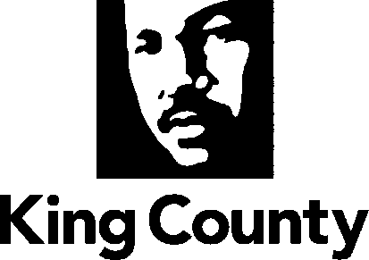
KING COUNTY
COMPREHENSIVE PLAN 2012
Attachment I

Amendments to Fall City Subarea Plan
September 2012
Page 21 of the Fall City Subarea Plan is revised as follows:

S-1 ((Privately owned o))On-site septic systems, ((community drainfields, or alternative sewage treatment technologies)) alternative wastewater disposal systems approved by the Seattle-King County Health Department (such as a community drainfield) are the preferred methods for wastewater treatment and disposal in Fall City. ((In order to provide the community with options for long term solutions to existing sewage treatment problems, and consistent with King County Comprehensive Plan Policy F-313 and King County Code 13.24.132 and 13.24.134, public sewers)) A self-contained sewage treatment and conveyance system approved by the Department of Ecology may be allowed to serve only the Fall City Business District if the preferred methods of wastewater treatment are proven to be technologically infeasible. Connection to and service by King County's regional wastewater system will be permitted only when necessary to address a threat to public health, as provided by King County policies and regulations ((if the preferred methods of wastewater treatment are proven to be technologically infeasible)). Business and commercial property owners in Fall City are the appropriate parties responsible for ((initiating and)) financing, operating and maintaining any future wastewater and disposal improvements in the business district. ((King County should convene a stakeholder group to consider and make recommendations regarding the business district’s septic system issues.)) King County may help facilitate by providing technical assistance in the development and implementation of the selected system and support when pursing outside funding sources.
Page 28 of the Fall City Subarea Plan is revised as follows:

L-4 Fall City’s existing commercial and industrial land base should be retained. ((Future expansion of the business district is provided for in this plan through potential community business zoning, which may be realized through an area-wide rezone initiated by the King County Council once alternative wastewater treatment systems or public sewers are available.)) All property within the downtown Fall City business district is zoned Community Business (CB) and is included within a designated Special District Overlay (SDO). Development within the SDO is permitted using on-site septic approved by the Seattle-King County Health Department. Development is also permitted using either an alternative wastewater disposal system (such as a community drainfield) approved by the Seattle-King County Health Department or a self-contained sewage conveyance and treatment system approved by the Department of Ecology provided that:
- The selected system shall be designed and constructed to serve only properties located within the designated SDO;
- If the selected system fails, and to prevent a potential health hazard, requires connection to the King County regional wastewater system, any such sewer conveyance shall be tight-lined. The tight-lined conveyance shall under no circumstance be used to provide sewage disposal service to residential properties in Fall City, except as provided by King County Comprehensive Plan policy R-508; and
- No costs to implement the selected system or to connect to the County's regional wastewater system shall be borne by properties outside the SDO. Funding from grants, loans and other outside sources may be used to help fund the system, and the County may assist in the pursuit of this additional funding.

The areas zoned for commercial uses in Fall City are not sufficient to serve local needs. Therefore, some expansion of the business district should be permitted ((when adequate wastewater treatment facilities are available)). Home occupations, home industries and specialty school uses allowed within the residential area also supplement the business activities in town. Additionally, there are several nonconforming businesses within the rural town boundaries of Fall City, which provide goods and services for the community, and which should be recognized with commercial zoning. Fall City residents want to protect the small rural character of their community and as such desire only limited ((additional)) commercial development, as provided for in this plan.

