September 10, 2001

Mr. Ike Nwankwo
Growth Management Planner
State of Washington
Office of Community Development
Growth Management Services
906 Columbia Street S.W.
PO Box 48350
Olympia, WA 98504-8350

Re: Final Adoption Notice for Ordinance No. 14187

Dear Mr. Nwankwo:

In accordance with RCW 36.70A.290(2)(b), the Metropolitan King County Council hereby notifies
the Office of Community Development Growth Management Services of final adoption of Ordinance
No. 14187, relating to determination of sensitive area designations, describing a process for determining the designation of sensitive areas, which passed by the Council on August 27, 2001.

Please direct inquiries to Lauren Smith, Lead Analyst at (206) 296-0352.

Sincerely,
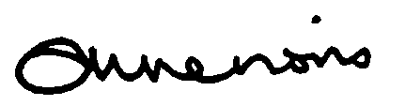

Anne Noris
Clerk of the Council

Attachment: Ordinance 14187

