Report on City of Kirkland Annexation Efforts
Prepared by King County Office of Management and Budget
Annexation Initiative
February 1, 2008

Introduction
Purpose of report
This report on city of Kirkland annexation efforts was prepared by the Office of Management and Budget Annexation Initiative team in response to a proviso included in the 2008 Adopted budget. The proviso reads as follows:

Of this appropriation, $50,000 shall not be encumbered or expended unless, by February 1, 2008, OMB has transmitted, and the council has approved by motion, a report on the progress of the city of Kirkland towards annexation of the Kirkland Potential Annexation Area. At a minimum, the study will include: (1) a discussion of the communication and outreach plan for the area; (2) a detailed discussion of the GIS mapping needs for the area and any areas of deficiency between what the city feels is needed and what could be provided by the county GIS division; and (3) a discussion of the needs for a fiscal model and any areas of deficiency between what the city feels is needed and what the county could provide. Furthermore, the report will provide options for funding such activities as well as the executive's preferred alternative for doing so.

Background
As part of the King County Annexation Initiative, the county has worked diligently with Kirkland on annexation issues since late 2004 when the Kingsgate-Juanita-Finn Hill area was designated as a priority focus Potential Annexation Area (PAA). Since that time the county has partnered with the city in multiple ways including: conducting resident outreach in the PAA and within the city at the city’s discretion; preparing extensive information regarding PAA financial, operational and capital infrastructure status; partnering in Olympia to seek revenue tools to support city annexation; contributing nearly $30,000 to the city for direct expenses related to annexation studies and surveys; offering options for short and long term service contracts with the county with the objective of lowering the cost of city service, particularly law enforcement and municipal court; and exploring whether there are King County owned properties within the PAA or city limits that might be available to support the city in expanding to serve the Kingsgate-Juanita-Finn Hill communities.

The Kirkland City Council has been actively considering the full range of issues associated with annexation of its PAA since late 2004. Over the past three years, the city has undertaken extensive study of the financial, operational, and capital infrastructure issues associated with its PAA along with an in-city and PAA based community outreach program.

In anticipation of the Kirkland City Council potentially completing its deliberations by the end of 2007 on the question of whether to move forward with the annexation, in September 2007, the city requested $18.8 million in financial support from the County Executive, primarily for roads and storm water related capital improvements in the PAA. While the county is not in a financial position to grant such a request, in November 2007, the County Executive extended a proposal, subject to County Council approval, offering $2.5 million in annexation related financial incentives, completion of certain roads and surface water management projects in advance of annexation, and an invitation to begin negotiations of an annexation transition interlocal agreement. (See Appendix A for copy of County Executive Sims’ proposal to Kirkland dated November 13, 2007.)

In addition to the $18.8 million request, the city requested $410,000 from the King County Council for funding of pre-annexation activities including $40,000 for additional communication and outreach; $280,000 for improvement to the GIS mapping data for the PAA; $70,000 for additional financial modeling; and $20,000 for legal services. This request to the King County Council was made with the assumption that the City Council was poised to move forward with an annexation vote in 2008 so the completion of these items was urgent and necessary for a successful annexation outcome. Based on Kirkland’s request, a proviso was included in the 2008 King County Adopted Budget requesting the King County Office of Management and Budget (OMB) study three aspects of the city request: communication and outreach, GIS mapping deficiencies, and additional financial modeling. The proviso also requested funding options and the County Executive’s preferred alternative.

By the end of 2007, the Kirkland City Council had not made a decision to either move forward or discontinue its annexation study process. In mid January 2008, the Kirkland City Council decided to defer its decision on moving forward or deferring annexation until April 2008 to allow for additional analysis. This delay was to allow additional time for analysis of ways to reduce the cost of annexation through service level reductions in the PAA and by potentially decreasing the size of the annexation to less than the entire PAA.

Further, the City Council, in its decision to delay, acknowledged that the city would be unable to proceed with an annexation vote until late 2009 with a 2010 effective date. As a result of this deferment, the urgency of the city’s funding request, and the time sensitivity of evaluating the city’s County Council request and potentially funding all or part of the city’s work program, is reduced.

Kirkland’s extension of its annexation decision timeline provides additional time to engage in a thoughtful discussion, in the context of an interlocal agreement negotiation, of the city’s immediate funding needs for completing pre-decision analysis, the pre-annexation items identified by the city, and post annexation issues. The work completed to prepare this report provides a basis for collaborating with the city to identify and implement any needed work to keep the city’s annexation study process moving forward.

Section 1 of this report provides a detailed summary of Kirkland’s progress towards annexation over the past three years and the partnership with King County in that effort.

Section 2 presents a discussion of the specific funding request items as required by the proviso, including:

- the communication and outreach plan for the area;
- detailed discussion of the existing GIS mapping resources compared with the city’s need, and; and
- discussion of the city’s fiscal model and its perceived deficiencies.

Section 3 presents several options for funding these activities and the County Executive’s preferred alternative. This discussion is presented in relation to the policy framework of the Annexation Initiative as set forth in Motion 12018 and considers the consistency of the options in comparison to the county’s partnerships with other cities annexing major PAAs.

Section 1
Kirkland Annexation Efforts Since 2004

The city’s PAA consists largely of residential neighborhoods, including some multifamily housing areas and relatively little, tax generating commercial space. The 2007 estimated population of the area is 33,500. The 2006 estimated population of incorporated Kirkland is 47,180. (Source: King County 2006 Annual Growth Report). The state Employment Security Department (2004) estimated the number of jobs in the area to be 4,053. Kirkland annexed the commercial area of Totem Lake, in the center of the PAA area, in 1973.

Kingsgate-Juanita-Finn Hill PAA – a priority
The county Annexation Initiative was formally launched in September 2004 with County Council passage of Motion 12018. The Kirkland PAA, covering the areas of Kingsgate, Juanita and Finn Hill, was identified as one of the ten largest remaining PAAs.

In the 2005 Executive Proposed Budget outlining the focus of the 2005 Annexation Initiative work program, the Kirkland PAA was designated as one of the three priority areas along with North Highline and West Hill/Skyway. The identification of the area as a priority reflected its large population size, the interest of the urban unincorporated residents in annexation, and the city’s interest in moving forward with annexation.

Annexation Progress in 2004 and 2005
Outreach on annexation to the PAA residents was initiated on October 16, 2004, with a community meeting sponsored by Councilmember Hague, at which then-Mayor Mary Alyce Burleigh spoke at length. County annexation staff also spoke at that meeting, which was attended by nearly 300 people.

The 2005 annual budget funds authorized to the Annexation Initiative to support study and outreach activities were increased by the County Council for specific support to Kirkland study and survey needs. In December of 2004, the County Executive and the city reached an agreement on pre-annexation activities to be jointly conducted by the city and county. Through that agreement, as subsequently amended in 2005, the county has reimbursed the city nearly $30,000 for the city’s annexation study efforts including contributing funding for:
- Polling of residents, and;
- Hiring a consultant to examine annexing the very large PAA all in one action or in phases and studying the issues associated with annexing territory currently served by the Finn Hill Park District and two fire districts in the PAA. The first phases of these studies were completed in mid-2005.

As part of the memorandum of understanding (MOU) for reimbursement of this work, the county reviewed survey questionnaires and scopes of work proposed by the city in advance of contracts being executed.

In addition to the above efforts, the city initiated a comprehensive study to examine the cost of providing city services to the PAA. They completed this work using internal city staff. King County provided the city extensive data on current county workload, expenditures, and revenues for the PAA. To facilitate Kirkland’s need for updated and improved PAA current revenue data, a TLT economist’s assistant was brought on to Office of Management and Budget staff in February 2005 to work on accelerating revenue data collection and analysis for Kirkland.

The updated costs reflected in the annexation study identified a significant annual operating deficit of approximately $5 million based on the level of service assumed in the model. The county offered to work with the city to identify cost saving options, including consideration of short and long term contracting with King County to address the deficit.

Annexation Progress in 2006 and 2007
Given the sizeable deficit, the City Council recognized that absent the ability to close the operating gap, it would be difficult to proceed with annexation. Accordingly, Kirkland focused its efforts on development of new revenue options. The city and county agreed to coordinate legislative efforts in Olympia on annexation with specific focus on revenue enhancement options for annexing cities.
Concurrently, early in 2006 the City Council approved a four-phase approach to exploring the potential of annexing the PAA in 2008. The city moved to “Phase 2” of the plan in April 2006, and remains in that “analysis” phase today. The four-phase plan is described below, excerpted from the city’s extensive annexation website:
PHASE 1: Begin “listening tour” with city of Kirkland residents and conduct long-range financial analysis. (Complete)
PHASE 2: Expand “listening tour” with PAA residents and city residents; continue fiscal analysis; develop initial Interlocal Agreement with King county; begin preliminary operational planning to determine essential service needs and resources, make determination whether to proceed with annexation. (In progress)
PHASE 3: If annexation is pursued, continue providing public information and responding to Phase 2 input; continue operational planning; establish proposed zoning and submit to King County Boundary Review Board; conduct election, proceed to Phase 4 if the vote is affirmed and the City Council confirms annexation and establishes an effective date.
PHASE 4: Prepare to provide services and continue public outreach
Phase 1 involved four (4) forums that were held in October, 2006 and March, 2007. County annexation staff attended these forums and responded to questions.

Phase 2 began in April, 2007 and included two public forums held in June. Two additional public forums were held in October, 2007. The county did not have a formal role in the April and June forums. County annexation staff attended the October forums and spoke as part of the formal presentations.

A list of City Council briefing and discussion sessions on annexation is reproduced at Appendix B.

Passage by the Washington State Legislature of SSB 6686 in 2006 reignited the city’s interest. The bill made available the revenue tool needed to address most, if not all, of the city’s annual operating gap was. This led the city to update its financial analysis of annexation again. In this phase of its financial work, the city contracted with Berk and Associates to develop a long term financial model with a ten year horizon to examine the service costs and local revenues associated with the PAA area alone, for the existing city, and for the larger combined area that would constitute the new city boundaries should annexation be successful. By structuring the analysis in that manner, the city examined the question of whether the annexation potentially would help, worsen, or be neutral in terms of affecting the city’s ongoing financial position.

The assessment, completed in the spring 2007, concluded that the city would over time be slightly better off financially as a result of annexation given the economies of scale, financial support of the state, and additional potential revenue capacity the assessed value of the PAA represents. However, in November 2007, further review identified an additional approximately $2.5 million in annual costs related to: (1) debt assumption from annexation of a fire district; (2) staffing of an additional fire battalion in the PAA; and (3) parks maintenance costs associated with expected termination of the Finn Hill Park District and ongoing obligations to maintain O.O. Denny Park (owned by the City of Seattle, located in the Kirkland PAA). As a result, it appeared that the financial gap between revenues and expenditures could not be closed without a reduction in service to either the city as a whole, or the PAA in particular. This additional $2.5 million gap includes the city’s use of nearly $4.8 million of annual assistance Kirkland would expect to receive from the state through the sales tax credit for major annexations.

Regarding the capital infrastructure, in the spring of 2007 the city undertook a review of the existing capital infrastructure in the PAA with specific focus on the surface water management system and local roads provided by King County. Again, the county worked actively with the city to provide access to information about those service areas and capital programs.

In the fall of 2007, the city requested nearly $18.8 million in financial support from the county to address capital infrastructure improvements it identified. The County Executive’s response to that request is included in Appendix A.

In January 2008, the City Council directed staff to further study means to close the financial gap in the PAA and deferred its decision to April 2008. Understanding that the city (like most local governments in the state) faces an ongoing challenge of growth in expenditure costs exceeding the rate in growth of revenues, the goal is to identify what services can be provided in the PAA if the “gap” between revenues and expenditures is no bigger than the existing gap for the city as a whole. Staff was directed to report back to council on this measure in April.

The April 2008 briefing date means that the city will be unable to forward annexation to the ballot in 2008 given the length of time to process annexations through the Boundary Review Board (BRB) and the likelihood of an appeal of any BRB decision. Because the city will ask annexing residents to assume their share of outstanding city indebtedness as a condition of annexation, the annexation election will have a validation requirement, meaning turnout at the annexation election must be at least 40% of the turnout at the last General Election. In addition, a minimum of 60% of those voting must approve the assumption of indebtedness. Because the November 2008 presidential election is expected to have a large turnout, it will be hard to validate items at a special election in 2009. The most likely annexation election date, if the city decides to proceed, is the next General Election: November 2009 with a 2010 effective date.

The county annexation team has been working with city staff to initiate a discussion to identify what the city needs to make progress on annexation and how the county and city can continue to partner in this effort.

Section 2
Discussion of 2008 Kirkland Annexation Work Program Funding Request

The Kirkland funding request of $410,000 to the County Council was premised on the assumption that the City Council was poised to make a decision about placing annexation on the November 2008 ballot by the end of the 2007. Understandably, the city identified that it would require a considerable amount of work to prepare for both the election and. most importantly for the provision of services in early 2009, assuming the successful annexation of the area. The work program included pre-election and post-election communication, and outreach in the PAA; GIS mapping in the PAA in preparation for provision of services; refinement of the city’s financial model for annexation; and legal services around special districts and debt issues, among others. Much of this work would only be undertaken in the event that the city made an affirmative decision to move forward with annexation.

With the city’s decision to delay and, in effect, take the 2008 annexation election option off the table, the pressure to complete the majority of this work in the near term is relieved. There is adequate time to work with the city of Kirkland to identify how the city and county can accomplish these tasks effectively, efficiently, and collaboratively. Section 2 of this report reviews each of the requested items specified in the 2008 proviso and recommends next steps for working with the city to jointly develop a work program that addresses the city’s needs to move successfully forward with annexation.

Once a more detailed work program and timeline is developed by Kirkland city staff and the county’s annexation team including King County Geographical Information Systems Division (KC GIS), the provision of additional county financial assistance could be made part of a larger interlocal agreement (ILA) addressing the issues of annexation transition, the Executive’s preferred course of action. In advance of completing a larger agreement, if warranted, more limited financial support from the county and city-county joint work programs could be provided from the budget authority granted annually to the Annexation Initiative. The city and county could formalize these agreements in a Memorandum of Understanding (MOU) between the City Manager and the County Executive consistent with past practice. Whenever possible, the Executive’s preference is to rely on existing city and county resources to complete these bodies of work over new consulting contracts. However, if it is determined that county and city resources are not available, feasible or economical, the provision of additional funding for consultant work would be an option.

Communication and Outreach Plan for the Kirkland PAA
In working with cities on annexation efforts, the county adjusts its approach to reflect the interest level, expectations, and priorities of each city and of the affected urban unincorporated residents. Based on these factors, the Annexation Initiative team determines whether to take a lead, co-lead, or a supporting role in community communication and outreach efforts. In any circumstance, the Annexation Initiative team is always available and responsive to all inquiries from urban unincorporated residents regarding annexation efforts and the Annexation Initiative. At a minimum, the county’s annexation website is updated to reflect current city and community activities and links.

With regard to the Kirkland PAA and annexation, Councilmember Hague has been the lead for the county in connecting with the unincorporated community. The first community meeting around annexation was sponsored by Councilmember Hague with participation from the city and Annexation Initiative team in October 2004. In May 2006, Councilmember Hague led town hall meetings on the issue as well.

In 2007 as part of the city “listening tour” outlined in Phase 2, the city sponsored four forums: two in the existing city limits and two within the PAA. The city contracted with EnviroIssues to be the facilitator for these forums to undertake communications planning and run several focus groups. The city independently undertook this contract and the development of the content, approach, and outreach design for the forum and focus groups. County Councilmembers for the PAA and members of the Annexation Initiative team were invited to attend the meetings but initially were not asked to play any specific role. After the first two meetings, the city requested the county staff to have a formal presentation role outlining the position of the county regarding annexation and be available for resident questions.

As of this point, the annexation team has not sponsored any community meetings or resident mailings in the PAA on a stand alone basis in deference to the study and outreach process undertaken by Kirkland. The annexation team has been waiting for the City Council to complete its annexation study and makes its decision. Once that decision is made, the county annexation team in coordination with County Councilmembers will determine what independent outreach efforts should be pursued in the urban unincorporated community on annexation issues. Annexation Initiative activity in the Finn Hill-Juanita-Kingsgate communities will likely be refocused depending on the city’s decision in April.

The city included $40,000 as part of its funding request to the County Council for communications and outreach to the annexation area. The work program associated with this item is described as follows:

“Communications and public outreach to the Potential Annexation Area (PAA) including pre-election planning, post election and implementation communication. We would continue working with EnviroIssues, our communications consultant, on this work.”

The city has not yet provided any additional detail regarding the timing or specific deliverables of this work or the current urgency of the work given the City Council’s delay of their decision to proceed with annexation.

RECOMMENDATION
Over the past several years, the county has shared outreach costs with its city partners. To date, as part of annexation transition ILA negotiations, the county has offered to reimburse the cities of Auburn, Federal Way, and Renton for as much as $25,000 for outreach and study activities subject to a MOU articulating joint development and/or county approval of activities and materials. Some cities have used this support to offset expenditures for materials and supplies for community meetings, resident mailings, as well as communications consultants and surveys. As noted earlier, in 2005, King County reimbursed the city for just over $30,000 in survey and consultant costs related to annexation.

The Annexation Initiative team has developed specific experience in doing outreach around annexation issues with a variety of cities and communities. In advance of funding a specific consultant contract, the executive would prefer that the city work with the county’s annexation team to jointly develop a proposal for outreach based on an agreed upon annexation timeline. If continued use of EnviroIssues to undertake this work is identified as needed, the city and county can determine how to appropriately share those costs.

Geographic Information System (GIS) mapping needs for the PAA
Kirkland, like many cities, relies on their GIS systems to support development review, long-range planning, public safety, environmental compliance, utility operations, and maintenance services among many. Kirkland requested $280,000 specifically to prepare the GIS data layers for the PAA, so that they are consistent with Kirkland GIS data standards and can support service city provision in the PAA once the area is annexed.

Kirkland described the tasks and activities associated with improved GIS mapping for the PAA as:

GIS mapping – getting the core GIS data layers in the annexation area into our enterprise-wide GIS and up to our data standards. In the PAA, available GIS data consists of King County sources and some Kirkland project mapping. However, the PAA GIS data is substandard and not current, and will not meet the needs of detailed spatial analysis needed. In order to support the city's PAA planning, the GIS program requires funding to extend key data layers out to the full extent of the PAA plus a nominal buffer. The primary data layers required for this planning and analysis work are: addresses, land parcels, easements, zoning, comprehensive plan land use, surface water drainage utilities, and street network.

First and foremost, in current discussions with Kirkland, the city confirmed that this GIS mapping effort is an important work item to complete only if it goes forward with annexation. The work is not necessary in advance of that decision. Ideally, the city would hope to have this work completed by the effective date of annexation. Working collaboratively with cities and special districts to improve the GIS data layers is a regular activity for the King County GIS Center. KC GIS is currently involved in projects of this nature with Burien and SeaTac. Should Kirkland decide to move forward with annexation, improved GIS mapping of the PAA offers an opportunity for the county to partner with the city.

King County GIS reviewed the tasks and concerns identified by the city as well as subsequent city information noting their data needs and concerns with KC GIS layers for the PAA. In their review, they agreed that data improvement at the parcel level particularly around the shorelines in the PAA is a reasonable project to undertake in partnership with the city in the event it moves ahead with annexation. KC GIS has noted that several of the county’s GIS layers for addresses (recently updated as part of a major E-911 project), streets, county land use, and zoning are up-to-date, reliable and available for city use. KC GIS indicates that King County and Kirkland code for easements differently. KC GIS acknowledge that King County does not maintain the detailed level of GIS data for storm water facilities and infrastructure desired by Kirkland. KC GIS does not dispute that county GIS data for the PAA differs from that of Kirkland and would support working with the city to address the differences collaboratively. KC GIS suggests that a significant portion of the work could be done using existing King County and Kirkland resources, which would significantly reduce the $280,000 request.

RECOMMENDATION
Requested at $280,000, this item is the largest component of the city’s request. This item is also most clearly connected to the provision of city services upon annexation. The specific tasks, personnel, and activities that would be performed by the city have not yet been provided to the county. Accordingly, given that there is no demonstrable need for this work until the city actually annexes the area, as well as, the lack of sufficient detail from the city to validate whether $280,000 would be an appropriate use of county funds, the Executive cannot recommend funding the city’s request at this time.

As an alternative, the County Executive will direct the county’s annexation team to coordinate discussions between KC GIS Center and Kirkland GIS unit about the data deficiencies from the perspective of the city and the possible ways to remedy them. While Kirkland suggests that it wants to continue a collaborative approach with King County on GIS work in general, at the same time, the city states that it does not think it would be cost effective to utilize KC GIS data to address many of the deficiencies. The county annexation team and counterparts from Kirkland will be working to determine what opportunities for partnership exist in this area.

Discussion of the city’s fiscal model, potential deficiencies, and requested resources.
The proviso requests the report include “a discussion of the needs for a fiscal model and any areas of deficiency between what the city feels is needed and what the county could provide”.

As part of the analytical work of the Annexation Initiative, the county has undertaken its own modeling of the revenue and expenses for the PAA reflecting the county revenue structure and levels of service. To date, all the annexation partner cities (Renton, Federal Way, Auburn, Seattle, Burien, Kent, Kirkland, and Issaquah) have undertaken their own financial modeling of the cost of annexation with only limited assistance from King County. County assistance usually includes provision of historical and forecasted revenues estimates for local sales tax, REET, and other revenue sources currently received by the county that would then go to the city. In addition, the county provides core data regarding assessed value and population. In general, because cities have a broader set of revenue options than a county, use of the county PAA financial model does not meet their needs. Further, the cities have not requested county involvement in their financial modeling work as it is a core function of the cities. Some cities have utilized consultants in this work, many have not. Kirkland has developed internally, or through consultants, its own models of revenue and expense forecasts for serving the PAA.

As noted in Section 1, Kirkland has undertaken a sophisticated, ten-year, financial analysis of the cost of serving the PAA and its potential effects on the financial position of the existing city. The Annexation Initiative team and OMB have had little involvement with the development of Kirkland’s financial modeling as the city has never requested our consultation absent provision of basic revenue inputs. The county has been provided information on the city’s model in the form of the staff reports presented before the City Council.

In terms of any deficiencies with the city’s current model, based on discussions with the city, the multi-year financial model developed under contract by Berk and Associates is a superior model, but is limited in its capabilities for alternative scenario testing. The request for $70,000 was identified for the following:

“Refinement of the annexation fiscal model to address any potential financial issues. This also includes work to manipulate the model to do future analysis on the issues around annexation.”

The use of the additional $70,000 would not be to address deficiencies but to allow the city to procure additional consultant services to explore other financial scenarios and issues. Specifically, additional consultant services may be needed because the city’s model is based on a set annexation geography that cannot be adjusted by city staff. Because the City Council has directed city staff to model the cost impacts of a smaller annexation that excludes the area of the PAA currently served by the Woodinville Fire and Rescue, the city will need to contract with the consultant to make this substantial adjustment to the model. Given this city-consultant arrangement, the county cannot directly assist with the city’s need for refinements to the model.

RECOMMENDATION
Of the four components for which the city requested funding, refinement of the city’s financial model is the single item for which there could indeed be urgency from the perspective of the city. The Kirkland City Council asked for further analysis of the cost of annexation for a smaller annexation excluding part of the PAA and if a ten percent reduction in the cost of services was applied to the larger and smaller alternatives. These alternatives are to be presented to the City Council at their April meeting. As of the drafting of this report, the city had not yet procured additional contractual services from the consultant.

Again, the county does not have detailed information as to how the $70,000 cost estimate was determined by the city nor any detail as to what specific activities and deliverables it would cover. There is adequate time to discuss the immediate versus longer term needs for further refinement to the city’s financial model and the appropriateness of the county sharing the costs of such work.

Section 3
Options for funding activities and County Executive’s preferred approach

The proviso requests the Executive to develop funding options for the city’s request and present a preferred alternative. As noted earlier in the report, given the city’s deferral of the annexation decision and its impact on the ultimate schedule for the annexation, the urgency for funding the city’s request is reduced. There is ample opportunity to work with the city to better understand their needs and the possibility of working collaboratively to refine the work program and associated budget. Nonetheless, to be responsive to the language of the proviso, several options are discussed below.

There are several issues to consider in terms of developing options. First, assuming that the provision of county funds for these purposes are timely, useful, and warranted, which is not yet clear, there is the question of what funding source is appropriate and available for such purposes. Second, there is the question of how funding a city request of this type and magnitude aligns with the objectives and policy tenets of the Annexation Initiative as set forth in Motion 12018 and with the Annexation Initiative practices to date. In particular, the county must consider whether to provide a city this level of financial support in advance of a commitment of a city to proceed with annexation and the potential precedent setting impacts of such financial support on future annexation work in other PAAs.

As noted earlier in the report, the county has already reimbursed Kirkland for over $30,000 in 2005 study and survey costs. This level of support is consistent with what has been offered to Kent, Auburn and Renton in advance of annexation elections as part of ILA negotiations, whether the annexations were ultimately successful or not. The only exception to that practice was when the county was prepared to provide the city of Renton considerably more -- $250,000 for community outreach and planning and capital infrastructure inventory and studies, in an ILA covering all three of its major PAAs with a total population nearing 55,000. The city of Renton has the largest combined PAA in the county and its annexation could potentially generate significant annual county savings should annexation of all the areas succeed. The offer of $250,000 reflects that unique circumstance of Renton. Ultimately, that agreement was not executed. Nonetheless, the Renton “roadmap” agreement would have required the city to commit to annexation timelines and elections. It would be a significant shift in county policy to begin providing cities annexation incentive funds in advance of their agreement to proceed with annexation.

Motion 12018 does permit the use of Annexation Initiative staff and annexation incentive related funding for a variety of purposes including:

“j. Conduct community outreach and communication in order to promote an environment supportive of annexations and incorporations
k. Facilitate, conduct, or review studies of specific annexation or incorporation proposals”

Based on the language of the motion, it appears that many aspects of Kirkland’s request would fit within the categories of expenditure envisioned in Motion 12018. Assuming the anticipated discussion with Kirkland results in the development of a sufficiently detailed work program, the work could be funded through a new General Fund allocation in a supplemental appropriation ordinance or an allocation from existing General Fund resources set aside for annexation related activities. In either case, in-kind services from the county could be offered to reduce the direct outlay of funds.

Given the significant county budget challenges anticipated in 2009, the Executive would not support funding this request from new General Fund resources. The Executive would support using part of the allocation of the annual budget appropriation granted to the Annexation Initiative for such purposes along with in-kind services, if additional financial support to Kirkland is required.

The 2008 budget appropriation to the Annexation Initiative for these types of activities totals approximately $160,000 and is referred to as the Annexation Initiative annual implementation budget. This is the appropriated budget available for county outreach, consultant support, surveys, and mailings for all of the PAAs. Given the need for use of that funding in the North Highline, Kent, and Renton PAAs activities and potentially Klahanie and Bellevue, the Executive would not support committing that source entirely to Kirkland, regardless of whether the city decided to move forward with annexation in April. The Executive could support use of no more than $20,000 from that source so that the needs of other cities and PAAs can be adequately addressed in the coming year. If the city does need significantly more support and that is the policy direction of the county, additional funding could come from the annexation incentive reserves as discussed below.

The city’s current request of $410,000 outstrips the annual annexation implementation budget used to address current year activities and needs across the urban unincorporated area in its entirety. If needed, additional funding could come from the remaining annexation incentive reserve. However, use of that resource for pre-annexation activities would represent a significant shift in county policy, though not in opposition to the Annexation Initiative motion per se. Further, Motion 12018 also specifies that the provision of annexation incentive funds to a city must be through an interlocal agreement consistent with the motion and approved by the County Council. To date, the Executive has requested use of the annexation incentive reserve funds only for two types of expenditures: 1) provision of incentive funds to cities after a successful annexation to address the service transition costs; and 2) to share in annexation election costs with the cities. The Executive has not proposed using the reserve funds for pre annexation activities or community or city outreach in advance of affirmative decisions to move forward. To date, annexation reserve funds have only been extended to cities as part of an approved interlocal agreement consistent with Motion 12018.

A key decision for the county is whether to provide a city significant financial support in advance of a city’s commitment to move forward with an annexation vote. If the policy direction is to do so, that decision would need to be reconciled with the Motion 12018 directing that the county’s provision of annexation incentive funding be directly tied to a city’s agreement to move forward with annexation in an interlocal agreement. This is a sound and reasonable policy supported by the Executive. The Executive would not support changing this fundamental policy of the Annexation Initiative. The policy clearly directs how and when these limited funds can be spent and requires a clear demonstration of the potential financial benefit to the county in advance. With that said, the following options are presented as the council could change the policy direction set in the motion.

Options to fund the city’s request include:

- Fund all or part of the city request from Annexation Incentive related funds or others in advance the city’s decision to proceed with an annexation and an agreement with the county.
- Fund all or part of the city request in advance of the city’s decision to proceed with an annexation and an agreement with the county, but with the understanding and agreement that the city would reimburse the county in full for these costs if the city does not move forward with an annexation vote by a certain date.
- Agree to reimburse the city for all or part of this work, but only after the city decides to proceed with annexation.
- Fund all or part of the city request as specific elements of an interlocal agreement only after the city decides to proceed with annexation.

The Executive’s preference for funding further pre-annexation activities by the city of Kirkland is to do so in the context of negotiating a county-city annexation transition interlocal agreement when the city has made its decision to move forward. If there are interim items that can be identified and funded from the annual Annexation Initiative implementation budget, the Executive is open to such discussions with the city.

Appendix A
Copy of Executive Sims’ Annexation Incentive Proposal to the City of Kirkland
November 13, 2007
(next page)

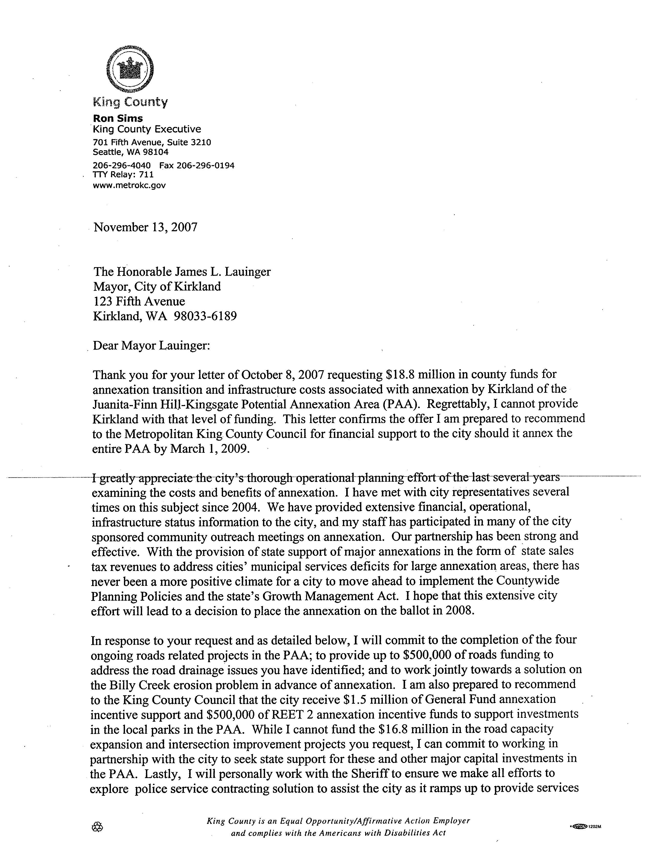

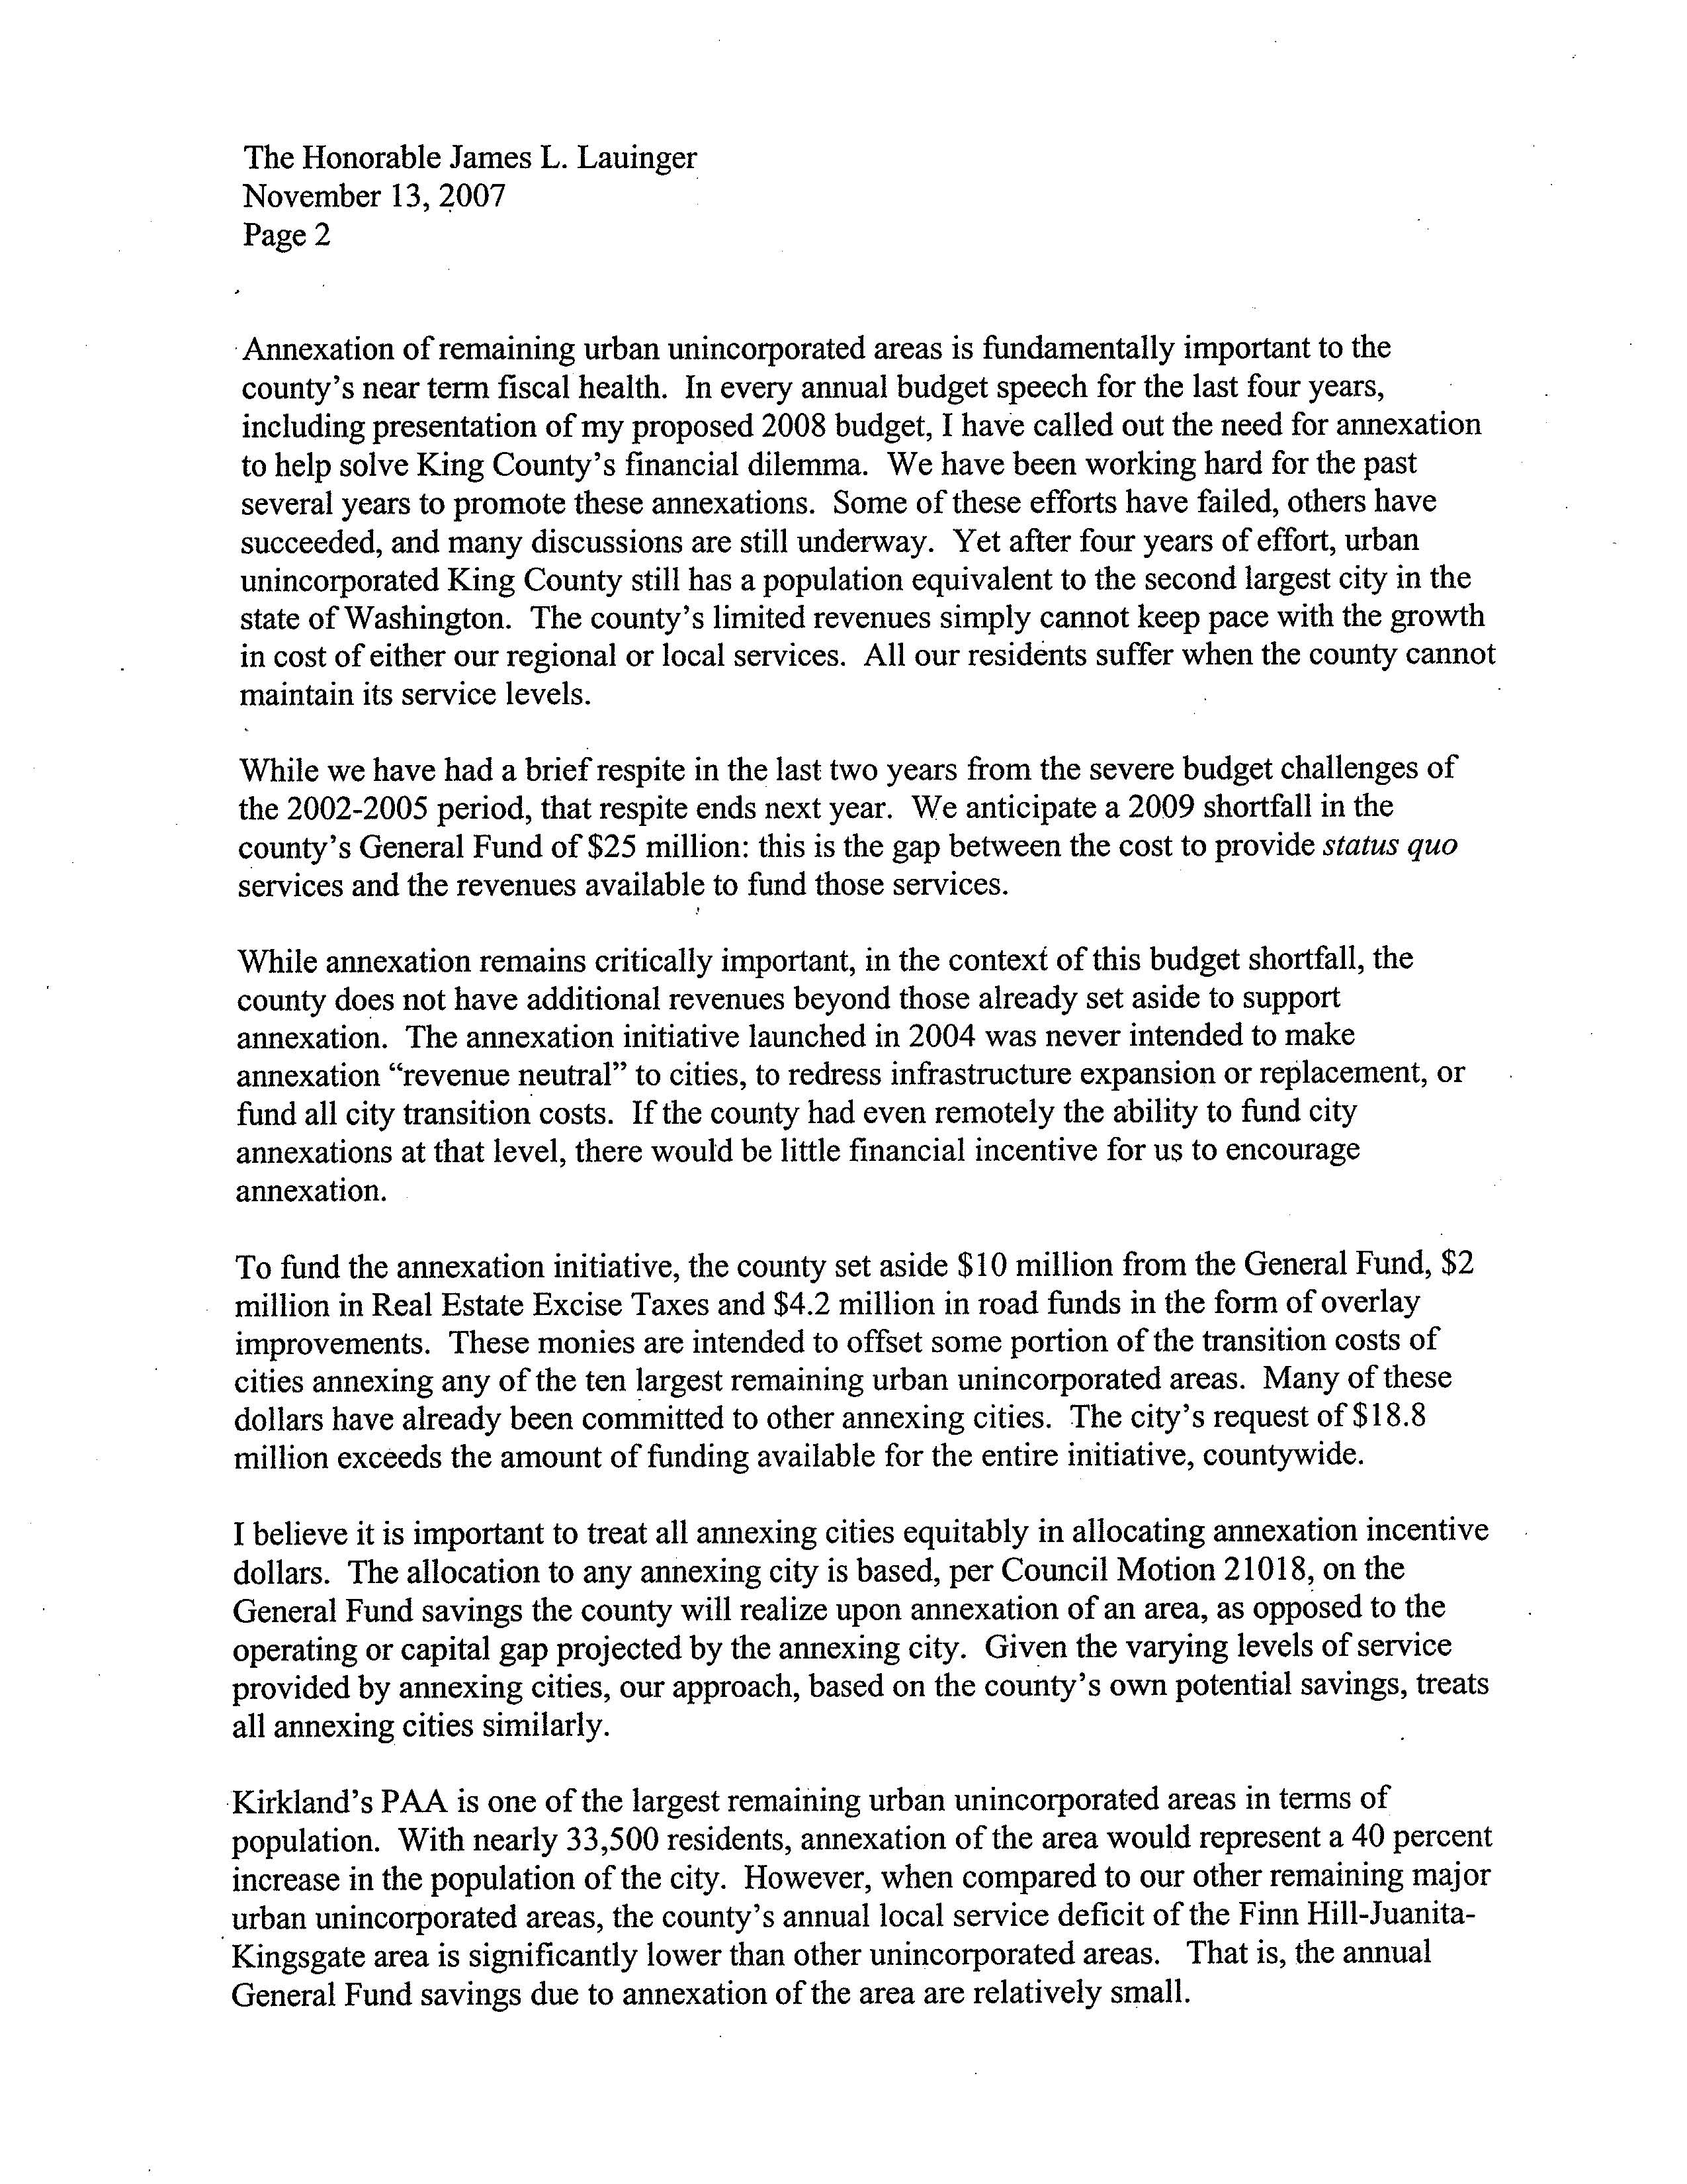

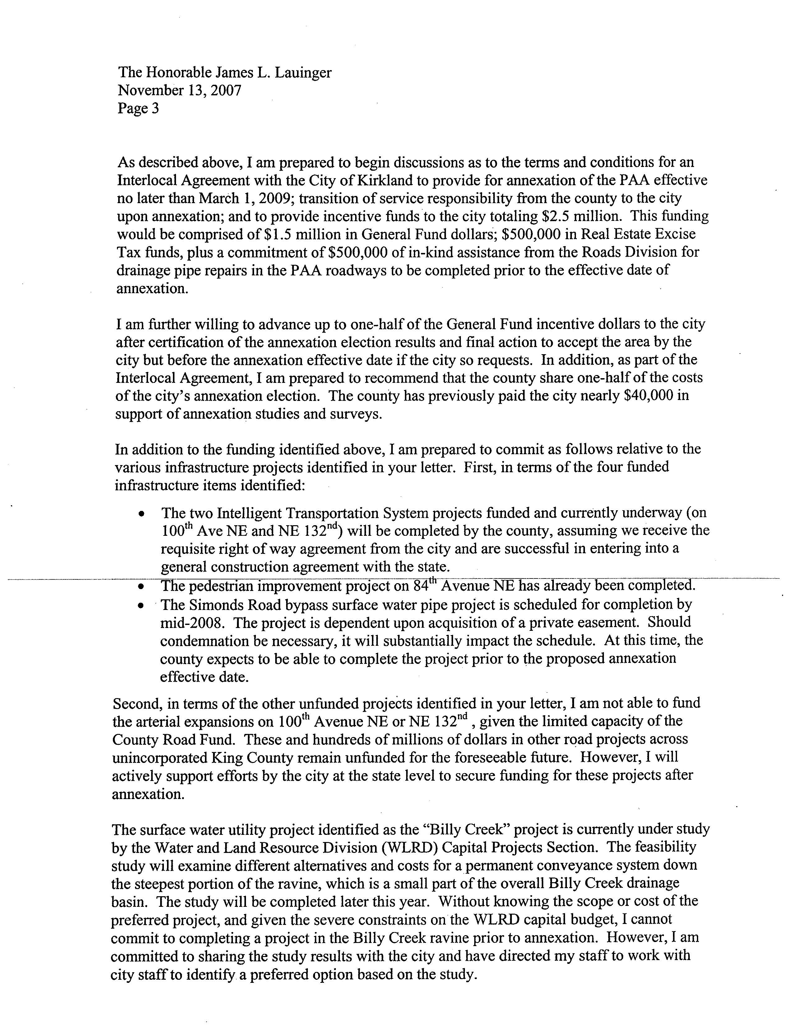

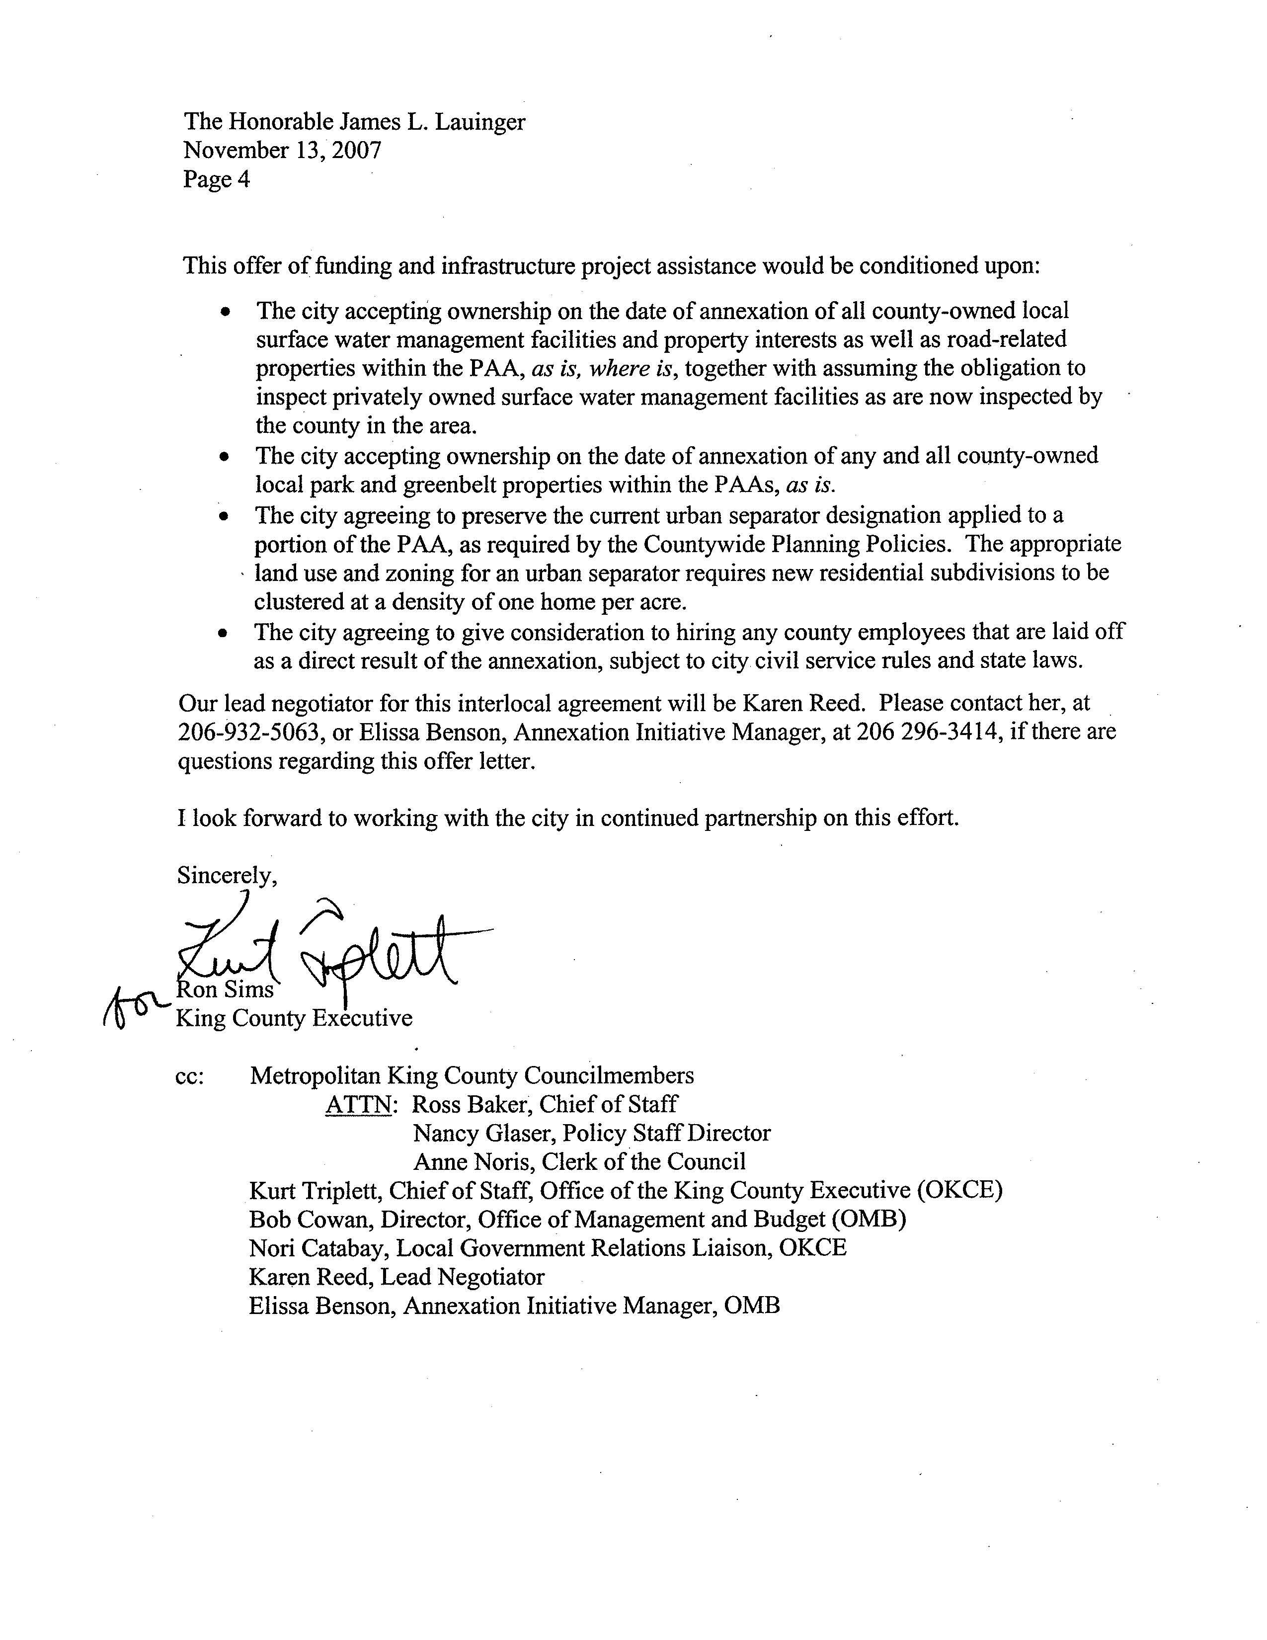

Appendix B
Kirkland City Council Agenda Items on Annexation

2008 City Council Agenda Items
January 2 | Study Session: Annexation zoning/ draft zoning ordinance
January 15 | Policy options and communications strategy

2007 City Council Agenda Items
January 9 | Special Study Session: Phase 1 fiscal analysis and public outreach
March 27 | Special Study Session: Phase 1 summary and Phase 2 resolution
April 3 | Phase 2 approval and service package requests
April 17 | Phase 2 service package requests and funding recommendations
June 5 | Phase 2 timeline, communications plan, and key policy issues
June 19 | Response to annexation correspondence
July 3 | Additional outreach funding and advisory vote discussion
October 2 | Special Study Session: Phase 2 activities and focus group results
November 7 | Response to annexation correspondence
November 15 | Special Study Session: Updated fiscal information
November 15 | Special Study Session: PowerPoint presentation
December 4 | Study Session: Potential actions and policy issues
December 4 | Study Session: Status of annexation zoning
2006 City Council Agenda Items
March 24 | Council Retreat: Annexation legislation and fiscal analysis
April 18 | Impacts of potential annexation and policy issues
May 16 | Steps for further study of potential annexation
June 6 | Proposed long-term fiscal analysis request for qualifications
June 20 | Zoning options in potential annexation area
July 18 | Proposed annexation timeline scenarios and four-phase process
September 5 | Proposed annexation communications strategy
October 3 | Potential annexation area and voting patterns
November 8 | Preliminary annexation long-term fiscal impact modeling
November 8 | Annexation fiscal analysis Council briefing
December 12 | Special Study Session: Fiscal analysis Council briefing

Appendix C Excerpt of Kirkland Funding Request

This annexation work program is made up of four components:

(1) Communications and public outreach to the Potential Annexation Area (PAA) including pre-election planning, post election and implementation communication. We would continue working with EnviroIssues, our communications consultant, on this work. Examples of their work, including the annexation listening log and hand-outs are available on the City web-site http://www.ci.kirkland.wa.us/depart/CMO/Annexation_Information.htm
(2) GIS mapping – getting the core GIS data layers in the annexation area into our enterprise-wide GIS and up to our data standards. In the PAA, available GIS data consists of King County sources and some Kirkland project mapping. However, the PAA GIS data is substandard and not current, and will not meet the needs of detailed spatial analysis needed. In order to support the city's PAA planning, the GIS program requires funding to extend key data layers out to the full extent of the PAA plus a nominal buffer. The primary data layers required for this planning and analysis work are: addresses, land parcels, easements, zoning, comprehensive plan land use, surface water drainage utilities, and street network.
(3) Refinement of the annexation fiscal model to address any potential financial issues. This also includes work to manipulate the model to do future analysis on the issues around annexation.
(4) Legal services, particularly outside counsel services to address debt issues, issues with special districts existing in the potential annexation area, and to assist in writing ballot propositions.

Kirkland 2008 Annexation Transition Budget

Communications/Outreach to Annexation Area | $40,000
GIS Mapping of Annexation Area | $280,000
Fiscal Model for Annexation Area | $70,000
Legal Services related to Annexation | $20,000
TOTAL | $410,000

