King County Metro
Public Transportation Service Changes for King County Related to Lynnwood Link Connections Mobility Project
Title VI Service Analysis
Prepared by King County Metro Service Planning
December 2023

Table of Contents
Page

1 Introduction 1
Service Guidelines Overview 1
Regular Service changes 2
Adverse Effect of a Major Service Change 2
Comparison Population Data 2
Disparate Impact Threshold 3
Disproportionate Burden Threshold 3
2 Service Change Area and Routes 4
Affected Areas 4
Affected Routes 4
3 Threshold 1 4
Is this a Major Service Change? 4
4 Threshold 2 5
Are Minority or Low-Income Census Tracts Affected? 5
Classifying minority and low-income census tracts 5
5 Threshold 3: 6
Is there a Disproportionate Burden on Low-Income Populations? 6
Title VI Analysis Results for Proposed Changes for Lynnwood Link Connections Service Change 7
6 Threshold 4 11
Alternatives and Mitigation 11

Introduction
The Federal Transit Administration (FTA) Circular 4702.1B, Chapter V, Section 7 requires transit agencies serving large, urbanized areas to evaluate major service changes and to determine whether proposed changes would have a discriminatory impact as defined in the United States Department of Transportation’s Title VI regulations.

In accordance with these FTA regulations, this report summarizes Metro’s service analysis of changes proposed for the service change submitted to the King County Council for approval associated with the opening of the Link 1 Line extension to Lynnwood, the implementation of Sound Transit bus rapid transit service in the State Route 522 corridor, and the opening of the N 130th Street infill Station on the Link 1 Line. As part of the ordinance, Metro is proposing to revise routes that currently serve north King County, and Seattle. This report details the results of the Title VI analysis of these changes, known as the Lynnwood Link Connections Mobility Project, which impact Bothell, Kenmore, Lake Forest Park, Seattle, and Shoreline.

Service Guidelines Overview
Metro’s Service Guidelines, which were last updated in 2021, contain King County’s policies concerning major service changes, disparate impact, and disproportionate burden. Metro developed these policies and submitted them to the King County Executive, who reviewed them and transmitted them to the King County Council for consideration and action. The Regional Transit Committee and the County Council’s Mobility and Environment Committee reviewed the legislation and forwarded it to the full County Council. The Council followed a public notification and participation process, held a public hearing, and then adopted the updated Service Guidelines via Ordinance 19637.
The 2021 update to King County Metro’s Strategic Plan for Public Transportation, 2021-2031 and related service guidelines outline the methodology Metro uses to evaluate service changes, consistent with FTA Title VI requirements (FTA Circular 4702.1B). The most relevant excerpts from the service guidelines are included below:

Regular Service changes
Metro revises service twice a year—in spring and fall. Major and minor service revisions occur during the spring and fall service changes. In rare cases of emergency or time-critical construction projects, Metro may make changes at other times.
Proposed route changes are subject to approval by the Metropolitan King County Council except as follows (per King County code 28.94.020):
- Any single change or cumulative changes in a service schedule which affect the established weekly service hours for a route by 25 percent or less.
- Any change in route location which does not move the location of any route stop by more than ½ mile.
- Any changes in route numbers.
The annual System Evaluation Report includes a comprehensive list of the prior years’ service changes. It identifies and discusses service changes that addressed performance-related issues.

Adverse Effect of a Major Service Change
An adverse effect of a major service change is defined as a reduction of 25 percent or more of the transit trips serving a census tract, in accordance with King County code 28.94.020. Title VI of the Civil Rights Act of 1964 requires all transit agencies to evaluate major service change impacts on minority and low-income populations.
Comparison Population Data
Metro uses population data for the county and for the service restructure project area because it enables Metro to evaluate the impact of the total changes of the service restructure. Using demographics allows Metro to identify Black, Indigenous, and people of color (BIPOC) and low-income communities and measure the impact of transit service restructures on the community regardless of whether or not that community takes transit. There are two primary reasons to not use ridership data for this type of analysis:
  - Route restructures that involve the creation of new routes would lack data on the impact of positive changes that new transit service will bring to a community. This might influence planners to be hesitant to delete low-performing routes, as deletion of service would negatively impact ridership-based equity analysis.
  - Ridership analysis that flags routes as BIPOC or low-income routes uses stop level data to determine where the majority of boardings happen on a route. Routes that have a majority of boardings in census tracts that are identified as BIPOC or low-income tracts are flagged as low-income or BIPOC routes. In certain instances, this can be an imperfect measure, as the presence of park and rides can dramatically skew ridership boarding numbers. Additionally, Metro does not conduct system-wide on-board surveys so it does not have data on the actual demographics of specific routes. In other words, just because boardings occur in a BIPOC or low-income tract does not mean that the people who got on the bus in those places share those identities.

Disparate Impact Threshold
A disparate impact occurs when a major service change results in adverse effects that are significantly greater for minority populations than for non-minority populations. Metro’s threshold for determining adverse effects is when the percentage of routes or tracts adversely affected by a major service change and classified as minority is 10 or more percentage points higher than the percentage of routes or tracts classified as minority in the system as a whole. Should Metro find a disparate impact, consideration will be given to modifying the proposed changes in order to avoid, minimize or mitigate the disparate impacts of the proposed changes.

Metro will measure disparate impacts by comparing changes in the number of trips serving minority or non-minority census tracts, or by comparing changes in the number of service hours on minority or non-minority routes. Metro defines a minority census tract as one in which the minority population percentage is greater than that of the county as a whole. For regular fixed-route service, Metro defines a minority route as one for which the percentage of inbound weekday boardings in minority census tracts is greater than the average percentage of inbound weekday boardings in minority census tracts for all Metro routes.

Disproportionate Burden Threshold
A disproportionate burden occurs when a major service change results in adverse effects that are significantly greater for low-income populations than for non-low-income populations. Metro’s threshold for determining adverse effects is when the percentage of routes or tracts adversely affected by a major service change and classified as low-income is 10 or more percentage points higher than the percentage of routes or tracts classified as low-income in the system as a whole. Should Metro find a disproportionate burden, consideration will be given to modifying the proposed changes in order to avoid, minimize, or mitigate the disproportionate burden of the proposed changes.

Metro will measure disproportionate burden by comparing changes in the number of trips serving low-income or non-low-income census tracts, or by comparing changes in the number of service hours on low-income or non-low-income routes. Metro defines a low-income census tract as one in which the percentage of low-income population is greater than that of the county as a whole. For regular fixed-route service, Metro defines a low-income route as one for which the percentage of inbound weekday boardings in low-income census tracts is greater than the average percentage of inbound weekday boardings in low-income census tracts for all Metro routes.

Service Change Area and Routes

Affected Areas
The proposed changes will affect 61 census tracts with a total population of approximately 267,348 residents.

Affected Routes
The affected routes in this project include routes 5, 16, 20, 28, 45, 64, 65, 67, 73, 75, 301, 302, 303, 304, 320, 322, 330, 346, 347, 348, 372.
Affected routes 16, 20, 64, 73, 301, 302, 304, 330, 346, 347, 372 would be replaced with routes 61, 72, 77, 333, and 365 expanded service on routes 45, 65, 75, 303, 322, 331, 345, 346, and 348.

Threshold 1

Is this a Major Service Change?
YES
For the purposes of complying with FTA Circular 4702.1B, Chapter IV, Metro defines any change in service as “major” if King County Council approval of the change is required pursuant to KCC 28.94.020.
The proposed changes meet all criteria for a major service change by Metro and FTA definitions. Appendix A lists the specific routes being changed in Fall 2024, Fall 2025, and Fall 2026 as part of the Lynnwood Link Connections Mobility Project.

Threshold 2

Are Minority or Low-Income Census Tracts Affected?
YES
Classifying minority and low-income census tracts
For the Title VI analysis, Metro classifies census tracts as minority tracts if the percentage of the population that is minority within a tract is greater than the percentage for King County as a whole. Based on the American Community Survey five-year average for 2016-2020 data, 49.90 percent of the population is classified as minority within the county as a whole.

The determination as to whether the proposed changes resulting in a reduction in service would have a disparate impact on minority populations was made by comparing changes in the number of Metro bus trips serving minority or non-minority census tracts. Similarly, the determination as to whether the proposed changes resulting in a reduction in service would have a disproportionate burden on low-income populations was made by comparing changes in the number of Metro bus trips serving low-income and non-low-income census tracts.

In line with recommendations made by the Service Guidelines Task Force, Metro recently changed the definition of “low-income” that is used to determine census tract designations from 100 percent to 200 percent of the federal poverty line, which aligns with the threshold of other programs, including ORCA LIFT. Based on the American Community Survey five-year average for 2016-2020, consistent with the dataset used in the project’s Equity Impact Review conducted by Metro, 39.54 percent of the population is classified as low-income within the county as a whole.

The proposed service changes addressed in this report will affect the level of service provided to 61 King County census tracts currently served by Metro. The low-income and minority characteristics of affected census tracts are provided in Table 1 below and figures 1 and 2 on the following pages.

Table 1. Low-Income and Minority Characteristics of Affected Census Tracts
 | Census Tract Classification
Total Census Tracts Affected | Minority &  Low-income | Minority ONLY | Low-income ONLY | Neither Minority nor Low-income
61 | 12 | 4 | 15 | 30

Threshold 3:

Is there a Disproportionate Burden on Low-Income Populations?
NO
Is there a Disparate Impact on Minority Populations?
NO
The September 2023 service change was used as the baseline for calculating the change in trips.

The proposed changes together affect 61 census tracts, including 4 minority-only census tracts, 15 low-income only census tracts, and 12 tracts which are both minority and low-income.
There are 8 tracts experiencing a reduction in trips greater than 25 percent, two are low-income only, and six are neither low-income nor minority tracts. The analysis indicates that the proposed changes would not place a disproportionate burden on low-income or minority populations.

A detailed description of the impacts to residents in these tracts experiencing adverse effects, is provided in Section V, along with the alternatives available to riders. There is a total of two low-income and/or minority tracts with adverse effects.
Notes for Tables 2 and 3
- An adverse effect is defined as a reduction of 25 percent or more in trips per week.
- Tracts are classified as low-income or minority when the percentage of low-income or minority persons in the tract is greater than the percentage of low-income or minority persons in the county as a whole.
- A disproportionate burden occurs when the percentage of low-income tracts with adverse effects is more than 10 percentage points greater than the county-wide percentage of low-income tracts.
- A disparate impact occurs when the percentage of minority tracts with adverse effects is more than 10 percentage points greater than the county-wide percentage of minority tracts.

Title VI Analysis Results for Proposed Changes for Lynnwood Link Connections Service Change

Table 2. Lynnwood Link Connections Service Change Title VI Analysis - Low-Income Populations
Category² | Tracts with Adverse Effects¹ | % of tracts adversely affected | % of tracts system-wide | Difference | Disproportionate Burden³?
Low-Income | 2 | 25% | 40% | -15% | NO
Non-Low-Income | 6 | 75% | 60%
Total | 8 | 100% | 100%

Table 3. Lynnwood Link Connections Service Change Title VI Analysis - Minority Populations
Category² | Tracts with Adverse Effects¹ | % of tracts adversely affected | % of tracts system-wide | Difference | Disparate Impact⁴?
Minority | 0 | 0% | 49% | -49% | NO
Non-Minority | 8 | 100% | 51%
Total | 8 | 100% | 100%

Figure 1. Impact of proposed changes on low-income census tracts.
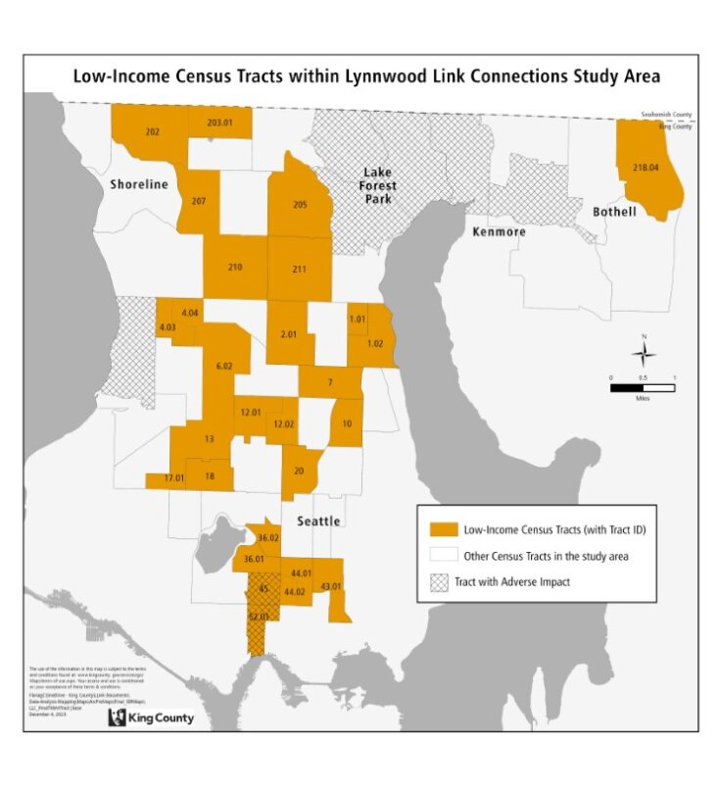
Figure 2. Impact of proposed changes on minority census tracts.

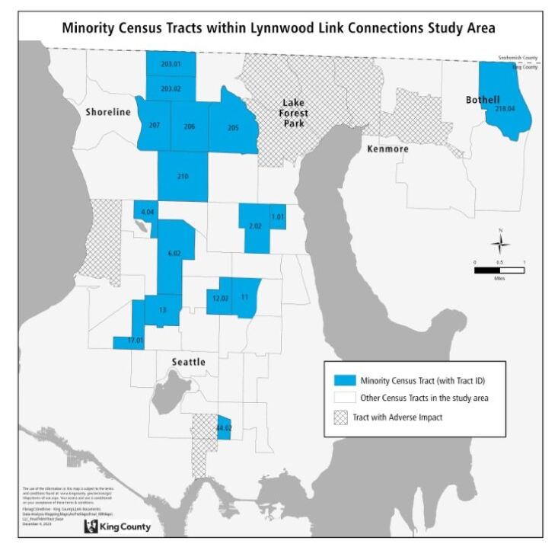

Figure 3. Adversely affected low-income tracts, detailed.
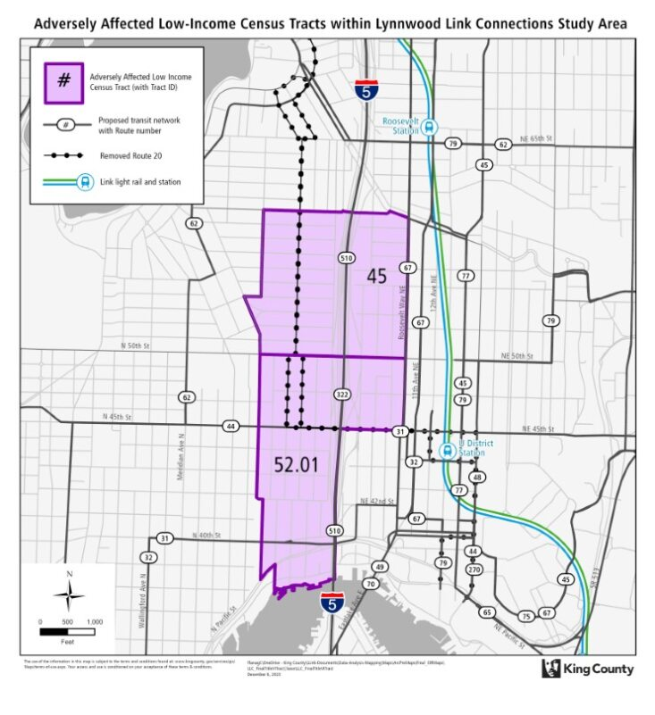

Threshold 4

Alternatives and Mitigation
As stated in Section IV, there are adverse effects as defined by the Title VI regulations in 2 census tracts, for the proposed service changes in north and east King County, and Seattle associated with implementing the proposal. As shown in Figures 3 and 4, low-income Tracts 45, and 52.01 are impacted.

Tract 45 – Meridian
Currently, this tract is served by Route 20 and 67. Route 20 is proposed to be deleted due to both low-ridership and duplication with the nearby Route 62. This change will reduce trips in this tract by 60 percent. Route 67 will be unchanged in the proposed network.

This census tract is bisected through the middle of the tract by I-5, making the areas east of I-5 inaccessible to those areas to the west. At a block group level, most of this tract’s minority population is in the eastern part of the census tract. This eastern part of the tract will see no change in service as the route serving these areas (Route 67) is unchanged.

Route 20 riders in the western part of the tract will be able to use Route 62 for north-south service and routes 44, and 45 for connections to the University District.

Tracts 52.01 – Eastern Wallingford
Tract 52.01 shows a 26 percent decline in trips. In the proposed network, the most significant change that leads to trip loss is the deletion of Routes 20, 64 (peak-only, currently suspended), and the revision of Route 322 (peak only). The deletion of Routes 64 and the revision of Route 322 have limited practical impact on this tract as they only served a single stop in the northbound direction in the PM peak. Southbound, these routes bypass this tract entirely by staying on I-5.

Connections to the north will be maintained by Route 67 which is unchanged and by Link light rail. Route 20’s deletion is the main driver of reductions in this census tract. Riders on Latona Ave. wanting to travel northbound to Green Lake will need to walk to Route 62, but this impact is about 5 riders/day on average. Riders heading to/from the University District (the majority of the ridership on the route in this area) will see their trip maintained on Routes 31, 32, and frequent Route 44.

Benefits

Altogether, the proposed network offers many benefits to respond to community-identified needs, including creating new and improved east-west transit connections, including:

- Transit access increases overall for the project area, similar levels for both total population and EPAs (6 percent increase in study area population served by transit, 6 percent for EPAs), including new Metro Flex service.
- Frequent transit improves for the overall project area, similar levels for both total population and EPAs (19 percent increase for total study area population, 17 percent increase for EPAs)
- Number of subsidized housing units served by frequent transit increases by 17 percent for units within the total study area, and 20 percent for units in EPAs
- Number of community assets served by transit increases
- Frequent transit access to low and medium wage jobs increases by 12 percent for the whole project area, 8 percent for EPAs

Travel Times
- Aurora Village Transit Center sees improved travel times to several destinations in Shoreline, downtown Seattle, and new areas (Bellevue, Overlake)
- Most areas east of I-5 see improved travel times to Shoreline Community College due to several new east-west connections
- Bitter Lake to Lake City connection sees significant improvements in travel times (11+ minute gain)

Other highlights
- Lake City will see a decrease in midday and weekend service due to Routes 72 and 77 operating less frequently than Sound Transit Express Route 522
- New Route 77 will connect Bitter Lake and Lake City, serving several EPAs
- Northwest Hospital service maintained and sees increased service with new Route 365
- Aurora Village Transit Center sees some trip losses, but gains several new travel options with Community Transit’s Swift BRT extension

APPENDIX A: Affected Routes and Rider Alternatives

Route | Change from Baseline  (no change, revised, replaced, or new) | Summary of Change | Alternatives
61 | New | New East-West route providing frequent service between Lake City, Northgate, and Greenwood. | N/A
72 | New | New route that operates between U-District and Lake City 7 days a week--providing very frequent service. | N/A
77 | New | New East-West route providing frequent service between Bitter Lake, the 130th Station, Lake City, Roosevelt Station, and U District Station. | N/A
333 | New | New route that serves MLT Station, North City via 15th Ave NE, NE 175th, Shoreline Community College, and the Shoreline South/148th Station via 145th St. | N/A
365 | New | New route that serves Northgate Station, North Seattle College, Northwest Hospital, Haller Lake, the Shoreline South/148th Station via Meridian Ave and 145th St., and the Shoreline North/185th Station via 5th Ave NE. | N/A
28 | Revised | The Broadview, peak-only, northern tail of the Route 28X is deleted. | Replacement service is provided by Route 5.
45 | Revised | Revised route to extend south along University Way to NE Pacific St. and Boat St. layover. Peak period frequency reduced slightly from 10-12min to 12min. | N/A
65 | Revised | Revised route that has weekday 15-min frequency south of Lake City and NE 125th, with alternating trips terminating at NE 130th St. and Lake City Way, and the other at the Shoreline South/148th Station via 30th Ave, NE 145th St., 25th Ave. NE, NE 150th St., 15th Ave. NE, and 155th NE. | N/A
75 | Revised | No pathway change. Decrease in frequency on weekdays from 10-15 min during peak to 15min. | N/A
303 | Revised | Pathway change to serve SLU via Mercer St before serving First Hill. One additional trip added to each of the AM and PM peak periods. | N/A
322 | Revised | Reorient the Route 322 to serve the Northgate Station instead of Roosevelt Station, and serve SLU via Mercer St before serving First Hill. Route 322 and 303 would provide coordinated frequent service between Northgate, SLU, and First Hill. | N/A
331 | Revised | Revised to serve Mountlake Terrace Station, and extended to UW Bothell. Extend span of service to end at 12am on weekdays and 11pm on weekends. | N/A
345 | Revised | Revised route that serves the Shoreline South/148th Station instead of Shoreline Community College via Westminster and NE 155th St. Revise pathway to serve DSHS office at North Seattle College. | N/A
346 | Revised | Revised version of the Route 346 that serves Meridian Ave between AVTC and the S Shoreline link station (via 155th) and provide 30-minute local service throughout the week. | N/A
348 | Revised | Revise Route 348 to include a short-turn variant so that half of Route 348 trips terminate at Richmond Beach, and the other half terminate between 3rd Ave. NW and 8th Ave. NW. Revise so that the overlapping portion of the route variants has frequent all-day service, with extended span of service until 12AM. Revise to serve the Shoreline North/185th Station. | N/A
5 | No Change | No change. | N/A
67 | No Change | No change. | N/A
16 | Deleted | Deleted route. | Replacement service is provided by Route 5.
20 | Deleted | Deleted route. | Replacement service is provided by Routes 44, 45, 61, and 62.
64 | Deleted | Deleted route. | Replacement service is provided by Routes 62, 65, 70, Link light rail, and the C Line.
73 | Deleted | Deleted route. | Replacement service is provided by new Route 77 and revised Route 348.
301 | Deleted | Deleted route. | Replacement service is provided by Link light rail, the Swift Blue Line, and Routes 303, 333, and 348.
302 | Deleted | Deleted route. | Replacement service is provided by revised routes 303, 322, 331, 348, and Link light rail.
304 | Deleted | Deleted route. | Replacement service is provided by Link light rail, and Routes 331, 333, 345, and 348.
320 | Deleted | Deleted route. | Replacement service is provided by new Route 61, revised Route 322, Stride S3, and Link light rail.
330 | Deleted | Deleted route. | Replacement service is provided by Routes 65, 72, 333, and 345.
347 | Deleted | Deleted route. | Replacement service is provided by Link light rail, new Routes 333 and 365, and Revised Route 348.
372 | Deleted | Deleted route. | Replacement service is provided by new routes 72 and 77, revised routes 322 and 331, and Stride 522.

This report uses American Community Survey five-year average for 2016-2020 to maintain consistency with the Lynnwood Link Connections Equity Impact Review analyses, which used ACS data available at the start of the project in 2021.

