STAFF REPORT

Agenda Item: | 9 | Name: | Nick Bowman
Proposed No.: | 2024-0263 | Date: | February 19, 2025

SUBJECT

Proposed Ordinance 2024-0263 would authorize the Executive to sign an Interlocal Agreement (ILA) with the City of Kent for the inspection and maintenance of the Rock Creek Bridge.

SUMMARY

The proposed ordinance would authorize the execution of an ILA (Attachment A) between the County and the City of Kent (Parties) for the inspection and maintenance of the Rock Creek Bridge which is primarily located in Kent and partially extends into unincorporated King County. The proposed ILA specifies the responsibilities of both parties regarding work necessary to keep the bridge functional and open for public use, assigns the cost associated with such work to the responsible party, and establishes a process for resolving disputes.

According to the transmitted fiscal note, the cost of performing the County activities identified in the proposed ILA would be negligible.

BACKGROUND

The City of Kent (City) completed the construction of the Rock Creek bridge in 2023, replacing three undersized roadway culverts with a larger, fish-passable roadway bridge. The bridge is located over Rock Creek at SE Summit Landsburg Road, placing approximately three quarters of the bridge in Kent and the remaining one-quarter in unincorporated King County. A map of the bridge location is provided in Figure 1 below.

RCW 36.75.020 requires that the County and the City jointly maintain Rock Creek Bridge by performing bridge inspections and minor repairs to address conditions identified during the inspections.

Figure 1. Rock Creek Bridge Location

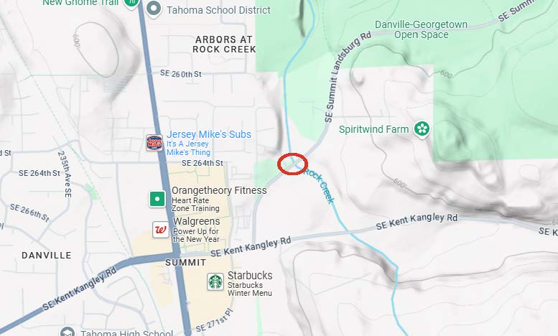

ANALYSIS

Proposed Ordinance 2024-0263 would authorize the Executive to execute an ILA with the City of Kent for the inspection and maintenance of the Rock Creek Bridge.

The key provisions of the proposed agreement include:

City Responsibilities (Section 3.A)

Section 3.A of the proposed ILA establishes the City’s roles and responsibilities under the agreement. These include:

- Conducting all inspections and studies;
- Maintaining all records and reports concerning the bridge, its inspections, and its conditions;
- Preparing plans and specifications for major maintenance of the bridge;
- Acting as the lead agency on all routine and major maintenance of the bridge structure and assuming all costs associated with such activities;
- Acting as the lead agency for structural overlay and resurfacing of the bridge deck while providing notice to the County and obtaining County approval prior to any expenditures associated with such work;
- Maintaining and repairing the bridge structure and appurtenances within the City limits;
- Replacing or reconstructing the bridge, in full or in part, to significantly improve the service level or extend the life of the bridge and obtaining any necessary permits and approval by the County for the portion of the project within the County’s jurisdiction; and
- Providing copies of all records on the bridge to the County.

County Responsibilities (Section 3.B)

Section 3.B of the proposed ILA establishes the County’s roles and responsibilities under the agreement. These include:

- Conducting regular surface maintenance including debris removal, sweeping, pavement markings, snow removal and anti-ice applications as necessary and assuming all costs associated with such activities;
- Sharing the costs of resurfacing the bridge deck with the City;
- Maintaining and repairing bridge appurtenances within the County’s jurisdiction; and
- Acting as the lead agency for the overlay of Summit Landsburg Road including the portion within the City limits.

Payment (Section 4)

Section 4 of the proposed ILA assigns the Parties share of bridge maintenance, inspection, and repair costs.

Under the proposed ILA the City will pay:

- 100% of all inspection and study costs;
- 100% of all routine and major maintenance of the bridge structure;
- 77% of bridge deck overlay costs;
- 100% of the costs to construct the bridge and maintain all records associated with the bridge;
- 100% of graffiti removal, vegetation maintenance activities, and concrete traffic barrier repairs; and
- 77% of any local match costs associated with any federal and state grants, or other funding alternative awarded to cover expenses for any bridge related capital project.

The City will also reimburse the County for the actual costs of the overlay of the portion of Summit Landsburg Road that is within the City limits.

Under the proposed ILA the County will pay:

- 23% of bridge deck overlay costs;
- 100% of regular surface maintenance; and
- 23% of any local match costs associated with any federal and state grants, or other funding alternative awarded to cover expenses for any bridge related capital project.
According to the transmitted fiscal note, the cost of performing the County activities identified in the proposed ILA would be negligible.

Section 5 Duration

Section 5 of the proposed ILA states that the ILA will become effective on the date of its mutual signing by the Parties. This section, while not explicitly stating so, intends for the agreement to continue in perpetuity. This reflects both Parties’ obligation to maintain and inspect the bridge under state law. However, state law also requires that the agreement specify a duration. Amendment 1 would add language consistent with the original intent while complying with state requirements.

Section 6 Amendment or Termination

Section 6 of the proposed ILA states that the ILA may only be amended by written agreement of both Parties.

Section 8 Dispute Resolution

Section 8 of the proposed ILA establishes a process for resolving disputes. Under this process the Parties shall first attempt to resolve the matter informally. If an informal resolution cannot be reached, the matter will be decided by the County Roads Director and the City Public Works Director. If a resolution still cannot be reached, either party may refer the matter to non-binding resolution wherein each party will be responsible for its own mediation costs and will share the costs of the mediator equally. Both Parties shall continue to perform all respective obligations under the ILA during the resolution process unless expressly agreed to by the Parties in writing.

AMENDMENT

Amendment 1 would delete the Executive transmitted Attachment A, an ILA between the County and the City of Kent regarding the inspection, maintenance, and repair of the Rock Creek Bridge, and replaces it with a revised Attachment A. The revised ILA:

- Makes technical and language consistency-related changes; and
- Adds language to “Section 5. Duration” and “Section 6. Amendment or Termination” necessary to comply with state law.

INVITED

- Rey Sugui, Intergovernmental Relations, Road Services Division of the Department of Local Services.

ATTACHMENTS

- Proposed Ordinance 2024-0263 (and its attachments)
- Amendment 1
- Transmittal Letter
- Fiscal Note

The estimated costs to perform the surface routine maintenance activities as identified in the ILA is approximately $1,000 per road mile. The Bridge is approximately 60 feet in length of which 23% is in the County and 77% is in the City.
RCW 39.34.030(3)

