Franchise Summary

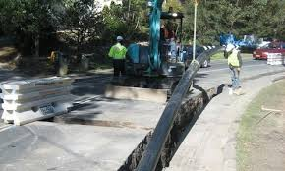

Franchisee City of Carnation
Type of Franchise Water
Legal Description Sections 9, 10, 11, 12, 14, 16, 23, 26, 28, 34, of Township 25 North, Range 7 East, W.M., King County, Washington
Council District 3, Kathy Lambert

Project Information

A franchise agreement approved by the King County Council is required of all public and private utilities to install, operate and maintain their infrastructure/facilities within King County rights-of-way. Granting of a franchise is subject to approval of the utility’s comprehensive plan by the King County Utility Technical Review Committee (UTRC) and the Council. The City of Carnation has met these requirements.

The subject franchise requested by the City of Carnation renews, consolidates and supercedes three existing water franchises.

Context
Rationale for approval: This action will renew, consolidate and replace three existing franchises into a single franchise, and reduce the franchise area.
Policy considerations: This franchise agreement incorporates the most recent state legislative amendments regarding capital recovery for water purveyor installations of fire suppression systems as allowed under state law.
Political considerations: This franchise agreement brings the City of Carnation into compliance with King County franchise requirements.
Community considerations: Ensures continuing water service to the public served by franchisee.
Other considerations: Not applicable.
Budget considerations: $2,500 application fee.
CIP/operational impacts: No impacts anticipated.
Change in property use: No planned change in the use of the subject property.
KC Strategic Plan impact: Furthers the strategic plan by shaping a built environment that allows communities to flourish.
.
Map of Franchise Area: 