STAFF REPORT

Agenda Item: | 7 | Name: | Wendy K. Soo Hoo
Proposed No.: | 2025-0236 | Date: | August 27, 2025

SUBJECT

Proposed Ordinance 2025-0236 would authorize the Executive to enter into a new agreement with Puget Sound Energy (PSE) for the sale of biomethane produced by the Cedar Hills Regional Landfill, as well as the associated environmental attributes.

SUMMARY

Landfill gas is generated through the decomposition of waste buried in the County's Cedar Hills Regional Landfill. Prior to 2023, this gas was captured by a gas control system on site at Cedar Hills and sold under contract to Bio Energy Washington (BEW), which processed the landfill gas into pipeline-quality gas; BEW then sold the processed gas to PSE. BEW ceased operating its Cedar Hills processing plant in 2023.

Under state law, landfill gas is classified as a "renewable resource." Associated with landfill gas, therefore, are environmental attributes (also referred to as emissions credits) that reflect the reduced environmental impacts from processed gas. Per its contract with BEW, the County retained the rights to the environmental attributes associated with the landfill gas production and, under a separate agreement, sold the environmental attributes directly to PSE.

In July 2025, the Council adopted Ordinance 19959, which authorized the Solid Waste Division to purchase the BEW processing plant. At the time, Executive staff indicated an intent to bring on a third-party operator to operate the former BEW plant and for the county to sell the processed landfill gas, or biomethane, directly to PSE, along with the environmental attributes.

Proposed Ordinance 2025-0236 would authorize a new agreement with PSE for the sale of both the biomethane and the environmental attributes for the period from September 1, 2025 through October 31, 2035. According to Executive staff, the agreement with PSE would generate $3.5 million in revenue to the Solid Waste Division in the last four months of this year, and then more than $10 million annually in future years. The Solid Waste Division also estimates expenditures of approximately $150,000 per year based on 12 cents per MMBTU for the use of PSE’s pipeline and related facilities.

Note that some of the provisions of the agreement are blank in accordance with a confidentiality agreement between the County and PSE; these provisions will be discussed in executive session in accordance with RCW 42.30.110.

BACKGROUND

Cedar Hills Landfill Gas Generation and Collection. The Cedar Hills Regional Landfill (“Cedar Hills”; “landfill”), owned by the County and located in unincorporated Maple Valley, is the single operating landfill in King County and receives garbage from the cities and unincorporated areas in the County’s regional solid waste system. Landfill gas is generated through the decomposition of waste buried in the landfill and as required by state and federal law, is captured by a gas control system operated by the Solid Waste Division to reduce emissions escaping through the ground or air.

Pre-2023 Contractual Arrangements for the Processing and Sale of the County’s Landfill Gas. A series of agreements have governed the processing of the landfill gas generated at Cedar Hills into renewable natural gas and its subsequent sale, as well as the sale of the environmental attributes associated with the landfill gas. Figure 1 provides a graphical depiction of the pre-2023 arrangements between the County, Bio Energy Washington (“BEW”), and Puget Sound Energy (“PSE”).

Under state law, landfill gas is classified as a “renewable resource” and therefore, associated with the landfill gas are environmental attributes, which can be sold or used as offset credits.

Prior to the arrangement shown in Figure 1, the County “flared” the landfill gas, which refers to burning the gas at a high temperature to reduce, but not eliminate, volumes of greenhouse gases by converting the landfill gas methane into less impactful carbon dioxide.

Figure 1.
Pre-2023 Contractual Arrangements for the Collection, Processing and Sale of County's Landfill Gas (and Associated Environmental Attributes)

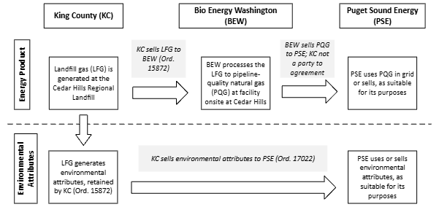

Past County Arrangement with BEW. In 2003, the Council approved legislation that authorized the King County Executive to enter into agreements with BEW, a private company for the sale and conversion of landfill gas into energy. In accordance with the original project agreements, BEW developed, built, and owned the landfill gas processing plant located at Cedar Hills on property leased to BEW by the County.

In 2007, the Council authorized the Executive to execute amended and updated agreements related to the project development, gas sales, and site lease that are in effect until 2030 with the possibility of extension. Until 2023 when the processing plant ceased operations, BEW had been processing the landfill gas to pipeline-quality, renewable natural gas at its processing plant.

Past BEW Arrangement with PSE. BEW had an agreement with PSE, to which the County was not a party, through which BEW sold PSE the processed pipeline-quality gas. This gas was routed through a nearby gas line into the PSE grid.

Past County Arrangement with PSE. Under the agreement between the County and BEW, the County retained any and all rights to the environmental attributes that are associated with the landfill gas. Between 2011 and when the last agreement with PSE expired in mid-2023, the County sold the environmental attributes to PSE, which resulted in PSE having the rights to both the processed landfill gas and the environmental attributes.

Current Situation. In 2023, BEW notified the County that it was ceasing operation of the landfill gas processing plant and subsequently filed suit against the County in U.S. District Court, claiming the County breached its contractual obligations to BEW, claiming in part the County was not following good engineering practices in gas collection and in determining responsibility for disposal of hazardous waste residuals after gas processing. The County countersued with multiple claims against BEW. The parties reached and executed a Settlement Agreement earlier this year, wherein the County and BEW would, among other things, negotiate an agreement for the County to acquire the processing plant from BEW. In July 2025, the Council adopted Ordinance 19959 approving the acquisition.

Since BEW ceased operation of the processing plant, Executive staff indicate that the Solid Waste Division has been flaring the landfill gas, as required by the landfill’s operational permits, which require flaring during periods when landfill gas cannot be sent to BEW.

ANALYSIS

Proposed Ordinance 2025-0236 would authorize the Executive to execute a new agreement with PSE for the sale of biomethane and environmental attributes produced at the Cedar Hills Regional Landfill to Puget Sound Energy. Some of the provisions of the agreement are blank in accordance with a confidentiality agreement between the County and PSE; these provisions will be discussed in executive session in accordance with RCW 42.30.110.

King County Code Requirements. The proposed agreement was developed as a negotiated direct sale to PSE. King County Code (KCC) Chapter 4.56 outlines the requirements concerning the County's real and personal property. Under KCC 4.56.250, the sale of rights, title, or interests in emissions credits held by the County are exempt from the standard real and personal property requirements "when unique circumstances are present." Code allows such sales to be made in the best interests of the public to a person or entity through a direct sale negotiated by the Executive and approved by the Council.

According to the Statement of Facts in the proposed ordinance, unique circumstances exist for this agreement “because the market for the sale of biomethane and the environmental attributes associated with biomethane is highly specialized and is subject to market variability… Puget Sound Energy is a logical purchaser of [renewable natural gas] produced by the Cedar Hills biogas processing facility… The sale of the biomethane and environmental attributes provide public benefit by increasing the revenue generated through the sale of the renewable natural gas resource.”

By adopting the ordinance, the Council would agree that unique circumstances are present and that it is in the best interest of the public to allow the direct negotiated sale of the biomethane and environmental attributes to PSE.

Proposed Agreement Terms. The proposal would allow for the sale of all of the biomethane generated at Cedar Hills Regional Landfill and a portion of the environmental attributes to PSE. The proposed agreement covers the period from September 1, 2025 through October 31, 2035.

Base Contract for Sale and Purchase of Natural Gas (Attachment A to Proposed Ordinance 2025-0236). Attachment A to Proposed Ordinance 2025-0236 covers the sale of all of the pipeline-quality gas and a portion of the associated environmental attributes to PSE. Some of the terms, including the volumes to be sold and rates, are not specified due to an agreement between the Solid Waste Division and PSE to keep these terms confidential. The Solid Waste Division anticipates selling the remainder of the environmental attributes through a separate agreement with Karbone, Inc. The proposed contractual arrangements are shown in Figure 2.

Figure 2.
Proposed and Planned Contractual Arrangements for the Collection, Processing and Sale of County's Landfill Gas (and Associated Environmental Attributes)

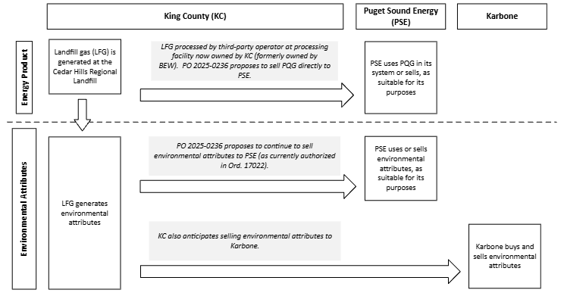

To be able to sell the biomethane to PSE, the Solid Waste Division is working to bring on a third-party processor to operate the gas processing plant and anticipates completing that agreement by late August.

Transfer Line Interconnection and Transportation Agreement (Attachment B to Proposed Ordinance 2025-0236). As part of the agreement, the County would compensate PSE at 12 cents per MMBTU for the use of its pipeline and related facilities and equipment that connect the Cedar Hills gas processing plant and interstate pipeline facilities operated by Northwest Pipeline.

Fiscal Impact. According to Executive staff, the agreement with PSE would generate $3.5 million in revenue to the Solid Waste Division in the last four months of this year, and then more than $10 million annually in future years. The majority of the revenue would be generated from the sale of the environmental attributes.

Proposed Ordinance 2025-0236 requires that revenue from the sale of the gas and the environmental attributes be allocated to the Solid Waste Division and used to offset debt and operating costs associated with operating the Cedar Hills biogas processing plant. The Proposed Ordinance further states that revenue in excess of debt and operating costs for the processing plant may be used to stabilize Solid Waste Division rates; however, the Solid Waste Division requests that the Council amend the legislation to state that any excess revenue may be used for other Solid Waste Division purposes.

Note that the Solid Waste Division estimates expenditures of approximately $150,000 per year based on 12 cents per MMBTU for the use of PSE’s pipeline and related facilities that connect the Cedar Hills gas processing plant and interstate pipeline facilities operated by Northwest Pipeline.

AMENDMENT

Council staff is drafting an amendment that would make technical corrections/clarifications and the amendment will be distributed before the Budget and Fiscal Management Committee meeting.

INVITED

- John Taylor, Director, Department of Natural Resources and Parks
- Rebecca Singer, Director, Solid Waste Division, Department of Natural Resources and Parks
- Christopher Stubbs, Deputy Director, Solid Waste Division
- David Broustis, Energy Manager, Solid Waste Division
- Katherine Taylor, Government Affairs Officer, Department of Natural Resources and Parks

ATTACHMENTS

- Proposed Ordinance 2025-0236 (and its attachments)
- Transmittal Letter

Ordinance 15872
RCW 19.285.030(21)
Ordinance 17022
Includes all cities in King County except for Seattle and Milton
RCW 19.285.030(21)
Ordinance 14723
Ordinance 15872
Ordinance 15782
Ordinance 17022; Ordinance 19562
U.S. District Court, Case No. 2:23-cv-00542-LK

