Acquisition Property Summary

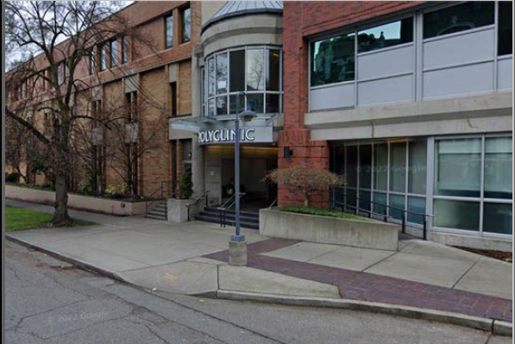

Address 1145 Broadway, Seattle WA
Sale Price $38,750,000
Sale Area 114,660 rentable sq. ft.
Assessor's Parcel 1978201270 and 1978201270
Zoning NC3
Council District 8
Funding Source Crisis Care Centers Levy plus bonds backed by anticipated tenant income
Template Status: Negotiated PSA with business considerations included.
Offer Expiration: Council Approval contingency included in the PSA. Parties have agreed to close on or before 12/15/2025.

Property Information
The building at 1145 Broadway consists of approximately 114,660 rentable square feet of medical office space and includes a 300+stall parking garage as well as a small parcel of undeveloped land on the South end of the site. The building was previously 100% occupied by the Polyclinic. After a merger with Optum, operations were merged and relocated off-site. As of this drafting, Optum is the only building tenant and is using the building primarily for two specialty clinics.

Context
Rationale for transaction: Purchase of this property will accelerate, potentially by a year, the opening of a crisis care center in the central Crisis Response Zone (CRZ). The building likely has the correct zoning, the correct mechanical and buildings systems for the use, and has historically been used for medical office purposes. In addition, the building is situated on First Hill in Seattle and has excellent transit connections as well as more than 300 on-site parking stalls.

Policy considerations: With the high demand for behavioral health services, opening a crisis care center in the most population dense area of the County is a high priority. In addition, there is a very tight real estate market for medical office space. This property would make quick renovation possible since it already has the correct zoning. There is no guarantee that another property could be found, as well situated, for the same cost of acquisition and development.

Political considerations: Any time the County looks to site a facility such as a crisis care center, communication with the surrounding community must be handled with care, as further discussed below. With mixed uses, including income generated from tenants who would occupy the portion of the building not used for CCC levy purposes, and inclusion of a floor of residential treatment beds, the County can finance the building acquisition by combining CCC Levy funds with tenant income and bond proceeds. As described below, the combined CCC Levy acquisition costs and conversion costs for the site are expected to total well below the amount that the CCC Levy fiscal model includes for capital costs for the central CRZ crisis care center plus one new mental health residential treatment facility (RTF).

Community considerations: The use of the facility is likely consistent with current zoning and the building has always been used for medical purposes. Through extensive community engagement in spring 2025, DCHS has confirmed the neighborhood has urgent need for crisis care center services.

Fiscal considerations: The cost of the building acquisition is $38.75 million or approximately $338 per square foot. The buildout of the crisis care center facility at this location is expected to cost between $300 and $750 per square foot with a current rough order of magnitude estimate of $577 per square foot or $16.1-$17.1 million (assuming a roughly 28,000 square foot buildout). Additionally, the building is very suitable for a mental health RTF. DCHS intends to locate a RTF on the floor above the anticipated location of the crisis care center, with an additional anticipated conversion cost of $3.5 million. Finally, approximately 55,000 square feet of space is available for use after crisis care center and the RFT are planned. Optum health has agreed to remain in a 28,000 square foot portion of the building, and the HMC bond program would likely pursue use of the majority of the remaining space, further reducing the net cost of acquisition to the CCC initiative. As a result of these multiple uses, the cost of acquisition and buildout would be funded by multiple sources. Financing of the acquisition through a combination of CCC Levy funds, bond proceeds, and tenant income are detailed above and below.

Other considerations: There is potential opportunity cost to not moving forward with this acquisition. This is because there is no guarantee that another building, sized correctly and zoned for a crisis care center, could be acquired or built by the County or an agency selected through a CCC Levy procurement. Additionally, FMD recognizes that the CCC may not be viewed by other building owners as a desirable tenant to be co-located with other private medical office uses inside of a larger commercial building, further limiting the options in the central zone. Real Estate Services has sought additional properties that could be usable as a crisis care center and has not located any other facilities that are as situated for success as this site.

CIP/operational impacts: The cost of this acquisition and tenant improvements related to CCC Levy uses is estimated to total approximately $61.85 million. Of this, $44.35 million is expected to be paid by the CCC Levy, and $17.5 million is supported by bond proceeds. The initial CCC Levy capital plan assumed $40 million for the crisis care center facility in the central zone. DCHS also intends to locate a mental health RTF facility on the site. The CCC Levy Implementation Plan assumed $13.5 million in capital for each mental health RTF, meaning the levy’s share of capital costs are expected to total well below the planned $53.5 million. To complete financing for the site, FMD has secured Optum as an additional tenant for vacant space in the building and expects the Harborview Medical Center (HMC) bond program to use the remainder of the site, including a portion of the site’s underground parking spaces.

Change in property use: Detailed zoning analysis has been performed by outside counsel at K&L Gates. The most likely outcome of the City’s land-use decision is that the crisis care center and RTF would be permitted outright or as legally non-conforming use. There is likely no change in use determination.

State Environmental Policy Act (SEPA) Review Required yes/no:​ Using a SEPA checklist reviewed by the Prosecuting Attorney’s Office, DCHS conducted a programmatic SEPA review for the Crisis Care Centers initiative, resulting in a determination of non-significance (DNS) in November 2024. The SEPA checklist and DNS were posted publicly, including to the Department of Ecology’s website, and returned no comments during the public comment period. This review included the potential for the County to acquire a site. The County believes that this acquisition would be categorially excluded from any SEPA requirements, however, future construction may be subject to a SEPA review, depending on scope of work and other considerations.

Equity and Social Justice impact: In accordance with Real Property Asset Management Plan (RAMP) policy, FMD and DCHS reviewed this potential acquisition for equity and social justice (ESJ) impacts. This purchase enables King County to offer a crisis care center and a mental health RTF at this location in the First Hill/Capitol Hill neighborhood of Seattle. This acquisition is expected to positively impact low-income communities, communities or color and limited English proficient communities by increasing access to crisis care services. The proposed use is similar to other property uses in the neighborhood, and consistent with the existing zoning.

Appraisal Process

Date of valuation: February 21, 2025
Appraised by: McKee Appraisal
Appraisal factors: Market Rate appraisal completed by use of the comparison method and the income method assuming highest and best use as medical office.
Comps analysis: Used market comparison of other comparable medical office space buildings in and around First/Capitol Hill Seattle.
Estimated FMV: $41,300,000.

Vicinity View Map

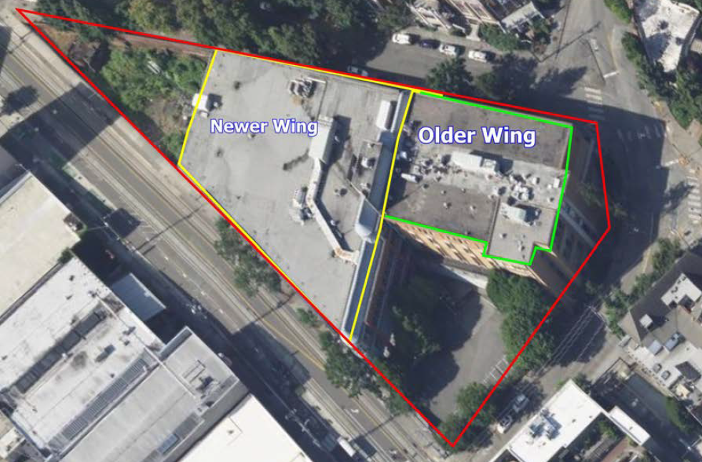

Parcel Map
