STAFF REPORT

Agenda Item: | 5 | Name: | Mary Bourguignon
Proposed No.: | 2024-0237 | Date: | August 28, 2024

SUBJECT

Proposed Ordinance 2024-0237 would authorize a 10-year lease with Washington State Ferries (WSF) at Pier 48 for storage and employee parking, as well as for moorage of a barge north of the pier to moor and maintain King County passenger-only ferry vessels.

SUMMARY

In 2012, the former King County Ferry District (KCFD) authorized a lease with the Washington State Department of Transportation’s Ferries Division (also known as Washington State Ferries, or WSF) to allow KCFD limited access to Pier 48 for employee parking and to moor a barge off the north side of Pier 48 for maintenance and moorage for KCFD’s passenger-only ferry vessels. (Pier 48 is located just south of the King County passenger-only ferry terminal at Pier 50.)

The 2012 lease was for four years with two one-year extensions and month-to-month tenancy after that. Rent was free for the first two years in recognition of the value of passenger-only ferry service in mitigating traffic during the construction of the Alaskan Way Viaduct replacement project; and $57,000 per year after the first two years.

Proposed Ordinance 2024-0237 would authorize a new lease with WSF for use of Pier 48. The proposed lease would be for 10 years beginning July 1, 2024, with two five-year extensions. The proposed lease would include moorage for the County’s maintenance barge, access from the pier to the barge, as well as five parking spaces for County employees and a fenced storage area on the pier itself.

The proposed lease cost would be $86,800 annually, adjusted each year by the Consumer Price Index. The proposed lease rate is based on the Port of Seattle’s Tariff No. 5 for moorage of a 200-foot vessel, discounted 25% for the public benefit of passenger-only ferry service and 62% for the condition of Pier 48. Lease costs would be covered by the County’s dedicated property tax for passenger-only ferry service.

BACKGROUND

Passenger-only ferry service in King County. In 2007, King County established the King County Ferry District (KCFD) as an independent government under State law to provide passenger-only ferry service.

KCFD operated passenger-only ferry service on two routes between Downtown Seattle (from Pier 50 on the Seattle Waterfront) to West Seattle and to Vashon Island.  In 2014, KCFD began planning for a renovation of its passenger-only ferry terminal at Pier 50, as part of the Washington State Ferries’ (WSF) development of its Seattle multimodal terminal at Colman Dock (Pier 52).  King County reached an agreement with WSF to split responsibilities and costs for the Pier 50 portion of the project, negotiated a 50-year lease with WSF for the continued use of Pier 50, and opened the renovated terminal at Pier 50 to water taxi passengers in 2019. | 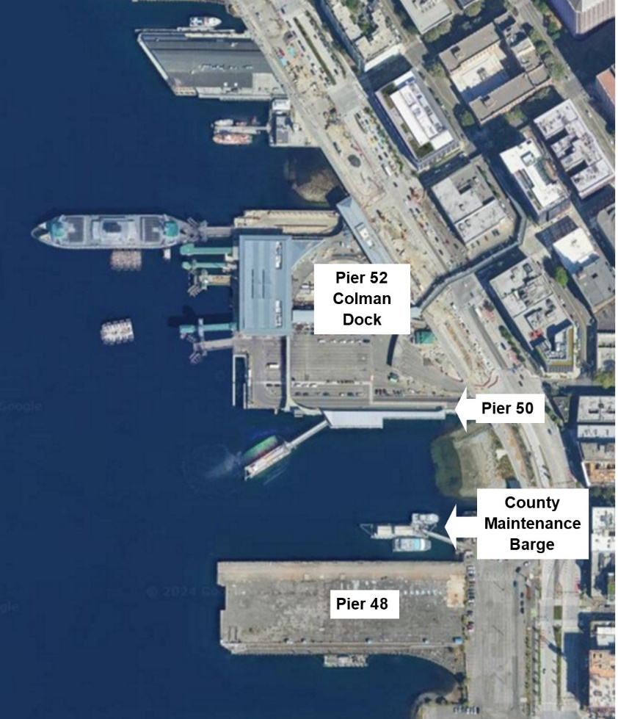

In 2014, KCFD was assumed into King County, becoming the Marine Division within the King County Department of Transportation. In 2019, the Marine Division was moved into the newly created Metro Transit Department.

King County’s passenger-only ferry service is funded through a dedicated property tax, which is currently set at a rate of $0.00845 per $1,000 of assessed value, and is estimated to collect $7 million in 2024.

2012 Pier 48 lease. In 2012, the KCFD Board authorized a lease with WSF to allow KCFD limited access to Pier 48 for employee parking and to the associated tide lands to locate a barge on the north side of Pier 48 for the maintenance and moorage of KCFD’s passenger-only ferry vessels.

Pier 48, which is located just south of the King County passenger-only ferry terminal at Pier 50, and is owned by WSF, was used primarily for contractor parking and staging during the construction of the Alaskan Way Viaduct replacement project. King County was granted access to a portion of the pier through its 2012 lease with WSF, including access from the pier to the County maintenance barge moored off the pier.

The 2012 lease had a term of four years, with two one-year extensions, and month-to-month tenancy after that.

The proposed new lease notes that WSF had prepared a draft amendment to the 2012 lease to further extend that lease after it expired, but that King County requested that WSF instead prepare a new lease that would reference King County rather than the former KCFD. As a result, the 2012 lease has been in “holdover” status, using month-to-month tenancy until the establishment of a new lease.

Rent under the 2012 lease was free for the first two years, in recognition of the value of passenger-only ferry service in mitigating traffic during the construction of the Alaskan Way Viaduct replacement project; and $57,000 per year after the first two years.

Following the expiration of the 2012 lease for Pier 48, and with the 50-year lease and renovation of Pier 50 indicating King County’s intent to use Pier 50 as a base for passenger-only ferry operations over the long term, the Executive negotiated a proposed new lease with WSF for continued access to Pier 48.

ANALYSIS

Proposed Ordinance 2024-0237 would authorize a 10-year lease with WSF, with two five-year extensions, for the use of Pier 48 and associated tidelands at 201 Alaskan Way in Seattle. This proposed term is shorter than the 50-year lease, with 25-year extension, that King County negotiated in 2016 for terminal operations at Pier 50. Metro states that the proposed lease term for Pier 48 is the longest WSF would grant due to its ongoing planning for the future use of Pier 48, including as a potential support location for electrification needs.

The proposed lease cost would be based on the Port of Seattle’s Tariff No. 5 for moorage of a 200-foot vessel, which would result in a base rate of $304,560 per year. This base rate would be discounted 25% to account for the public benefit of passenger-only ferry service and 62% for the condition of Pier 48, resulting in the proposed lease cost of $86,800 annually. Lease costs would be adjusted each year by the Consumer Price Index, beginning July 1, 2025.

Key conditions of the proposed Pier 48 lease are summarized in Table 1.

Table 1. Pier 48 Proposed Lease, Summary of Key Conditions

Issue | Lease Section | Description
Access and Use Rights | 2.1 | - King County to have access and use rights to:  - A portion of Pier 48 and associated tidelands (“Pier 48”)  - Infrastructure located at Pier 48, including gangway, fending and gate, and the concrete pad adjacent to the seawall (“Pier 48 Facilities”)  - An area at Pier 48 for access and parking  - An area for utility services and connections  - King County to locate and secure a maintenance and moorage barge for its passenger-only ferries  - Moorage of up to four passenger-only ferry vessels to the barge allowed at a time  - King County solely responsible for the security of the barge and any associated vehicles and vessels, loss of or damage to the barge, and any damage resulting from the County’s use and occupancy or Pier 48  - King County to have access to five parking spaces on Pier 48 for County employees or vendors  - King County to have 24/7 access to Pier 48, Pier 48 Facilities
Use and Occupancy of Pier 48 for Barge | 2.2 | - King County to use Pier 48 and Pier 48 Facilities for:  - Use of the pile and gangway  - Utility service installation, including power, potable water, sewer, communication lines, fire, and water  - Authorized Pier 48 upland parking  - Use and maintenance of the existing abutment pier  - The tie-up of the barge  - The docking of the County’s passenger-only ferry vessels  - The loading and unloading of supplies from the vessels  - The moorage of County passenger-only ferry vessels during service hours, non-service hours during the day, and nighttime tie-up  - Maintenance of the County’s ferry vessels
County Improvements | 2.3 | - King County may make improvements to Pier 48 and the Pier 48 Facilities, with approved improvements including:  - Gangway  - Pier installation  - Pile frame assembly installation  - Utility installation  - WSF to review future modifications or improvements  - WSF may use County utility connections if no impact on County’s operations
Term | 3 | - The lease commences July 1, 2024  - Lease term is for 10 years  - Lease may be extended via two extensions of five years each  - If the lease is not extended, ongoing use to be through month-to-month tenancy
Rent | 4 | - County to pay fair market rent, discounted to reflect the limited facilities and access at Pier 48, calculated as:  - Port of Seattle’s Tariff No. 5 moorage rate for a 200-foot vessel to be used as base rate ($304,560/year)  - 25% discount to be applied for public benefit (results in $228,420 rent/year)  - 62% discount to be applied for deteriorated condition of Pier 48 (results in $86,800 rent/year)  - Rent to be adjusted each year, beginning July 1, 2025, based on Consumer Price Index
Taxes and Operating Costs | 5 | - County to pay all relevant taxes  - County to pay the cost of all utilities that serve the leased Pier 48 and Pier 48 Facilities  - County to pay any law enforcement cost incurred on behalf of the County’s use of Pier 48
Capital Projects and Disruptions | 6 | - There may be disruptions to access to Pier 48 due to construction of the Seattle Multimodal Terminal Project (Pier 52) or Seattle Waterfront Redevelopment Project  - WSF is not liable to County for any damages from these or other ongoing construction projects
Insurance | 7 | - County to keep its activities, vessels, and equipment insured or self-insured  - Insurance policies to name WSDOT/WSF as additional insureds
Responsibilities | 8 | - County responsible for the operation, maintenance, and repair of the leased area of Pier 48  - County responsible for maintenance and security of its barge  - WSF responsible for portions of Pier 48 that are not part of the County’s lease and that WSF is using
Termination | 12 | - County may terminate the lease with three months’ notice  - WSF may terminate the lease with 12 months’ notice

Fiscal Impact. Lease costs would be covered by King County’s dedicated property tax for passenger-only ferry service.

ATTACHMENTS

- Proposed Ordinance 2024-0237 (and its attachment)
- Transmittal Letter
- Fiscal Note
- Property Summary (from Executive transmittal)

Resolution FD2012-05 (link)
Ordinance 15739. The King County Ferry District (KCFD) included the entire boundary of King County, and its Board was made up of the members of the King County Council, acting ex officio and independently. The KCFD Board had the authority to levy each year an ad valorem tax on all taxable property located in the district not to exceed $0.75 per $1,000 of assessed value to be used only for providing ferry services.
RCW 36.54.110
Passenger-only ferry service is also referred to as water taxi service.
KCFD assumed operations of King County’s seasonal Elliott Bay Water Taxi between Downtown and West Seattle in 2007 (Ordinance 15739) and began year-round service to West Seattle in 2010 (documented in FD2014-05). KCFD began Vashon service in 2009 (FD2009-15, FD2009-17), taking over service that had previously been operated by WSF.
Washington State Ferries, Seattle Multimodal Terminal at Colman Dock Project (link)
Resolutions FD2014-11, FD2014-12, FD2014-13
Ordinance 18340 (The 50-year lease of Pier 50 authorized by Ordinance 18340 was approved in 2016, by which time the KCFD had been assumed into King County.)
King County Water Taxi, Captain’s Blog, August 19, 2019, Scenes from the opening day of the new passenger-only ferry terminal at Pier 50 (link)
Ordinance 17935
Ordinance 18777. Metro’s adopted policy documents have since been updated (by Ordinance 19367) to incorporated policies related to water taxi service.
King County Assessor, 2024 Codes and Levies, King County Taxing Districts (link)
July 2024 King County Economic and Revenue Forecast, Office of Economic and Financial Analysis (link)
Resolution FD2012-05 (link)
Note that this staff report refers interchangeably to King County and the KCFD when referring to the 2012 lease. This is because King County assumed the functions and responsibilities of the KCFD in 2014, meaning that use of Pier 48 since then has been under the auspices of King County, not KCFD.
Washington State Department of Transportation, Alaskan Way Viaduct Replacement Program (link)
Proposed Ordinance 2024-0237, Attachment A, p. 2
Ordinance 18350
Ordinance 18350
Port of Seattle Tariff No. 5 sets the base rate for a 200-foot vessel at $846 per day (link)
Consumer Price Index for the U.S. City Average for All Urban Consumers as published by the U.S. Bureau of Labor Statistics (the “Index”).
County improvements are documented in Exhibit B to the proposed lease
Port of Seattle Tariff No. 5 sets the base rate for a 200-foot vessel at $846 per day (link)
Consumer Price Index for the U.S. City Average for All Urban Consumers as published by the U.S. Bureau of Labor Statistics (the “Index”).

