Revised January 16, 2025

Scoping Document for Updating the Regional Wastewater Services Plan

Prepared by the Wastewater Treatment Division – January 2025

Introduction

This scoping document describes the overall approach that will be used, and some of the major policy issues that will be analyzed, to update King County’s Regional Wastewater Services Plan (RWSP). The document was produced to solicit input and feedback on the scope of the RWSP Update from members of the Regional Water Quality Committee (RWQC) and the Metropolitan Water Pollution Abatement Advisory Committee (MWPAAC).

The King County Wastewater Treatment Division (WTD) drafted this scoping document based on initial verbal and written input from RWQC and MWPAAC members and staff as well as feedback obtained during and after the Clean Water Plan process. The scoping document was discussed at the August 28 MWPAAC general meeting, the September 4 RWQC workshop, the September 5 MWPAAC Engineering and Planning (E&P) subcommittee meeting, the October 2 RWQC meeting, and the November 7 joint meeting of the MWPAAC E&P and Rates and Finance subcommittees. WTD revised the document based on feedback from MWPAAC and RWQC and an updated version was then discussed at the December 4 RWQC meeting. Additional edits were received and incorporated into this final version. More detailed scopes of work for specific tasks under the RWSP Update will be developed as needed.

Key Terms

The following key terms are used throughout the scoping document. Because these terms can have different meanings depending on the context, the following definitions apply for purposes of the RWSP and associated materials unless otherwise noted.

Term | Definition
Equity and Social Justice | Equity is defined as full and equal access to opportunities, power, and resources so that all people achieve their full potential and thrive.  Social justice refers to all aspects of justice – including legal, political, economic, and environmental – and requires the fair distribution of and access to public goods, institutional resources, and life opportunities for all people (source: King County Equity and Social Justice Strategic Plan 2016-2022).
Rate Equity and Fairness | “Rates should be designed to distribute the cost of service equitably among each type and class of service. Non-cost of service rates that achieve certain other objectives such as affordability and water conservation may be considered in some situations.” (source: Revised: AWWA Policy Statement: Financing, Accounting, and Rates – American Water Works Association, November 5, 2024). The AWWA Principles of Water Rates, Fees, and Charges Manual states “Rate-making endeavors to assign costs to classes of customers in a nondiscriminatory, cost-responsive manner so that rates can be designed to closely meet the cost of providing service to such customer classes.”
Customer Affordability | “The National Coalition for Legislation on Water Affordability defined water affordability as the cost of provision that does not impede people from meeting other basic needs or human rights. There is, however, currently no one generally accepted definition of water affordability. It varies depending on the purpose of the water affordability assessment… Affordability researchers generally agree that no one single metric can or should be used in measuring water affordability, rather, a variety of quantitative and qualitative data should be considered.” (source: Schneemann, M., 2019, Defining & Measuring Water Affordability: A Literature Review; Illinois-Indiana Sea Grant). The measure of customer affordability will need to be further quantified and defined during the RSWP update process.

Background

The RWSP, a supplement to the King County Comprehensive Water Pollution Abatement Plan, was adopted by the King County Council in November 1999 by Ordinance 13680, and the RWSP policies were subsequently codified in King County Code (KCC), Chapter 28.86. The RWSP identifies projects and programs needed to provide wastewater capacity for homes and businesses in King County’s wastewater service area through 2030 and provides policy direction for the operation and continued development of the wastewater system. The RWSP has largely been implemented, and it is now time to update the plan to guide future investments and actions. Changed conditions, including population growth, climate change, aging assets, regulatory requirements, and customer affordability, also justify another major update to the RWSP.

The updated plan, along with the analytical work (e.g., review of the capacity charge) performed as part of the RWSP Update planning process, will support the extension of local agency sewage disposal contracts, many of which expire in 2036, and continue to strengthen WTD’s relationship with local agencies. An update to the RWSP will also help make the case for additional state and federal funding and meet the requirements for a General Sewer Plan update for approval by the Washington State Department of Ecology (Ecology).

The planning process to update the RWSP started in 2019 as the Clean Water Plan; it was paused at the end of 2021 to fully consider and address feedback received during the planning process. The pause in the Clean Water Plan process also provided an opportunity for more regulatory certainty regarding combined sewer overflow (CSO) obligations and nutrient reduction obligations. The planning process restarted in 2024 as the RWSP Update planning effort. The renewed process includes important adjustments intended to address feedback received during the Clean Water Plan process. The current RWSP Update planning process is generally similar to the process used to develop the 1999 RWSP.

Project Objectives

The overall project objectives are to develop an update to the RWSP, and to update the policies in King County Code 28.86. The project will also define a future 75-year vision (“Vision for Clean Water”), beyond the scope of the RWSP, for the utility that is consistent with WTD’s mission – “We protect public health and the environment by collecting and cleaning wastewater while recovering valuable resources for a healthy and resilient Puget Sound.”

The Vision for Clean Water will inform but not constrain policies and investments that are included in the final RWSP Update. The planning process will produce an RWSP Update that will guide future investments; support the core mission to protect water quality; seek to achieve affordable wastewater utility rates into the future; meet regulatory and legal obligations; and reflect County initiatives including equity and social justice, strategic climate action planning, and Clean Water Healthy Habitat.

The resulting RWSP Update document will include the 75-year Vision for Clean Water, a capital investment plan, and policy updates to King County Code for King County Council review and approval. The RWSP Update will reflect the County’s and WTD’s commitment to transparency and accountability in implementing the RWSP. Once adopted by the Council, the document will be transmitted to Ecology for review and approval.

Scope for the Effort

Figure 1 shows the planning process for the RWSP Update. The tasks are also described below with the associated deliverables.

Figure 1. Overall Draft Schedule for Completing the Update to King County’s Wastewater Plan

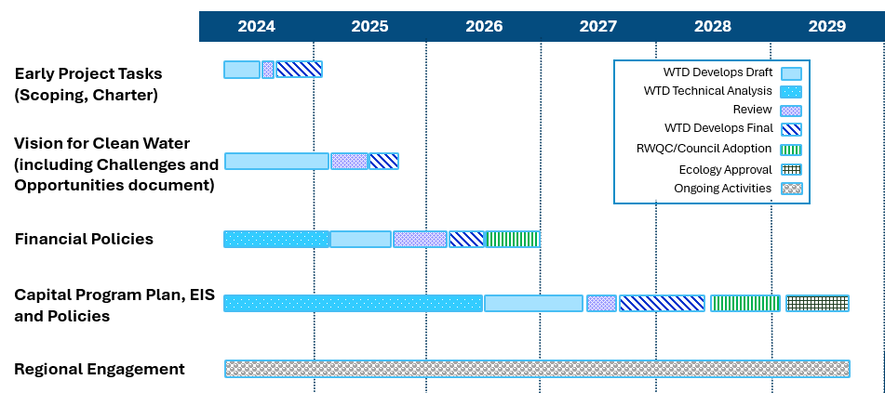

Tasks/Deliverables
Early Project Tasks – The early project tasks are designed to inform the RWQC and MWPAAC of the scope and objectives of the project and the major policy issues to be addressed as part of the update to the RWSP.
Scoping – Scoping will identify the major issues that will be addressed and the process to address those issues. The work will include the following:
  - Developing a draft scoping document.
  - Soliciting feedback on the draft scoping document.
  - Finalizing the scoping document.
Timeline: Final completed in 1st quarter 2025.

RWSP Working Group – The Working Group will serve as a forum for MWPAAC and RWQC member staff to collaborate with WTD’s RWSP project team through development and successful adoption of the RWSP update. The Working Group will help guide, shape and influence RWSP work products; it will serve as one channel for clear communication across key groups and will report out and receive feedback from MWPAAC and RWQC. The work will include the following:

- Convening a RWSP Working group with members from MWPAAC, RWQC staff, and Sound Cities Association (SCA) and WTD’s RWSP planning staff
Timeline: Formation of Working Group in 4th quarter 2024.
Charter – The charter will serve as a framework for collaboration, partnership, and process between WTD, MWPAAC, and RWQC to update the RWSP. The process will include identifying how WTD will ensure transparency and accountability during the RWSP update to the partners. The work will include the following:
- Developing the draft sections of the charter in partnership with the RWSP Working Group
- MWPAAC and RWQC review and input to the charter language
- Finalizing the charter
- Chairs of RWQC and MWPAAC, and WTD Director approve the charter as a commitment to collaboration and process to guide the RWSP update effort.
Timeline: Final completed in 1st quarter 2025.
Vision for Clean Water for Wastewater Services – The Vision for Clean Water for Wastewater Services will articulate the 75-year future of WTD and will inform but not constrain policies and investments that are included in the final RWSP Update. A document describing the challenges and opportunities facing the wastewater industry will be used to shape the vision. RWQC and MWPAAC members will have multiple opportunities to comment on challenges, opportunities, and provide feedback on the proposed final Vision components.
Challenges and Opportunities – This document will summarize the status of major challenges affecting the future of WTD’s wastewater system, projected trends for those challenges in the coming decades, emerging trends and potential opportunities for the future of water-sector utilities, and key questions to be explored in future regional discussions. Challenges and opportunities will inform but not constrain the scope of work, policy analysis, investment plans, and financial strategies. The work will include the following:
  - Reviewing relevant materials developed during the previous Clean Water Plan process.
  - Reviewing industry research on drivers and trends.
  - Updating information on the regional wastewater system.
  - Interviewing national water utility experts and thought leaders.
  - Listening sessions with interested and potentially affected parties.
  - Developing a draft challenges and opportunities document.
  - Soliciting feedback on the draft challenges and opportunities document.
  - Finalizing the challenges and opportunities document.
Timeline: Final completed in 1st quarter 2025.
Vision – The Vision for Clean Water will articulate the future of WTD over the next 75 years. The work will occur in the first stages of the RWSP update process and will include the following:
  - Reviewing existing documentation of regional priorities and feedback.
  - Conducting interviews and listening sessions to confirm and refresh feedback as well as hear new ideas.
  - Drafting several initial vision concepts.
  - Conducting broad outreach and engagement to gather feedback on the initial vision concepts and the accompanying challenges and opportunities document.
  - Finalizing the vision to be adopted with the RWSP Update.
Timeline: Final completed in 3rd quarter 2025.
Financial Policies – Technical analysis will be performed to provide information to support proposed changes to the financial policies in King County Code 28.86.160. The analysis will consider cost structure and rate equity and fairness (including the capacity charge), capital financing and debt management, and financial planning and revenue sufficiency. The work will include the following:
  - Studying peer utility agency financial policy structures and evaluating them within a WTD specific context.
  - Developing draft policy revisions and seeking review from the RWSP Working Group with members from MWPAAC, RWQC staff, and SCA.
  - Finalizing financial policy revisions and developing a proposed ordinance for Council review and approval.
Timeline: Final completed in 4th quarter 2026.
Capital Program Plan, Environmental Impact Statement (EIS), and Policies – Technical analysis will provide the information to support proposed policy changes and WTD’s future capital program. The information will be used to develop a draft and final RWSP Update, draft and final EIS, and draft and final policy revisions. The work will include the following:
Technical analysis
  - Identifying current/existing conditions in our service area in terms of demographics, the economy, water quality, and wastewater infrastructure.
  - Gathering background information on current policies.
  - Developing a range of options/strategies for policy questions. All options/strategies will meet legal obligations. Note that the approaches below should not be construed to mean least costly, more costly, and most costly, and that the recommended option may be a combination of the 3 below.
    - Stay the Course: Under this strategy, WTD would largely maintain current policies while investing, as needed, to meet current and future regulatory obligations with as little disruption as possible.
    - Strategic Enhancement: Under this strategy, WTD would largely maintain current policies but look to enhance or proactively invest in key areas that may include asset management, resource recovery (biosolids, recycled water), and additional treatment capacity.
    - Pioneering Utility: Under this strategy, WTD would shift to an even more innovative, future-focused utility, including, but not limited to, investing earlier in upgraded treatment levels to meet all future legal obligations, eliminating Puget Sound discharges, maximizing resource recovery, proactively managing assets, and actively managing infiltration/inflow (I/I) to the system.
  - Evaluating possible policy revisions.
  - Identifying the capital projects, including timelines, costs, and rate impacts, associated with the options/strategies.

Draft Plan and EIS
  - Conducting State Environmental Policy Act scoping.
  - Writing a draft RWSP Update that includes draft projects and policies, along with a draft EIS that describes the environmental impacts associated with the draft RWSP Update.
  - Conducting broad outreach and engagement to gather feedback on the draft RWSP Update and draft EIS.

Final Plan and EIS
  - Responding to comments and feedback on the draft RWSP Update and draft EIS.
  - Selecting among the options/strategies to create a proposed strategy that includes a list of capital projects, timelines, and policy revisions.
  - Identifying outcome measures to evaluate progress and measure success.
  - Identifying future update schedules and/or triggers.
  - Preparing a proposed RWSP Update and final EIS.
  - Developing and transmitting to Council an ordinance to adopt the proposed RWSP Update.
  - Developing and submitting to Ecology the adopted RWSP Update as a proposed amendment to King County’s General Sewer Plan.

Approvals
  - Council adopting the RWSP Update.
  - Ecology approving the RWSP Update, satisfying WTD’s regulatory obligation for an amended general sewer plan.
Timeline: Final completed in 3rd quarter 2029.
Regional Engagement – Regional engagement throughout the planning process ensures that interested and affected parties are informed and involved with the project. In addition to RWQC and MWPAAC, the following categories of interested and potentially affected parties may be engaged in the process (note: more detailed audience lists will be developed along with work plans and supporting outreach or event plans during each phase):
  - Local Jurisdictions and Local Sewer Utilities
  - Sound Cities Association
  - Wastewater Professionals and industry peers
  - Community-Based Organizations (Equity and Social Justice, Immigrant and Refugee, Environmental Justice)
  - Communities that have/are experiencing the greatest environmental and health burdens
  - Environmental Organizations /Nongovernmental Organizations
  - Regulators and Resource Managers
  - Neighborhood Groups
  - Public Health Community-Based Organizations
  - Water Resource Organizations
  - Ratepayers
  - Youth and Students
  - Business community
  - Agricultural community
  - Faith-Based Organizations
  - Homeowner Associations
  - Labor Unions
  - Thought leaders and experts from inside and outside the region
Timeline: Final completed in 3rd quarter 2029.
A specific plan and approach will be developed to engage with Tribal Governments. Figure 2 shows RWQC engagement during the RWSP Update planning effort. RWQC will have an opportunity to provide input before drafts are produced and feedback once drafts are available; WTD will provide status briefings along the way before RWQC is asked to take action.

Figure 2. Draft Summary of RWQC Engagement During Effort to Update King County’s Wastewater Plan

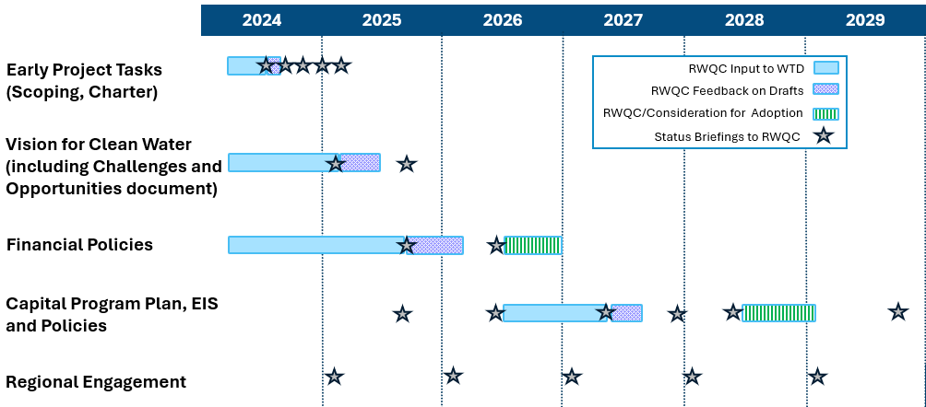

Major Policy Issues and Questions

King County has identified several major decisions regarding the future of our regional wastewater system that will need to be made in this process. To build and operate the large regional system, WTD has a long and growing list of capital projects in the coming decades, with significant forecasted costs. In making these investments, King County needs to consider many issues like our aging wastewater system, capacity drivers like population growth and infiltration and inflow, future regulations, water quality goals, energy and resource conservation and recovery, customer affordability, and climate change.

The update to the RWSP will not include stormwater planning for the region but will instead include how to address stormwater entering the wastewater system. Similarly, the update to the RWSP will not include water supply planning, but will include water reuse, which has a nexus between wastewater and water.

The policy questions in the table below have been grouped into major topics/themes that WTD has identified as known challenges and opportunities for the wastewater sector. Though a question is identified under one topic, it may also intersect with other topics in the table.

Challenges and Opportunities – Topics/Themes | Major Policy Questions to be Analyzed in RWSP Update
Regulatory Landscape  CSO, nutrients, per- and polyfluoroalkyl substances (PFAS) and other contaminants of emerging concern (CECs), current and existing requirements, new and anticipated requirements, opportunities for larger regional partnerships to address water concerns,  requirement to comply with future total maximum daily loads | Should the County evaluate costs and plan for levels of treatment beyond current legal requirements?  How should the County anticipate, engage with, and plan for future nutrient permit requirements, regulations related to CECs such as PFAS, or other future regulatory changes?  What upstream or source control actions should the region undertake to prevent contaminants and reduce costs?  How should WTD efforts support the water quality of Puget Sound and applicable inland waterways?
Capacity Demands  I/I, population growth, conveyance and treatment capacity demand, including on-site septic systems in urban areas | Given the uncertainties in future growth rates reported by Washington State and the Puget Sound Regional Council, how aggressively beyond legal requirements should WTD expand capacity to account for future population growth?  To what extent should WTD prioritize use of existing facility sites vs. acquiring new property to accommodate future treatment needs (including capacity)?  Should the region continue to provide a centralized approach for regional wastewater treatment, or should the region move towards a more decentralized approach?  How should I/I be managed and how can costs be fairly apportioned? Should system capacity be expanded to account for increases in I/I? Should I/I policies change to support reducing the capacity needed for I/I?  How should the conversion of on-site septic systems to sewers in the service area be managed and should WTD implement programs to encourage conversion within the service area?
Infrastructure Resiliency  Asset management, maintenance, improvements, renewal, replacement, labor and supply chain disruptions, natural hazard resiliency | How proactive vs. reactive should WTD be when deciding to refurbish or replace aging infrastructure?  What level of resiliency should WTD plan for regarding seismic and other natural hazards to avoid or minimize risks? What level of risk tolerance should WTD accept? How can these considerations be best informed by the long-term capital motion work in progress?  What level of redundancy of critical systems should WTD have?
Equity and Social Justice  Distributional equity, WTD role in safeguarding public health | What actions should WTD take to increase equity and social justice for the regional wastewater system?  How will equity and social justice be interwoven in the update: community engagement, rate structure analysis, etc.?  How should the regional wastewater system address environmental justice concerns as described in the 2021 Healthy Environment for All Act, such as addressing the disproportionate environmental health impacts of vulnerable populations and overburdened communities?
Climate Change  Mitigation – green building, eliminating/reducing fossil fuel use, energy and water efficiency, renewable energy, materials management, tree planting, etc.  Adaptation – sea level rise, more extreme heat, increased storm intensities, wildfire smoke, increased river flooding, etc. | Should existing wastewater policy language (KCC 28.86) be revised to specifically call out planning for future climate conditions in addition to population growth and other environmental factors?  How much should WTD reduce energy use and reduce greenhouse gas emissions?  How should WTD prepare and adapt to climate impacts (e.g., precipitation/storm intensities, sea level rise, river flooding, etc.) in line with the Strategic Climate Action Plan? What level of climate impact risk tolerance should WTD plan for to avoid or minimize risks to the system?
Resource Recovery  Recycled water, biosolids, energy capture | Energy production and heat recovery – Should WTD be expanding its efforts to capture energy and heat? If so, at what level of effort?  Biosolids – Should WTD further expand its efforts to develop Class A biosolids? What changes are needed to biosolid recovery policies to get to Class A?  Recycled water – Under what circumstances should the region expand the use of reclaimed water? Which uses (e.g., environmental benefits, groundwater recharge, industrial uses, irrigation) are most appropriate?  How can WTD best support environmental benefits while instituting safeguards to protect against environmental risks of contamination? How should cost considerations be weighed?
Finance / Customer Affordability  Rate equity, fairness, and structure, capital financing and debt management, financial planning and revenue sufficiency | How will WTD measure customer affordability for contract agencies and ratepayers?  Is there a better rate structure for the sewer rate? (Note: WTD has identified a work plan to further evaluate the residential customer equivalent conversion factor of 750 cubic feet per month.)  Will WTD maintain a single uniform sewer rate per residential customer equivalent (Robinswood “one for all, all for one”), or consider alternative cost recovery rate structures to reflect other system impacts?  Should WTD update the rate structure for the capacity charge to align with current industry standards? (Note: The capacity charge rate structure was updated in 2021. A capacity charge methodology study is in progress.)  What other rate relief approaches should WTD implement to improve customer affordability for those who may struggle to pay their sewer bill?
Relationship to Contracts and Functional Plans | How will policies embedded in the current component agency contracts and WTD Functional Plans be evaluated for consideration of a) inclusion in the RWSP as currently implemented, b) inclusion in the RWSP but modified from current implementation, or c) not included in the RWSP at this time but recommended for further study and analysis?  How will WTD implement the RWSP Update consistent with direction and requirements expected of contract agencies?

RCW 70.A.02

