Public Safety

The proposed House of Representatives 2009-11 Operating Budget calls for the elimination of JRA Enhanced Parole.

Eliminating Enhanced Parole means that one-third of youth committed to JRA would be released and return to the community without re-entry services or supervision.

JRA serves the highest risk, most serious, and most violent juvenile offenders in Washington State. Each year about 470 youth released from JRA residential facilities are placed on Enhanced Parole for a period of twenty weeks. 200+ youth are under Enhanced Parole supervision on any given day.

The committing offenses of 202 youth receiving Enhanced Parole services on April 6, 2008 are shown in the table to the left. The number of previous offenses by these youth is shown in the chart below.

Many of the young people currently on Enhanced Parole are deeply gang involved. With no Enhanced Parole, such youth would be more active in the gang lifestyle and associated crime and violence.

Without the services and supervision provided under Enhanced Parole, young people released from JRA would be at much higher risk to re-offend. Criminal victimization would increase, as would demands on law enforcement, courts, and the rehabilitation and prison systems.

Unmet Service Needs

60% of JRA youth have serious mental health problems, about 60% are chemically dependent, and approximately 40% are to some degree cognitively impaired. Most JRA youth are behind in school or need vocational training to enter the workforce.

Services addressing these issues are at no time more critical than during the post-release transition period. Without Enhanced Parole and the linkage to services it provides, youth with mental health problems will quickly destabilize, youth with chemical dependency struggles will quickly re-use, and cognitively impaired youth will have little guidance to meet their ongoing needs. Neither would youth have the support of parole counselors in establishing protective factors such as school and vocational college enrollment and assistance in finding employment leading to independence.

Many youth committed to JRA return to troubled families. Eliminating Enhanced Parole means that one-third of JRA youth and their families would not receive Functional Family Parole (FFP) services. Based on Functional Family Therapy, FFP improves communication, builds hope and engages families in understanding, supporting, and reinforcing positive change made by youth as a result of services received in JRA residential facilities.

Disparate Minority Impact

Were Enhance Parole to be eliminated, 53% of youth from minority communities would be denied the services and support it provides. In contrast, 33% of Caucasian youth committed to JRA would be released without ongoing services and support. The following percentages of youth committed to JRA would be impacted by elimination of Enhanced Parole:

Asian Youth 65%
Mixed Race Youth 60%
Hispanic Youth 52%
African American Youth 38%
Native American Youth 38%
Caucasian Youth 33%

Implications of Eliminating Enhanced Parole
JRA
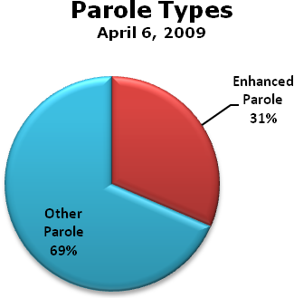

N=202
N=440

Youth on Enhanced Parole
April 6, 2009
Offense | #Youths
Assault | 49
Robbery | 40
Burglary | 31
Drug Offense | 11
Theft | 10
Weapon Offense | 9
Sex Offense | 6
Arson | 6
Murder/Manslaughter | 3
Other Offense | 37
Total | 202

N=203

# Previous Offenses Enhanced Parole Youth
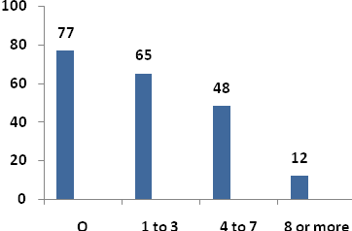
N = 202

