2006-0034
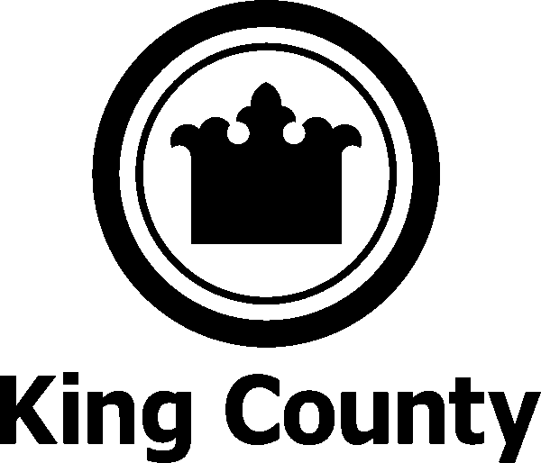 | KING COUNTY, WASHINGTON  2006 (FY 2007) FEDERAL AGENDA

 | PROJECT | DESCRIPTION OF REQUEST
1 | Transportation | Secure the following in the Transportation Appropriations bill:  - $5 million for Bus Radio Replacement Program;  - $5 million for Tolt River Bridge Replacement (Snoqualmie Bridge);  - $1.8 million for Vashon Island Passenger Only Ferry;  - $5 million for the I-405 Bus Rapid Transit;  - $9 million for Taxiway Rehabilitation and Emergency Equipment  - $2 million for BNSF Multimodal Greenway Corridor.
2 | Salmon Recovery | Secure the following in the Energy and Water Appropriations bill (Corps of Engineers):  - $2.5 million for the Duwamish/Green Ecosystem Restoration Program;  - Funding for Salmon Habitat Restoration Studies, specifically:  - $779,000 for the Lake Washington/Ship Canal Ecosystem Study;  - $1.9 million for the Puget Sound Nearshore Ecosystem Restoration Project; and  - $510,000 for the White River Flood Control and Ecosystem Restoration study.  Support $90 million funding level for the Pacific Coastal Salmon Recovery Program, which is critical to habitat recovery projects in King County.  Support efforts to design, implement and maintain a series of on-the-ground restoration projects on private agricultural lands for salmon habitat restoration in the Snoqualmie Watershed through the USDA’s Natural Resources Conservation Service, Wildlife Habitat Incentives Program

3 | Puget Sound Recovery Initiative | Support Pacific Northwest National Laboratory’s efforts to secure funding for Endocrine Disrupting Compounds (EDC) research in partnership with King County on aquatic effects and effective treatment methods.  Support continued federal funding of the Puget Sound Initiative.
4 | Wastewater | Secure $2 million funding under EPA’s State Tribal Assistance Grant (STAG) program for construction of Quartermaster Harbor community wastewater treatment facilities.
5 | Workforce Development | Support $1 million in the Labor-Health and Human Services-Education Appropriations bill for the Seattle King County Workforce Development Council to integrate workforce training services into other social services currently offered to ex-offenders transitioning back into the community.
6 | Emergency Management | Support federal legislation that provides revenue tools to local governments to fund the new infrastructure needed to provide effective e-911 services resulting from internet service providers offering Voice over Internet Protocol (VOIP). Monitor future activity pertaining to the FCC regulation requiring VoIP to provide e-911 service.
7 | Homeland Security/ Bioterrorism | Support first-responder legislation currently pending in Congress to streamline funding to local first responders and provide them with greater control over how grant resources would be expended at the local level.  Support legislation that would allow for the funding of FTE’s for critical HS functions via the various HS grant programs.
8 | Sheriff’s Wireless Communications Project | Secure $3.8 million for the second phase of deployment of a Regional Interagency Wireless Communications and Data Sharing Program to enhance King County’s ability to communicate with local, state and federal agencies in the All Hazards Response environment.

9 | Public Health Emergency Preparedness | $450,000 in Centers for Disease Control and Prevention’s Environmental Health Programs for the development and implementation of a 24-hour data communications and notification system.  Support Pandemic Flu preparedness legislation that would:  - Guarantee funding, including reimbursement to local governments, for antiviral drugs sufficient to treat a minimum of 25% of the national population;  - Provide direct funding to local governments to develop adequate and sustainable health care system medical surge capacity sufficient to meet the needs of a large scale public health care emergency such as a severe influenza pandemic.
10 | Medicaid | Support legislation to broaden allowable Medicaid mental health services following the recommendations of the President’s New Freedom Commission on Mental health.
11 | Methamphetamine Superfund | Support legislation to increase funding for methamphetamine site clean-up and effective substance abuse treatment for methamphetamine users.
12 | Health Care Reform | Support acceleration and expansion of the Centers for Medicare & Medicaid Services (CMS) and the Department of Health and Human Services (HHS) efforts to:  - Publicly support and implement quality measures endorsed by the Institute of Medicine (IOM) and public reporting of the measures;  - Support health information technology, clinical information system adoption and clinical management capabilities;  - Fund regional, interoperable health information technology networks; and  - Fund Pay for Quality Improvement pilot programs.  Seek to position the Puget Sound Health Alliance as a pilot for health information technology networks and/or a Quality Improvement pilot.  Support CMS and the Agency of Health Research and Quality (AHRQ) to continue to:  - Publicly support cost-effective evidence-based medicine and medical practices;  - Advocate the importance of improving quality of health care delivered; and  - Fund innovative pilot programs, demonstration projects and evaluations that focus on quality of care issues.  Seek to position the Puget Sound Health Alliance as an innovative pilot or demonstration project for quality of care issues.
13 | Housing, Homeless and Community Development Funds | HUD and HHS Budgets –  - Increase appropriation for CDBG formula funds to $5 billion nation wide and ensure that King County’s formula share is maintained or increased.  - Adequately fund the Section 8 voucher program  - Maintain or increase funding for Homeless Assistance (McKinney) and ensure the renewal of Shelter Plus Care funding.  - Maintain or increase funding for HOME program.  - Support legislation to provide supportive services for homeless housing.
14 | Magnuson Act | Support proposed legislative language in the current reauthorization bill that would allow NOAA the discretionary authority to access and employ local law enforcement resources to fulfill certain duties mandated by the Magnuson Act.  Oppose changes to imposed de facto limits on oil tanker traffic in Puget Sound that restricts the expansion of refinery terminals or docks in the sound, unless needed by consumers who live in Washington state.

