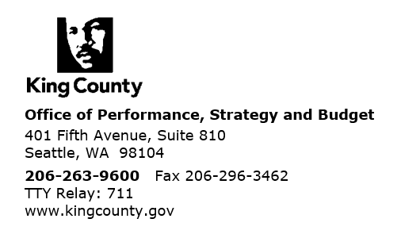

September 27, 2022

The Honorable Claudia Balducci
Chair, King County Council
Room 1200
C O U R T H O U S E

Dear Councilmember Balducci:

With the 2023-2024 Proposed Budget, Executive Constantine transmitted an ordinance requesting an extension of the suspension of Metro’s farebox recovery policy in 2023-2024. This letter provides additional information about Metro’s approach to updating its fares strategy in the upcoming biennium.
In November 2020, the King County Council approved Ordinance 19206, which suspended Metro’s farebox recovery policy for the 2021-2022 biennium in response to the COVID pandemic’s effect on ridership. The farebox recovery policy, as outlined in Ordinance 18321, requires that fare revenue cover at least 25 percent, with a goal of 30 percent, of the operating costs of the fixed route bus system. The intent of Metro’s farebox recovery policy is to ensure that a set portion of the costs to operate service are covered by fare revenue collected from customers using the service.
Although Metro and the region are in a much better place with COVID’s impacts than in 2020, ridership and work patterns (i.e., remote, in-person, hybrid) have not stabilized. Ridership and farebox recovery are still much lower than in 2019. Before the pandemic, Metro delivered approximately 400,000 trips every weekday, and in June 2022 Metro’s average weekday boardings were 218,215. Similarly, Metro’s farebox recovery dropped from 23.8 percent in 2019 to 7.2 percent in 2021.
As the region recovers from the pandemic, Metro continues to monitor how riders use transit so that service can be restored and grown in a way that meets ridership needs. Metro is also working with employers and other partners to understand what commute patterns and ridership will look like in the future.

At the same time, Metro continues to develop a holistic fare strategy. As is consistent with Metro’s Strategic Plan for Public Transportation and the Equity and Social Justice Strategic Plan, Metro does not want fares to be a barrier for people who cannot afford them. Metro is in the process of implementing two notable fare policy changes to increase accessibility: reducing the youth fare to $0 and a 16-month pilot to set the ORCA LIFT fare to $1. These changes will impact Metro’s farebox recovery by reducing fare revenue from those fare categories.
Metro intends to use the 2023-2024 biennium to work with community and agency partners to develop an updated fare strategy, which is expected to include:
- Next steps for how to expand the income-based fares program to ensure Metro’s discounts address affordability needs and advance equity. This will build on current work to expand access to ORCA LIFT and the subsidized annual pass program. Metro has also discussed potential solutions to affordability and access issues through past community engagement and is currently talking with regional ORCA partners about viable solutions. Metro will engage with community and partners to identify which program and policy solutions to implement.
- A timeline, key milestones, and process for Metro’s transition to cashless-on-board fare payment and recommended ways to make fare payment accessible to everyone. These will be developed with community, building on the engagement done in responding to Motion 16152 (“The future of Metro Transit Department’s fare collection system”) and current efforts to expand access to Next Generation ORCA.
- Recommendations for a more equitable fare verification system, cocreated with customers and frontline employees. These recommendations are being designed within the Safety, Security, and Fare Enforcement (SaFE) Reform Initiative already underway.
A recommendation will be transmitted with the 2025-2026 Proposed Budget regarding updates Metro’s farebox recovery policy, incorporating learnings from transit ridership, regional work trends, the free youth fare policy, the ORCA LIFT pilot, and other fare policy recommendations. This approach will ensure that potential updates to the farebox recovery policy are developed with thorough information about regional travel patterns and Metro’s policies and programs to ensure the farebox recovery policy is useful for managing the system in the future.

Thank you for your consideration of the farebox recovery policy ordinance. If your staff have any questions, please contact Terry White at 206-477-6065.
Sincerely,



Terry White
General Manager, King County Metro

Dwight Dively
Director, Office of Performance, Strategy and Budget

cc: King County Councilmembers
ATTN: Stephanie Cirkovich, Chief of Staff
Melani Pedroza, Clerk of the Council
Shannon Braddock, Chief of Staff, Office of the Executive
Karan Gill, Deputy Chief of Staff, Office of the Executive
Mina Hashemi, Council Relations Director, Office of the Executive

