KCRHA Contract Transition Plan

Background

On July 1, 2026, King County Executive Zahilay and City of Seattle Mayor Wilson announced their plan to stabilize, right-size, and reset the King County Regional Homelessness Authority (KCRHA). This announcement followed an independent forensic evaluation, released in April 2026, identifying significant concerns related to KCRHA’s financial management, governance structure, and internal controls.

Stabilize: The County and City have brought on a third-party financial consulting firm to bolster KCRHA’s administrative infrastructure by providing financial management support. The firm has been contracted to strengthen financial oversight, improve accountability, and position KCRHA to more successfully manage public resources and compete for critical federal funding.

Right-size: To streamline and reduce the administrative burden on KCRHA, the County and City will transition county- and city-funded contract administration back to the Department of Community and Human Services (DCHS) and Human Services Department (HSD) beginning in January 2027, allowing KCHRA to focus on its regional responsibilities, including:

- Serving as King County’s Continuum of Care lead entity;
- Administering the Homeless Management Information System (HMIS);
- Overseeing Coordinated Entry;
- Conducting the Point in Time County required by the U.S. Department of Housing and Urban Development; and
- Severe weather response.

This transition will be implemented with the least amount of disruption to service delivery as possible, while also protecting the integrity of County and City public funds.

Reset: The County and City remain committed to a regional response to homelessness. Through the rest of 2026 and early 2027, the County and City will jointly convene Regional Reset Conversations with providers, labor, business, and philanthropic representatives to inform the future evolution of KCRHA.

Consistent with the Executive’s prior public statements about needing KCRHA to continue to serve as a key regional partner, the Executive respectfully requests that the King County Council not take action at this time to dissolve KCRHA.

Shared Values for Developing Contract Transition Plans

The Executive and Mayor developed this Contract Transition Plan with shared values:

- Provide high-quality shelter, services, and housing to our region’s most vulnerable community members
- Provide a clear pathway for individuals to exit from homelessness to shelter and services and to long-term housing
- Understand homelessness as a regional issue that requires coordination and collaboration with government partners and stakeholders across King County

Key considerations for the Executive and Mayor in adopting this plan include:

- Protect federal funding for the region
- Minimize disruption to services for clients and providers
- Maintain a regional approach to homelessness

Centering Our Regional Stakeholders and Systemic Stability

This Contract Transition Plan reflects King County and the City of Seattle’s commitment to regional stakeholders, including:

- Thousands of individuals and families who are currently utilizing, or who have successfully transitioned through, our regional homelessness crisis response system
- Frontline workforce who deliver essential care daily
- Community-based organizations that serve as the operational backbone of the homelessness response system
- Local governments—including King County and all 39 distinct cities
- Businesses, workers, and neighbors who comprise our communities.

By enhancing structural, contractual, and fiscal oversight, the County and City, together with KCRHA, are taking decisive action to honor community trust, safeguard collective funding, and maintain a highly functional, fully compliant, and accountable regional network.

Overview of Contracts and Timeline of Activities to Transfer Contracts Beginning in January 2027

Beginning in January 2027, DCHS’s Housing and Community Development (HCD) Division will resume administration of 100 county-funded emergency homelessness response contracts, totaling $46.3 million with 40 providers.

Table 1.
Overview of Contracts to be Administered by DCHS

Program Type | Number of Contracts | Total Funding
Diversion | 1 | $161,000
Day Centers/Outreach | 4 | $3,250,000
Emergency Shelter | 52 | $33,100,000
Transitional Housing | 10 | $947,000
Rapid ReHousing | 15 | $6,030,000
System Support | 9 | $2,800,000
Total | 100 | $46,288,000

Some King County funded contracts may remain with KCRHA, such as:

- Contracts for severe weather shelter only where King County does not already hold a contract with the agency;
- Contracts where King County funds match an existing Housing and Urban Development (HUD) Continuum of Care award and may be used in the same project for HUD-eligible activities.

Decisions about contracts that will remain with KCRHA will be made on a contract-by-contract basis.

To ensure a smooth transition, King County and the City of Seattle will extend providers’ 2026 contracts through 2027. King County’s DCHS and the City’s HSD are currently working to align contract terms as much as possible ahead of the transition and are documenting where and why there are differences.

With the 2027 contracts, DCHS and HSD will carry forward the outcomes and requirements of the existing KCRHA contracts to the greatest extent possible. Both will continue utilizing the Seattle/King County Continuum of Care (CoC) key system performance measures: enrollments, average length of stay, utilization rates, and exits to permanent housing and homelessness. These metrics have been in KCRHA’s service contracts since 2022, and in DCHS and HSD contracts prior to that.

Figure 1.
Timeline of Contract Transition Activities
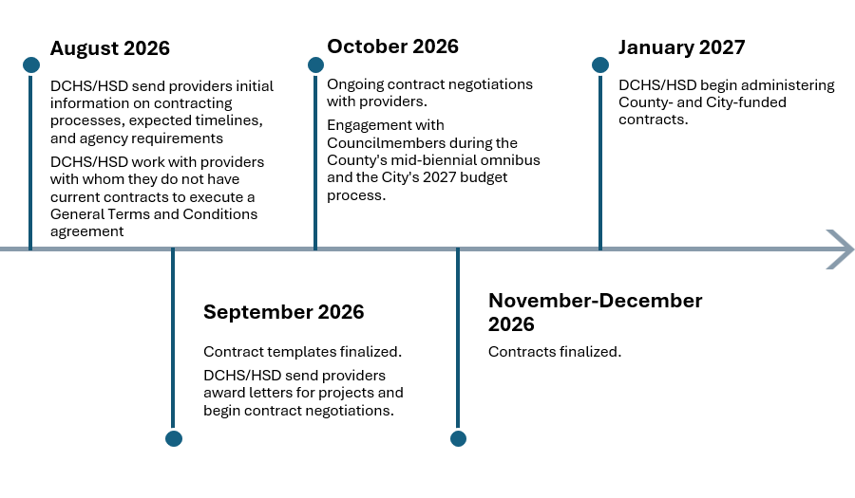

King County Council Motion 16970 requested information on potential financial risks during transition of any activities from KCRHA. Extending provider contracts through 2027 through DCHS and HSD and onboarding contract management staff before January 2027 are intended to help prevent disruption of contracted services. Transition of contracts from KCRHA to the County and City creates risk of inadvertent administrative errors that could cause issues with provider payments. Additionally, there is risk of increased administrative funding needs to ensure staffing within KCRHA and the County and City is adequate to manage the transition. The County, City, and KCRHA will work through the process of contract transitions and management to ensure continuity of contracts, including compliance and reporting requirements.

In addition, DCHS and HSD have begun convening meetings to provide timely updates to providers on the contract transition plan, answer questions, and gather feedback. The initial meeting was held on July 1, 2026, and follow-up meetings are scheduled for July 31 and September 9, 2026. Note that bimonthly meetings are envisioned to occur through the first quarter of 2028 to continue to provide input on contract administration, assess the CoC Notice of Funding Opportunity (NOFO) outcome, and contribute to planning for a joint procurement.

Working towards a Future Combined King County and Seattle Notice of Funding Availability (NOFA)

DCHS and HSD will continue efforts to harmonize their contracting processes by collaboratively confirming and using commonly held definitions for the emergency homelessness response systems (e.g., program types, service approaches, etc.).

Planning for the joint NOFA will occur early- to mid-2027 with an anticipated NOFA release in the third quarter of 2027 and a late first quarter of 2028 RFP release. Awards would be announced in Q3 2028 with new contracts beginning in January 2029.

DCHS Housing and Community Development Division (HCD) Ability and Readiness to Administer Emergency Homelessness Response Contracts

Motion 16970 requests an assessment of the ability and readiness of any county department that the Executive determines should undertake activities currently carried out by KCRHA. While a recent audit has identified areas for DCHS to strengthen its internal controls, DCHS has taken this seriously and is swiftly addressing the findings. The Executive is confident in the department's leadership, staff expertise, and commitment to continuous improvement. The King County Auditor’s most recent update in April 2026 reaffirms that DCHS has made significant progress on audit recommendations, including training and awareness, and improved its internal controls.

Prior to the creation of KCRHA, DCHS’s HCD was responsible for administering many of these same contracts and programs. In fact, HCD successfully managed this work during one of the most challenging periods in our region's history - during the COVID-19 pandemic. During that time, the department oversaw substantial housing and homelessness investments while helping communities navigate unprecedented public health and economic challenges. To date, HCD continues to successfully manage housing contracts with local, state and federal funds.

HCD anticipates hiring approximately ten full-time equivalent employees (FTEs) and one term-limited temporary (TLT) position, as shown in Table 2 below. These staff will administer the 100 contracts that will be transferred from KCRHA. DCHS has already hired a TLT Human Resource Analyst to support the ramping up of staffing. HCD anticipates hiring the Contract Specialist II, Business & Finance Officer IV, and Project/Program Manager IV (i.e., Positions 2 through 4 in the table below) to start in September.

In addition to the new positions listed below, some existing positions within HCD will have increased workloads due to this transition.

Table 2.
New Positions in HCD to Support Emergency Homelessness Response
Contract Administration
Position Title | Additional Detail
1. HR Analyst | TLT to support hiring and onboarding of new HCD positions; hired in July
2. Contract Specialist II | Position to develop contract templates and manage processes in contract software system
3. Business & Finance Officer IV | Fiscal and compliance lead
4. Program Project Manager IV | Team lead
5. Program Project Manager II | Up to six contract managers
6. Program Project Manager II | Up to six contract managers
7. Program Project Manager II | Up to six contract managers
8. Program Project Manager II | Up to six contract managers
9. Program Project Manager II | Up to six contract managers
10. Program Project Manager II | Up to six contract managers
11. Business & Finance Officer II | Invoicing and fund management

Staggered hiring for the remaining positions will occur through December 2026. Additionally, where possible, the County and City will coordinate start dates for employees hired from KCRHA to not adversely affect KCRHA operations. A question that has been raised is whether KCRHA employees can be brought on directly by DCHS and HSD. All hires will be made through competitive processes, consistent with the King County Charter and King County Code. However, the County and City are exploring ways to ensure that competitive hire processes seek to include skills, ability, and experience that may position existing KCRHA employees to be well qualified. KCRHA employees will be encouraged to apply for positions in DCHS and HSD, as well as other positions within the County and City.

Assuming all six contract manager positions are filled, the ongoing cost could total about $4 million per biennium. However, as the Executive continues to develop the mid-biennial omnibus budget ordinance for the fall, these figures could be further refined. Note that King County Council added 10 unfunded FTEs in the first omnibus (Ordinance 20086) in the HCD appropriation unit. The Executive will propose funding to support the positions in the mid-biennial omnibus in the fall. Options include diverting revenues, such as document recording fees, from other HCD programs. Other options include contributions from the Behavioral Health sales tax or Veterans, Seniors, and Human Services Levy, though these revenue sources are highly constrained. Additional review of potential revenue sources is ongoing.

Regional Reset Conversations

The future evolution of KCRHA must be informed by extensive partner and provider input. Some of this work will be addressed through Executive Zahilay’s Breaking the Cycle Workgroup announced in March 2026. As part of the Breaking the Cycle Workgroup, a subgroup examining the question of whether the County should have a standalone Department of Housing and Homelessness will be convened. Some of the answers around KCRHA’s future state may likely surface in those conversations.

The Mayor and Executive also see opportunities for further and deeper input through additional interjurisdictional processes, in partnership with the KCRHA Governing Board. The County and City will invite the KCRHA Governing Board to jointly convene facilitated “Regional Reset Conversations” with providers, labor and business, philanthropic representatives, individuals with lived experience, and advocacy organizations to identify what has and has not worked well. This broad engagement approach will consider the future of regional homeless service delivery, including the role and organizational placement of the ombuds, and system performance and alignment with an aim to make recommendations by the first quarter of 2027. Any recommendation on KCRHA’s future will follow from what we learn through those conversations.

Listening sessions will be convened with partners and stakeholders, including but not limited to:

- King County and Seattle councilmembers
- KCRHA Governing Board and CoC Board members
- Providers currently contracting with KCRHA to support youth, families, and single individuals
- Providers for those affected by gender-based violence
- Veteran service providers
- Individuals with lived experience
- Representatives of philanthropy and from the business community
- Advocates (labor, human services, and other constituencies)
- Representatives from other jurisdictions in King County

Closing

King County and the City of Seattle are committed to ensuring an effective regional response to homelessness and a smooth transition of contracts. King County and the City will continue to partner closely with each other and with stakeholders to inform future decisions and/or the evolution of KCRHA.

