REVISED STAFF REPORT

Agenda Item: | 7 | Name: | Sherrie Hsu
Proposed No.: | 2024-0298 | Date: | October 7, 2024

COMMITTEE ACTION

Proposed Substitute Motion 2024.0298.2, which would appoint a qualified person to the Coal Creek Utility District Board of Commissioners, passed out of committee on October 7, 2024 with a "Do Pass" recommendation. The motion was amended in committee with an oral amendment that inserted the name Kim William Lane on line 19 the proposed motion.

SUBJECT

Proposed Motion 2024-0298 would appoint a qualified person to the Coal Creek Utility District Board of Commissioners.

SUMMARY

Position 3 on the Coal Creek Utility District Board of Commissioners has been vacant since July 5, 2024. Under state law, if the local governing body does not fill the vacancy within 90 days, then the county legislative authority is responsible for appointing a qualified person to fill the vacancy. The board did not fill the position within 90 days (by October 3, 2024), and the King County Council is now responsible for filling the vacancy within 180 days (by January 1, 2025).

Proposed Motion 2024-0298 would appoint a qualified person to the Coal Creek Utility District Board of Commissioners. An oral amendment would be required to insert the name of the appointee on line 19 of the Proposed Motion.

BACKGROUND

Coal Creek Utility District (the "district") is a special purpose district located in King County. The district is located in King County Council District 9 and serves approximately 3,600 customers in portions of the cities of Newcastle, Renton, and unincorporated King County. The district also provides sanitary sewer services to over 2,900 connections, and it has an agreement with King County for wastewater conveyance, treatment, and disposal.

Coal Creek Utility District Map
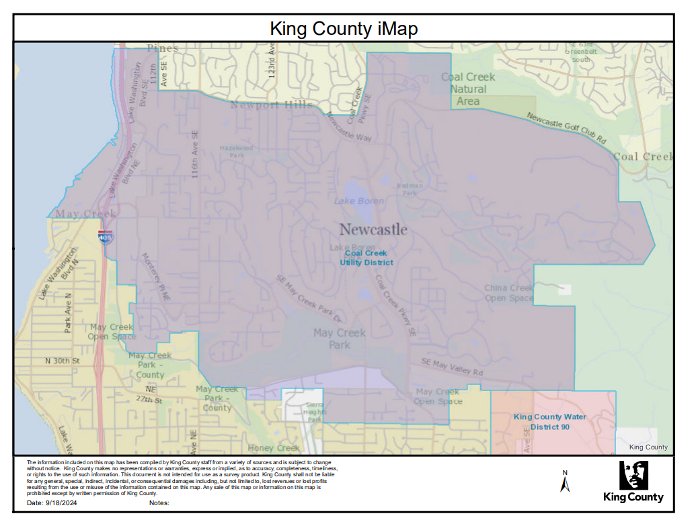

The district's governing body is a three-member board of commissioners ("board"). Position No. 3 on the board has been vacant since July 5, 2024, when former commissioner Douglas Kunkel resigned. Douglas Kunkel was elected to the position in the November 2021 election for a six-year term.

Under RCW 42.12.080, in case of a vacancy, remaining members of the governing body for the special purpose district nominate at least one candidate at a meeting of the governing body. They are required to post notice of the vacancy and name(s) of nominated candidate(s) for at least 15 days. After this period, they may appoint a qualified person to fill the vacancy. If the local governing body does not fill the vacancy within 90 days, then its authority to fill the vacancy ends, and the county legislative authority is then responsible for appointing a qualified person to fill the vacancy within 180 days of the vacancy.

The board has taken the following actions:

- At the board's July 24, 2024 meeting, the board nominated John Dulcich and Kim Lane to fill the vacancy. The notice was posted in three public places with the names of two nominees for at least 15 days as required by state law.

- At the board's August 14, 2024 meeting, the board received three applications to fill the vacancy: John Dulcich, Kim Lane, and Eric Vermeire. All candidates were interviewed at a special meeting of the district's board on August 20, 2024. No vote was taken.

- At the board's August 28, 2024 meeting, the board evaluated the qualifications of candidates. The board was unable to select a candidate to fill the position. Eric Vermeire withdrew on September 5.

- The board discussed candidates again at their September 11, 2024 meeting and was unable to select a candidate to fill the position.

The board has until October 3 to fill the vacancy. The district's staff informed King County staff that it is unlikely their board will fill the position by the deadline.

If the board does not fill the position within 90 days (by October 3), under RCW 42.12.080, the King County Council would now be responsible for appointing a commissioner to fill the vacancy within 180 days of the vacancy, by January 5, 2025. If the County Council does not fill the vacancy, then the County Council or the board may petition the governor to appoint a qualified person to fill the vacancy.

The person appointed would be up for election in November 2025, and at that time, the person elected would serve out the remainder of the unexpired term through 2027.

Appointment Process by the King County Council. On September 25, 2024, the Chair of the County Council notified all County Councilmembers about the appointment process, which is that the County Council would consider the two applicants the district nominated to fill the vacancy. The Council intends to interview two candidates, John Dulcich and Kim Lane, at the Committee of the Whole meeting on October 7, 2024.

AMENDMENT

An oral amendment would be required to insert the name of the appointee on line 19 of Proposed Motion 2024-0298.

RCW 42.12.080. [LINK]
RCW 42.12.080

