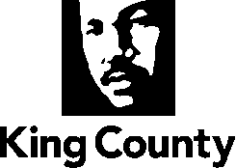

EXECUTIVE RECOMMENDED PLAN

Snoqualmie Agricultural Production District Boundary Adjustment Area Zoning and Land Use Study

I. OVERVIEW
The 2020 Comprehensive Plan Midpoint Update Scope of Work includes a study to consider expanding the Agricultural Production District. The Scope directs the following:

Consider expansion of the Agricultural Production District (APD) boundary to increase opportunities for farming, including areas near the Snoqualmie APD – Fall City areas and Carnation area, and the Enumclaw APD.

Five parcels, totaling approximately 68 acres, adjacent to the Snoqualmie Agricultural Production District, have been identified to include within the Agricultural Production District boundary. These parcels are currently in or have been in agricultural use and would be compatible with a rezone from Rural Area (RA) to Agriculture (A) zoning. Three parcels are proximate to the city of Carnation and two are proximate to the Fall City rural town. Property owners are interested in the rezone and inclusion in the Agricultural Production District.

II. POLICY CONTEXT
The King County Comprehensive Plan is the long-range guiding policy document for all land use and development regulations in unincorporated King County. Within the Comprehensive Plan, several policies reference the Agricultural Production Districts and supporting agriculture in King County.

Agricultural Production Districts were first designated in 1985 to protect irreplaceable agricultural lands and agricultural supportive uses. Policy directs Agricultural Production Districts to be contiguous blocks with clear boundaries, to reduce conflicts with other land uses. All parcels included in this study are contiguous to the current Snoqualmie Agricultural Production District and are in agricultural use.

R-643 Agricultural Production Districts are blocks of contiguous farmlands where agriculture is supported through the protection of agricultural soils and related support services and activities. Roads and natural features are appropriate boundaries for Agricultural Production Districts to reduce the possibility of conflicts with adjacent land uses.

The parcels in consideration for this study are currently zoned for rural use (RA-10), but meet the size and use criteria for A-10 zoning. The five parcels range in size from six acres to 31 acres and are in agricultural use.

R-645 All parcels within the boundaries of an Agricultural Production District should be zoned Agricultural, either A-10 or A-35.

R-646 Lands within APDs should remain in parcels large enough for commercial agriculture. A residential density of one home per 35 acres shall be applied where the predominant lot size is 35 acres or larger, and a residential density of one home per 10 acres shall be applied where the predominant lot size is smaller than 35 acres.

R-647 Agriculture should be the principal land use in the APDs. Permanent new construction within districts shall be sited to prevent conflicts with commercial farming or other agricultural uses, and nonagricultural uses shall be limited. New development shall not disrupt agriculture operations and shall have a scale compatible with an active farming district.

Three of the parcels considered in this study border the Urban Growth Area and Carnation city boundary. Policy supports including these parcels in the Agricultural Production District to preserve and support their agricultural use, and to mitigate against land use conflicts between agricultural and urban development. These parcels have also been preserved through a Farmland Preservation Program easement recognizing their agricultural suitability and inherent development pressure.

R-652 King County commits to preserve Agricultural Production District parcels in or near the Urban Growth Area because of their high production capabilities, their proximity to markets, and their value as open space. King County should work with cities adjacent to or near Agricultural Production Districts to minimize the operational and environmental impacts of urban development on farming, and to promote activities and infrastructure, such as Farmers Markets and agriculture processing businesses, that benefit both the cities and the farms by improving access to locally grown agricultural products.

R-642 King County shall continue to implement the objectives of the Farmland Preservation Program. Protection of property purchased under the Farmland Preservation Program shall be a high priority when balancing conflicting interests such as locating transportation, active recreation, utility facilities, or other uses that could have an adverse impact on farm operations. King County shall use the Transfer of Development Rights Program as another tool to preserve farmland.

This proposal supports the goal of the Local Food Initiative adopted in 2014, namely to expand King County’s local food economy to ensure job growth and economic viability for King county food businesses and farms. Expanding the Agricultural Production District to include viable and historically farmed land preserves agricultural land for farming and food production.

III. BACKGROUND INFORMATION
This study considers the inclusion of private lands currently zoned RA into the adjacent Snoqualmie Agricultural Production District. The study parcels are located in two distinct groups, one bordering the City of Carnation and the other in the vicinity of the Fall City rural town. Each group of parcels has a separate justification for inclusion.

Parcels adjacent to the Snoqualmie APD proximate to the City of Carnation
This historically farmed property is in the rural area adjacent to the Agricultural Production District, the City of Carnation, and a 60-acre farm protected by a Farmland Preservation Program easement. In 2016, the owner of the property was considering developing these lands, as allowed by King County Code. To protect the land for its agricultural resource value, the land was purchased by King County with the intention to "buy-protect-sell" the property to preserve the agricultural use. King County Council authorized sale of this property and in October 2018. It was sold to Phong Cha along with a Forest Protection Program easement that permanently protects the land for farming and open space values. Mr. Cha is a Hmong farmer in the Snoqualmie Valley who intends to grow flowers and vegetables on approximately 13 acres of prime agricultural soil, as well as harvesting forest products in the upland area. Mr. Cha is interested in the inclusion of his properties into the Agricultural Production District and the rezone to agricultural zoning.

Parcels adjacent to the Snoqualmie APD proximate to Fall City
The two properties proximate to the Fall City rural town are located within the floodway of the Snoqualmie River, on the eastern side of State Route 203, across the highway from the southeastern boundary of the Snoqualmie Agricultural Production District. The Snoqualmie Valley is subject to periodic flooding; approximately 95 percent of the agricultural lands in the area are in the 100 year flood plain. Elevated farm pads mitigate flood damage by providing high ground to harbor livestock and to store farm machinery and other agricultural equipment and supplies in frequently flooded areas.

Farm pads are allowed on otherwise unbuildable agricultural land under King County Code 21A.24.260 C: “New residential or nonresidential structures are prohibited within the mapped FEMA floodway, except for farm pads and nonresidential agricultural accessory buildings within an agricultural production district…” The farms are outside the Agricultural Production District (Figure 1) and currently unable to construct farm pads. Inclusion in the Agricultural Production District will increase the agricultural viability of this farmland by allowing the farmers to enroll in the farm pad program. Thong Cha, the owner of the property adjacent to SR 202/203 is interested in including his property in the Agricultural Production District and the associated rezone to agricultural zoning, as is Pamela Thompson, the owner of the adjacent parcel to the Northeast.

Approximately one acre of the western portion of parcel 1424079078 is zoned with a property specific development condition, SV-P03, which does not allow new or additional fill from being placed within the Federal Emergency Management Agency (FEMA) delineated floodway. This condition affects three parcels in this area, including one of the parcels subject to this study. This condition should not affect the location of a farm pad on the property. Given this, the development condition is not proposed to be amended on any of the three parcels as it provides flood protection in this area.

Maps

Figure 1. Vicinity map of APD additions. Parcels are within blue circles.
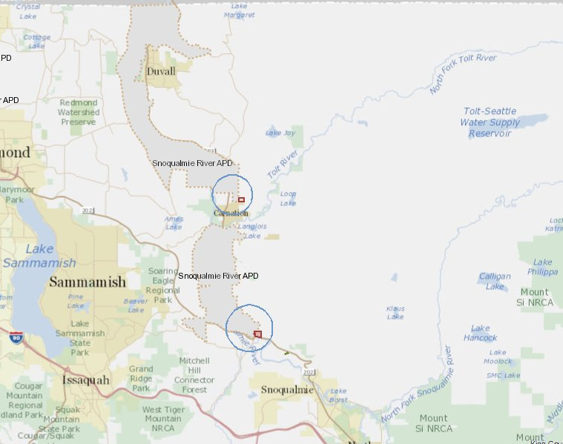

 | 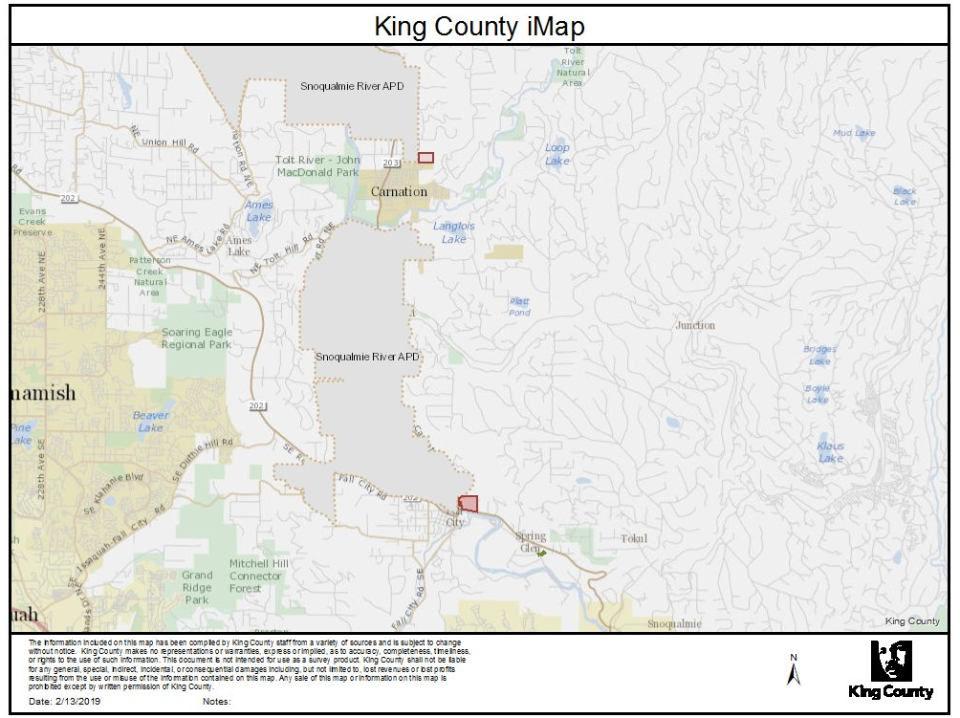
Fall City Area  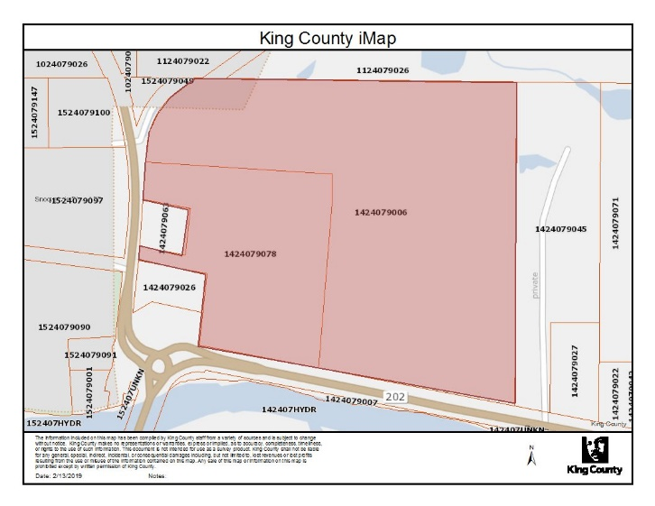 |  | Carnation Area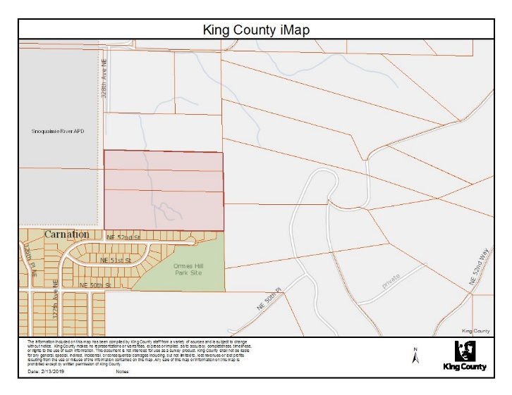
Figure 2. Parcel locations in the Snoqualmie Agricultural Production District, including the Fall City area parcel boundaries and the parcel boundaries proximate to the city of Carnation.

IV. PARCEL INFORMATION
APD | Parcel Number | Zoning | Comprehensive Plan Land Use | Acres | Present Use
Snoqualmie | 1424079006 | RA-10 | Rural Area | 30.46 | Agricultural
Snoqualmie | 1424079078 | RA-10 / RA-10-P | Rural Area | 11.35 | Agricultural
Snoqualmie | 1525079049 | RA-10 | Rural Area | 13 | Vacant (Single Family)
Snoqualmie | 1525079005 | RA-10 | Rural Area | 6.7 | Vacant (Single Family)
Snoqualmie | 1525079010 | RA-10 | Rural Area | 6.27 | Vacant (Single Family)
 |  | Total |  | 67.78

Land Use
Currently, all parcels have Rural Area comprehensive plan land use, and are adjacent to land planned as agriculture or Rural Area. The study parcels bordering the City of Carnation are adjacent to a built out urban residential area, zoned at approximately six dwelling units per acre. All parcels in this study are actively being farmed as of 2019. King County holds a Farmland Preservation Program easement on the Phong Cha parcels in Carnation and is in the process of acquiring a Forest Protection Program easement on Thong Cha’s parcels in the vicinity of Fall City. The Forest Protection Program easement limits uses on the site to agriculture and open space. The easement allows one residence and the future owner has the option to purchase the right to develop up to two additional residences. The easement limits the non-tillable surfaces to 5 percent of the site.

V. INFRASTRUCTURE

Snoqualmie Agricultural Production District - Carnation
Land is vacant. Access to 328th Ave NE is via a farm field access road along the western property line.

Snoqualmie Agricultural Production District - Fall City
Land is vacant. There is direct access to SR 203 from both parcels.

APD | Parcel Number | Infrastructure
Snoqualmie  (Fall City) | 1424079006 | Agricultural, no septic/sewer, private water, access to SR 203
Snoqualmie  (Fall City) | 1424079078 | Agricultural, no septic/sewer, Water District, access to SR 203
Snoqualmie (Carnation) | 1525079049 | Vacant, no septic/sewer, no water
Snoqualmie (Carnation) | 1525079005 | Vacant, no septic/sewer, no water
Snoqualmie (Carnation) | 1525079010 | Vacant, no septic/sewer, no water

VI. ENVIRONMENTAL

Snoqualmie Agricultural Production District - Carnation
Parcels run from the toe of a steep slope onto a level plain; peak elevation of 150 feet to a base of 70 feet. The soils are Sultan silt loam best suited to seeded grass pasture or row crops.

Snoqualmie Agricultural Production District - Fall City
The site elevation is 180 feet with level topography. A large wetland complex is found in the northwestern portion. The soils are Edgewick silt loams best used for hay and pasture. Both parcels are within the 100 year floodplain.

Critical Areas
The rezoning will not have an effect on the protections for critical areas on the parcels. This means that farming will be a viable use on these sites as a whole even with these designations.
APD | Parcel Number | Critical Areas & Flood Hazard
Snoqualmie  (Fall City) | 1424079006 | Wetland, Floodplain, Seismic Hazard
Snoqualmie  (Fall City) | 1424079078 | Wetland, Floodplain/Floodway. Seismic Hazard
Snoqualmie (Carnation) | 1525079049 | Seismic, Landslide, Erosion Hazard
Snoqualmie (Carnation) | 1525079005 | Seismic, Landslide, Erosion Hazard
Snoqualmie (Carnation) | 1525079010 | Seismic, Landslide, Erosion Hazard

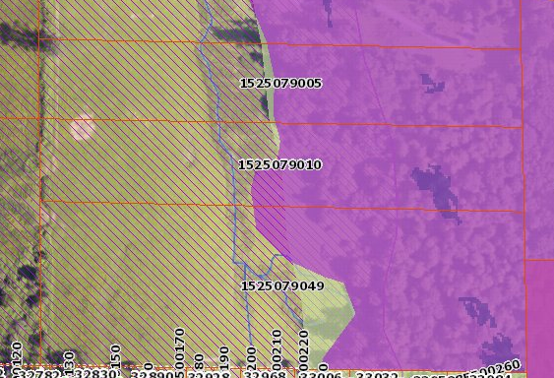
Carnation parcels Critical Area - Landslide hazard (purple shade),
erosion hazard (green shade), seismic hazard (purple hatch)
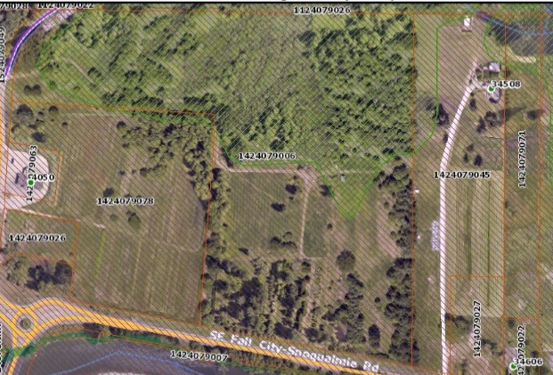
1424079078
1424079006
Fall City parcels Critical Areas - Wetland (green hatch),
Seismic hazard (purple hatch)

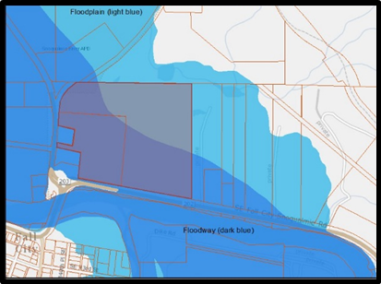
Critical areas and flood hazard on Fall City parcels properties -
Floodplain (light blue), Floodway (dark blue)

VII. CONCLUSION & RECOMMENDATION
Change the land use of five parcels from rural area to agriculture to include in the Snoqualmie Agricultural Production District, and rezone five parcels from RA-10 to A-10 zoning.

Land Use
Change the land use category on parcels 1424079006, 1424079078, 1525079049, 1525079005, 1525079010 from Rural Area to Agriculture, and include them in the Snoqualmie Agricultural Production District.

Zoning
Change the zoning on parcels 1424079006, 1424079078, 1525079049, 1525079005, 1525079010 from RA-10 to A-10, consistent with their proposed land use and inclusion in the Snoqualmie Agricultural Production District. Maintain the P-suffix SV-P03 on parcel 1424079078.

The inclusion of these five parcels in the Snoqualmie Agricultural Production District is supported by the Comprehensive Plan, the Farmland Protection Program, and the Local Food Initiative. All proposed parcels are, or will be, actively farmed and all land owners are interested in inclusion in the Agricultural Production District to preserve and further the agricultural enterprise of their property.

page intentionally left blank

