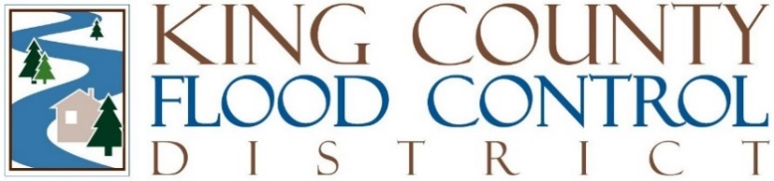

STAFF REPORT

Agenda Item: | 7 | Name: | Steven Schauer
Proposed Legislation: | FCDECM2025-03 | Date: | May 7, 2025

Proposed FCD Executive Committee Motion FCDECM2025-03: A Motion relating to the King County Flood Control Zone District’s personnel, adopting updated Staffing and Personnel Policies.

The Executive Committee of the Board of Supervisors for the King County Flood Control District has delegated authority from the Board of Supervisors through the District’s Rules and Operating Procedures at Section 4 to establish personnel policies and procedures to govern the District’s employees. Consistent with that delegated authority, the Executive Committee previously adopted FCDECM 2022-02 which incorporated, by reference, county standards relating to employee conduct and policy for equipment and facilities. The Executive Committee recognized the need to re-evaluate these policies relating to personnel and staff in step with the Legislative Branch’s processes, to efficiently and effectively provide a safe and respectful workplace environment in line with King County standards.

Since the time of the last policy’s adoption, the Legislative Branch has adopted updated personnel policies. Consistent with the direction from the Executive Committee, this Motion seeks to harmonize experiences among employees and provide clear guidelines for future projects and workplace interactions.

With approval of this Motion, the District is incorporating the most recent and applicable standards of King County’s legislative branch employees and equipment/facility policies. This process will continue to aid the King County Flood Control District’s implementation of a performance evaluation framework that is clear, achievable, and contributes to staff success by codifying a detailed set of guidelines used by all members and employees of the District.

