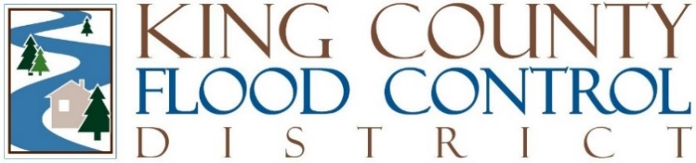

STAFF REPORT

Agenda Item: | 9 | Name: | Steven Schauer
Proposed Legislation: | FCD24-04 | Date: | October 2, 2024

A MOTION of the Board of Supervisors of the King County Flood Control Zone District, renaming the Flood Reduction Grant Program the Steve Bleifuhs Memorial Flood Reduction Grant Program.

In 2014, the King County Flood Control District (District) created the Flood Reduction Grant Program to provide grant funding for projects with flood reduction benefits, including, but not limited to, surface water overflows, near shore flooding, lake flooding due to outflow blockage, or the clearance of clogged agricultural drainage systems. The District expanded the Flood Reduction Grant Program in 2020 to provide grant funding for projects addressing the countywide flood issues of urban streams, coastal erosion/coastal flooding, and culvert replacement/fish passage restoration. The District's 2024 budget provides over $13.5 million in funding for the Flood Reduction Grant Program, which equates to over 20% of the District’s 2024 revenue generation, indicating the significance of the annual Flood Reduction Grant Program.

In July 2024, Steve Bleifuhs, who worked for King County’s Department of Natural Resources and Parks (DNRP) for nearly 30 years, passed unexpectedly in a small-plane crash. In addition to being a recognized competitive road cyclist in Washington and an avid outdoor enthusiast, Steve was a distinguished staff member of DNRP’s Water and Land Resources Division, managing a team of nearly 70 staff members.

Steve was instrumental in the creation of the District and its successes over the years. He served as the Managing Supervisor responsible for the development of the 2006 King County Flood Hazard Management Plan, which was the blueprint for county management of more than 500 flood control facilities, and featured capital improvement projects as well as floodplain management programs. The District was created in April 2007, a few months after the release of this critically important document. The flood hazard management plan developed under Steve’s leadership was a foundational driver of the District’s actions aimed at protecting lives and property and ensuring that a significant portion of King County’s economic infrastructure is safe from the damage that can be caused by fall and winter storms.

In the ensuing years, Steve was the DNRP’s main contact with the District, serving as a conduit of the County’s expertise, and aiding the collaboration between the District and County, which, since the District’s 2007 creation, has resulted in the implementation of over 370 capital projects aimed at mitigating the risk of levee and revetment failures.

In honor of Steve’s legacy of service to the people of King County, leading efforts to protect life and property from the dangers and damages of flooding, the District desires to rename the Flood Reduction Grant Program to the Steve Bleifuhs Memorial Flood Reduction Grant Program.

The Steve Bleifuhs Memorial Flood Reduction Grant Program will be promoted and awarded annually to worthy projects throughout King County, similar to how the grant program is currently administered. The projects funded with these grant dollars are the types of projects championed by Steve over the years. By naming this grant program after him, it is the sincere intent of the District’s Board of Supervisors to keep Steve’s legacy alive and progressing into the future with new flood risk reduction projects being funded in his honor.

Approval of this Motion is administrative and does not change the authorized grant program budget. The Motion has been reviewed by legal counsel.

