STAFF REPORT

Agenda Item: | 7 | Name: | Melissa Bailey
Proposed No.: | 2024-0080 | Date: | May 22, 2024

SUBJECT

The proposed motion would acknowledge receipt of the civil protection order evaluation report required by the 2023-2024 Adopted Biennial Budget (Ordinance 19546, Section 35, Proviso P1.B).

SUMMARY

In recent years, the Washington State Legislature passed legislation to clarify and simplify civil protection order statutes. King County Superior Court (Superior Court) and the Department of Judicial Administration (DJA) received one-time state funding to implement a Protection Order Court Pilot Program (the pilot). According to Superior Court and DJA, the goal of the pilot is to implement the new state law while assessing the impact the changes have on Superior Court and DJA resources. The pilot began on January 17, 2023, and is set to run through the end of 2024.

When the Council provided appropriation authority for the pilot in the 2023-2024 Adopted Biennial Budget, it also included a proviso requesting two reports. The first report was transmitted on June 1, 2023; the Council passed a motion acknowledging receipt of it later that year, which released the first half of the appropriation authority withheld by the proviso ($200,000 of a total $400,000 withheld). On March 6, 2024, Superior Court transmitted the second report along with Proposed Motion 2024-0080 to acknowledge receipt. Passage of the proposed motion would release the remaining $200,000 of restricted appropriation authority in DJA's budget. The report, which is Attachment A to the proposed motion, appears to address the proviso requirements.

Amendment 1 is a technical amendment that would correct typographical errors in the proposed motion. Title Amendment T1 would correct the name of the report in the title of the proposed motion so that it aligns with the name of the report as it appears in the body of the motion and in the attachment.
BACKGROUND

Civil Protection Orders. Civil protection orders allow a person to petition a court to seek protection from harmful or threatening behavior from another individual. Some civil protection orders may also include protection for people beyond the petitioner, such as their children. There are six types of civil protection orders (see Table 1).

Table 1. Types of Civil Protection Orders

No. |  | Type of  Protection Order |  | Description
1. |  | Domestic Violence |  | Alleges the existence of domestic violence committed against the petitioner(s) by an intimate partner or family household member.
2. |  | Sexual Assault |  | Alleges the existence of nonconsensual sexual conduct or nonconsensual sexual penetration that was committed against the petitioner by the respondent.
3. |  | Stalking |  | Alleges the existence of stalking committed against the petitioner(s) by the respondent.
4. |  | Anti-Harassment |  | Alleges the existence of unlawful harassment committed against the petitioner by the respondent.
5. |  | Vulnerable Adult Abuse |  | Alleges the person is a vulnerable adult and has been abandoned, abused, financially exploited, neglected or is threatened with these things by the respondent.
6. |  | Extreme Risk |  | Allows the court to prohibit a person from possessing, purchasing, accessing, or receiving a firearm if the person poses a significant risk of harm to self or others by having possession or access to firearms.

In Washington state, both district and superior courts may hear civil protection order matters, but vulnerable adult abuse protection orders and full hearings for extreme risk protection orders are only heard in superior court. Civil protection order proceedings are considered "special proceedings" and the standard rules of evidence for criminal legal proceedings do not apply. The standard of proof is a preponderance of evidence, rather than the stricter reasonable doubt standard, and juries are not used.
While both King County Superior and District Courts may hear civil protection orders, the proviso, and therefore this staff report, focuses on Superior Court. King County Superior Court (Superior Court) is a general jurisdiction trial court. The Department of Judicial Administration (DJA), also known as the Superior Court Clerk's Office (Clerk's Office), carries out several responsibilities related to civil protection orders. Specifically, the Clerk's Office provides information and customer service support to the public, processes and maintains court records, and, when a civil protection order is issued, the Clerk's Office forwards a copy of relevant court documents to the appropriate law enforcement agency for service on the respondent. By law, the Clerk's Office cannot provide legal advice or support.

Changes to State Law. In recent years, the Washington State Legislature passed legislation to clarify and simplify civil protection order statutes. The Legislature said the changes were needed to ensure protection orders and corresponding court processes are more easily accessible to all litigants and particularly parties who may experience high barriers to accessing justice.

E2SHB 1320. In 2021, the Legislature passed, and the Governor signed, Engrossed Second Substitute House Bill (E2SHB) 1320. The bill streamlined civil protection order procedures by consolidating the six types of civil protection order categories under one new chapter of law. It also increased uniformity in the rules and procedures that govern protection order petitions and proceedings, improved data collection, and increased access to the courts through the use of technology. Examples of changes resulting from this new law include the Administrative Office of the Courts developing and distributing a single form to petition for any type of civil protection order (except extreme risk protection orders) and direction that all courts should allow petitioners and respondents to electronically track the status of their petition or order.

E2SHB 1320 also required the Administrative Office of the Courts, through the Washington State Supreme Court Gender and Justice Commission (the Commission), to convene a stakeholder group and develop recommendations for improving the civil protection order process. The E2SHB 1320 Stakeholder Group (Stakeholder Group) met over the course of a year and included judges from district, superior, and tribal courts, county clerks, advocates, researchers, attorneys, and court administrators. The Stakeholder Group produced a final report with recommendations to the Legislature in December 2021. It also submitted recommendations to the courts in June 2022.
SHB 1901. In 2022, the Governor signed Substitute House Bill (SHB) 1901 to implement recommendations made by the E2SHB 1320 Stakeholder Group relating to the jurisdiction of courts over civil protection order proceedings and the inclusion of coercive control in the definition of domestic violence. Additional changes were also made relating to the filing and service of petitions, hearing procedures, issuance of orders, violation and enforcement, and the modification or termination of orders.

Both district and superior courts have jurisdiction over proceedings for domestic violence, sexual assault, stalking, and anti-harassment protection orders. However, based on the Stakeholder Group's recommendations, SHB 1901 requires civil protection order proceedings to be transferred from district court to superior court in the following circumstances:
- A superior court has exercised or is exercising jurisdiction over a proceeding involving the parties;
- The action would have the effect of interfering with a respondent's care, control, or custody of the respondent's minor child;
- The action would affect the use or enjoyment of real property for which the respondent has a cognizable claim or would exclude a party from a shared dwelling;
- The petitioner, victim, or respondent to the petition is under 18 years of age; or
- The district court is unable to verify whether there are potentially conflicting or related orders involving the parties.

Civil Protection Order Audit. In May 2022, the King County Auditor's Office released an audit titled Protection Orders: User-Focused Approach Could Help Address Barriers. The audit was conducted in parallel to, but separately from, the state legislative process described earlier in this staff report. The Auditor's Office made ten recommendations, many of which aligned with the state level changes; however, the Auditor's Office notes that it drew its conclusions independently. The Auditor's Office plans to release a follow-up report (tentatively scheduled for summer 2024).

Civil Protection Order Court Pilot. In 2021, the Legislature provided counties with moneys to assist with one-time costs related to law enforcement and criminal justice legislation enacted between January 1, 2020, and June 30, 2021. King County received $8.8 million from the state, of which about $1.17 million was provided to Superior Court and $1.17 million to DJA for a Protection Order Court Pilot Project (the pilot).

According to Superior Court and DJA, the goal of the pilot is to implement the new state law while assessing the impact the changes have on Superior Court and DJA resources. The pilot began on January 17, 2023 and is set to run through the end of 2024. It is funded solely with the one-time state dollars; however, Superior Court and DJA note that there are ongoing costs beyond the pilot and an ongoing revenue source has not been identified. Tables 2 and 3 show the pilot's budgeted costs broken down by Superior Court and DJA, respectively.

Table 2. Superior Court: Civil Protection Order Pilot Budgeted Costs

Superior Court Pilot Item |  | Amount
Staffing for 4 TLTs |  | $1,043,000
Pro Tem Judicial Officers |  | $115,000
Training |  | $10,000
Total |  | $1,168,000

Table 3. DJA: Civil Protection Order Pilot Budgeted Costs

DJA Pilot Item |  | Amount
Staffing for 5 TLTs |  | $1,024,714
Electronic Notifications |  | $100,000
Automatic Form Generator |  | $50,000
Total |  | $1,174,714

DJA indicates that their staffing expenditures represent ongoing costs beyond the pilot; however, they have not had to expend moneys for the automatic form generator since one was provided by Washington Law Help. Additionally, it is not yet determined whether there will be ongoing funding needs for electronic notifications. DJA reports that Thurston County is piloting a program with WA VINE for electronic notifications, and the development and testing has taken longer than anticipated. If that pilot is successful and can be implemented in King County, DJA would need ongoing funding to contract for the service (unless the state funds and implements electronic notifications statewide).

Civil Protection Order Process. DJA and Superior Court summarize the civil protection order process as follows, which is directed by state law:

After each hearing, DJA sends a service packet containing any orders and further instructions to the protected party, a service packet to law enforcement, as well as additional paperwork allowing law enforcement to enter the protection order information in the state database system. Superior Court confirms that temporary protection orders are often reissued and hearings rescheduled in these cases because, for example, it may take longer than two weeks for the respondent to be served and made aware of the legal proceedings.
Proviso Report Requirement. The 2023-2024 Adopted Biennial Budget included a proviso that withheld $400,000 in appropriation authority from DJA's budget:

Of this appropriation, $400,000 shall not be expended or encumbered until the executive transmits a report as required in subsection A. of this proviso describing the new protection order process, along with a protection order pilot program evaluation report as required in subsection B. of this proviso, a motion that should acknowledge receipt of each report, and both motions are passed by the council. Each motion should reference the subject matter, the proviso's ordinance number, ordinance section and proviso number in both the title and body of each motion.

- The report describing the new protection order process and plans for the pilot program shall include, but not be limited to, the following:
- A discussion of how the department of judicial administration and superior court protection order pilot addresses the recommendations to the courts from the E2SHB 1320 Stakeholder Group;
- A discussion of the department of judicial administration and superior court's plan to expand language access for both petitioners and respondents, including but not limited to the plans to translate forms to major non-English languages spoken in King County;
- An evaluation plan for the protection order pilot, including identification of the performance metrics to be used to evaluate the pilot, including measures to assess whether access has been improved for unrepresented litigants;
- A summary of the initial feedback for the department of judicial administration and superior court from stakeholders, including petitioners, advocates, respondents, civil legal aid providers, law enforcement and the prosecuting attorney's office on any suggested improvements based on the initial pilot program; and
- A plan to solicit feedback throughout the pilot period from interested stakeholders, including petitioners, advocates, respondents, civil legal aid providers, law enforcement and the prosecuting attorney's office.

- For the protection order pilot evaluation report, the report shall include, but not be limited to, the following information:
- Recommendations for any needed improvements to the department of judicial administration and superior court protection order pilot program based on lessons learned during the pilot period, implementation of the evaluation plan and tracking of performance metrics referenced in subsection A.3. of this proviso and feedback from stakeholders referenced in subsection A.5. of this proviso;
- Summary of feedback solicited throughout the process from interested stakeholders, as referenced in subsection A.5. of this proviso;
- Description of actions taken by the department of judicial administration and superior court in response to initial and ongoing feedback from stakeholders, as referenced in subsection A.4. and 5. of this proviso;
- The number of protection orders filed by type;
- The median wait time by type of order for a petitioner between filing for a protection order and receiving a full order;
- A summary by type of orders, the percentage of petitioners by race that were successful in obtaining a full order, the percentage of petitioners by race successful in obtaining only a temporary order and the percentage of petitioners by race that did not receive any type of order;
- Percentage of orders by type denied versus dismissed broken out by measureable metrics, including race;
- Percentage of petitioners obtaining a temporary order but no full order; and
- Reasons for denials or dismissals.

Moneys shall be unencumbered in $200,000 increments upon adoption of the motion acknowledging receipt of each report is passed by the council.

The executive should electronically file the first report with requirements specified in subsection A. of this proviso and motion required by this proviso by June 1, 2023, with the clerk of the council, who shall retain an electronic copy and provide an electronic copy to all councilmembers, the council chief of staff and the lead staff for the law, justice, health and human services committee or its successor.

The executive should electronically file the second report with requirements specified in subsection B. of this proviso and motion required by this proviso by March 6, 2024, with the clerk of the council, who shall retain an electronic copy and provide an electronic copy to all councilmembers, the council chief of staff and the lead staff for the law, justice, health and human services committee or its successor.

ANALYSIS

Civil Protection Order Pilot Evaluation Report. The proposed motion would acknowledge receipt of the Civil Protection Order Pilot Evaluation Report, which was transmitted by Superior Court on March 6, 2024. Superior Court and DJA produced the report, which is attachment A to Proposed Motion 2024-0080. It appears to address the requirements of subsection B of the proviso. Passage of the motion would release the remaining $200,000 of restricted appropriation authority in DJA's budget. Key highlights from the report include:

B.1. Recommendations for any needed improvements to the pilot based on lessons learned during the pilot period, implementation of the evaluation plan, tracking of performance metrics referenced in subsection A.3. of the proviso, and feedback from stakeholders referenced in subsection A.5. of the proviso.

According to the report, DJA and Superior Court have worked together throughout the pilot to monitor program performance, engage key stakeholders (such as law enforcement, District Court, the Prosecuting Attorney's Office, and advocate groups), and implement needed improvements to better serve civil protection order (CPO) participants. They note that "progress has been made on improving language access for non-English speaking CPO participants, making the Clerk's CPO website more accessible, establishing a workgroup with CPO stakeholders to provide training for judicial officers, and reviewing the CPO customer experience." They state that further improvements are necessary but would require additional capacity and funding. Recommendations from the report are summarized in Table 4.

Table 4. CPO Pilot Evaluation Report Recommendations

Recommendation | Notes from the Report
Training. Provide additional training for staff and judicial officers on topics such as trauma-informed customer service, domestic violence dynamics, statutory information, and managing employee stress related to working on CPOs.  Funding is needed to pay for trainings as well as for pro tem coverage (so commissioners and judicial officers can attend trainings). | Training was provided for judicial officers throughout the pilot on topics including coercive control, trauma-informed courts, and CPO-specific items.  Stakeholder feedback noted the importance of ongoing training, so the Court established a judicial training development workgroup in January 2024. The workgroup, which includes stakeholders such as the Coalition Against Gender-Based Violence and the King County Weapons Surrender Program, meets quarterly to discuss training topics and help determine available resources.
User-Friendly Resources. Continue making electronic CPO resources, such as the KC Script E-Submission Portal and the Clerk's website, more user-friendly.  Additional updates to the Clerk’s website are expected to be implemented by the end of Q2 2024. | Advocate feedback indicated a need to improve accessibility and navigability of the KC Script E-Submission Portal and the Clerk's website. In response, DJA made updates (such as providing instructions and language access resources). Advocates reported these updates were successful in improving the CPO customer experience, but additional changes are still necessary.
Support for CPO Filers. Provide more advocates and legal assistance for CPO filers. This includes more multicultural advocates, bilingual advocates, and advocates for people with disabilities to ensure equitable access to the CPO process.  The report notes that this is outside the scope of DJA/Superior Court and would require further action at the county and/or state level. | Performance metrics and feedback solicited during the pilot indicate a need for more support for CPO filers. For example, filers that had legal representation were 25 percent more likely than self-represented filers to receive a full protection order. However, from 2019-2023, only 12 percent of CPO filers had legal representation.  Additionally, domestic violence advocates and the PAO's Protection Order Advocacy Program have a limited scope, supporting people filing domestic violence petitions. However, the biggest increase in the type of petitions filed has been anti-harassment petitions.
Law Enforcement Info Sharing. Establish a statewide, digital system that would allow law enforcement to exchange information more readily across jurisdictions.  The report notes that this is outside the scope of DJA/Superior Court and would likely require changes to state law and funding for implementation through the Administrative Office of the Courts (AOC). | Per the report, "law enforcement agencies receive CPO documents to serve respondents and enter information into the criminal database system via email. The volume of documents received daily and the need to forward documents to different jurisdictions to serve respondents makes this process inefficient. Relying on email for these essential processes creates the potential for service delays that impact both petitioners and respondents in protection order cases."
Simplify CPO Forms. The report asserts that simpler forms would make it easier for customers to complete the form accurately.  DJA and Superior Court are unable to change the forms, which are provided by the state and are mandatory. DJA staff will share the recommendation to simplify the forms with the AOC CPO forms subcommittee. | The new petition form and supplemental documents created by the AOC are longer (30-50 pages minimum). DJA and Superior Court have found that customers find it difficult to complete the forms without making errors or missing required fields. Additionally, the length of the forms has increased the time it takes for DJA and Superior Court to review and process the forms.
Funding to Address Caseload. Provide funding to Superior Court and DJA so they are able to address the increased CPO caseload due to:  - Increased number of CPO filings, hearings, and orders;  - State statutory requirements;  - Increased complexity and time needed to process cases.  Superior Court is currently using one-time state funding and federal CLFR funding; however, both end in 2024. According to the report, without additional funding, the Court's capacity to deal with CPOs and weapons surrender will be severely diminished at the end of 2024.  Superior Court and DJA recommend the following to ensure adequate coverage:  Superior Court  - 3 Commissioners  - 4 Court Coordinators  - 1 Weapons Surrender Coordinator  - 1 Program Supervisor  DJA  - 6 Clerk Administrative Specialists to support the three commissioners  - 2 Customer Service Specialists to staff DJA's Protection Order offices at KCCH and MRJC  Compared to current staffing, this proposal would add one new family law commissioner, two new court coordinators in Superior Court, and three new clerk administrative specialists in DJA. | In 2023, DJA and Superior Court managed more than 5,000 CPO cases. The number of petitions filed that year was 26 percent higher than the number filed in 2022.  In addition to more filings, there have been more hearings. Per the report, an increase in the number of initial hearings has impacted the Ex Parte department's ability to meet workload demands in other areas such as guardianship and unlawful detainers (eviction petitions).  The return hearings in Family Law have also had an impact on operations. These hearings have required additional preparation time, often due to lengthy pleadings and audio and/or video evidence that must be reviewed by the judicial officer prior to the scheduled hearing.  Full hearings also take longer as more evidence is considered to determine whether or not coercive control exists. The report states that a pattern of behavior over a long period of time can be relevant in making a determination, meaning many prior incidents of control and documentation become admissible (often evidence is hundreds of pages).  In addition, the Court must prepare final orders in cases in which parties are self-represented, which as previously noted, is the majority of CPO cases. The report notes that the family law commissioner hearings have exceeded capacity.  Changes in state law have also meant that that Orders to Surrender Weapons are entered in most civil protection order cases – not just domestic violence and extreme risk protection orders. The report states that this increase in firearms surrender orders has nearly doubled the volume of cases on Weapons Surrender Review Calendars.

B.2. Summary of feedback solicited throughout the process from interested stakeholders, as referenced in subsection A.5. of the proviso.

According to the report, feedback was solicited throughout the pilot from interested parties including CPO petitioners, respondents, civil legal aid providers, law enforcement, and advocates including representatives from the Protection Order Advocacy Program of the Prosecuting Attorney's Office. The report provides a summary of how feedback was gathered (electronic surveys and discussion groups) and the topics covered (language access, digital accessibility via the KC Script E-Submission Portal and DJA's CPO website, service of CPO documents, and overall CPO participant experience). This section of the report does not describe the specific feedback given; however, this information is provided in the response to B.3.

B.3. Description of actions taken by the DJA and Superior Court in response to initial and ongoing feedback from stakeholders, as referenced in subsection A.4. and 5. of the proviso.

The report summarizes feedback provided on each topic and the corresponding actions taken by DJA and Superior Court.

Language Access and Digital Accessibility. Feedback from advocate groups serving non-English speaking clients indicated that the Clerk's website and the KC Script E-Submission Portal should be updated to better serve people with limited English proficiency. In response, DJA worked with the advocate groups to review the Clerk's website and identify potential changes. The report notes that a prototype incorporating the feedback was developed and advocates were invited to review it and provide another round of feedback. Using this input, website updates are being finalized and implementation is expected by the end of Q2 2024.

In addition to the website updates, DJA also reviewed the messages sent to customers after they submit a petition via the KC Script E-Submissions Portal. These messages let customers know if their petition was successfully filed, if there are any corrections required, and what the next steps in the CPO process are. The report states that English messages and their translated counterparts were simplified using plain language to improve accessibility.

Service of CPO Documents. According to the report, feedback from law enforcement agencies showed they required additional support to ensure CPO documents are served in a timely manner. In response to this input, Superior Court has provided a direct contact for law enforcement agencies to use if there are questions about a civil protection order or when an order needs to be amended. Additionally, Superior Court and DJA have instituted monthly meetings with law enforcement agencies to discuss issues related to CPO service and entry of orders into law enforcement databases.

CPO Participant Experience. The report states that participants noted areas for improvement including additional language access support throughout the CPO process, making the website and E-Submission Portal more user friendly, and providing continued training for DJA and Superior Court staff and judicial officers on trauma-informed customer support and domestic violence dynamics. As previously mentioned, the report notes that training was developed and provided to judicial officers. Additionally, training is being identified for staff by the judicial training development workgroup; however, more funding will likely be required to support this work.

The report also states that CPO participants commented on the availability of staff to support CPO customers over the phone and in-person and noted the need for increased DJA and Superior Court staffing.

B.4. The number of protection orders filed by type.

The report states that the "total number of petitions filed or transferred increased by 28 [percent] from 2019 to 2023 and is significantly higher than pre-pandemic levels. This increase has been primarily in anti-harassment orders. While the number of domestic violence orders has been fairly stable over the last five years, the number of anti-harassment orders has increased by 190 [percent] since 2018."

Table 5. Number of Protection Order Petitions Filed or Transferred by Type
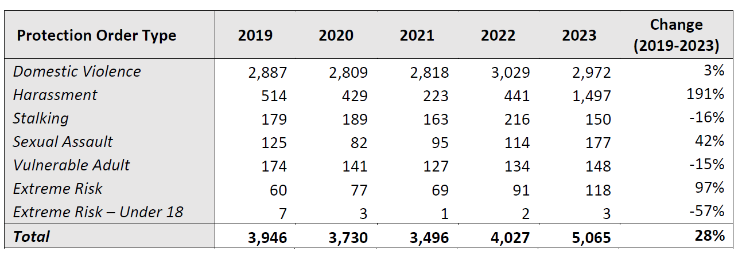

Effective January 1, 2023, no filing fee may be charged to a petitioner seeking an anti-harassment protection order if there were acts of stalking, violence, indications of a hate crime or other offenses outlined by law. The report notes that this change likely contributed to the significant increase in anti-harassment petitions.

B.5. The median wait time by type of order for a petitioner between filing for a protection order and receiving a full order.

As noted in the report, a "petitioner who requests a temporary protection order is prioritized by the Court. The Court has until the following business day to hear the case. If the Court grants the temporary order, it is issued the same day as the hearing is held." These hearing procedures are directed by state law.

DJA and Superior Court interpreted "type of order" to mean temporary versus full order (rather than breaking information down by domestic violence, anti-harassment, stalking, sexual assault, vulnerable adult, and extreme risk protection orders).

Table 6. Wait Time for Final Orders from Time of Initial Filing
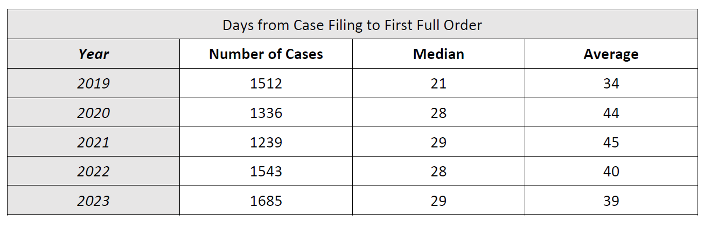

Table 7. Wait Time for Final Orders from Last Temporary Order Entry
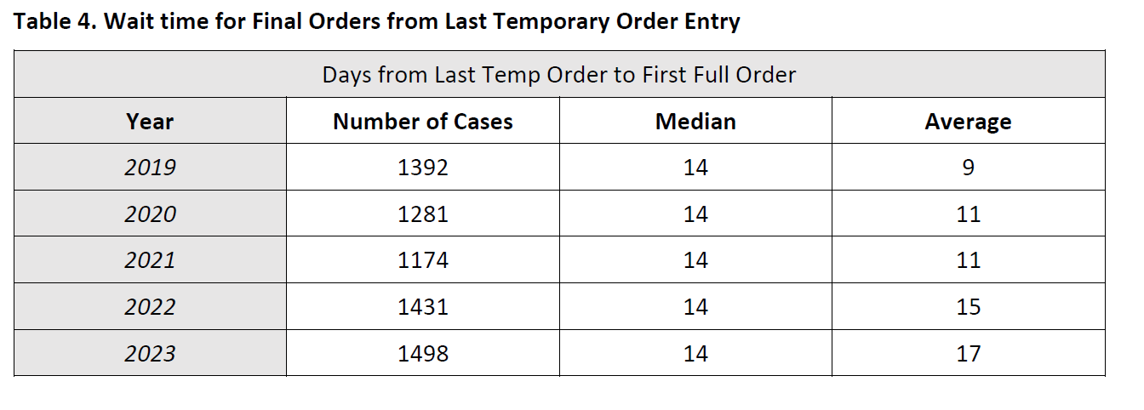

B.6. A summary by type of orders, the percentage of petitioners by race that were successful in obtaining a full order, the percentage of petitioners by race successful in obtaining only a temporary order and the percentage of petitioners by race that did not receive any type of order.

In response to this requirement, the report provides two tables – one that shows the percentage of petitioners by race and year, and another that shows the percentage of petitioners with existing orders by race, year, and type of order. DJA and Superior Court interpreted "type of order" to mean temporary versus full order (rather than breaking information down by domestic violence, anti-harassment, stalking, sexual assault, vulnerable adult, and extreme risk protection orders).

Table 8. Race of Petitioners by Percentage
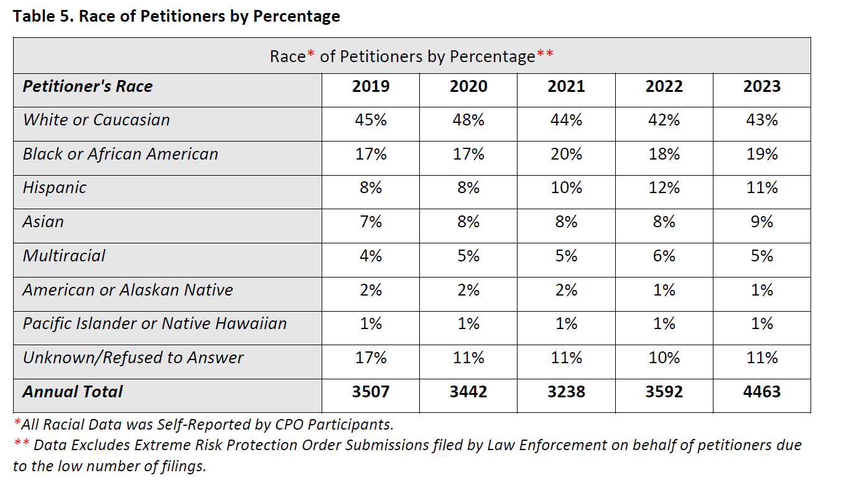
As noted, the report also includes a table that provides the percentage of petitioners with existing orders by race and type of order for each year beginning in 2019 and ending in 2023. At the end of the table is a compilation that summarizes at all five years totaled (2019-2023). For readability, this staff report only shows the compilation, which allows for a comparison of race and type of order (temporary, full, dismissed, etc.) but does not illustrate the changes from year to year.

According to the data provided, petitioners identifying as Black/African American or Pacific Islander/Native Hawaiian are more likely to receive a temporary order only, no full order. Native American/Alaskan Native petitioners are more likely to have "no order found" in the system. DJA cautions against drawing any conclusions from this data given some of the numbers are relatively small and they have not done an analysis to determine if the variances are statistically significant. DJA states, however, that where there appears to be differences between groups, it may mean it is an area worthy of further study.

Table 9. Summary of Order Type by Race (Percentage of Orders Entered)
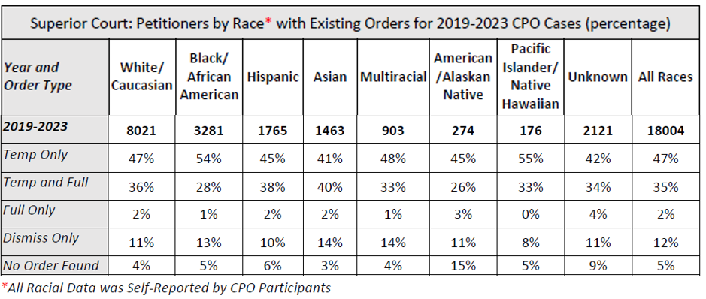
B.7. Percentage of orders by type denied versus dismissed broken out by measurable metrics, including race.

In response to this requirement, the report provides a table that shows the percentage of orders by reason for denial/dismissal, race, and year. It does not break the information down further by type of order (domestic violence, anti-harassment, stalking, sexual assault, vulnerable adult, or extreme risk protection orders). The table includes a compilation that summarizes all five years totaled (2019-2023). For readability, this staff report only shows the compilation, which allows for a comparison of race and reason for denial/dismissal, but which does not illustrate changes from year to year (see Table 10).

According to the data, people who identified as Black/African American, Native American/Alaskan Native, or Pacific Islander/Native Hawaiian are more likely to have their order dismissed or denied due to failure to appear for a hearing. Petitioners identifying as Pacific Islander/Native Hawaiian are more likely to have a request for dismissal cited as the reason for a dismissal. Again, DJA cautions against drawing any conclusions from this data given some of the numbers are relatively small and they have not done an analysis to determine if the variances are statistically significant. However, it may mean it is an area worthy of further study.

Table 10. Summary of Orders Denied or Dismissed by Race (Percentage)
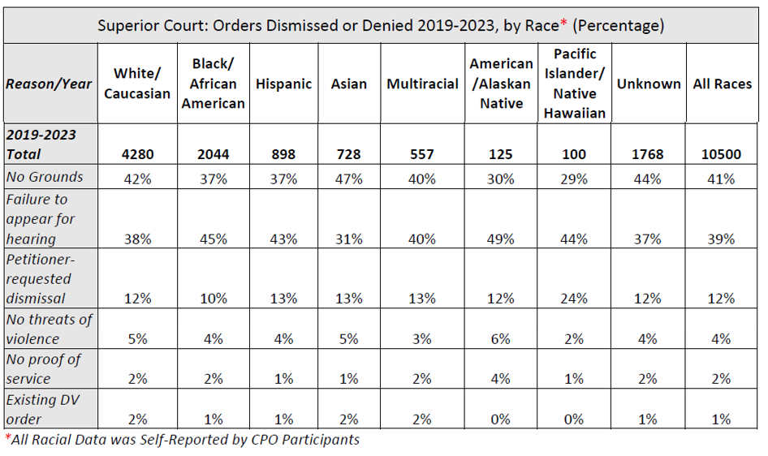

B.8. Percentage of petitioners obtaining a temporary order but no full order.

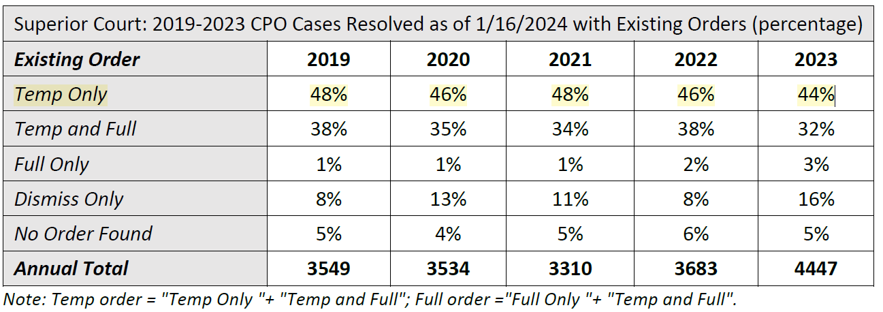
Table 11. CPO Case Order Types 2019-2023

B.9. Reasons for denials or dismissals.

The report provides a figure that shows the percentage rates of CPO dismissal by case type (in this instance, meaning cause such as domestic violence, anti-harassment, etc.) between 2019 and 2023. It also provides two tables, one that shows orders dismissed by year and case type (again referring to domestic violence, anti-harassment, etc.) and another that shows the percentage of orders denied or dismissed by year and reason.

Note that the figures in the table do not add up to 100 percent as they show the percentage of dismissals within a particular category. For example, in 2019, 6 percent of domestic violence protection orders were dismissed compared to 16 percent of anti-harassment orders.

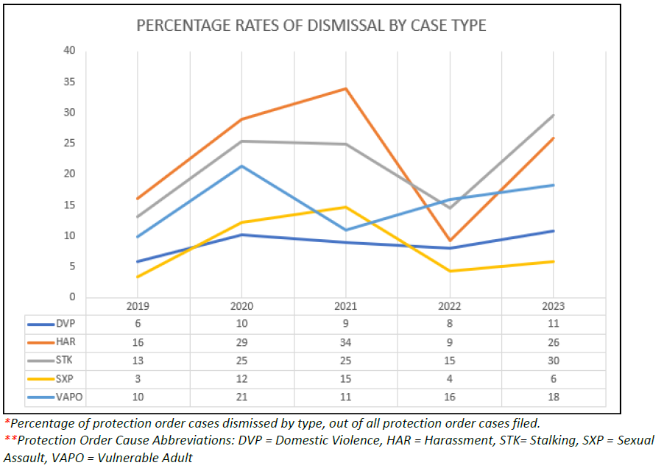

Table 12. Orders Dismissed by Year and Cause
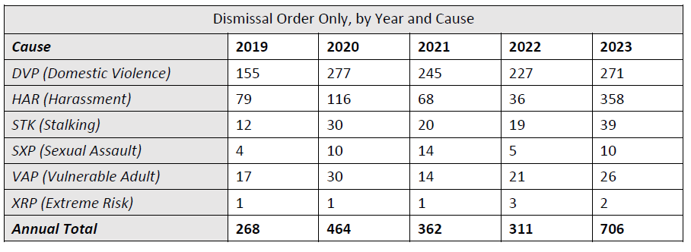

Table 13. Percentage of Orders Denied or Dismissed Overall by Reason
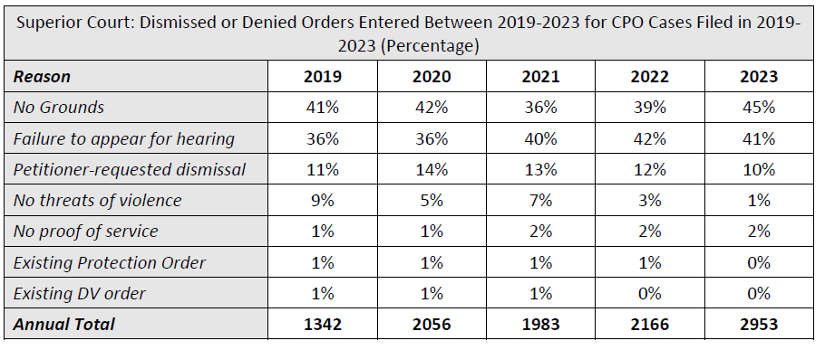

Next steps. According to the proviso report, "DJA and Superior Court will continue to refine and develop materials and resources for the CPO Program in consultation with CPO Stakeholders. It will be essential to secure permanent funding for the CPO Program to ensure that improvements made during the pilot period remain in effect and
continue to evolve."

AMENDMENT

Amendment 1 is a technical amendment that would correct typographical errors in the proposed motion.

Title Amendment T1 would correct the name of the report in the title of the proposed motion so that it aligns with the name of the report as it appears in the body of the motion and in the attachment.

INVITED

- The Honorable Ketu Shah, Presiding Judge, King County Superior Court (KCSC)
- The Honorable Aimée Sutton, Chief Judge, Unified Family Court, KCSC
- Catherine Cornwall, Director, Department of Judicial Administration/KCSC Clerk

ATTACHMENTS

- Proposed Motion 2024-0080 and its attachment
- Amendment 1
- Title Amendment 1
- Transmittal Letter

Ordinance 19546, Section 35, Proviso P1
Motion 16444
Civil protection orders are distinct from criminal protection orders, no-contact orders, and restraining orders, which are requested as part of separate existing criminal or family law cases. This proviso report, and therefore staff report, focuses on civil protection orders.
See RCW 7.105.010 for definitions. Descriptions are taken from the DJA website [LINK]
Vulnerable adult abuse protection orders are only heard in superior courts. District courts can issue an extreme risk protection order on a temporary basis, but for a longer-term order, district court must transfer the case to superior court. There are additional circumstances that require district court to transfer protection order proceedings to superior court (see Changes to State Law subsection of this staff report).
RCW 7.105.200
RCW 7.105.225 and Washington State Court Rule ER 1101(c)
RCW 2.32.050, RCW 2.32.090, and RCW 7.105.120(3)
See the Findings and Intent section, Section 1, of E2SHB 1320 (2021) [LINK]
Chapter 7.105 RCW
For a complete summary of changes, see the final bill report for E2SHB 1320 (2021). [LINK]
Both King County District and Superior Courts participated in the Stakeholder Group. For a full list, see the Gender and Justice Commission website [LINK]
E2SHB 1320 Stakeholder Recommendations Report to the Legislature, 2021 [LINK]
E2SHB 1320 Stakeholder Group's Recommendations to the Courts [LINK]
RCW 7.105.010(4) "Coercive control" is defined to mean a pattern of behavior that is used to cause another to suffer physical, emotional, or psychological harm, and in purpose or effect unreasonably interferes with a person's free will and personal liberty.
SHB 1901 (2022). Final Bill Report. [LINK]
King County Auditor's Office (May 2022). Protection Orders: User-Focused Approach Could Help Address Barriers. May 3, 2022. [LINK]
The Office of Financial Management distributed the moneys to counties according to population size. See ESSB 5092 (2021), Section 740. [LINK]
Of the $8.8 million from the state, a total of $3.14 million has been budgeted to support protection order related work. In 2022, DJA received $145,000 to conduct business analysis needed to implement the new state law. Council also provided DJA with $100,000 evaluation and language access in the 2023-2024 Biennial Budget. In addition to the moneys for DJA and Superior Court, the 2023-2024 Biennial Budget provided the Prosecuting Attorney's Office with $675,000 ($300,000 for legal assistance to those seeking civil protection orders through the Project Safety Program and $375,000 for the Protection Order Advocacy Program to support resource navigation and to develop training and resource materials for community-based organizations, advocates, pro bono attorneys, and other involved parties on the changes in state law related to civil protection orders).
One commissioner, one court coordinator, one weapons surrender coordinator, and one supervisor.
Three clerk administrative specialists and two customer service specialists.
Washington Law Help, a non-profit legal aid agency, received state funding to create the form generator service, which is a tool that can assist protection order customers in filling out the required forms and information. [LINK]
Chapter 7.105 RCW
According to the proviso report, a service packet contains all the documents filed in the case and copies of the court orders. Law enforcement is generally responsible for serving the respondent, which involves giving a respondent legal notice and copies of the case documents. The protected party receives a copy of the service packet so that they have it available to provide law enforcement if they need to call 9-1-1 due to the other party violating the protection order. In instances in which law enforcement has not yet served the respondent, they can then be served on the spot.
Ordinance 19546, Section 35, Proviso P1
DJA is an executive department administered by an appointee of Superior Court. Since DJA is an executive department, the proviso requested the Executive transmit the report. However, according to the transmittal letter, it was transmitted by Superior Court in consultation with the Executive.
CLFR = Coronavirus Local Fiscal Recovery, a federal pandemic-relief program for local governments.
As previously reported, the surveys are available in English, Spanish, Amharic, Vietnamese, Russian, and Chinese (traditional and simplified). DJA notes that Microsoft Forms does not support the Somali language, so that is not included. Information originally provided in the Staff Report for Motion 16444.
See Appendix C of the proviso report.
The report notes that anti-harassment orders include matters such as disputes between neighbors or juvenile classmates, as well as other patterns of behavior directed at a person that cause substantial distress through alarming, annoying, or harassing someone while serving no legitimate purpose.
Table 2 in the proviso report.
RCW 7.105.105(9)(b).
RCW 7.105.200.
Table 3 in proviso report
Table 4 in proviso report
Table 5 in the proviso report. This is copied directly from the report, and DJA confirms that the red text has no significance.
Table 6 in the proviso report.
Taken from Table 6 in the proviso report. Temp Only refers to cases where a petitioner received a temporary order only, no full order. Temp and Full is when a petitioner received a temporary order and then a full order. Fully Only is when a petitioner does not receive a temporary order and is immediately granted a full order (according to DJA and Superior Court, this does not happen often). Dismissed Only means neither a temporary nor a full order were granted. No Order Found means that no orders are found in the system, this could mean that orders were not entered for some reason.
Taken from Table 7 in the proviso report.
Table 8 in the proviso report.
Figure 2 in the proviso report

