

EXECUTIVE RECOMMENDED PLAN

Special District Overlay SO-230: Floodplain Densities
Area Zoning and Land Use Study

I. OVERVIEW
The 2020 Comprehensive Plan Midpoint Update Scope of Work includes an analysis of deletion of an existing Special District Overlay. The Scope directs the following:

Analyze deletion of Special District Overlay SO-230: Floodplain Densities on all parcels to which it applies (this is an outcome of a 2018 Docket Request).

In 2018, a property owner submitted a Comprehensive Plan Docket Request to remove Special District Overlay SO-230: Floodplain Densities (SO-230), which applies limitations for density for parcels in the floodplain, on their property.

The 2018 Docket Report noted that removal of Special District Overlays, per King County Code Title 21A.38.040 Special District Overlay - General Provisions, are accomplished through an Area Zoning Process, and are analyzed through an Area Zoning and Land Use Study as part of a Comprehensive Plan update. As such, and given that the SO-230 applies to over 400 properties, the County Executive recommended that this be considered in a future Comprehensive Plan update. The Docket Report also noted that a request to remove the same Special District Overlay was considered, and supported, in the 2016 Comprehensive Plan. This consideration is occurring through the 2020 Midpoint Update.

II. BACKGROUND
The purpose of a Special District Overlay is to carry out Comprehensive Plan and community, subarea or neighborhood plan policies that identify special opportunities for achieving public benefits by allowing or requiring alternative uses and development standards that differ from general code provisions.

Special district overlays are generally applied to a group of individual properties or entire community, subarea or neighborhood planning areas and are designated primarily through the area zoning process. Removal is done through the same process.

The text of the subject Special District Overlay includes the following conditions:

21A.38.240 Special district overlay - Floodplain Density.
A. The purpose of the floodplain density special district overlay is to provide a means to designate areas that cannot accommodate additional density due to severe flooding problems. This district overlay limits development in sensitive areas to reduce potential future flooding.
B. The following development standards shall be applied to all development proposals on RA-5 zoned parcels located within a floodplain density special district overlay:
1. Density is limited to one home per 10 acres for any property that is located within a sensitive area; and
2. All development shall be clustered outside of the identified sensitive areas, unless the entire parcel is a mapped sensitive area. (Ord. 12823 § 19, 1997).

This Special District Overlay originated in the 1989 Snoqualmie Valley Community Plan. The condition stems from Area wide Suffix Condition AR-5-P, which limits density on Rural Area 5 parcels. The condition is shown on, or referenced in, multiple maps (pages 123, 125, 129, 132, 133, 141, and 181) and reads as follows:

AR-5-P (one home per five acres with P-Suffix)
The purpose of this zoning is to implement policies of the King County Comprehensive Plan which call for maintaining the rural community character of the planning areas and protect sensitive natural features. The following P-suffix shall apply: Subdivision activity within this zone designation requires the site plan review process to determine the boundary of sensitive areas as defined in the King County Sensitive Areas Folio. Density is restricted to one home per 10 acres for sensitive areas. One home per five acres is allowed on the non-sensitive areas. Mandatory clustering is required on the non-sensitive areas unless the entire site is a mapped sensitive area. This zoning implements Snoqualmie Valley Community Plan policies SQP 45 and SQP 48.

The two referenced policies from the Community Plan read as follows:

SQP 45 In unincorporated areas, a density of one home per 5 acres shall be applied to areas where there is an existing platting pattern of 5 acre lots or larger, where there are a minimum of environmental hazards or other land use constraints and where resources do not exist on site or nearby which would benefit from lesser density.

SQP 48 To minimize the risk to public safety and reduce the potential for property damage, the following environmentally sensitive areas shall be designated one home per 10 acres.
A. floodways and flood-fringe areas (flood plains),
B. class iii landslide hazard areas,
C. slopes of a grade of 40% or more,
D. unique/outstanding or significant wetlands,
E. lands with erosion hazards or a combination of seismic and erosion hazards.

These conditions were imposed through the adoption of the Community Plan and subsequent ordinances that amended the plan and conditions. While the Snoqualmie Valley Community Plan is no longer in effect, SO-230 remains in effect.

During the zoning conversion in the mid-1990s, the rationale for the limitation was shortened to just flood hazards even though other critical areas were also protected under the original zoning.

While the current focus of SO-230 is on floodplain densities, the language still refers to "areas that cannot accommodate density" rather than parcels, and states that development be clustered outside of the "identified sensitive area" not just outside of the floodplain area. These retain and convey a focus that is broader than just floodplains.

The parcels to which SO-230 apply are shown on the following map.

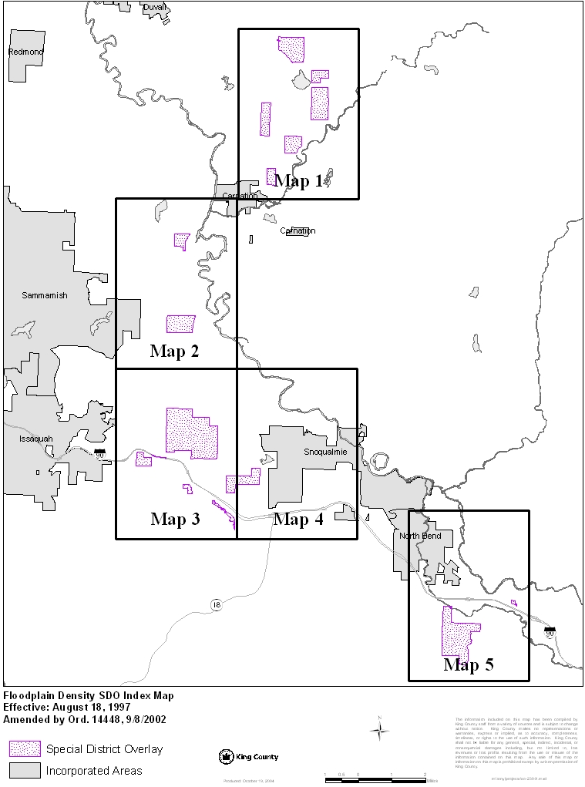

As noted previously, the removal of SO-230 from another property in the 2016 Comprehensive Plan found that the while County’s Sensitive Areas Ordinance and Surface Water Design Manual had been adopted in 1990, and while the Special District Overlay built on those provisions, both the Ordinance and Manual had been updated numerous times since 1990 to reflect best available science and both include rigorous standards for protecting critical areas and controlling runoff and sedimentation during the development process.

The Manual does this by addressing a wide variety of topics from drainage plan submittal requirements, hydrologic analysis and design, conveyance system analysis and design, flow control design and more. The effect of these requirements and standards are to minimize and mitigate impacts on water resources and functions.

In the 2016 Comprehensive Plan, the County determined that removing the Special District Overlay from the parcels at issue at that time would not likely result in any significant flooding or sedimentation issue, that the aforementioned regulations superseded the overlay in controlling runoff from new development, and therefore the Special District Overlay was no longer needed.

Looking at the broader context in 2018, SO-230 applies to a total of 426 parcels that are or were zoned Rural Area 5 when the Special District Overlay was established. Of these parcels, 30 are in public ownership and therefore likely to never be developed, six are within cities and therefore not subject to this condition, and 89 are not zoned RA-5 and therefore not subject to this condition. Of the remaining 301 parcels, 229 are less than 10 acres, meaning they are unlikely to have sufficient size to be subdivided with or without the overlay. This leaves 72 parcels that are theoretically subdividable.

Of these, 19 show some type of environmental feature (such as wetlands, seismic or erosion hazard areas, stream corridors) in the County's mapping programs. While the exact impact of these constraints on development potential is beyond the scope of this study and infeasible to precisely quantify without a development proposal, the overall impact is some level of reduction or impact avoidance if the 72 larger sized parcels move to development.

The following map shows the parcels, as well as the size breakdown, public ownership, and environmental features. The parcels in white are smaller than 10 acres, and those in blue are over 10 acres and therefore potentially impacted by the Special District Overlay.

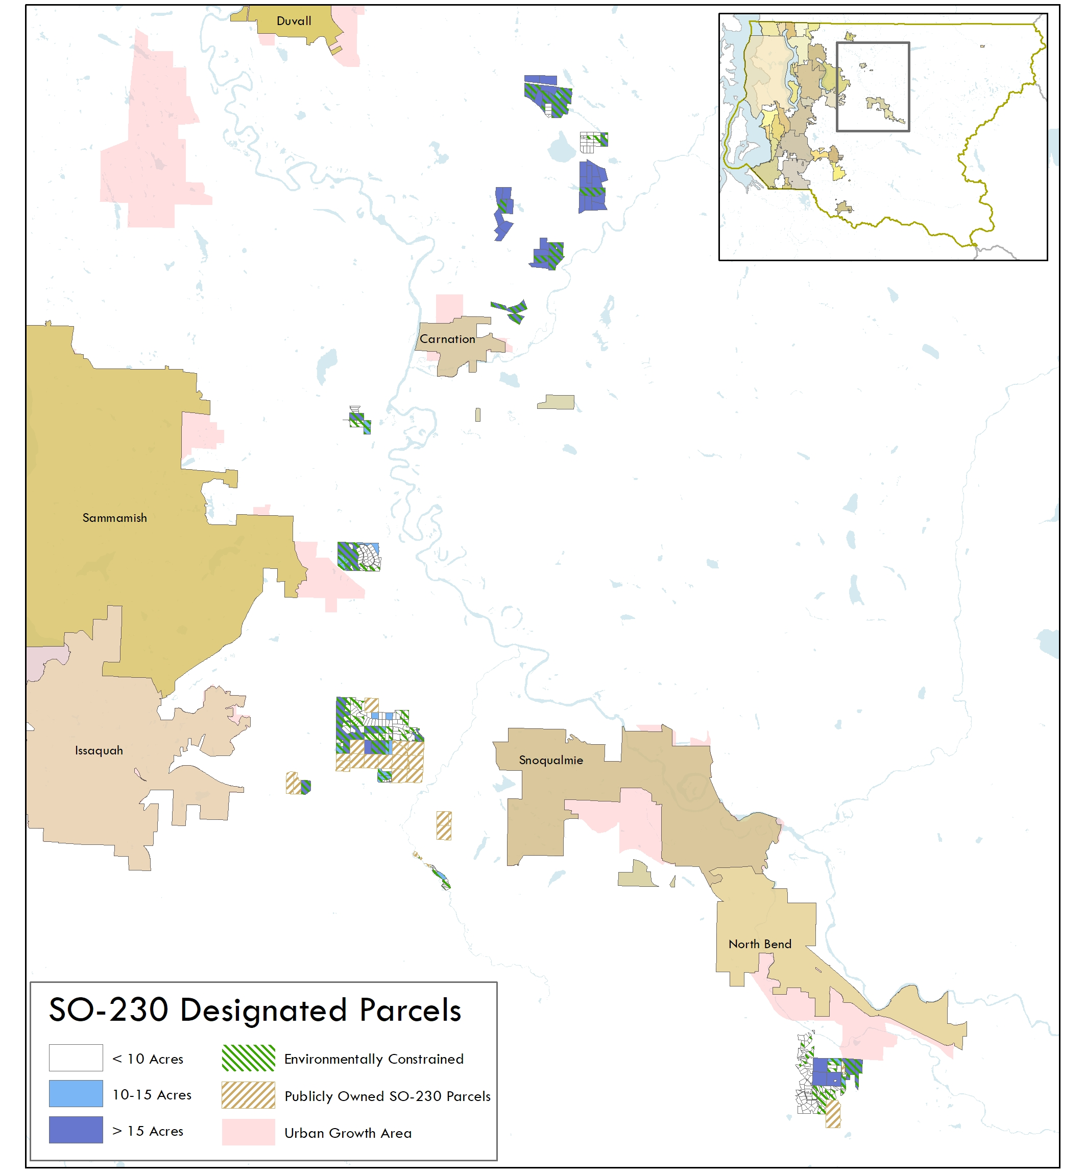

III. POLICY CONTEXT
As concluded in the analysis in 2016, removal of the Special District Overlay will have a limited impact given that the other regulations in place have superseded this. In addition to these regulations, other policies in the Comprehensive Plan help guide development in a manner that will limit impacts on floodplain densities. Some of these policies are noted below.

E-462 Development shall occur in a manner that supports continued ecological and hydrologic functioning of water resources and should not have a significant adverse impact on water quality or water quantity, or sediment transport, and should maintain base flows, natural water level fluctuations, unpolluted groundwater recharge in Critical Aquifer Recharge Areas and fish and wildlife habitat.

E-499qq King County shall implement a comprehensive local floodplain management program that protects lives, minimizes damage and disruption to infrastructure and critical facilities, preserves and restores natural floodplain functions, and ensures that new development does not put people in harm’s way or cause adverse flooding impacts elsewhere, consistent with the King County Flood Hazard Management Plan.

E-499qqq King County shall continue to exceed the federal minimum standards stipulated by the National Flood Insurance Program for unincorporated areas to better protect public safety, reduce the risk of flood and channel migration hazards to existing public and private property.

IV. CONCLUSION AND RECOMMENDATION

Conclusion
In summary, the Special District Overlay applies to a limited set of potentially subdividable Rural Area 5 parcels; these parcels frequently have other environmental constraints that could minimize development potential or minimize impacts from development; and impacts of future development proposals (both on floodplains and environmental features) will be addressed through County regulations that have superseded this Special District Overlay.

Recommendation
Based on this analysis, and the previous analysis in 2016 and 2018, the Executive recommends deletion of Floodplain Density Special District Overlay (21A.38.240) and removal of the designation from the all the parcels to which it currently applies. This includes the following parcels.

Parcel Number
0098300010
0098300020
0098300030
0098300040
0098300050
0098300060
0098300070
0098300080
0098300090
0098300100
0098300110
0098300120
0098300130
0098300140
0098300150
0098300160
0098300170
0098300180
0098300190
0098300200
0098300210
0098300220
0098300230
0098300240
0098300250
0098300260
0098300270
0098300280
0098300290
0098300300
0098300310
0098300320
0098300330
0098300340
0098300350
0098300360
0098300370
0098300380
0098300390
0098300400
0098300410
0098300420
0098300430
0098300440
0125079028
0125079029
0125079030
0125079031
0125079032
0125079033
0125079034
0125079035
0125079042
0125079046
0125079047
0125079048
0323079066
0323079067
0325079025
0325079026
0325079027
0325079028
0325079029
0325079031
0325079048
0325079049
0325079053
0325079055
0325079057
0423079002
0423079004
0423079018
0423079022
0423079025
0423079026
0423079027
0423079028
0423079031
0423079032
0423079033
0423079034
0423079036
0423079037
0423079038
0423079039
0423079043
0423079046
0423079047
0423079048
0423079050
0423079054
0423079055
0423079056
0423079059
042307HYDR
1125079002
1125079003
1125079096
1125079097
1125079102
1125079104
1125079105
1125079108
1125079109
1125079112
1323089093
1323089097
1323089098
1323089125
1323089166
1323089176
1425079063
1425079116
1525079073
1525079074
1525079075
1525079076
1525079077
1525079078
1525079080
2024079003
2024079005
2024079007
2024079008
2024079009
2024079010
2024079011
2024079013
2024079016
2024079017
2024079018
2024079019
2024079020
2024079022
2024079023
2024079024
2024079025
2024079026
2024079027
2024079028
2024079031
2024079032
2024079033
2024079034
2024079035
2024079036
2024079040
2024079041
2024079042
2024079043
2024079044
2024079052
2024079053
2024079054
2024079055
2024079058
2024079059
2024079060
2024079061
2024079062
2024079063
2024079064
2024079065
2024079066
2024079067
2024079068
2024079069
2024079070
2024079071
2024079072
2024079073
2024079074
2024079075
2124079010
2124079032
2124079047
2124079048
2124079049
2124079050
2124079051
2124079052
2124079053
2124079056
2124079058
2124079059
2124079060
2124079072
2124079073
2124079074
2124079084
2124079085
2124079093
2124079104
2223089013
2223089014
2223089015
2223089016
2223089018
2223089055
2223089067
2223089068
2223089069
2223089092
2323089010
2323089020
2323089031
2323089032
2323089038
2323089079
2623089010
2623089023
2623089024
2623089025
2623089031
2623089044
2623089055
2623089058
2623089062
2623089085
2623089122
2623089144
2623089145
2623089158
2626079001
2626079046
2626079047
2626079048
2626079049
2626079057
2626079081
2626079083
2626079084
2626079085
2626079086
2626079087
2626079088
2626079089
2626079090
2626079091
2626079092
2626079093
2626079095
262607UNKN
2723089004
2723089024
2723089101
2723089105
2726079037
2824079005
2824079006
2824079007
2824079008
2824079009
2824079010
2924079001
2924079002
2924079003
2924079004
2924079005
2924079006
2924079007
2924079008
2924079015
2924079022
2924079029
2924079030
2924079034
2924079041
2924079042
2924079044
2924079047
2924079052
2924079059
2924079060
2924079061
2924079062
2924079063
292407UNKN
2925079006
2925079007
2925079008
2925079050
2925079058
2925079059
2925079078
2925079079
2925079080
2925079081
2925079082
2925079083
2925079084
3024079011
3024079100
3024079101
3124079017
3324079005
3324079006
3324079017
3424079001
3626079003
3626079005
3626079007
3626079020
3626079021
3626079022
3626079023
3626079024
3626079025
3626079026
3626079027
3626079028
3626079029
3626079030
3626079031
3626079032
3626079033
3626079034
3626079035
3626079036
3626079037
3626079038
3626079039
3626079040
3626079041
3626079053
3626079054
3626079058
3626079059
3626079060
3626079062
3626079065
8835800010
8835800020
8835800030
8835800040
8835800050
8835800060
8835800070
8835800160
8835800170
8835800180
8835800190
8835800200
8835800210
8835800230
8835800240
8835800250
8835800260
8835800270
8835800280
8835800290
8835800300
8835800310
8835800320
8835800330
8835800340
8835800350
8835800360
8835800370
8835800380
8835800390
8835800400
8835800410
8835800420
8835800430
8835800440
8835800450
8835800460
8835800470
8835800480
8835800490
8835800500
8835800510
8835800520
8835800530
8835800540
8835800550
8835800560
8835800570
8835800580
8835800590
8835800600
8835800630
8835800640
8835800650
8835800660
8835800670
8835800680
8835800690
8835800700
8835800720
009830TR-X
009830TRCT
009830TRCT
212407TRCT
212407TRCT
292407TR-A
292407TR-B
292407TR-C
292407TR-D
292407TR-E
292507TR-A
292507TR-B
292507TR-C
292507TR-D
292507TR-E
292507TR-F
883577TR-K
883580TR-C
883580TR-D
883580TR-E
883580TR-F
883580TR-F
883580TR-G
883580TR-I
883580TR-J
883580TR-K
883580TR-L
883580TR-M
883580TR-N
883580TR-Q
883580TR-R
883580TR-S
883580TRCT
0325079054
0325079056

King County Code Title 20.18.140: Provision for receipt, review of and response to the docket.
https://www.kingcounty.gov/depts/permitting-environmental-review/gis/DevConditionsSearch/SDO/SO-230.aspx
https://www.kingcounty.gov/~/media/depts/executive/performance-strategy-budget/regional-planning/2016CompPlanUpdate/Subarea-and-CommPlans/SnoqualmieValleyCommPlan.ashx?la=en
https://kingcounty.gov/council/legislation/kc_code/24_30_Title_21A.aspx
https://your.kingcounty.gov/dnrp/library/water-and-land/stormwater/surface-water-design-manual/SWDM%202016%20complete%20document%20FINAL%20first%20errata%206%2015%202016.pdf
Note: The numbers in this Study vary slightly from those published in the 2018 Docket Report, but support the same conclusion published in the Docket.

