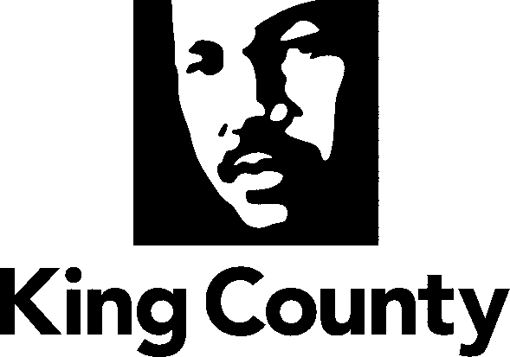

Metropolitan King County Council
TRANSPORTATION COMMITTEE

STAFF REPORT

AGENDA ITEM: | 12 |  | PREPARED BY: | Paul Carlson
PROPOSED No.: | 2008-B0013 |  | DATE: | January 23, 2008

SUBJECT: Draft Transportation Committee Work Program for 2008.

BACKGROUND: This agenda item outlines the Committee’s draft work program for 2008. The draft work program includes Council initiatives along with motions and ordinances, briefings, and proviso responses that the King County Department of Transportation (KCDOT) expects to forward to the Council.

The times listed in the work program are approximate and are subject to change, and additional items are likely to come up throughout the year. Some of these ordinances, motions, and proviso responses may be assigned to other committees.

ATTACHMENT: 1. Transportation Committee Draft 2008 Work Program

