Lease Property Summary
Photos of Property

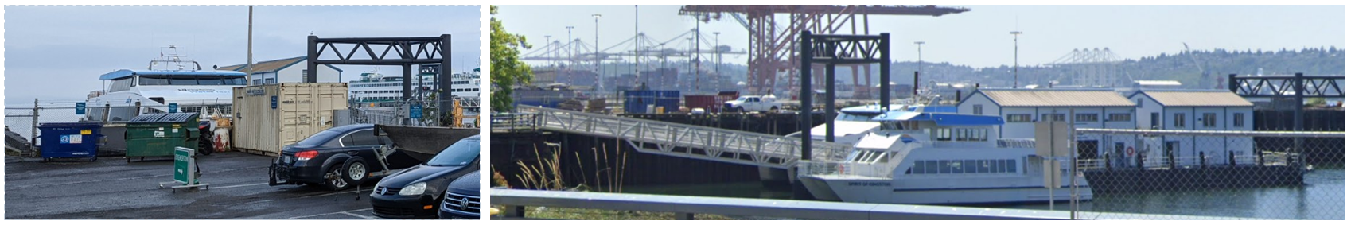

Property Owner: ​Washington State Department of Transportation, Ferry Division
Address: 201 Alaskan Way S, Seattle WA 98104
Rent: $86,800 rent payment for the year, then rent will be adjusted annually on July 1st of each year commencing July 1, 2025
Operating Costs: Utility costs and any costs incurred by County for use of Pier 48 paid by County
Term: Initial 10-year term with 2 additional 5-year options to extend
Use Dimension: 200 linear-foot moorage plus 5 parking spaces and fenced skiff storage area
Council District: Eight
Funding Source: King County Metro Transit Department, Marine Division
Previous Location: Same location
Offer Timeline: WSDOT/WSF approval requested by/around 2nd Quarter of 2024 and County Council approval requested by/around 4th Quarter of 2024

Lease Synopsis:
Washington State Department of Transportation (WSDOT) owns Pier 48 and associated tidelands at 201 Alaskan Way S in Seattle. Pier 48 is just south of the Pier 50 terminal used by King County’s West Seattle and Vashon Island passenger-only water taxis. This lease will allow the Metro Transit Department’s Marine Division to continue to use Pier 48 to moor its maintenance and moorage barge that services the ferry vessels and will provide parking spaces for Division employees.

Context
Rationale for transaction: The Marine Division previously leased the Pier 48 property from December 28, 2011 until June 30, 2018, when the lease expired. This new lease will allow the Marine Division to continue to moor its maintenance barge and maintain its water taxi vessels at Pier 48.

Policy considerations: Retaining the Marine Division maintenance barge at this location allows the Marine Division to continue to support the adjacent water taxi at Pier 50. This location also provides the Marine Division the opportunity to access future electrical facilities that will be installed to support its future electric fleet.

Political considerations: The proximity between the maintenance operations at Pier 48 and the sailings of the water taxi from Pier 50 enables the Marine Division to efficiently maintain its ferry vessels and enhance passenger-only ferry service, while helping to mitigate vehicular traffic congestion on roadways and on WSDOT’s drive-on ferries at Colman Dock, the Seattle ferry terminal, at Pier 52.

Community considerations or partnerships: King County’s passenger-only ferry service provides a significant public benefit, and the lease provides a measure of certainty regarding the near and future availability of Pier 48 for the County’s existing and long-term planning of the maintenance barge.

Fiscal considerations: The base rent for the initial 10 years is $86,800 per year.

Other Considerations: None

King County Strategic Plan impact: This lease supports the King County Strategic Plan goal of efficient, accountable regional and local government by optimizing King County operations and delivering consistent, responsive services to all King County departments.

Equity and Social Justice Impact: This location serves the downtown Seattle area of King County and has convenient access to County and City services.

Energy Efficiency impact: Not Applicable

Lease Alternatives Analysis
Summary: N/A – not relevant for this particular transaction.

Vicinity View Map

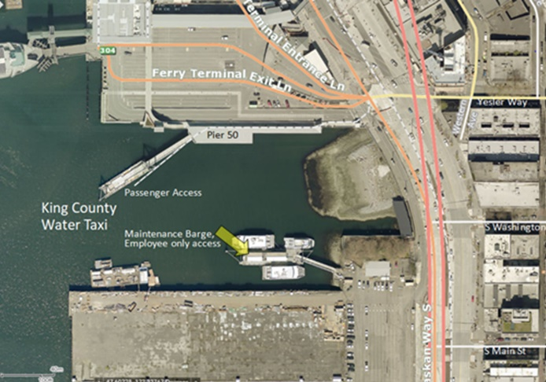

Site Map
