Attachment A - 18234
KITSAP COUNTY
DEPT. OF EMERGENCY MANAGEMENT
911 Carver Street
Bremerton, WA 98312
(360) 307-5871

INTERLOCAL COOPERATIVE AGREEMENT TO PURCHASE LIDAR DATA
BY
KING COUNTY, WA.
KC- -2015

THIS AGREEMENT is between King County, a municipal corporation, and Kitsap County, a municipal corporation, all in the State of Washington.

WITNESSETH:

WHEREAS, The Interlocal Cooperation Act, as amended and codified in Chapter 39.34 of the Revised Code of Washington provides for Interlocal cooperation between governmental agencies; and

WHEREAS, Chapter 39.33 of the Revised Code of Washington provides for the intergovernmental disposition of property, and

WHEREAS, both parties are required to make certain purchases by formal advertisement and bid process, which is a time consuming and expensive process; and it is in the public interest to cooperate in the combination of bidding requirements to obtain the most favorable bid for each party where it is in their mutual interest; and

WHEREAS, the parties also wish to utilize each other's contracts where it is in their mutual interest;

NOW, THEREFORE, the parties agree as follows:

1. PURPOSE. The purpose of this agreement is to acknowledge the parties' mutual interest to jointly bid the acquisition of goods and services and disposition of property where such mutual effort can be planned in advance and to authorize the acquisition of goods and services and the purchase or acquisition of goods and services under contracts where a price and the terms and conditions are extended by either party's bidder to other governmental agencies;

2. ADMINISTRATION. No new or separate legal or administrative entity is created to administer the provision of this agreement. The Administrator of this agreement is the Director of Emergency Management of Kitsap County, Washington.

3. SCOPE. This agreement shall allow the following activities:

- Purchase or acquisition of goods and services by each party acting as agent for either or both parties when agreed to in advance, in writing;
- Purchase or acquisition of goods and services by each party where provision has been provided in contracts for other agencies to avail themselves of goods and services offered under the contract.
- Disposal of goods by each party acting as agent for either, or both parties when agreed to in advance, in writing.

4. DURATION OF AGREEMENT - TERMINATION. This agreement shall become effective upon signature of both parties for a one (1) year period.

A. Termination for Default
If Kitsap County does not perform the work, or Kitsap County fails to perform in the manner called for in this agreement, or if Kitsap County fails to comply with any material provisions of this Agreement, King County may terminate this Agreement, in whole or in part, for default as follows:

- A “notice to cure” shall be served on Kitsap County by certified or registered first class mail. Kitsap County shall have ten (10) days from the date of receipt to cure the default or, at King County's discretion, provide King County with a detailed written plan for review and acceptance, which indicates the time and methods needed to bring the work into compliance and cure the default.
- If Kitsap County has not cured the default or the plan to cure the default is not acceptable to King County, King County may terminate this Agreement by serving a "notice of termination" setting forth the manner in which Kitsap County is in default and the effective date of termination.
- Kitsap County shall only be paid for work performed and accepted less any damages to King County caused by or arising from such default.
- The termination of this agreement shall in no way relieve Kitsap County from any of its obligations under this agreement nor limit the rights and remedies of the County hereunder in any manner.

- Termination for Non-Appropriation

- If expected or actual funding is withdrawn, reduced or limited in any way prior to the termination date set forth in this agreement or in any amendment hereto, King County may, upon written notice to Kitsap County, terminate this agreement in whole or in part. If this agreement is terminated pursuant to this section, 1) King County shall be liable only for payment in accordance with the terms of this agreement for work performed and accepted prior to the effective date of termination; and 2) Kitsap County shall be released from any obligation under this agreement affected by the termination or a related purchase order to provide further work pursuant to this agreement.
- Notwithstanding any provision to the contrary, funding under this agreement beyond the current appropriation year is conditional upon the appropriation by the County Council of sufficient funds to support the work described in this agreement. Should such an appropriation not be approved, this agreement shall terminate at the close of the current appropriation year.

5. RIGHT TO CONTRACT INDEPENDENT ACTION PRESERVED. Each party reserves the right to contract independently for the acquisition of goods or services and or disposal of any property without notice to the other party and shall not bind or otherwise obligate the other party to participate in the activity.

- COMPLIANCE WITH LEGAL REOUIREMENTS. Each party accepts responsibility for compliance with federal, state or local laws and regulations including, in particular, bidding requirements applicable to its acquisition of goods and services or disposal of property.

7. FINANCING. The method of financing of payment shall be through budgeted funds or other available funds of the party for whose use the property is actually acquired or disposed. Each party accepts no responsibility for the payment of the acquisition price of any goods or services intended for use by the other party.

8. FILING. Executed copies of this agreement shall be filed as required by Section 39.34.040 RCW prior to this agreement becoming effective.

9. INTERLOCAL COOPERATION DISCLOSURE. Each party may insert in its solicitations for goods a provision disclosing that other authorized government agencies may also wish to procure the goods being offered to the party and allowing the bidder the option of extending its bid to other agencies at the same bid price, terms and conditions.

10. NON-DELEGATION/NON-ASSIGNMENT. Neither party may delegate the performance of any contractual obligation, to a third party, unless mutually agreed in writing. Neither party may assign this agreement without the written consent of the other party.

11. SEVERABILITY. Any provision of this agreement, which is prohibited or unenforceable, shall be ineffective to the extent of such prohibition or unenforceability, without invalidating the remaining provision or affecting the validity or enforcement of such provision.

12. DISPUTES. In the event a dispute arises under this agreement, the parties shall endeavor to resolve the dispute in an amicable manner by direct discussions. The parties may engage in alternative dispute resolution by mutual agreement. No party waives its rights to seek legal remedy.

13. LiDAR SURVEY DATA. Kitsap County has contracted with Quantum Spatial Inc. to provide public-domain high-resolution LiDAR topographic survey data in the Pacific Northwest. Exhibit A outlines costs associated with Puget Sound LiDAR Consortium’s rate structure agreed upon with Quantum Spatial, Inc. under its contract terms and noted in Exhibit B is the Quantum Spatial, Inc. project proposal. Pursuant to paragraph 3.A of this agreement, Kitsap County will act as the agent for King County, Washington and all other Parties listed in Exhibit C. King County in turn will act as fiscal agent for the Parties listed in Exhibit C. Kitsap County will obtain and provide to King County the data described in Exhibit B from Quantum Spatial, Inc. The project, referred to as the King County LiDAR Project has a total costs for King County of $267,702. The Project Costs is a total of LiDAR services at $234,826 and a service fee for contract administration and Quality Assurance of $32,876. King County agrees to pay the costs and the amount specified in this contract not to exceed $267,702. Payments will be made per contract milestones as (1) Acquisition - $133,851, (2) Delivery - $80,310, and (3) Acceptance - $53,541. Kitsap County will obtain this data under its contract with Quantum Spatial Inc.

14. RIGHTS AND REMEDIES. The parties agree that although Kitsap County is administering the contact for King County, King County is able to independently exercise all rights and remedies related to Kitsap County’s contract with Quantum Spatial, Inc. as if King County was named in the original contract.

15. INDEMNIFICATION. Each party shall protect, defend, indemnify and save harmless the other party, its officers, officials, employees and agents while acting within the scope of their employment as such, from any and all suits, costs, claims, actions, losses, penalties, judgments, and/or awards of damages, of whatsoever kind arising out of, or in connection with, or incident to the services associated with this Contract caused by or resulting from each party's own negligent acts or omissions. Each party agrees that it is fully responsible for the acts and omissions of its own subcontractors, their employees and agents, acting within the scope of their employment as such, as it is for the acts and omissions of its own employees and agents. Each party agrees that its obligations under this provision extend to any claim, demand, and/or cause of action brought by or on behalf of any of its employees, or agents. The foregoing indemnity is specifically and expressly intended to constitute a waiver of each party's immunity under Washington's Industrial Insurance act, RCW Title 51, as respects the other party only, and only to the extent necessary to provide the indemnified party with a full and complete indemnity of claims made by the indemnitor’s employees. The parties acknowledge that these provisions were specifically and mutually negotiated.

 | Accepted:  Kitsap County Department of Emergency Management  Kitsap County, Washington  _______________________________________  Michael Gordon, Director  Kitsap County Emergency Management  _____________________________________  Date  BOARD OF COUNTY COMMISSIONERS  KITSAP COUNTY, WASHINGTON  ___________________________________________  ROBERT GELDER, Chair  __________________________________________  EDWARD E. WOLFE, Commissioner  __________________________________________  CHARLOTTE GARRIDO, Commissioner  ATTEST:  __________________________________________  Clerk of the Board
  Accepted:
  King County, Washington
  ___________________________________
  Dow Constantine, County Executive
  King County
  ___________________________________
  Date

Exhibit A
Puget Sound LiDAR Consortium Rate Structure

Provider: | Kitsap County
Agreement No.: | KC-244-12
Agreement Title: | Remote Watershed LiDAR Services

Area Extent | Price per  Acre | Price per  Square Mile | Contours | Intensity  Images | Gain-  normalized  Intensities
50 to 100 sq. miles  (32,000 to 64,000 acres) | $1.42 | $909 | $0.142 | $0 | $0.080
100 to150 sq. miles  (64,000 to 96,000 acres) | $1.11 | $710 | $0.111 | $0 | $0.060
150 to 200 sq. miles  (96,000 to 128,000 acres) | $0.94 | $602 | $0.094 | $0 | $0.050
200 to 250 sq. miles  (128,000 to 160,000 ac) | $0.84 | $538 | $0.084 | $0 | $0.040
Greater than 250 sq. mi  (Greater than 160,000 ac) | $0.78 | $499 | $0.078 | $0 | $0.035
The Puget Sound LiDAR Consortium (PSLC) adds a 14% overhead fee to the total cost. 7% is for contract and administrative services by Kitsap County Department of Emergency Management and 7% to the Puget Sound LiDAR Consortium for Data analysis.
Exhibit B

LiDAR Data Acquisition Cost Proposal – King County, Wa.

September 9, 2015

Michael Gordon
Kitsap County Department of Emergency Management
911 Carver St
Bremerton, WA 98312
360-307-5872
mgordon@co.kitsap.wa.us

RE: LiDAR Data Acquisition Cost Proposal – King County 2015 Project Area, WA

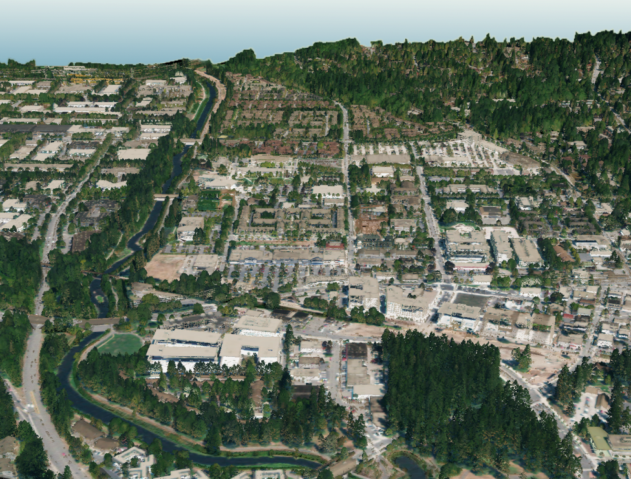
Quantum Spatial, Inc. appreciates the opportunity to present to the Puget Sound LiDAR Consortium (PSLC) a cost proposal for acquiring and processing high-resolution (> 8 pulses/m²) LiDAR data for the project area of interest to King County, WA. Our cost for LiDAR acquisition and processing abides by our negotiated cost structure with the PSLC, assuming that a contract for standard deliverables will be administered through Kitsap County, WA.

LiDAR point cloud colored by NAIP imagery of downtown Redmond, Washington.

Services
Airborne LiDAR

QSI will collect LiDAR data using a Leica LiDAR system to produce a highly accurate, high resolution (> 8 pulses/m²) LiDAR dataset with no gaps and ample buffers (at least 100m) around project boundaries. Data will be collected at a ≤ 30º field of view (+/-15º from nadir), with at least 50% overlap among swaths to minimize gaps and laser shadowing. The LiDAR system records up to four range measurements (returns) per pulse (first, second, third, and last). All overlapping flight lines will be flown in opposing directions to maximize detection of swath to swath inconsistencies used to resolve system misalignments. Our GPS receivers and LiDAR systems are GNSS-capable ensuring low PDOP values and adequate satellite constellations throughout the mission. GPS quality is predicted before the flight and checked during post processing to ensure that positional accuracy exceeds specifications.

Using a combination of automated and manual techniques that are tailored to the particular land cover and terrain of the study area, LiDAR processing will include kinematic corrections, calculation of laser point position, relative accuracy testing and calibrations, classification of ground and non-ground points, assessments of statistical absolute accuracy, and creation of ground surface models.

LiDAR Specifications Summary
Multi-Swath Pulse Density | ≥ 8 pulses/m²
Scan Angle | ≤30º (+/-15º from Nadir)
Returns Collected Per Laser Pulse | Up to 4
Intensity Range | 1-255
Swath Overlap | 50% side-lap (100% overlap)
GPS PDOP During Acquisition | ≤3.0
GPS Satellite Constellation | ≥6
Maximum GPS Baseline | 13 nautical miles
Accuracy_{z} (1.96 ), slope <20º | < 20 cm
Vertical Accuracy (), slope <20º | ≤ 15 cm
Horizontal Accuracy () | ≤ 30 cm
Absolute accuracy assessments will compare known RTK ground survey points to derived LiDAR points. Accuracies are described as the mean and standard deviation (sigma~σ) of divergence from RTK ground survey point coordinates. All accuracy statistics (RMSE_{z}, Accuracy_{z} - 1.96, skewness/distribution, and percentile deviations) will be reported in the final report. Statements of statistical accuracy will apply to fixed terrestrial surfaces only.

Survey Control

Simultaneous to the LiDAR data collection mission, QSI will conduct a static (1 Hz recording frequency) survey of the horizontal and vertical positions of two or more survey control dual-frequency DGPS base stations established at monuments with known coordinates. Maximum baseline lengths between control points and the aircraft GPS do not exceed 24 kilometers (13 nautical miles). After the static GPS data have been collected, the files will be processed using the Online Positioning User Service (OPUS). Multiple sessions will be processed over the same monument to confirm antenna height measurements and reported OPUS position accuracy. Control monument locations will be certified by a QSI Washington PLS.

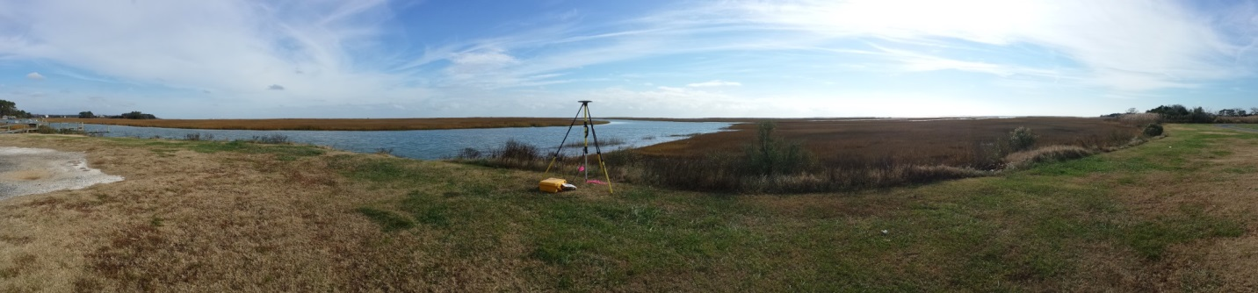
Quality control real-time kinematic (RTK) ground check survey data will be collected within the project area, with an established Root Mean Square Error (RMSE) of less than 2 cm. Absolute laser spot accuracies will be statistically analyzed based upon an adequate sample (500 per 50,000 acres, depending on access and GPS conditions within study area) of well-distributed RTK ground survey points on open, bare earth surfaces with level slope.

Deliverables

Deliverables will match standard for Puget Sound LiDAR Consortium:
LiDAR
Report of Survey | Text report that describes survey methods; results; vendor's accuracy assessments, including internal consistency and absolute accuracy; and metadata  .pdf, .doc, or .odt format
Aircraft trajectories (SBET files) | Aircraft position (easting, northing, elevation) and attitude (heading, pitch, roll) and GPS time recorded at regular intervals of 1 second or less. May include additional attributes.  ASCII text format
All-return point cloud | List of all valid returns. For each return: GPS week, GPS second, easting, northing, elevation, intensity, return#, return classification. May include additional attributes. No duplicate entries.  ASCII text and LAS version 1.2 format  1/100th USGS 7.5-minute quadrangle (0.75 minute by 0.75 minute) tiles
Ground point list | List of X,Y,Z coordinates of all identified ground points.  ASCII text.  1/100th USGS 7.5-minute quadrangle (0.75 minute by 0. 75 minute) tiles
Ground surface model | Raster of ground surface, interpolated via triangulated irregular network from identified ground points. No unavoidable point misclassification  ESRI floating point grid, 3 ft cell size, snapped to (0,0), 1/4th USGS 7.5-minute quadrangle (3.75 minute by 3.75 minute) tiles
First-return (highest-hit) surface model | Raster of first-return surface, cell heights are highest recorded value within that cell, voids may be filled with ground surface model  ESRI floating point grid, 3 ft cell size, snapped to (0,0), 1/4th USGS 7.5-minute quadrangle (3.75 minute by 3.75 minute) tiles
Intensity image | GeoTIFF,1.5. ft pixel size, 1/4th USGS 7.5-minute quadrangle (3.75 minute by 3.75 minute) tiles
Files shall conform to a consistent naming scheme. Files shall have consistent internal formats. Surface models shall have no tiling artifacts and no gaps at tile boundaries. Areas outside survey boundary shall be coded as NoData. Internal voids (e.g., open water areas, shadowed areas in first-return surface) may be coded as NoData.

Coordinate System*
Projection | Washington State Plane North
Horizontal Datum | NAD83 (CORS96)
Vertical Datum | NAVD88 (GEOID03)
Units | U.S. Survey Feet
Delineations | USGS Quadrangle tiling scheme
*To match with existing data. The data will be created in NAD83 (CORS96),
but for GIS purposes will be defined as NAD83 (HARN).

Area of Interest – King County, WA
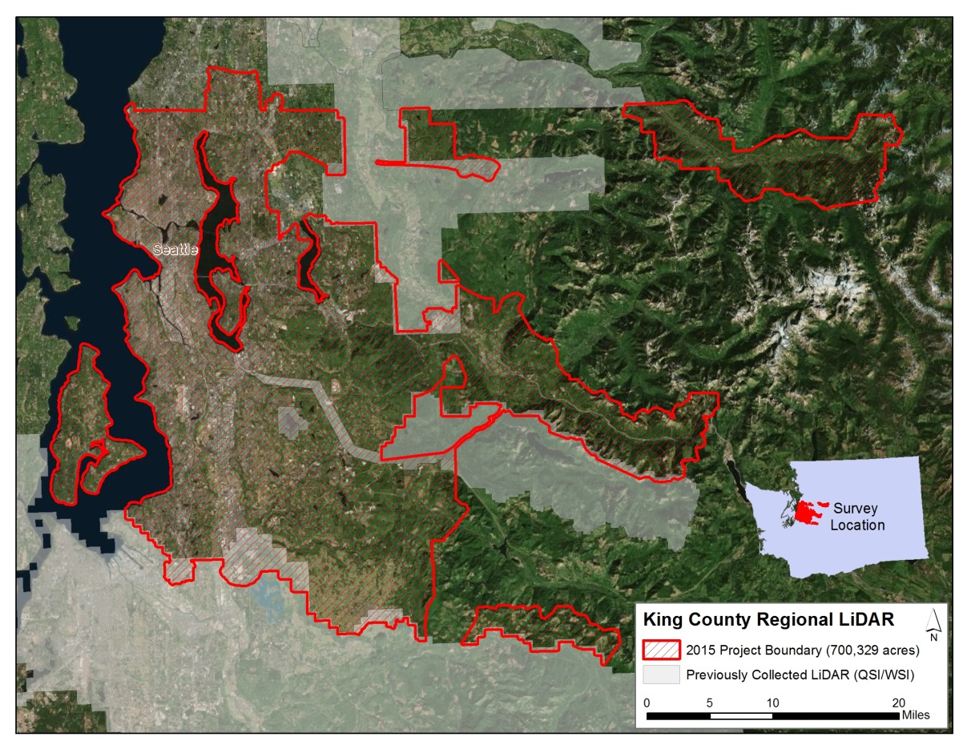
The area of interest (AOI) for this cost proposal includes 700,329 acres spread through King County, WA (Figure 1). Previous LiDAR collections for the PSLC and Pierce County are shown in grey. Overlap between collections will facilitate data matching. The AOI will be buffered by 100 meters to ensure complete coverage and adequate point densities around study area boundaries.

Figure 1. Area of interest for LiDAR acquisition in King County, WA.

Schedule
QSI will work with PSLC and King County to coordinate timing of data collection during fall 2015 as best meets the needs of the project. All data are delivered to PSLC within 60 days of acquisition.

Cost Proposal
The following table presents LiDAR acquisition and processing costs for the project area portrayed in Figure 1, assuming above specifications and deliverables. Costs for acquisition and base level processing are in accordance with QSI’s negotiated area-weighted rate structure with the Puget Sound LiDAR Consortium.
King County, WA Regional LiDAR 2015 (700,329 acres) | Total Cost | Per  Acre Cost
LiDAR Acquisition and Base Processing | $546,256.62 | $0.78
* Budget does not include 14% PSLC administrative fee.
Exhibit C

Parties for which King County is acting as fiscal agent

The City of Algona, the Town of Beaux Arts Village, the City of Burien, the City of Clyde Hill, the City of Des Moines, the City of Enumclaw, Highlands Sewer District, the Town of Hunts Point, the City of Kenmore, the King County Water District 111, the King County Water District 125, King County, the City of Lake Forest Park, the City of Medina, the City of Mercer Island, the City of Milton, the Muckleshoot Tribe, the City of Newcastle, the City of Normandy Park, the City of SeaTac, the Port of Seattle, the City of Shoreline, the Skyway Water and Sewer District, the City of Snoqualmie, the City of Tukwila, the Valley View Sewer District, the Vashon Sewer District, the City of Woodinville, and the Town of Yarrow Point.

