STAFF REPORT

Agenda Item: | 7 | Name: | Sam Porter
Proposed No.: | 2024-0243 | Date: | January 8, 2025

SUBJECT

A proposed motion accepting the 2023 Mental Illness and Drug Dependency annual report.

SUMMARY

The 2023 Mental Illness and Drug Dependency (MIDD) Annual Report is Attachment A to Proposed Motion 2024-0243. The requirements for the MIDD annual report are outlined in King County Code 4A.500.309 and include performance measurement statistics, utilization statistics, expenditure status updates, and progress reports on evaluation and implementation. The MIDD Advisory Committee reviewed the 2023 MIDD annual report at their June 6, 2024 meeting. This legislation is a nonmandatory dual referral to both the Regional Policy and the Health and Human Services Committees.

BACKGROUND

State Authorizes Sales Tax. In 2005, the Washington State Legislature authorized counties to implement a one-tenth of one percent sales and use tax to support new and expanded chemical dependency and mental health treatment programs and services, and for the operation of new or expanded therapeutic court programs and services.

King County Authorizes Sales Tax. In 2007, the King County Council adopted Ordinance 15949 authorizing the first MIDD sales tax. Ordinance 15949 established the expiration date of MIDD 1 as January 1, 2017. Subsequent ordinances established the MIDD Oversight Committee (April 2008) and the MIDD implementation Plan and MIDD Evaluation Plan (October 2008). Ordinance 18333 established MIDD 2 as a continuation of the MIDD sales tax established in Ordinance 15949, with an expiration date of January 1, 2026.

King County Council Approved Extension of the MIDD Sales Tax in August 2016. On August 22, 2016, the King County Council passed Ordinance 18333, extending collections of the MIDD sales tax through 2025. MIDD 2 became effective on January 1, 2017. Ordinance 18333 set forth the following five policy goals for the MIDD:
- Divert individuals with behavioral health needs from costly interventions such as jail, emergency rooms and hospitals.
- Reduce the number, length, and frequency of behavioral health crisis events.
- Increase culturally-appropriate, trauma-informed behavioral health services.
- Improve the health and wellness of individuals living with behavioral health conditions.
- Explicit linkage with, and furthering the work of, King County and community initiatives.

MIDD Renewal 2025. MIDD 2 is set to expire on January 1, 2026. In anticipation of the expiration, the Executive intends to transmit a renewal ordinance to Council later this year. RCW 82.14.055 requires that a local sales and use tax change may take effect no sooner than 75 days after the Department of Revenue receives notice of the change. Therefore, the renewal of MIDD must occur no later than October 17, 2025 to avoid a gap in collections.

ANALYSIS

The 2023 MIDD annual report appears to meet the requirements of K.C.C. 4A.500.309. The services and programs funded by the MIDD are evaluated by staff in King County’s Department of Community and Human Services (DCHS) based on data submitted by providers. King County Code 4A.500.309.D.1 requires that the annual summary evaluation report shall include at a minimum the following:
A. Performance measurement statistics;
B. Program utilization statistics;
C. Request for proposal and expenditure status updates;
D. Progress reports on evaluation implementation;
E. Geographic distribution of the sales tax expenditures across the county, including collection of residential ZIP Code data for individuals served by the programs and strategies;
F. Updated performance measure targets for the following year of MIDD initiatives, programs and services;
G. Recommendations on either program changes or process changes, or both, to the funded programs based on the measurement and evaluation data; and
H. Summary of cumulative calendar year data.

Figure 1 below provides the page numbers for specific sections of the report. Additional information provided through the web-based 2023 MIDD Data Dashboard at this address: https://kingcounty.gov/en/dept/dchs/human-social-services/community-funded-initiatives/midd-behavioral-health-tax/midd-behavioral-health-sales-tax-dashboard

Figure 1. 2023 MIDD Annual Report Sections
Section | Page
2023 Results | 8
Participants | 16
Evaluation and Continuous Improvement | 18
Geographic Distribution of Participants | 15
Fiscal Information | 20

Items of note in the 2023 MIDD annual report:
- In 2023, total MIDD expenditures were approximately $84.9 million.
- 24,342 people were served by MIDD programs in 2023; approximately 5,000 more than the previous year. Of those, according to the dashboard, 63 percent were adults ages 18-54, ten percent were youth ages 0 to 17, and 27 percent were age 55 and over.
- Figure 2 provides information about the geographic distribution of people served in 2023
- Figure 3 provides information about additional demographics of those served.

Figure 2. Geographic Distribution of People Served by MIDD, 2023

Figure 3. Additional Demographics of People Served by MIDD, 2023
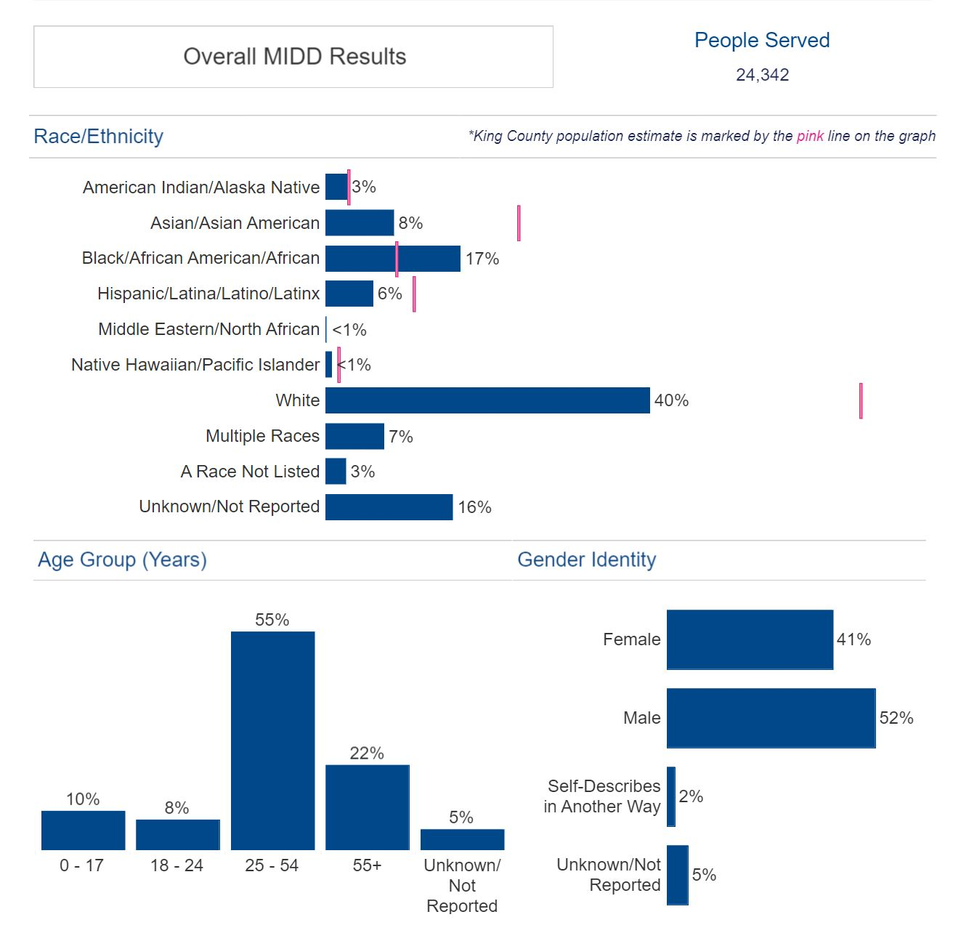

Ordinance 19546, Section 71, ER1 and P1. The 2023-2024 biennial budget included a $200,000 expenditure restriction on the MIDD fund for a grant-based art therapy pilot program. The expenditure restriction required the pilot program to incorporate, “culturally appropriate, trauma-informed behavioral health services for cultural and ethnic communities […] The goal of the pilot program shall be to support an art therapy program that improves cognitive functioning, fosters self-esteem and self-awareness, cultivates emotional resilience, promotes insight, enhances social skills, reduces and resolves conflicts and distress and supports recovery. […] The pilot project funded through this appropriation must be highlighted and evaluated in the 2023 and 2024 annual mental illness and drug dependency evaluation summary report.”

The required highlight and evaluation of the art therapy pilot program is included in the 2023 annual report beginning on page 15. The summary states that Unified Outreach, received Council-directed grant-based art therapy pilot funding. Unified Outreach is an arts-based nonprofit that, “provides programs to community centers, public and private schools, transitional housing/youth shelters, and other organizations seeking to provide industry level Arts instruction to children in Seattle’s under-served neighborhoods.” According to the report, Unified Outreach, “partnered with and served students from Southwest Youth and Family Services, Denny Middle School, and Southwest Boys and Girls Club. The program released the first print copy of Vibrant, a magazine featuring students’ works, in December 2023.” Through this pilot program, Unified Outreach served 62 participants ages 11 to 19 years old, with 97 percent identifying as people of color. The report states that, “83 percent reported increases in their sense of community belonging, through participation in group art projects, engaging in healing circle dialogue, and providing peer reviews to other artists in the program.”

INVITED

- Kelly Rider, Director, Department of Community and Human Services (DCHS)
- Susan McLaughlin, Director, Behavioral Health and Recovery Division (BHRD), DCHS
- Robin Pfohman, MIDD Coordinator, BHRD, DCHS

ATTACHMENTS:

- Proposed Motion 2024-0243
a. 2023 MIDD annual report
- Transmittal Letter

MIDD Advisory Committee, https://kingcounty.gov/depts/community-human-services/mental-health-substance-abuse/midd/midd-committees.aspx
In 2005, the Washington state legislature authorized counties to implement a one-tenth of one percent sales and use tax to support new or expanded chemical dependency or mental health treatment programs and services and for the operation of new or expanded therapeutic court programs and services.
The MIDD Oversight Committee was established in Ordinance 16077 and is an advisory body to the King County Executive and the Council. The purpose of the Oversight Committee is to ensure that the implementation and evaluation of the strategies and programs funded by the tax revenue are transparent, accountable, and collaborative.
In October 2008, the Council adopted the MIDD 1mplementation Plan and the MIDD Evaluation Plan via Ordinance 16261 and Ordinance 16262.
2023 MIDD Data Dashboard, accessed August 1, 2024. https://kingcounty.gov/en/dept/dchs/human-social-services/community-funded-initiatives/midd-behavioral-health-tax/midd-behavioral-health-sales-tax-dashboard
2023 MIDD Annual Report, page 18
2023 MIDD Data Dashboard, accessed August 1, 2024. https://kingcounty.gov/en/dept/dchs/human-social-services/community-funded-initiatives/midd-behavioral-health-tax/midd-behavioral-health-sales-tax-dashboard
Unified Outreach, https://unified-outreach.com/

