FIRST AMENDMENT TO INTERLOCAL AGREEMENT FOR REGIONAL TRANSFER OF DEVELOPMENT RIGHTS AND TAX INCREMENT FINANCING OF INFRASTRUCTURE BY AND BETWEEN THE CITY OF SEATTLE AND KING COUNTY

Ordinance 20059

This First Amendment to ILA (“First Amendment”) is made between King County, a home rule charter county and political subdivision of the State of Washington (“County”), and the City of Seattle, State of Washington first-class charter city, by and through its Seattle Parks and Recreation Department, each of which may be referred to individually herein as a “Party” and collectively as the “Parties.”

RECITALS

- The Washington state Growth Management Act (“GMA”), Revised Code of Washington (“RCW”) 36.70A, establishes a policy of directing growth and development into urban areas, protecting rural and resource land, and encouraging the use of innovative tools like transfer of development rights (“TDR”) to accomplish these outcomes.

- King County adopted a TDR program (“TDR Program”) in 2001 to permanently preserve rural and resource lands by transferring rural development potential into existing incorporated and unincorporated urban areas; since 2001, the King County TDR Program has protected over 148,000 acres of rural and resource lands in unincorporated King County.

- King County has worked with the City of Seattle to develop a means by which King County TDRs may be used to increase density within the city to achieve conservation of rural farm and forest lands in the unincorporated areas.

- The City of Seattle, by City Council Ordinance 124172, amended Seattle Municipal Code chapter 23.58 to allow the South Lake Union, Denny/Broad, and Commercial Core areas of its downtown to be receiving areas for King County TDRs, subject to an adopted interlocal agreement with King County.
- The 2011 Washington state Legislature affirmed the value of regional TDR by adopting Engrossed Substitute Senate Bill 5253, the Landscape Conservation and Local Infrastructure Program (“LCLIP”), codified as RCW 39.108.

- RCW 39.108 creates a mechanism for the cities and counties to partner on regional TDR efforts and urban infrastructure investments to support urban growth simultaneous with rural and resource land conservation.

- RCW 39.108 allows cities to accept development rights from county rural and resource lands to increase development capacity inside incorporated urban areas in exchange for

cities receiving a portion of county property tax revenue generated from new construction in a designated “Local Infrastructure Project Area” (“LIPA”). Cities are required to invest these funds in infrastructure projects and public improvements that support the increased development growth in the LIPA.

- King County and the City of Seattle entered into an interlocal agreement (“ILA”) in 2013 to implement LCLIP, which was authorized by King County Ordinance 17663.

- The ILA contained an open space investments project list appended as Exhibit C to the ILA. The projects enumerated in Exhibit C have been already completed or are being funded through alternative funding sources.

- Section VIII.E of the LCLIP ILA provides that any modification to the ILA must be in writing and signed by the parties. Approval of such modifications by each respective legislative body is required by Chapter 39.34 RCW.

- By Seattle City Council Ordinance 127377, the City of Seattle approved its most recent amendment to the City’s Landscape Conservation Program Funding Plan for South lake Union and Downtown to include an updated open space investments project list reflecting current and future community needs within the LIPA, as informed by community engagement.

- The Parties desire to amend the LCLIP ILA project list in Exhibit C to reflect current program needs, in accordance with the changes approved by the Seattle City Council in Seattle City Council Ordinance 127377.

NOW THEREFORE, in consideration of the promises, acts, and other terms and conditions set forth below, the Parties agree as follows:

  - Exhibit C of the ILA, Landscape Conservation and Local Infrastructure Program Infrastructure Funding Plan For South Lake Union and Downtown, is hereby deleted in its entirety and replaced with Exhibit C-1, attached hereto as Attachment 1 and incorporated herein by this reference.

  - Unless otherwise defined in this First Amendment, capitalized terms used herein and defined in the ILA shall be used herein as defined in the ILA. The terms that are defined in the recitals above are made a part of this First Amendment.

  - This First Amendment, together with the ILA, contains the entire agreement between the Parties with respect to the subject matter hereof and supersedes all prior understandings and agreements on such subject matter.

  - Except as expressly modified by this First Amendment, all terms, covenants, and conditions of the ILA shall remain in full force and effect and are hereby ratified and confirmed. To the extent the provisions of this First Amendment are inconsistent with the

ILA, the terms of this First Amendment shall control.

  - This First Amendment may be executed in any number of counterparts and all counterparts shall be deemed to constitute a single agreement. The execution of one counterpart by any Party shall have the same force and effect as if that Party had signed all other counterparts. The signatures to this Amendment may be executed on separate pages and when attached to this Amendment shall constitute one complete document. A portable document format (PDF) signature on this Amendment shall be equivalent to, and have the same force and effect as, an original signature.

IN WITNESS WHEREOF, the Parties hereby execute this First Amendment to the ILA, effective as of the last day and year written below:

KING COUNTY:  KING COUNTY, a home rule charter County and political subdivision of the State of Washington  By: ___________________________  Date: | APPROVED AS TO FORM ONLY:  By: ____________  Erin Jackson  Senior Deputy Prosecuting Attorney
CITY OF SEATTLE:  City of Seattle, a Washington first-class charter city  By: ___________________________  Date: | APPROVED AS TO FORM ONLY:  By: -----____________  Name: _________________________  Assistant City Attorney

ATTACHMENT 1
(Exhibit C-1 to ILA)
Landscape Conservation and Local Infrastructure Program Infrastructure Funding Plan
For South Lake Union and Downtown
June 13, 2013
Amended April 22, 2025
Amended July 18. 2025
Amended December 16, 2025

This plan outlines potential infrastructure investments that could be implemented through funding generated by the Landscape Conservation and Local Infrastructure Program (LCLIP) that is being proposed by the City of Seattle in cooperation with King County. While specific funding decisions will be made by the City based on the amount of funding available, project timing, opportunities to leverage outside funds, opportunities to leverage developer improvements, and other factors, this plan outlines the scope of potential items that could be funded through this program. Funding of any items not included in this plan through the LCLIP program would require modification of the plan by legislative action. All dollar amounts are in 2012 dollars.

Background

The City of Seattle, in cooperation with King County, is proposing to implement the LCLIP program in the neighborhoods of South Lake Union and Downtown. The LCLIP program allows cities to receive a portion of future county property tax revenue for local infrastructure investments if they implement a program to obtain regional Transferable Development Rights (TDR). The City is proposing to meet the requirements for capturing TDRs through the incentive zoning program in South Lake Union and Downtown. The overall purpose of the Infrastructure Funding and Regional TDR Programs is to preserve farm and forest land by transferring development capacity from these lands to cities and generate funds for local infrastructure projects in the communities where the additional development capacity is located.

The Regional TDR program would be implemented by requiring developers to earn extra floor area and height in part by purchasing and extinguishing development rights (also known as TDR credits) from regional farms and forests.

In exchange for implementing a Regional TDR Program through the City’s incentive zoning program, the City would be entitled to receive 17.44% of property tax revenue from new development occurring in the Local Infrastructure Project Area (LIPA) for up to 25 years
according to the standards of RCW 39.108. The boundary area of the proposed LIPA is shown below.

ro frastructur
11 I

l------l��4+��r-T""""l�Tr,----L:--:k:----'"""""'�--+--\,_;i_;r,1rl1�T"'",:_�:_t�l ,_' 1-
e

a
Union �

RO
ST

ST
CER
ER
1---t---+--'-I_ l_J
I I
I I
r-1-- -

t---t--+-t-f-f-j----l- it--11--1--1-r-.-1
+-+--+-+--I- 1"--+--+-+-it-f--1H---t,�

ETHO

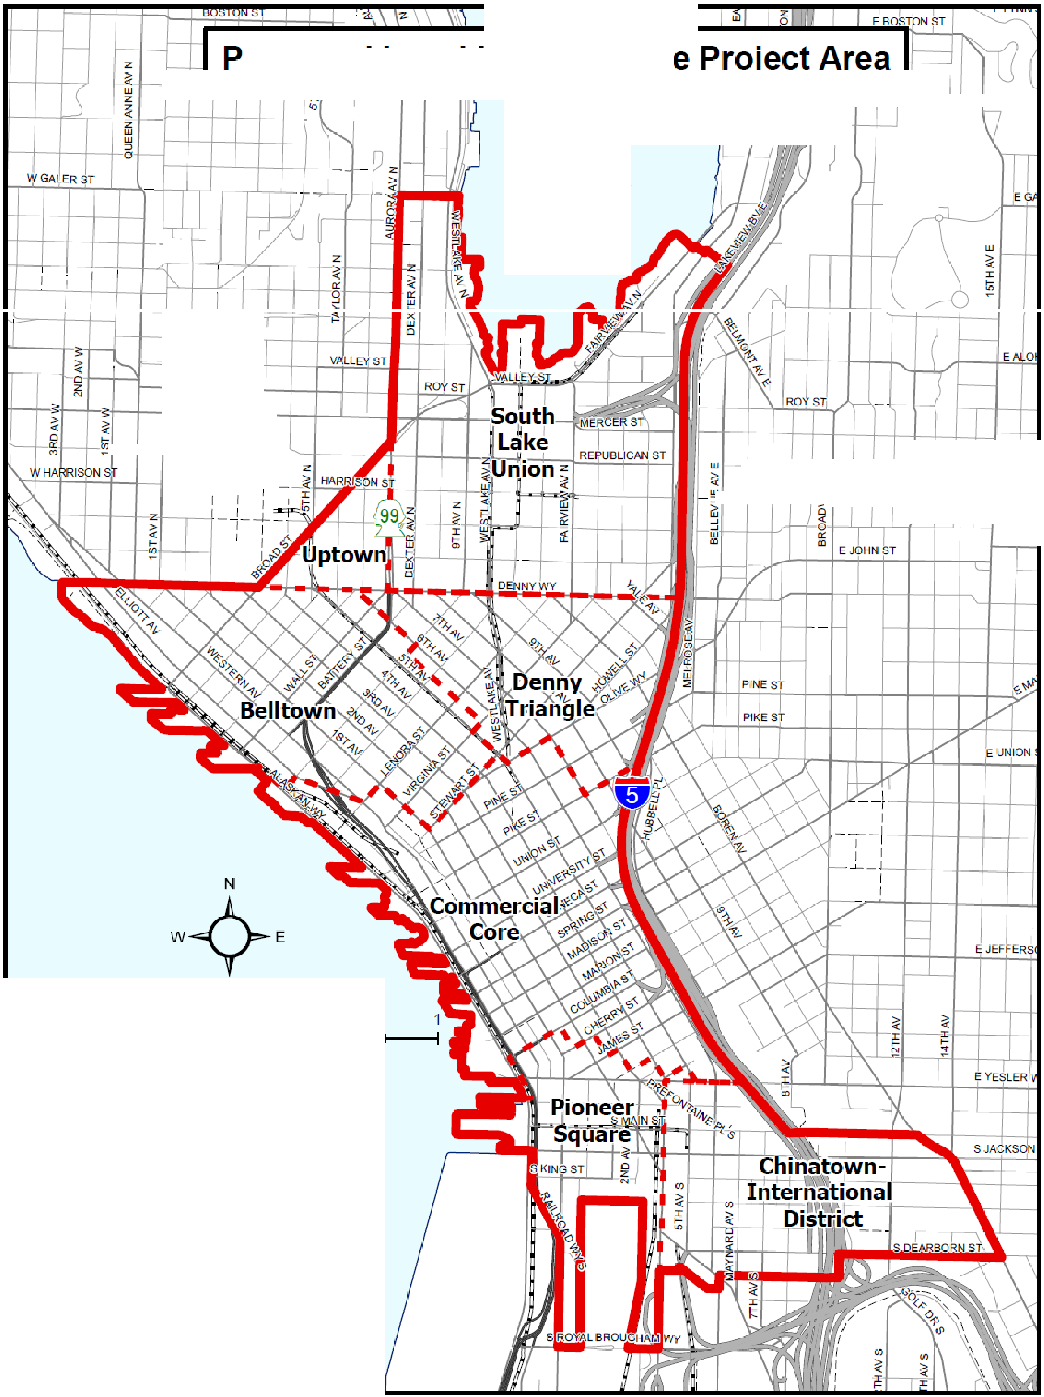
.--
c::
J Project Area
1 •• 1 Urban Center Urban Village

0 025

Elliott

Bay
s
05
Miles

This funding would be contingent on meeting certain thresholds over time. The initial length of the program would be 10 years. The program would be extended to:
- 15 years if 400 credits are obtained within 9.5 years;
- 20 years if 600 credits are obtained within 14.5 years; or
- 25 years if 800 credits are obtained within 19.5 years.

King County would agree to consider each threshold met if, prior to each deadline, at least 70%-80% of the TDR credits necessary to meet the local property tax threshold had been obtained (the exact percentage varies by threshold) and the City requested in writing, that the threshold be considered met. If the option to extend to 25 years is used prior to obtaining 800 credits, the City would be required to continue the TDR program until 800 credits were obtained even if it required the TDR program to extend beyond 25 years.

Anticipated Revenue
It is anticipated that this program will result in $27.5M in revenue from King County property taxes over 25 years. If an annual discount rate of 3% is used to account for the reduced value of having money in the future, these funds would be equivalent to $15.7M in 2012 dollars. Below is an estimate of expected revenue by year.
County Property Tax Value
$3.0
$2.5
$2.0
$1.5
$1.0
$0.5
$-

Year
Annual Revenue (in Millions)

Funding Strategy
2014
2015
2016
2017
2018
2019
2020
2021
2022
2023
2024
2025
2026
2027
2028
2029
2030
2031
2032
2033
2034
2035
2036
2037
2038
Revenue generated from the LCLIP program will be spent on streetscape and open space investments as described below and detailed in the “specific investments” section.

These funds would be split between projects in South Lake Union and Downtown based on the proportion of regional TDR generated in each area. It is estimated that this split will result in

about 60% of the funds or $16.5M ($9.4M in 2012 dollars) being allocated to South Lake Union projects and 40% of the funds or $11.0M ($6.3M in 2012 dollars) to Downtown projects.

Decisions about which projects to implement and when they will be implemented will be made by the City based on the amount of funding available, project timing, opportunities to leverage outside funds, opportunities to leverage developer improvements, and other factors. In order to streamline this process, the City is proposing to stage the projects such that the first 10 years of revenue would go toward streetscape and transportation projects managed by the Department of Transportation, the second 10 years of revenue would go to Open Space Investments managed by the Department of Parks and Recreation, and the last 5 years again would go to streetscape projects managed by the Department of Transportation.

A chart summarizing the proposed staging and projects (with priority projects in bold) is shown below:

Revenue Years | Agency | Estimated Total Revenue (2012 Dollars) | Proposed Projects by Area
Revenue Years | Agency | Estimated Total Revenue (2012 Dollars) | South Lake Union | Downtown
0-10 years | SDOT | $2.9M | - Green Streets  (Thomas & 8th)  - Bike, Pedestrian, and Transit Improvements (Harrison & Denny) | - 3rd Avenue Improvements (Capital Projects & Programs)
11-20 years | Parks | $7.8M | - Park Improvements
21-25 years | SDOT | $5.0M | - Transportation Improvements – specific  improvements to be determined later

In general, the City plans to spend money as it is received; however, opportunities to use bonding to implement projects prior to the receipt of funds will be considered on a project-by-project basis.

Specific Investments
The specific investments that are proposed to be funded in part through LCLIP are outlined on the following pages. It is anticipated that funds generated though LCLIP will be combined with funds from other sources to accomplish these projects.

South Lake Union Streetscape Investment

Thomas Street Green Street (from Dexter Ave to Fairview Ave)

Proposed Improvements | Cost Estimate
Implement “green street” improvements to support Thomas Street’s role as an important new east / west green street and public realm connection, linking the Cascade neighborhood through South Lake Union to the Seattle Center. The current proposal includes a two-way, two-lane configuration with on-street parking. Curb bulbs will be added where appropriate and the north sidewalk will be expanded to provide a green promenade.  Pedestrian-scale lighting and streetscape improvements will be made throughout. | $1,500,000
8th Avenue NE Green Street (from Mercer Street to John Street)

Proposed Improvements | Cost Estimate
Create a pedestrian-oriented street from Mercer to John with an enhanced green street environment that could serve as a woonerf. The project will likely include widened sidewalks, new trees and plantings, new pedestrian  lighting, and streetscape improvements. | $2,500,000

Harrison Street Improvements (from Dexter Avenue to Fairview Avenue)

Proposed Improvements | Cost Estimate
Rebuild or repair pavement between Dexter and Eastlake to allow potential transit use and provide a three-lane roadway section as necessary; repair, replace or enhance sidewalks and install curb bulbs as needed; improve planting areas, tree canopy and parking as possible; provide pedestrian lighting and streetscape improvements. Harrison will become the primary street for traveling east / west through South Lake Union between Mercer  Street and Denny Street. | $5,500,000

Denny Way Improvements (from Broad Street to Stewart Street)

Proposed Improvements | Cost Estimate
Make spot improvements consistent with Denny Way Streetscape Concept Plan; improve pedestrian crossing conditions, enhance signalized intersections, replace sidewalk in poor condition, improve planting strips and  provide street trees where needed; Improve roadway delineation in locations where two streets intersect Denny at a diagonal. | $2,500,000

Downtown Streetscape Investments

Third Avenue Corridor Improvements

Proposed Improvements | Cost Estimate
This project makes multimodal improvements in the Third Avenue downtown corridor, a major travel corridor for pedestrians and transit vehicles. The project enhances the walking, biking and transit environment and improves safety for all travel modes. Improvements may include repair or enhancement of streets, improving sidewalks, upgrading or installing curb ramps, remarking crosswalks, and installing pedestrian countdown signals. It may also include pedestrian-scale lighting, bicycle facilities at select locations, high-capacity solar trash receptacles and wayfinding information. Transit will be made more attractive and convenient with improvements such as real-time transit information, transit maps and schedule information, improved weather protection, ticket vending machines or ORCA card readers. | $40 to 70 million

Open Space Investments
This funding plan outlines the scope of potential Open Space Investments that could be implemented through funding generated by the Landscape Conservation and Local Infrastructure Program (“LCLIP”) that has been underway by the City of Seattle in cooperation with King County since 2013. This Open Space Investments funding plan in no way affects the proposed South Lake Union Streetscape Investment or the Downtown Streetscape Investments, both of which are under the purview of the Department of Transportation. Funding of any items through the LCLIP program not included in this plan would require modification of the plan by legislative action. The estimated $7.8M that SPR would get in 2012 dollars (in the table above) is equivalent to $14M in 2025 dollars.
Decisions about which projects to implement and when will be made by the City based on the amount of funding available, project timing, opportunities to leverage outside funds, opportunities to leverage developer improvements, and other factors. The Open Space Investments project list below amends the Open Space Investments project list approved with the 2013 legislation (Ord. 124286). The projects initially proposed with that legislation have already been completed by the Department utilizing other sources of funding with the exception of a north downtown community center.

Open Space Investments

Northwest Native Canoe Carving Center
Proposed Improvements | Cost  Estimate | Year
Improvements for a new timber framed structure with localized site modifications within the existing Lake Union Park. | $550,000 | 2025-2026

Prefontaine Plaza

Proposed Improvements | Cost  Estimate | Year
Improvements to restoring functionality at existing fountain and  improving pathway safety at site. | $400,000 | 2025-2026
Lake Union Waterline Project
Proposed Improvements | Cost  Estimate | Year
Improvements for a new water distribution system needed within Lake  Union Park. | $4,500,000 | 2026-2029
City Hall Park
Proposed Improvements | Cost  Estimate | Year
Site improvements at park to address user safety concerns, improved  pedestrian circulation, and landscape plantings. | $3,000,000 | 2030-2032
Westlake Park
Proposed Improvements | Cost  Estimate | Year
Expansion of 2025 project scope to include site improvements associated with the removal and storage of the Seven Hills artwork and elements of the existing water wall and arch (relocation will be  funded separately). | $1,000,000 | 2025-2026

South Lake Union Community Council SLU Parks Task Force Projects
Proposed Improvements | Cost  Estimate | Year
Projects identified in collaboration with community members from South Lake Union to provide expanded activation and infrastructure to  Lake Union Park, Denny Park and Cascade Playground. | $2,730,000 | 2026-2034

Downtown District Community-led Projects
Proposed Improvements | Cost  Estimate | Year
Projects identified in parks in the Downtown District, in collaboration with community members from that district, to expand activation and infrastructure: Myrtle Edwards Park, Alaskan Way Boulevard, Belltown Cottage Park, Urban Triangle Park, Bell Street Park Boulevard, Westlake Square, McGraw Square, Victor Steinbrueck Park, Westlake Park, Freeway Park, Pioneer Square, Prefontaine Place, City Hall Park,  Occidental Square, Pioneer Square, Union Station Square. | $1,070,000 | 2026-2034

Chinatown/International District Community-led Projects
Proposed Improvements | Cost  Estimate | Year
Projects identified in parks in the Chinatown/International District, in collaboration with community members from that district, to expand activation and infrastructure: Kobe Terrace, Hing Hay Park, Hoa Mai  Park, Donnie Chin International Children’s Park, Beacon Place. | $750,000 | 2030-2034

Reserve
Proposed Improvements | Cost  Estimate | Year
Set aside funds to address potential de minimus scope changes or cost  increases. | $1,000,000 | 2030-2034
Total Open Space Investments: $15,000,000 (*note that SPR received approximately $1,000,000 in excess revenue above the amount originally projected in SPR’s first year of the program which is being allocated to the Westlake Project).

