Alternative Services

Metro offers public transportation products to supplement fixed-route transit service. These services expand mobility options and can provide cost-effective travel alternatives in areas where fixed-route service is not cost-effective.

FLEXIBLE TRANSIT SERVICES

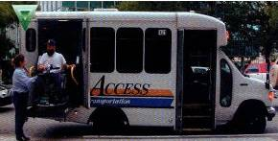
- ACCESS Paratransit. Available for people with disabilities who cannot use the fixed-route system
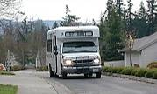
- Dial-A-Ride (DART) Transit on a fixed schedule that can go off its regular routing

RIDESHARING

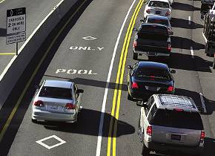
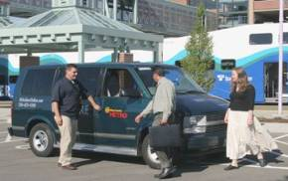
- VanPools. Prearranged program where people commute together
- VanShare. Bridges the distance between a transit terminal and the destination
- Carpools. Pre-arranged, shared use of a car
- Flexible Carpools. Not arranged in advance; can be facilitated with the use of technology. Commonly referred to as ‘slugging’ or ‘real-time carpooling. For example, in Washington DC and San Francisco, people use flexible carpools to take advantage of HOV lanes and congestion free lanes on the roadway. Potential passengers line up at transit centers or other known locations and wait for a driver who is headed the direction they want to go.
- Flexible Vanpools. Informal or formal. Works when a ‘pool’ of vanpools serve the same location.

COMMUNITY AND EMPLOYER PROGRAMS
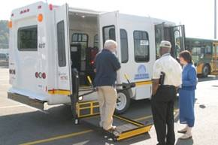
- Community Access Transportation (CAT). Through the CAT program, King County Metro provides vans, maintenance and some operating funds to community organizations to provide their own transportation to clients and others. Example: Circle of Friends adult daycare.

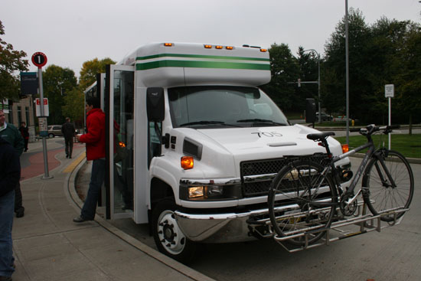
- Employer-provided Transportation. Employer programs range from large scale services such as the Microsoft Connector program to shorter-distance shuttle programs such as the one found at Children’s
TAXI PROGRAMS


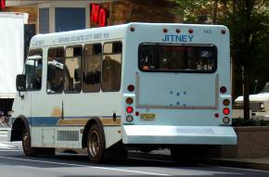
- Taxi Scrip. A taxi scrip program pays a percentage of the cost of a taxi ride for low income customers who are seniors or adults under age 65 with a disability.

- Shared Taxi. A shared taxi uses taxi cars or vans to provide service along a transit route at set intervals, picking up and dropping passengers off at bus stops. Shared taxis could be private vehicles or contracted by the transit agency.

OTHER PROGRAMS


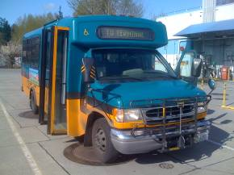
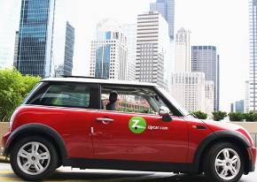

- Custom Bus. Subscription service provided for employers and schools

- Jobs Access Transportation Programs (JARC). Transportation to transition low-income and welfare reform clients into employment

- Car Sharing. Access to a shared car, such as ZipCar

