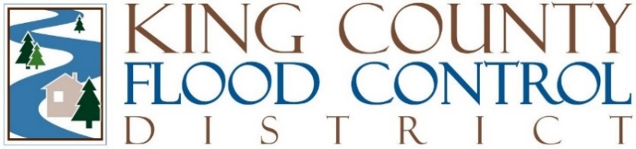

STAFF REPORT

Agenda Item: | 8 | Name: | Michelle Clark
Proposed Legislation: | FCD24-03 | Date: | September 10, 2024

Proposed Motion FCD2024-03: A motion directing the development of a planning process for the Lower Green River Corridor Flood Hazard Management Plan based on the Final Programmatic Environmental Impact Statement.

Proposed Motion FCD24-03 directs the development of a work plan and budget for a planning process for the Lower Green River Corridor Flood Hazard Management Plan and Capital Investment Strategy (Plan) based on the information and analysis contained in the King County Flood Control District’s (District) Final Programmatic Environmental Impact Statement (Final PEIS).

The work plan and budget for the Plan shall incorporate the topic areas of the PEIS based in on the information and analysis contained the Final PEIS and the Enhanced Systematic Implementation of Multibenefits Alternative, Alternative Three, policy framework and decision making hierarchy.

The planning process will incorporate the extensive community outreach and collaboration framework used by King County in the creation of its updated Draft Flood Hazard Management Plan, including but not limited to, seeking input and advice from Tribes, jurisdictions, agencies, and community members, and other interested parties; and working with Community Navigators to increase the input from residents in the Corridor directly impacted by flooding and flood risk reduction activities.

The work plan will include the topic areas of the Plan, including but not limited to:

  - The elements common to all PEIS alternatives
    - Actions by the District must be related to flood hazard management needs.
    - The District would continue to fulfill its duty under Chapter 86.15 RCW to plan, construct, acquire, repair, maintain and operate all necessary equipment, facilities, improvements and works to control, conserve and remove flood and storm water as well as take action necessary to protect life and property from flood water damage.
    - The District would honor and respect tribal and treaty reserved rights.
    - The District would continue to rely on a system of flood facilities that include levees, revetments, and floodwalls to protect people, jobs, and property on the Lower Green River.
    - The District would use the provisional 18,800 cfs, plus three feet of freeboard, or 500-year level of protection, to evaluate and design potential flood hazard management measures. Should the US Army Corps of Engineers adjust the 500-year flood level in the Lower Green in the future, the District would evaluate and design potential flood hazard management measures to the new flow level.
    - The District would maintain enrollment in the US Army Corps of Engineers PL 84-99 program for those facilities that are currently enrolled.
    - The District would protect and not isolate housing and neighborhoods with flood hazard management facilities.
    - The District would protect housing and community facilities used by historically disadvantaged populations (low-income and people of color).
    - The District would prioritize the design and implementation of multibenefit floodplain management projects as described in FCD Motion 20-07.
    - The District would follow the policies included in the adopted County-wide Flood Hazard Management Plan including the policy to ensure that its actions will not have an adverse flooding impact on upstream or downstream property owners.
    - The District would continuously use best available science for climate change in its flood hazard management planning, adaptive management, and facility design.

  - The District would design facilities to improve habitat and water quality (e.g., vegetation to provide shading or large woody debris) when practicable. The Plan will incorporate the decision making hierarchy outlined in the Enhanced Systematic Implementation of Multibenefits Alternative in the PEIS as the paradigm for the District when establishing project prioritization and implementation including project design.

  - The Plan will require the District to pursue flood reduction activities and systematically pursue habitat protection and restoration while pursuing all of the multiple benefits in the Multibenefit Motion where practicable.

  - The Plan will require the District to look for opportunities to set levees and floodwalls further from the river, enhance habitat , open space, and recreation opportunities where practicable. The District will work with jurisdictions to identify areas where redevelopment might happen.

  - The Plan will require all relevant and updated scientific modelling and assessment during the implementation of District flood risk reduction activities in the Corridor including, but not limited to the effects of sea level rise due to climate change, dynamic river conditions (e.g. flows, bathymetry, and topography), overtopping and level breach scenarios, changes to the USGS gauge rating curve, and the ecological connectivity for wildlife and plants, the analysis of current hydrologic conditions as they may have changed based on the natural processes of the Green River or actions of jurisdictions or partners including WRIA 9;

  - The Plan will require the District to study protecting agricultural lands from more frequent, lower flow events while allowing inundation to occur, thereby preserving flood storage at higher flow events including the potential impacts to property, productive agricultural lands, and habitat prior to implementing a flood risk reduction project intended to protect agricultural lands.

The work plan and budget for the Plan will be transmitted to the board of supervisors by October 15, 2024.

Approval of this motion does not require a contract amendment with Parametrix.

