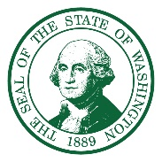
STATE OF WASHINGTON
DEPARTMENT OF ECOLOGY
Northwest Region Office
PO Box 330316, Shoreline, WA 98133-9716 • 206-594-0000

June 20, 2024

Dow Constantine
King County Executive
401 5th Avenue
Suite 800
Seattle, WA, 98104

Dear Executive Constantine:

The purpose of this letter is to inform you that the Washington State Department of Ecology (Ecology) hereby approves the King County Flood Management Plan (the plan) dated April 2024. The plan addresses flood risks posed by the South Fork Skykomish/Snoqualmie watershed, Lake Washington/Cedar/Sammamish River watershed, Green/Duwamish River watershed, and White River basin, through development of a long-term flood hazard management approach. The approved comprehensive flood hazard management plan qualifies King County for eligibility to request Flood Control Assistance Account Program funding to be used within the study area.

As a reminder, Ecology approval of the plan is limited to the document’s planning focus only. Detailed, site-specific analysis will be needed to assess environmental impacts and all necessary permits will need to be obtained prior to the implementation of any of the proposed projects contained within the plan.

I encourage you to forward copies of the plan to the Federal Emergency Management Agency Region X and the Emergency Management Division of the State Military Department for their reference. Access to the plan by these agencies may expedite eligibility determinations for future disaster relief and hazard mitigation funding. Thank you for your efforts in developing the King County Flood Management Plan. We look forward to a continued positive working relationship.

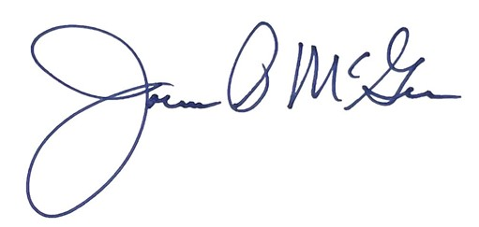
Sincerely,

Joenne McGerr, Program Manager
Shorelands & Environmental Assistance Program
cc:
Jason Wilkinson, King County
FEMA Region X
Stacey McClain, Washington Military Department
Tom Buroker, Washington Department of Ecology
Joe Burcar, Washington Department of Ecology
Kayla Eicholtz, Washington Department of Ecology

